**MATLAB Homework 04**

Yifu Huang

**Codes location:** [**https://github.com/yifuhhh/EE385J_Biomed_Image/tree/master/HW04/Submission**](https://github.com/yifuhhh/EE385J_Biomed_Image/tree/master/HW04/Submission)

1. **Using the “k-space” array from the matlab_monday_04.mat explore manipulating the k-space data and comment on these manipulations’ effects on the imaging data.**
2. Set every other row in k-space equal to zero, then reconstruct the image. Now, set every other column in k-space equal to zero and then reconstruct the image. Describe what is happening in these two images. Can you think of why this is happening?

As shown in Fig. 1 and 2, when every other row in k-space was set as 0, the image would repeat itself vertically. While the image would repeat itself horizontally when every other column in k-space was set as 0.

To explain the phenomenon, let’s take Fig. 1 as an example. When put every other row in k-space as 0, the image equivalently went through a diffraction grating with a set of slits of spacing one pixel. It will cause the image to have diffraction. When reconstruct the image, the repeating images on the top and bottom side are the fake images caused by diffraction.

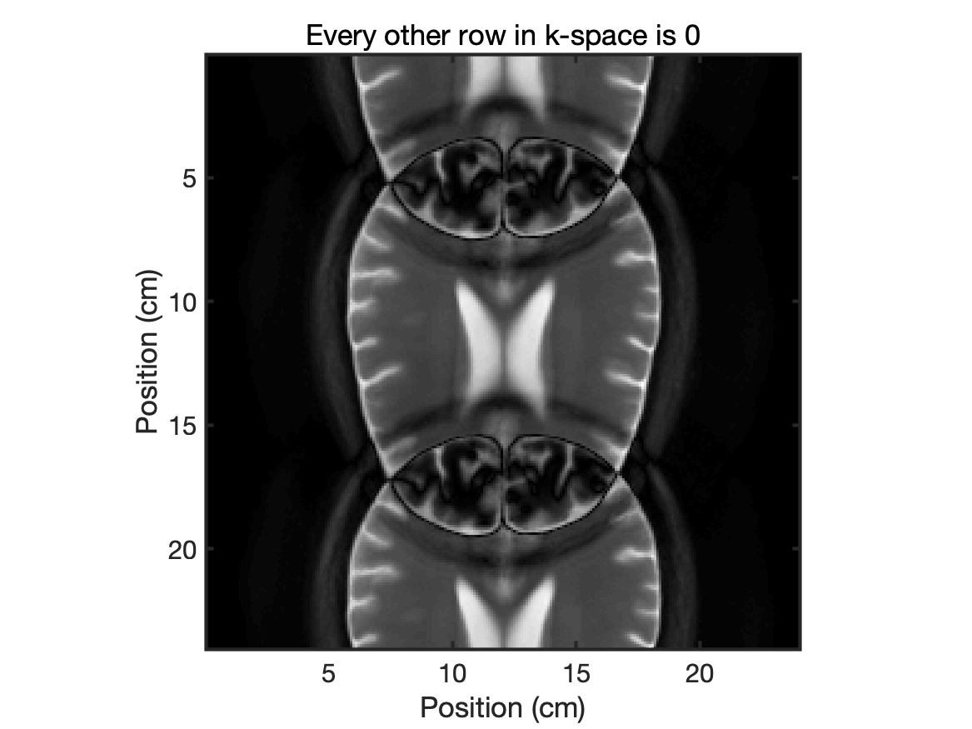

Figure 1. Set every other row in k-space equal to 0

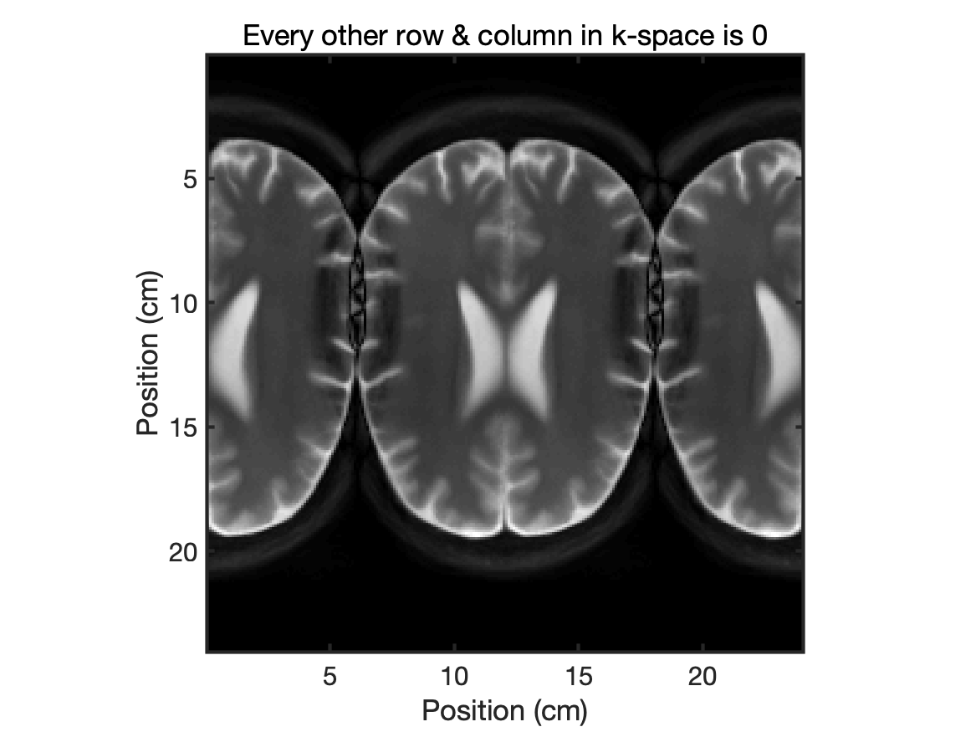

Figure 2. Set every other column in k-space equal to 0

1. How would you edit k-space to remove high-spatial-frequency information? Demonstrate an example of this by displaying both the k-space image and the reconstructed image.

The high-spatial-frequency information is the parts far away from the center of k-space. We can create a filter to remove the surrounding parts in k-space matrix. As is shown in Fig. 3, I created a circular filtered area with the diameter of 1/3 side length of the k-space matrix. The reconstructed area is shown as Fig. 4.

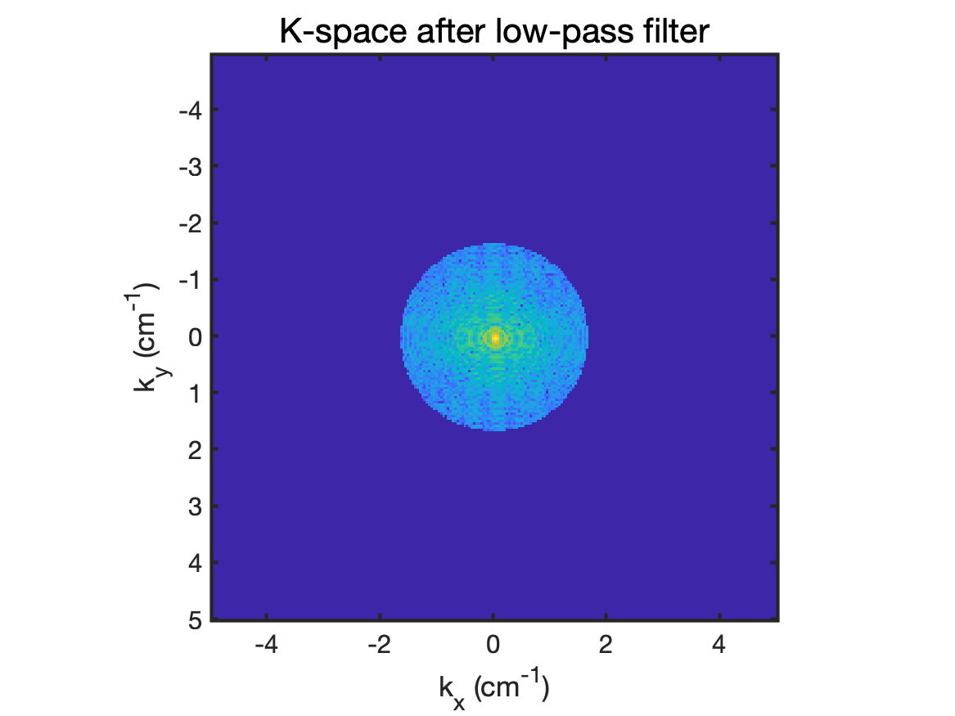

Figure 3. K-space without high-spatial-frequency information

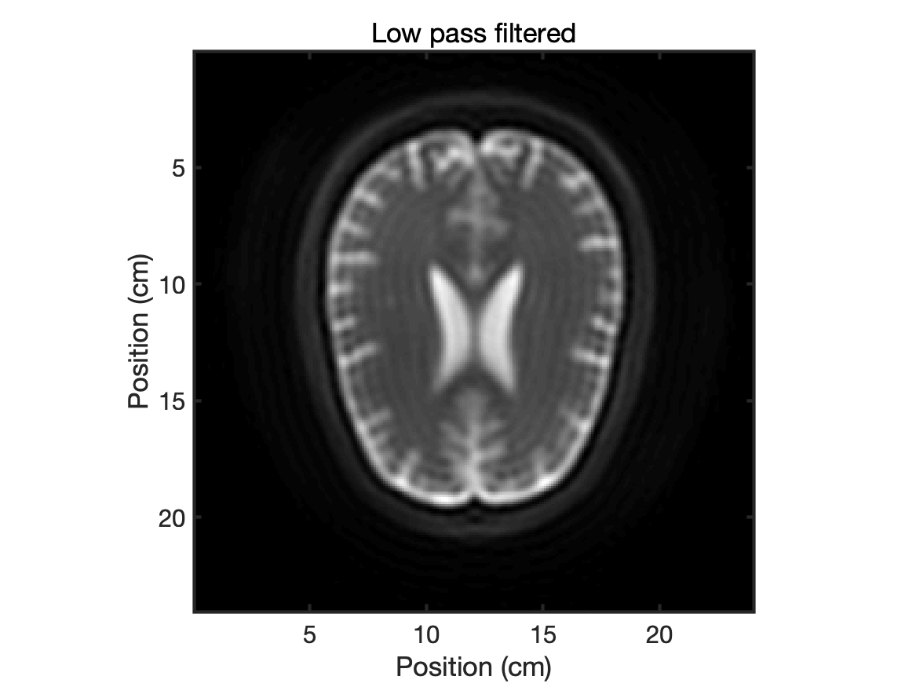

Figure 4. Reconstructed image after low pass filter

1. How would you edit k-space to remove low spatial frequency information? Demonstrate an example of this by displaying both the k-space image and the reconstructed image.

I created a filtered area exactly opposite to that in Question 1(b), which is shown in Fig. 5. The center part of the k-space matrix was removed. The reconstructed image is shown as Fig. 6.

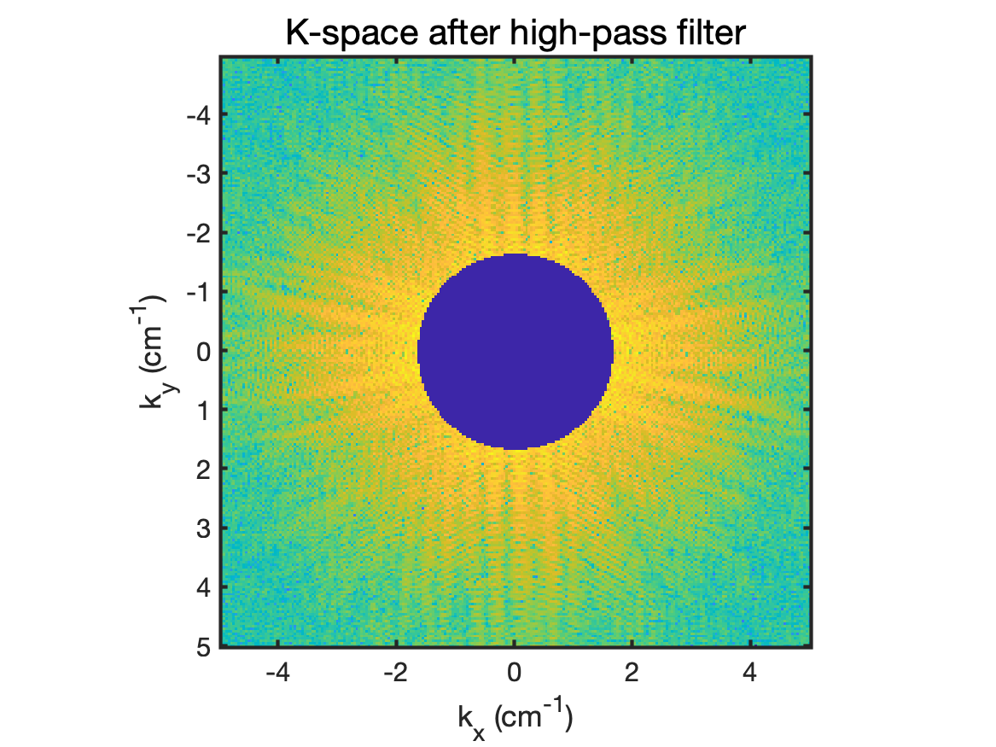

Figure 5. K-space without low-spatial-frequency information

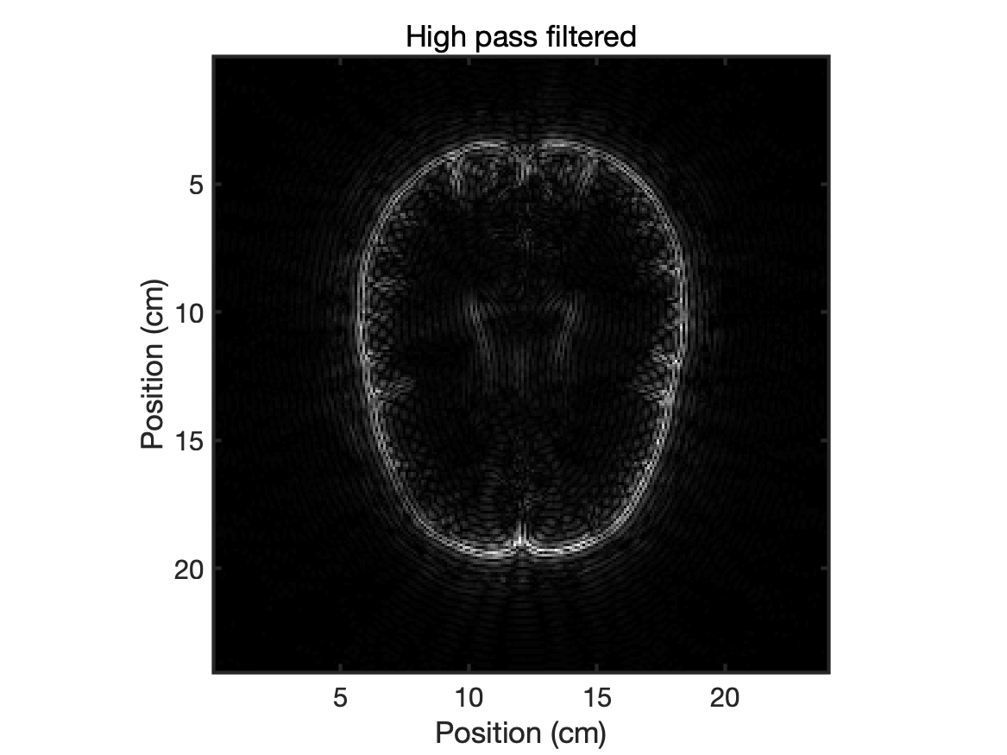

Figure 6. Reconstructed image after high pass filter

1. T1 Mapping. A common technique in MRI is to measure the longitudinal relaxation time T1 within tissue. There are several different approaches out there, and here we will look at two different approaches variable flip angle (VFA) and variable repetition time (VTR). For a VTR approach, we typically collect several spin echo (SE) images with a known TE and a range of TR values. The signal is described by the equation below:

For VTR we have two different sequences we want to evaluate. Sequence 1 was collected with TRs defined in TR_s1, while sequence 2 was collected with TRs defined in TR_s2. Use lsqcurvefit to estimate the T1 and S0 values from both datasets (Sequence 1 = VTR_s1 Sequence 2 = VTR_s2). VTR_s1(y,x) refers to the y-th T1 value collected at the x-th TR;

1. For both sequences plot the known T1 (saved as “T1”) versus the estimated T1.

Figure 7. Estimated T1 using TR_s1

Figure 8. Estimated T1 using TR_s2

1. Calculate the error using the equation below for both approaches.

The error of TR_s1 is 0.1490.

The error of TR_s2 is 0.8320.

1. Comment on the results, why do you think Sequence 2 has increased error at later time points?

As is shown Fig. 9, TR_s2 is around 1/3 of TR_s1 at the end of the sequence. In the later time points, values in TR_s2 cannot satisfy TR >> T1, so the error would be larger than TR_s1.

Figure 9. Repetition time in both sequences