**MATLAB Homework 05**

Yifu Huang

**Codes location:** [**https://github.com/yifuhhh/EE385J_Biomed_Image/tree/master/HW05/Submission**](https://github.com/yifuhhh/EE385J_Biomed_Image/tree/master/HW05/Submission)

1. **For each patient, display the image slices with tumors, with your ROI displayed on top of it.**
2. Discuss how you determined what was cancerous from healthy tissue. (What were your assumptions).

The slices with tumors are shown below. Slice 5 ~ 7 of Patient 1 and Slice 1 ~ 8 of Patient 2 are chosen here for ROI analysis.

The criteria I determined what was cancerous from healthy tissue is based on the color and contrast in the image. The boundary of the tumor is blurry, and the shape is irregular.

**Patient 1:**

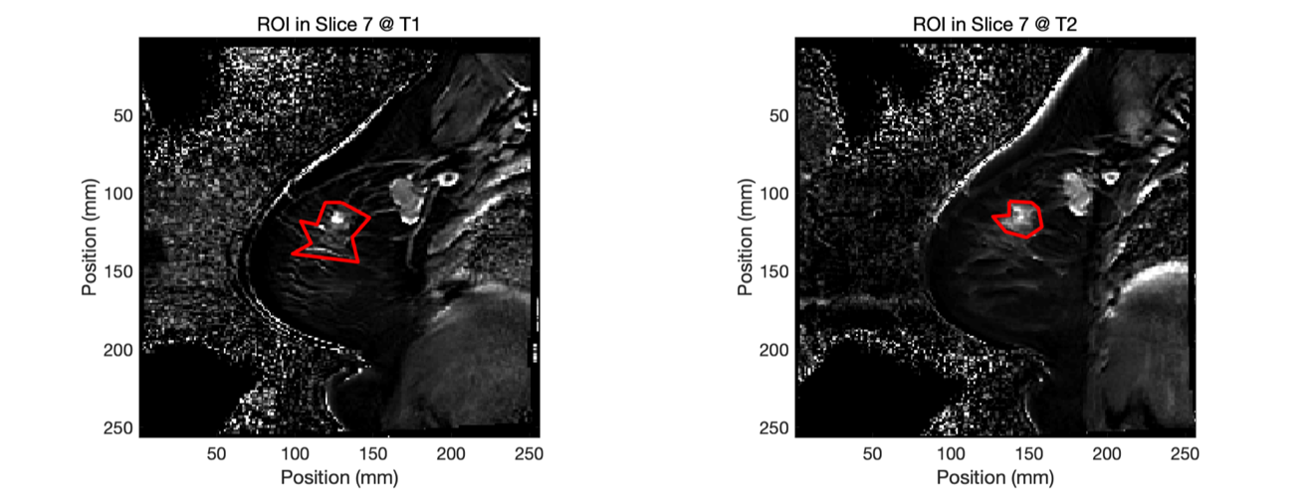

**Patient 2**

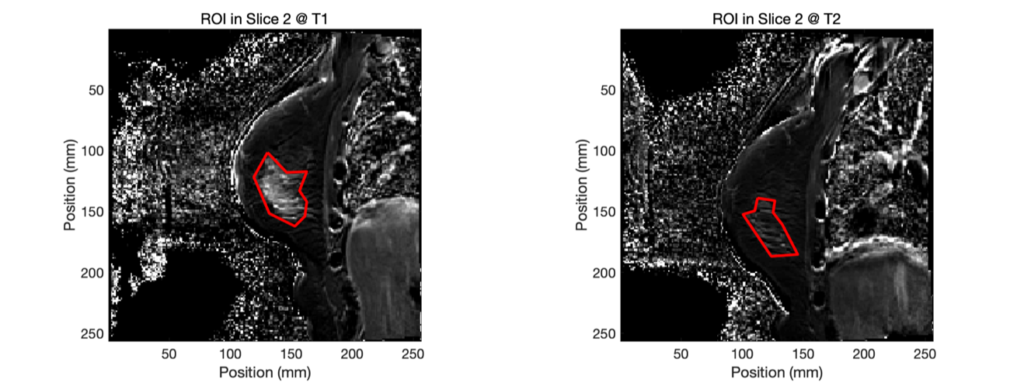

1. **Create/code up a RECIST function that returns the longest dimensions at each time point, and the RECIST criteria (CR, PR, SD, PD).**

function maxdist = solvedist(mask)

ind = find(mask == 1);

[x, y, z] = ind2sub(size(mask), ind);

tumor_arr = [x, y, z];

npoints = size(tumor_arr);

for i = 1 : npoints % select one voxel,

for j = 1 : npoints % loop through all the other voxels, calculate distance

dx = x(i) - x(j);

dy = y(i) - y(j);

dz = z(i) - z(j);

dist(j) = sqrt(dx^2 + dy^2 + (dz * 5)^2); % store distance for each voxel

end

mdist(i) = max(dist); % store maximum distance for voxel "i"

end

maxdist = max(mdist);

end

1. **Calculate patient response**

|  |  |  |
| --- | --- | --- |
|  | **Volume change** | **RECIST criteria** |
| **Patient 1** | -51.12% | PR |
| **Patient 2** | -14.91% | SD |