**Simple Explanation for the Question 3:**

Simply, I first move the gripper to the handle of the hammer. Then, I adjust the gripper a bit to form a good position to grip the handle of the hammer. Then, I simply grip the handle. After gripping is done, I lift the hammer. Then I adjust the position of the head of the hammer by rotating the gripper for a good angle of the hammer to hit the ball in a neat way. Then, to obtain a better acceleration while hitting the ball, I move back the hammer a bit. Then, I simply hit the ball. The END.

**Screenshots for the related process:**

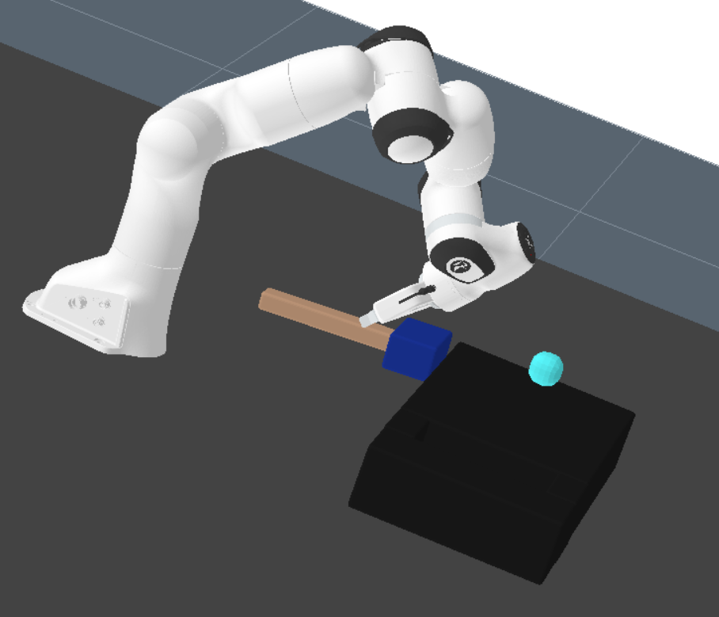

**Figure 1: First step.**

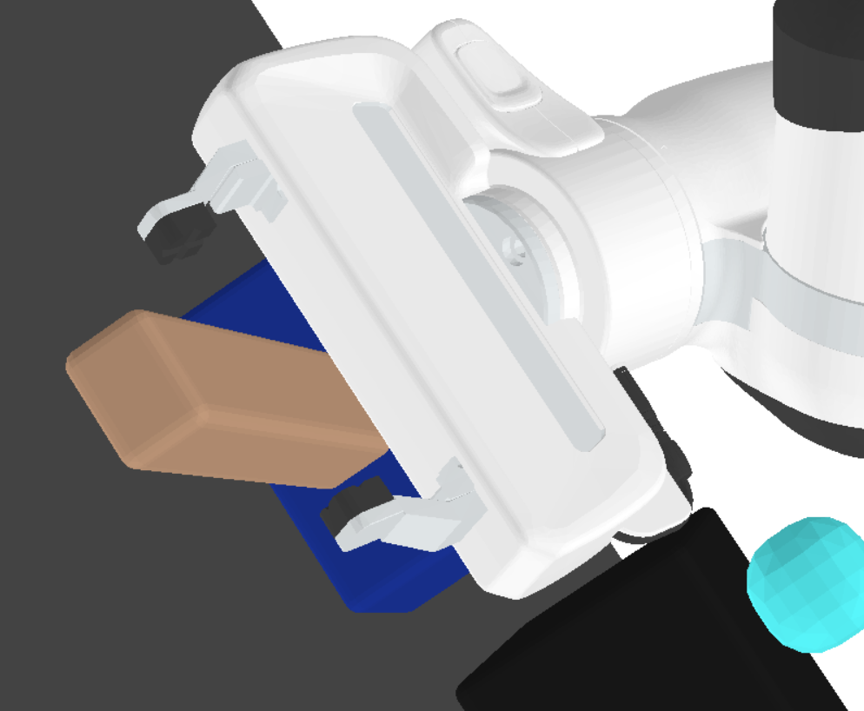

**Figure 2: Second step, now it is a good position to grip the handle.**

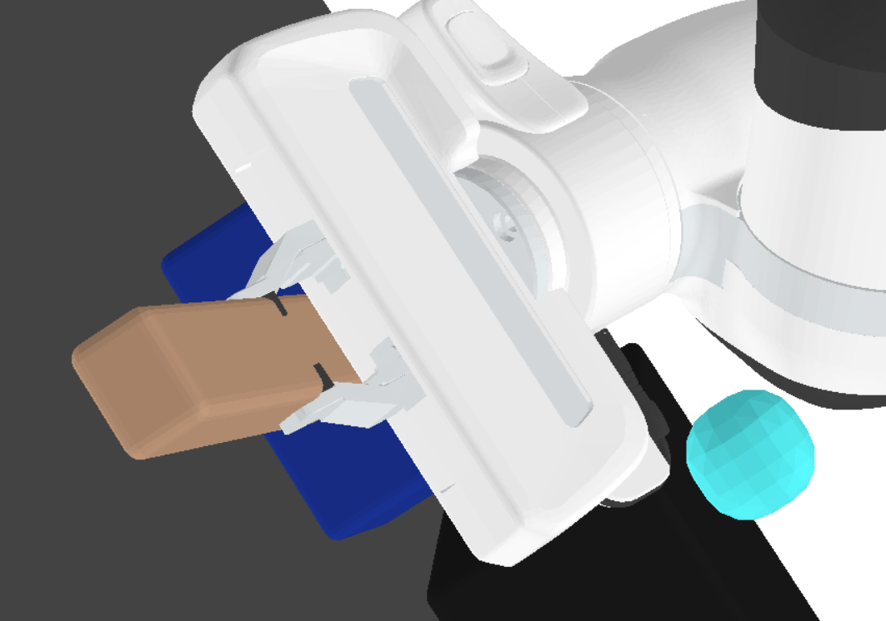

**Figure 3: Third step, gripping is done.**

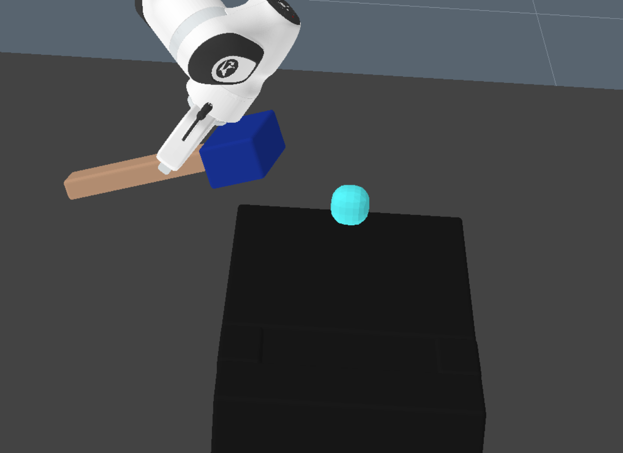

**Figure 4: Fourth step, after gripping is done, lifted is done.**

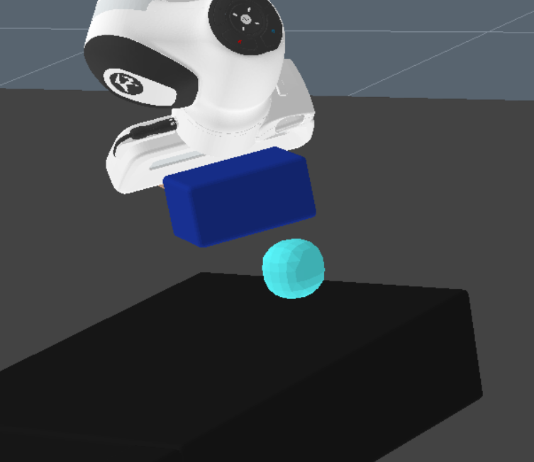

**Figure 5: Fifth step, head of hammer is adjusted accordingly.**

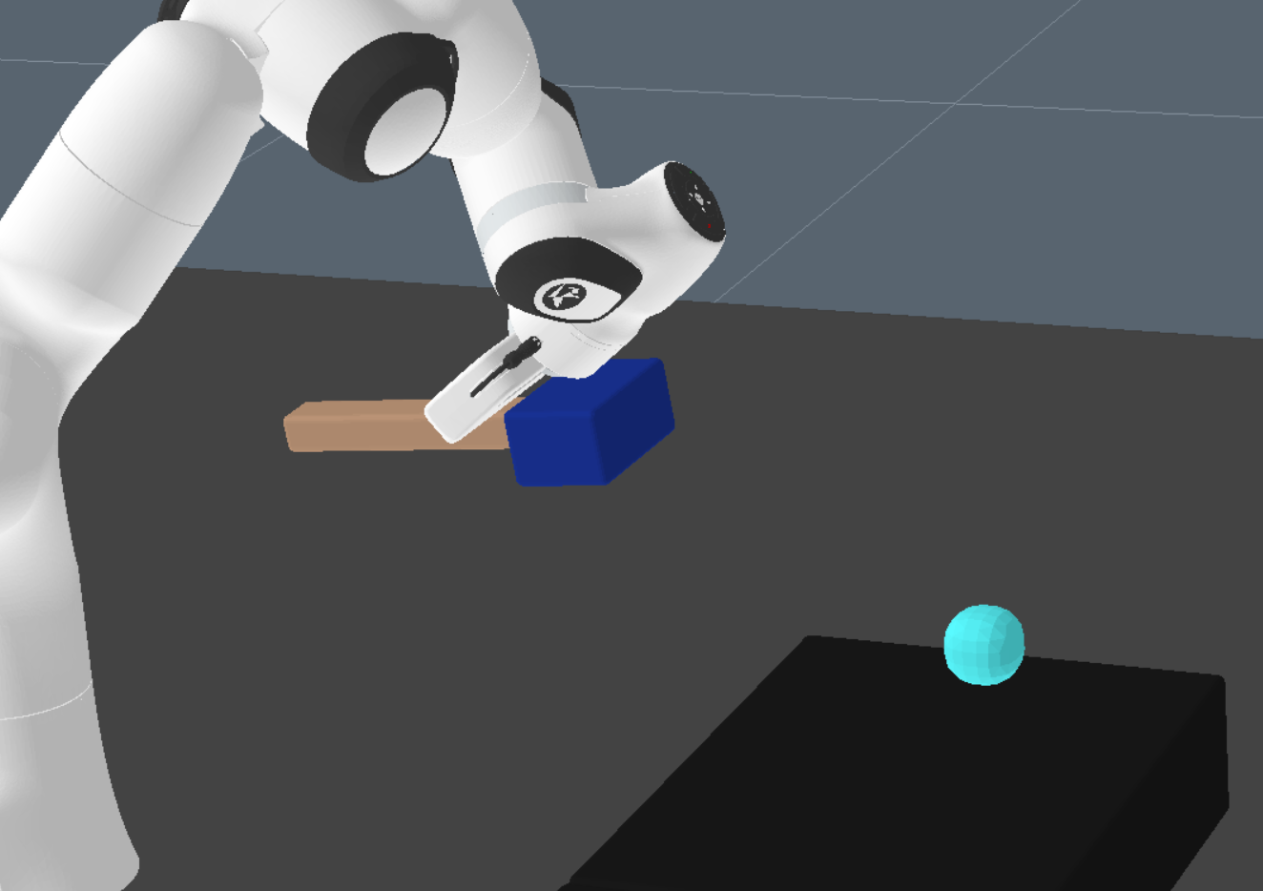

**Figure 6: Sixth step, moved back the hammer.**

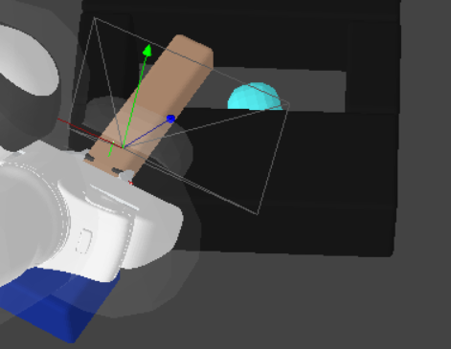

**Figure 7: Seventh step, simply hit the ball. The END.**