
TC
NISANTASI UNIVERSITY
FACULTY OF ECONOMICS ADMINISTRATIVE AND SOCIAL SCIENCES
MANAGEMENT INFORMATION SYSTEMS PROGRAM

EMIS302 ADVANCED DATABASE APPLICATIONS
FINAL EXAM ASSIGNMENT

Instructor of the Course
Assistant Professor Mustafa Coruh

June – 2025

Student Name Surname | : Yiğit Abuş
Student number | : 20214043035

Project Assignment for Final Exam

This is Database (DB) design and reporting project Final exam. This DB project will be worth 50 points as described in the Lesson Plan. The name of this Assignment will be EMIS302-AdvancedDBApplications-Project-StudentNameSurname.docx. In addition, the Script file named EMIS302-AdvancedDBApplications-Project-StudentNameSurname-SQLScript.sql will be uploaded to Sanalkampus.nisantasi.edu.tr. The texts in this document will be written in Times New Roman font and 12-point font.
Project: Write a SQL Script that creates an Employee Wages Tracking Application (EWTA) Database consisting of the tables given below. Report the Conceptual, Logical and Physical models of the technical user guide of the DB, which will be named Db_NameSurname. When the written SQL script is run, it should create the Database named db_NameSurname and its tables and add its data. These codes should be tested by running on SQL Server 2022 Express and only working codes should be delivered.
Note Rubric: Creating database (db_NameSurname) and tables with SQL Script and Entering data with SQL script is 10 points. Answering 10 questions with SQL script is 30 Points. Preparing the Project's Technical User's Guide is 10 Points. Word and SQL files should be made into a zip file and uploaded to the virtual campus as a single file. If the SQL script does not work in SQL Server 2022 Express, at least 30 points will be deducted from the final exam.
The names of the tables and column names will be as follows:
Employees Table | Wages Table | Departments Table | Users Table | Categories Table
Empl_ID | Wage_ID | Dept_ID | User_ID | LK_ID
Empl_FName | Empl_ID | Dept_Name | User_Name | Gender
Empl_LName | Wage_Date | Dept_Phone | User_Psw | Title
Empl_BDate | Wage_Amount | Manager_ID | Role_ID | City
Empl_Name (Calculation) | Wage_Commission |  |  | Province
Emp _Start_Date | Wage_Total (Calculation) |  |  | Country
Empl_Left_Date | Month_ID |  |  | Month
Empl_Address | Wage_Year (Calculation) |  |  | Role
Empl_City
Empl_Province
Empl_Phone
Empl_Cell
Empl_Email
Dept_ID
Gender_ID
Title_ID
Empl_Photo
Empl_CV
Empl_CV_File
Empl_CV_Web
Entered_ID
Entered_Date
Is_Empl_Active
tbl_Employees | tbl_EmployeeWages | tbl_Departments | tbl_Users | tbl_Lookups

The project will be evaluated with the following Grade Rubric:
Project Grade Rubric
Explanation | Full points | Scores and Comments Received
Running SQL Script | 10 Points
Answering the 10 questions with Script | 30 points
Technical User Guide | 10 Points
Total | 50 Points

After you write your name and student numbers on the first page, do not delete the parts up to here. Add your own technical user guide information after this page.

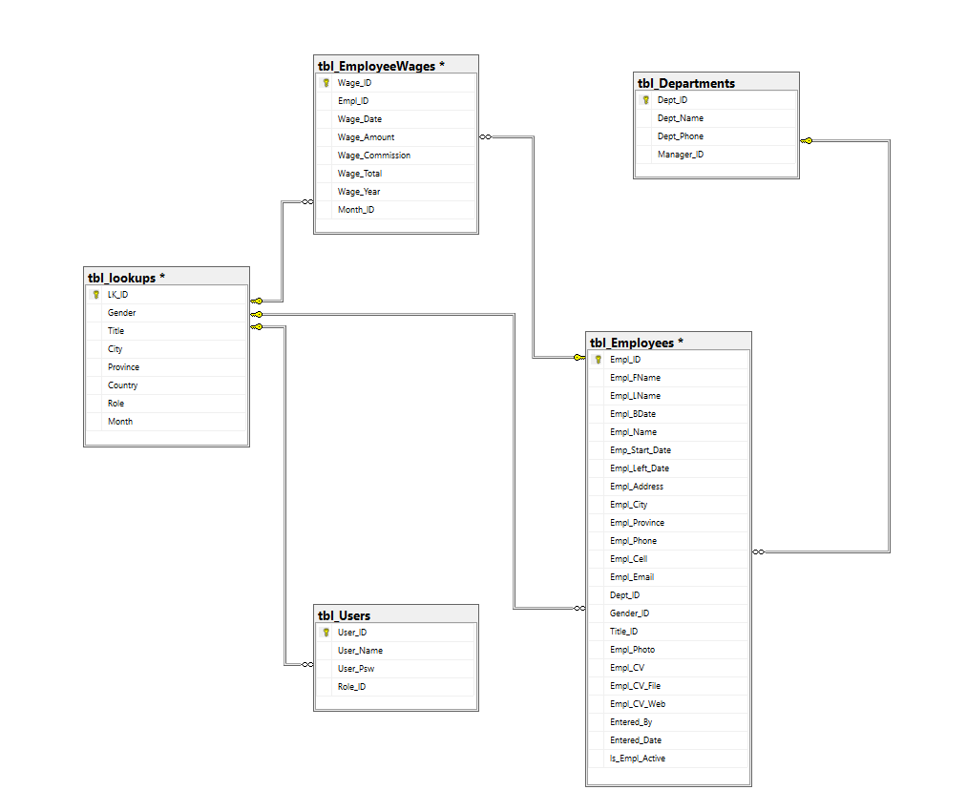
Database Conceptual Model

Database Logical Model
tbl_Employees (Empl_ID, Empl_FName, Empl_LName, Empl_BDate, Empl_Name, Emp_Start_Date, Empl_Left_Date, Empl_Address, Empl_City, Empl_Province, Empl_Phone, Empl_Cell, Empl_Email, Dept_ID, Gender_ID, Title_ID, Empl_Photo, Empl_CV, Empl_CV_File, Empl_CV_Web, Entered_By, Entered_Date, Is_Empl_Active)
tbl_Wages (Wage_ID, Empl_ID, Wage_Date, Wage_Amount, Wage_Commission, Wage_Total, Month_ID, Wage_Year)
tbl_Departments (Dept_ID, Dept_Name, Dept_Phone, Manager_ID)
tbl_Users (User_ID, User_Name, User_Psw, Role_ID)
tbl_Categories (LK_ID, Gender, Title, City, Province, Country, Month, Role)

Database Physical Model
(Creating Database and Data Entry Codes with T-SQL Script)
USE master
GO
/****** Creating the Database ******/
CREATE DATABASE db_YigitAbus
ON PRIMARY
(NAME = 'db_YigitAbus', FILENAME = 'C:\db_YigitAbus.mdf', SIZE = 5120KB, FILEGROWTH = 1024KB)
LOG ON
(NAME = 'db_YigitAbus_log', FILENAME = 'C:\db_YigitAbus_log.ldf', SIZE = 1024KB, FILEGROWTH = 1024KB)
GO
ALTER DATABASE db_YigitAbus SET COMPATIBILITY_LEVEL = 160
GO
/****** Creating the Tables ******/
CREATE TABLE tbl_Lookups (
LK_ID INT PRIMARY KEY,
Title VARCHAR(50),
Gender VARCHAR(10),
Role VARCHAR(50)
)

CREATE TABLE tbl_Departments (
Dept_ID INT PRIMARY KEY,
Dept_Name VARCHAR(100),
Dept_Phone VARCHAR(20),
Manager_ID INT
)

CREATE TABLE tbl_Users (
User_ID INT PRIMARY KEY,
User_Name VARCHAR(50),
User_Psw VARCHAR(50),
Role_ID INT
)

CREATE TABLE tbl_Employees (
Empl_ID INT PRIMARY KEY,
Empl_FName VARCHAR(50),
Empl_LName VARCHAR(50),
Empl_BDate DATE,
City VARCHAR(50),
Province VARCHAR(50),
Country VARCHAR(50),
Emp_Start_Date DATE,
Empl_Left_Date DATE,
Empl_Address VARCHAR(255),
Empl_City VARCHAR(50),
Empl_Province VARCHAR(50),
Empl_Phone VARCHAR(20),
Empl_Cell VARCHAR(20),
Empl_Email VARCHAR(100),
Dept_ID INT,
Gender_ID INT,
Title_ID INT,
Empl_Photo VARBINARY(MAX),
Empl_CV VARBINARY(MAX),
Empl_CV_File VARCHAR(255),
Empl_CV_Web VARCHAR(255),
Entered_ID INT,
Entered_Date DATE,
Is_Empl_Active BIT,
CONSTRAINT FK_Dept FOREIGN KEY (Dept_ID) REFERENCES tbl_Departments(Dept_ID)
)
CREATE TABLE tbl_Wages (
Wage_ID INT PRIMARY KEY,
Empl_ID INT,
Wage_Date DATE,
Wage_Amount DECIMAL(10,2),
Wage_Commission DECIMAL(10,2),
Wage_Total DECIMAL(10,2),
Month_ID INT,
Wage_Year INT,
FOREIGN KEY (Empl_ID) REFERENCES tbl_Employees(Empl_ID));

CREATE TABLE tbl_EmployeeWages (
Wage_ID INT PRIMARY KEY,
Empl_ID INT,
Wage_Date DATE,
Wage_Amount DECIMAL(10,2),
Wage_Commission DECIMAL(10,2),
Month_ID INT,
CONSTRAINT FK_Empl FOREIGN KEY (Empl_ID) REFERENCES tbl_Employees(Empl_ID)
)

/****** Creating Calculation Fields ******/
ALTER TABLE tbl_Employees ADD Empl_Name AS (Empl_FName + ' ' + Empl_LName)
ALTER TABLE tbl_EmployeeWages ADD Wage_Total AS (Wage_Amount + Wage_Commission)
ALTER TABLE tbl_EmployeeWages ADD Wage_Year AS (datepart(year,Wage_Date))
GO
/******* Entering Data ******/
INSERT INTO tbl_Lookups (LK_ID, Title, Gender, Role) VALUES
(1, 'Engineer', 'Male', 'User'),
(2, 'Manager', 'Male', 'Admin'),
(3, 'Technician', 'Male', 'User'),
(4, 'HR Specialist', 'Female', 'User'),
(5, 'Data Analyst', 'Male', 'Admin'),
(6, 'Marketer', 'Female', 'User');

INSERT INTO tbl_Departments (Dept_ID, Dept_Name, Dept_Phone, Manager_ID) VALUES
(1, 'IT', '0212-1234567', NULL),
(2, 'HR', '0212-7654321', NULL),
(3, 'Sales', '0212-1357910', NULL),
(4, 'Customer Relations', '0212-1097531', NULL),
(5, 'R&D', '0212-2468135', NULL);

INSERT INTO tbl_Users (User_ID, User_Name, User_Psw, Role_ID) VALUES
(1, 'admin', 'sirketsahibi34', 1),
(2, 'user', 'kullanici123', 2)

INSERT INTO tbl_Employees (
Empl_ID, Empl_FName, Empl_LName, Empl_BDate, City, Province, Country,
Emp_Start_Date, Empl_Left_Date, Empl_Address, Empl_City, Empl_Province,
Empl_Phone, Empl_Cell, Empl_Email, Dept_ID, Gender_ID, Title_ID,
Empl_Photo, Empl_CV, Empl_CV_File, Empl_CV_Web, Entered_ID, Entered_Date, Is_Empl_Active
) VALUES
(1, 'Yigit', 'Abus', '2003-05-15', 'Golbasi', 'Ankara', 'Turkey',
'2023-06-01', NULL, 'Bezirhane Mah. No:21', 'Golbasi', 'Ankara',
'0312-1234567', '0555-1234567', 'yigit@icloud.com', 1, 1, 1,
NULL, NULL, 'CV_Yigit.pdf', 'http://yigitcv.com', 1, GETDATE(), 1),

(2, 'Hulya', 'Melan', '1999-09-26', 'Pursaklar', 'Ankara', 'Turkey',
'2025-05-21', NULL, 'Altinova Mah. No:21', 'Pursaklar', 'Ankara',
'0312-1234568', '0555-1234568', 'hulya@icloud.com', 2, 2, 4,
NULL, NULL, 'CV_Hulya.pdf', 'http://hulyacv.com', 2, GETDATE(), 1),

(3, 'Mehmet', 'Kaya', '1990-02-11', 'Kecioren', 'Ankara', 'Turkey',
'2021-03-10', NULL, 'Ataturk Cad. No:5', 'Kecioren', 'Ankara',
'0312-1234569', '0555-1234569', 'mehmet.kaya@icloud.com', 1, 1, 1,
NULL, NULL, 'CV_Mehmet.pdf', 'http://mehmetcv.com', 1, GETDATE(), 1),

(4, 'Meryem', 'Dogan', '1988-08-22', 'Cankaya', 'Ankara', 'Turkey',
'2022-07-01', NULL, 'Bahcelievler Mah. No:9', 'Cankaya', 'Ankara',
'0312-1234570', '0555-1234570', 'meryem.dogan@icloud.com', 2, 2, 4,
NULL, NULL, 'CV_Meryem.pdf', 'http://meryemcv.com', 2, GETDATE(), 1),

(5, 'Cem', 'Yilmaz', '1995-03-12', 'Etimesgut', 'Ankara', 'Turkey',
'2023-01-15', NULL, 'Turgut Ozal Blv. No:16', 'Etimesgut', 'Ankara',
'0312-1234571', '0555-1234571', 'cem.yilmaz@icloud.com', 5, 1, 5,
NULL, NULL, 'CV_Cem.pdf', 'http://cemcv.com', 1, GETDATE(), 1),

(6, 'Elif', 'Sari', '1992-04-17', 'Kadikoy', 'Istanbul', 'Turkey',
'2020-11-23', NULL, 'Bagdat Cad. No:31', 'Kadikoy', 'Istanbul',
'0216-1234572', '0555-1234572', 'elif.sari@icloud.com', 3, 2, 2,
NULL, NULL, 'CV_Elif.pdf', 'http://elifcv.com', 2, GETDATE(), 1),

(7, 'Ahmet', 'Topal', '1991-01-01', 'Sisli', 'Istanbul', 'Turkey',
'2019-04-20', NULL, 'Nisantasi No:12', 'Sisli', 'Istanbul',
'0212-1234573', '0555-1234573', 'ahmet.topal@icloud.com', 4, 1, 3,
NULL, NULL, 'CV_Ahmet.pdf', 'http://ahmetcv.com', 1, GETDATE(), 1),

(8, 'Zeynep', 'Korkmaz', '1996-06-06', 'Alsancak', 'Izmir', 'Turkey',
'2024-02-01', NULL, 'Kordon Boyu No:88', 'Alsancak', 'Izmir',
'0232-1234574', '0555-1234574', 'zeynep.korkmaz@icloud.com', 3, 2, 5,
NULL, NULL, 'CV_Zeynep.pdf', 'http://zeynepcv.com', 2, GETDATE(), 1),

(9, 'Baran', 'Ercan', '1994-12-30', 'Osmangazi', 'Bursa', 'Turkey',
'2021-09-17', NULL, 'Heykel Mah. No:55', 'Osmangazi', 'Bursa',
'0224-1234575', '0555-1234575', 'baran.ercan@icloud.com', 4, 1, 2,
NULL, NULL, 'CV_Baran.pdf', 'http://barancv.com', 1, GETDATE(), 1),

(10, 'Berk', 'Yildiz', '1995-04-18', 'Besiktas', 'Istanbul', 'Turkey',
'2024-04-10', NULL, 'Levent Mah. No:45', 'Besiktas', 'Istanbul',
'0212-9988776', '0542-1234567', 'berk.yildiz@company.com', 5, 1, 3,
NULL, NULL, 'CV_Berk.pdf', 'http://berkcv.com', 1, GETDATE(), 1),

(11, 'Melis', 'Karaca', '1994-07-22', 'Buca', 'Izmir', 'Turkey',
'2024-03-01', NULL, 'Ataturk Cad. No:19', 'Buca', 'Izmir',
'0232-5554443', '0533-9988776', 'melis.karaca@company.com', 3, 2, 6,
NULL, NULL, 'CV_Melis.pdf', 'http://meliscv.com', 2, GETDATE(), 1);

INSERT INTO tbl_EmployeeWages (Wage_ID, Empl_ID, Wage_Date, Wage_Amount, Wage_Commission, Month_ID) VALUES
(1, 1, '2023-06-01', 15000.00, 1000.00, 6),
(2, 2, '2025-05-21', 14500.00, 800.00, 5),
(3, 3, '2024-03-10', 16000.00, 1200.00, 3),
(4, 4, '2022-11-15', 14000.00, 700.00, 11),
(5, 5, '2023-01-20', 15500.00, 950.00, 1),
(6, 6, '2024-08-05', 17000.00, 1300.00, 8),
(7, 7, '2023-07-12', 13800.00, 600.00, 7),
(8, 8, '2024-02-28', 14200.00, 750.00, 2),
(9, 9, '2023-10-03', 13500.00, 500.00, 10);

INSERT INTO tbl_Wages (Wage_ID, Empl_ID, Wage_Date, Wage_Amount, Wage_Commission, Wage_Total, Month_ID, Wage_Year) VALUES
(1, 1, '2023-06-01', 15000.00, 1000.00, 16000.00, 6, 2023),
(2, 2, '2025-05-21', 14500.00, 800.00, 15300.00, 5, 2025),
(3, 3, '2024-03-10', 16000.00, 1200.00, 17200.00, 3, 2024),
(4, 4, '2022-11-15', 14000.00, 700.00, 14700.00, 11, 2022),
(5, 5, '2023-01-20', 15500.00, 950.00, 16450.00, 1, 2023),
(6, 6, '2024-08-05', 17000.00, 1300.00, 18300.00, 8, 2024),
(7, 7, '2023-07-12', 13800.00, 600.00, 14400.00, 7, 2023),
(8, 8, '2024-02-28', 14200.00, 750.00, 14950.00, 2, 2024),
(9, 9, '2023-10-03', 13500.00, 500.00, 14000.00, 10, 2023);

/******* Creating Table Foreign Keys and Defaults ******/
ALTER TABLE dbo.tbl_Employees
ADD CONSTRAINT FK_Employees_Department
FOREIGN KEY (Dept_ID)
REFERENCES dbo.tbl_Departments(Dept_ID);

ALTER TABLE dbo.tbl_Employees
ADD CONSTRAINT FK_Employees_Gender
FOREIGN KEY (Gender_ID)
REFERENCES dbo.tbl_Lookups(LK_ID);

ALTER TABLE dbo.tbl_Employees
ADD CONSTRAINT FK_Employees_Title
FOREIGN KEY (Title_ID)
REFERENCES dbo.tbl_Lookups(LK_ID);

ALTER TABLE dbo.tbl_Employees
ADD CONSTRAINT DF_Employees_IsActive
DEFAULT (1) FOR Is_Empl_Active;

ALTER TABLE dbo.tbl_Users
ADD CONSTRAINT FK_Users_Role
FOREIGN KEY (Role_ID)
REFERENCES dbo.tbl_Lookups(LK_ID);

ALTER TABLE dbo.tbl_EmployeeWages
ADD CONSTRAINT FK_Wages_Employee
FOREIGN KEY (Empl_ID)
REFERENCES dbo.tbl_Employees(Empl_ID);

/******* Advanced DB Specific Questions to Answer ******/
--Q1: List the employees who work in Ankara.
SELECT * FROM tbl_Employees WHERE Empl_Province = 'Ankara'

--Q2: List the names of the provinces where more than two employees work.
SELECT Empl_Province, COUNT(*) AS Empl_Count FROM tbl_Employees
GROUP BY Empl_Province HAVING COUNT(*) > 2

--Q3: List the average employee wages by departments.
SELECT D.Dept_Name, AVG(W.Wage_Amount) AS Avg_Wage
FROM tbl_EmployeeWages W
JOIN tbl_Employees E ON W.Empl_ID = E.Empl_ID
JOIN tbl_Departments D ON E.Dept_ID = D.Dept_ID
GROUP BY D.Dept_Name

--Q4: List the employees whose names contain the letter "M".
SELECT * FROM tbl_Employees WHERE Empl_FName LIKE '%M%'

--Q5: List the Department Name and Department Phone Numbers of the Employees.
SELECT (Empl_FName + ' ' + Empl_LName) AS Empl_FullName, D.Dept_Name, D.Dept_Phone
FROM tbl_Employees E
JOIN tbl_Departments D ON E.Dept_ID = D.Dept_ID;

--Q6: List the total annual salaries paid to the employees by year.
SELECT YEAR(Wage_Date) AS Wage_Year, SUM(Wage_Amount + Wage_Commission) AS Total_Annual_Salary
FROM tbl_EmployeeWages
GROUP BY YEAR(Wage_Date);

--Q7: Write the query that lists the first letter and surname of the employee's name. For example, like “mcoruh”
SELECT LOWER(LEFT(Empl_FName,1) + Empl_LName) AS ShortName FROM tbl_Employees

--Q8: Write a query that calculates the ages of the employees.
SELECT (Empl_FName + ' ' + Empl_LName) AS Empl_FullName, DATEDIFF(YEAR, Empl_BDate, GETDATE()) AS Age
FROM tbl_Employees;

--Q9: Write the update query that changes the password of user 2 in the Users table.
UPDATE tbl_Users SET User_Psw = 'UserYeniSifre34' WHERE User_ID = 2

--Q10: Delete the employee whose title is “Marketer” from the tbl_Employees table.
DELETE FROM tbl_Employees WHERE Title_ID IN (
SELECT LK_ID FROM tbl_Lookups WHERE Title = 'Marketer'
)

/****** Querying Tables ******/
SELECT * FROM tbl_Lookups
SELECT * FROM tbl_Departments
SELECT * FROM tbl_Employees
SELECT * FROM tbl_Wages
SELECT * FROM tbl_Users

