PROJECT DOCUMENTATION
Subject: Networking Issues in Mobile Systems

Part 1 – Conceptual Design
Project Topic: Smart City Parking System (Project B – alternative topic approved by the instructor)

1. General Information
Project Name: Smart City Parking System
Project Authors: Yiğit Demir, student ID 56442 – individual project (approved by the instructor)
Field of Study: Computer Science
Year / Semester: 4th year / 7th semester, academic year 2026/2027
Supervisor: Marcin Kacprowicz
Submission Date: 05.10.2026
Git repository: https://github.com/yigitdemirr/smart-city-parking – demonstrated revision: tag m1 (commit 7ee147c)

2. Project Description

2.1. Project Objective
The aim of the project is to create a mobile application that helps a driver find the nearest parking facility with a free space, temporarily block (hold) that space, confirm it with a simulated payment and keep a history of reservations. An administrator manages facilities and spaces through the web service.
The value for the user is a reservation that stays correct even when the mobile connection is unreliable. The main problem studied in this project comes from the lecture on mobile databases: the server can process a request correctly while the delivery of the answer to the moving user fails. The design therefore makes every data-changing request safe to repeat and lets the client find out afterwards what the server actually did.

2.2. Project Scope
Module | Role
Mobile application (Flutter, Android) | User interface for drivers and the administrator; reads the device position with its observation time; keeps a read-only local cache (last search, history) with timestamps; keeps pending data-changing operations for recovery after a lost response.
Web Service (Python FastAPI, REST/JSON) | Business logic and validation; authentication and authorisation (JWT, roles); location-dependent search; holds, simulated payments and cancellations; duplicate protection and operation-status queries; automatic expiry of unpaid holds. It is the coordinating server that records the authoritative outcome of every change.
Database (PostgreSQL 16) | Stores users, facilities, spaces, reservations, simulated payments and operation records. Constraints guarantee consistency (no double booking, one successful payment per reservation, payments always simulated).
Out of scope: real payments (every payment is simulated and labelled as such), real occupancy sensors, road-network routing and push notifications. They are listed as extensions in Section 8.

2.3. Technologies
Layer | Technology | Reason
Mobile client | Flutter (Dart), Android target; SQLite (sqflite) cache; geolocator for GPS | One code base; the Android emulator can simulate loss of connectivity
Web service | Python 3.12, FastAPI, Uvicorn, JWT | Simple REST/JSON service with automatic OpenAPI documentation
Database | PostgreSQL 16 (btree_gist, pgcrypto) | Transactions, range types and exclusion constraints prevent double booking inside the database
Contract and diagrams | OpenAPI 3.0.3 (api/openapi.yaml), Mermaid sources (docs/diagrams/*.mmd) | Text files versioned in Git together with the code
Reproducible startup | Docker Compose (docker-compose.yml) | Same database for development and demonstration

3. System Requirements

3.1. Functional Requirements
ID | Function Name | Description | Priority
F1 | User registration | The user can create an account with e-mail, password and display name. The e-mail is unique. | High
F2 | Login / logout | The user can log in (receives a JWT valid for 1 hour) and log out. | High
F3 | Position acquisition | The app obtains the device position with latitude, longitude, accuracy and observation time, using a mixed INFORM reporting rule (Section 3.3). | High
F4 | Nearest parking search | The driver can search for the nearest facilities with at least one free space for a chosen period within a radius (default 1000 m). | High
F5 | Facility details | The driver can view the spaces of a facility with availability for the chosen period, type and price. | High
F6 | Hold a space | The driver can temporarily block one space for a period (max 24 h). The hold lasts 10 minutes. | High
F7 | Simulated payment | The driver can pay for a held reservation with a simulated payment; success changes the reservation to CONFIRMED. The UI always shows “SIMULATED – no real money”. | High
F8 | Cancel reservation | The driver can cancel a HELD reservation, or a CONFIRMED one before its start time. | Medium
F9 | Reservation history | The driver can view all reservations with their statuses, newest first. | Medium
F10 | Operation status | The client can ask whether a data-changing operation was executed (GET /operations/{operationId}). | High
F11 | Space administration | The administrator can create facilities and spaces, change prices and activate or deactivate spaces. | Medium
F12 | Hold expiry | The service expires unpaid holds after 10 minutes and marks finished reservations as COMPLETED. | High
F13 | Offline behaviour | The app shows its connectivity state, displays cached read-only data with its timestamp and blocks data-changing actions while offline. | High

3.2. Non-Functional Requirements
ID | Name | Description | Category
N1 | Performance | Server-side search answers in < 1 s for 1000 facilities; other requests ≤ 2 s on a development machine. Client timeouts: connect 5 s, reads 8 s, actions 10 s. | Performance
N2 | No double booking | Two active (HELD/CONFIRMED) reservations may never overlap on the same space; at most one successful payment per reservation. Enforced by database constraints. | Consistency
N3 | Idempotency | Every data-changing request can be repeated any number of times without a duplicate effect (stable operation identity, Section 6.4). | Reliability
N4 | Freshness transparency | Every read response contains generatedAt; location-based results also return the position used and its observedAt. Cached data is always shown with its age. | Reliability
N5 | Wireless traffic economy | No background location upload; the position is sent only with a search. At most 50 results; gzip compression; reads retried at most twice (1 s, 3 s). | Performance
N6 | Security | Passwords hashed with bcrypt; JWT authentication; ADMIN role for /admin/*; all input validated on the server; prices and amounts computed only on the server; HTTPS in deployment. | Security
N7 | Privacy | The server does not store a location history; the position is used only to answer one query. | Security
N8 | Reproducibility | Startup is documented in README and scripted (Docker Compose, SQL files); every demonstration refers to a Git revision. | Maintainability
N9 | Usability | The hold countdown uses the server value holdExpiresAt; simulated payments are clearly labelled; error messages tell the user what to do next. | Usability
N10 | Maintainability | API contract, schema and diagrams are text files in Git and change together with the code. | Maintainability

3.3. Origin and Freshness of Data, Meaning of “Nearest”
Facility and space data. Locations, labels and prices are entered by an administrator (data_source = ADMIN_ENTRY) or loaded as simulated city data for Łódź (SEED_SIMULATED). They change rarely; updated_at records the last change.
Availability. There are no physical sensors in scope. A space is available for a period if no HELD or CONFIRMED reservation in the system’s own database overlaps that period. Availability is computed at request time and is authoritative only at generatedAt. It can become stale while the answer travels to the device, so the app labels lists older than 2 minutes “may be out of date”, and the server always re-checks availability when a hold is requested. A stale list can therefore never cause a double booking.
User position – INFORM on the client (lecture slides 2–3). The app uses the device’s fused location provider with a mixed rule: while the search screen is open, a new fix is taken when the user has moved more than 100 m or the last fix is older than 60 s. A purely temporal rule wastes messages for a stationary user; a purely distance-based rule lets a fix become very old. The position is not uploaded in the background (N5, N7); it is sent only as a parameter of a search together with observedAt and accuracyM. If the fix is older than 2 minutes or less accurate than 100 m, the app tries to get a fresh fix for up to 5 s; otherwise it uses the last known position and says so.
Uncertain position as a circle (slide 8). The reported accuracy is treated as a circle of radius accuracyM around the position. Facilities whose distance is smaller than this radius are shown as “about here” instead of an exact distance, and the radius is returned in the response so the user knows how precise the ranking is.
Why the SEARCH strategy is not needed (slides 4–5). All communication is started by the client (request–response). The service never sends an unsolicited message to the device, so it never has to locate the user. Push notifications would introduce this problem and are listed as an extension.
Meaning of “nearest” (slide 6). Nearest = smallest straight-line (great-circle, haversine) distance in metres between the reported position and the facility coordinates, among active facilities with at least one free space for the requested period, within the radius. Ties are broken by lower price, then by name. The response states distanceModel = STRAIGHT_LINE_HAVERSINE. Known limitation: a facility across a river can be close in a straight line but far in the street-network graph; road distance is an extension.
Cost of the query (slide 7). The cost consists of locating the user (one GPS fix on the device), execution time (one indexed query on the server) and communication cost (one request and one compressed response limited to 50 results). Limiting the radius and the number of results is the chosen compromise between cost and accuracy.

3.4. Connectivity Policy: Reads versus Actions Requiring Confirmation
Request class | Examples | While offline | Timeout / lost response
Reads (safe, no state change) | search, facility spaces, history, reservation details, operation status | Show the last cached result with its generatedAt and position time; no new request | Retry automatically at most 2 times (1 s, 3 s), then a “Retry” button
Actions requiring server confirmation | register, log in, hold, pay, cancel, admin changes | Blocked, not queued. The button is disabled with an explanation | Keep the pending operation; ask GET /operations/{id}; resend with the same operationId only if the server never executed it
Decision: offline changes are blocked, not queued. Whether a space is free and whether a hold is still valid are decided only by the server at the moment the request arrives. A hold queued offline could be executed minutes later in a different situation (the space taken, the driver elsewhere), and a payment must never be executed silently later. Blocking keeps the user’s model simple: an action is either confirmed by the server or not done. Only the pending operation of a request that was already sent is kept locally, for recovery (Section 6.4).

3.5. Requirements and Network-Scenario Matrix
Each row is a test case for Milestone M3. The scenarios cover every function and the required situations: loss before and after submission, timeout, delayed response, retry, cached display, reconnection and competing data-changing requests. The same matrix is kept in the repository as docs/network-scenarios.csv and .md.
ID | Function – scenario | Situation | User-visible state | Server state | Expected result (test)
NS-01 | Register – Loss before submission | No connection when the user taps Register | Banner “You are offline - registration needs a connection”; button disabled | No request received; no user row | No request is sent; no user exists; form data stays on screen
NS-02 | Register – Lost response / retry | Request committed but response lost; user taps again | “Checking…” then “Account already exists - log in” | One user row (e-mail unique) | Second request returns 409 EMAIL_TAKEN; exactly one user row; app offers login
NS-03 | Log in – Timeout | No answer within 10 s | “Server not reachable - try again”; stays on login screen | No session state (stateless JWT) | No token stored; retry allowed; no server-side change
NS-04 | Search nearest parking – Cached display (offline) | Opens search with no connection | Last results with label “Saved 09:41 - may be out of date”; Hold button disabled | Unchanged | Cached list shown with its generatedAt and position time; no hold possible offline
NS-05 | Search nearest parking – Delayed response + movement (migration of response) | Answer arrives 6 s late and the user moved > 100 m since observedAt | Old list not shown; “You have moved - updating results…” then new list | Search is read-only; nothing stored | Response echoes position + observedAt; app detects movement > 100 m, discards the result and reissues the query once with the new fix
NS-06 | Search nearest parking – Stale position | Last GPS fix older than 2 min or accuracy > 100 m | “Getting your location…” (max 5 s), then results or warning “using last known position” | Receives observedAt and accuracyM | Request carries observedAt; response states distanceModel=STRAIGHT_LINE and the position used
NS-07 | Search nearest parking – Retry | Search times out | Spinner then automatic single retry | Read-only | Reads are retried safely (max 2, back-off 1 s / 3 s); no operationId needed
NS-08 | View facility & spaces – Delayed response | Space list arrives after a 6 s delay | List with “Updated 09:42”; free/occupied state | Read-only | Each list carries generatedAt; hold is re-validated by server, so stale list cannot cause double booking
NS-09 | Hold space – Loss before submission | Connection drops before the user taps Hold | “You are offline - holding a space needs a connection” | No request; space still free | Action BLOCKED (not queued); no pending operation created
NS-10 | Hold space – Loss after submission (lost response) | Server committed HELD but response lost | “Checking your reservation…” then “Space A-01 held until 10:12” | 1 reservation HELD + 1 operation SUCCEEDED | App calls GET /operations/{id}; gets stored 201 body; exactly one reservation exists
NS-11 | Hold space – Lost request | Request never reached the server | “Checking…” then hold succeeds after resend | GET /operations/{id} -> 404; then one HELD reservation | 404 means not executed; app resends with SAME operationId; one reservation
NS-12 | Hold space – Retry (duplicate) | User taps Hold twice / app retries | Single confirmation | One operation row; one reservation | Second request with same operationId returns stored response with header Idempotent-Replay: true
NS-13 | Hold space – Competing requests | Two drivers hold the same space for overlapping periods | Winner: “Held”; loser: “Space just taken” + alternatives | One HELD reservation (EXCLUDE constraint) | Exactly one 201 and one 409 SPACE_UNAVAILABLE; no overlap in database
NS-14 | Hold space – Operation-id reuse | Same operationId sent with a different body (bug) | Error message | No change | 422 IDEMPOTENCY_KEY_REUSED; request_hash differs; nothing written
NS-15 | Pay (simulated) – Loss after submission | Payment committed but response lost | “Confirming payment…” then “Reservation confirmed (SIMULATED payment)” | Payment SUCCEEDED + reservation CONFIRMED | GET /operations/{id} returns stored 200; exactly one successful payment (unique index)
NS-16 | Pay (simulated) – Timeout near hold expiry | Response delayed; hold expires during the wait | “Hold expired - search again” | If paid before expiry: CONFIRMED; otherwise HELD->EXPIRED and no payment | Server decides using its clock: payment after holdExpiresAt returns 409 HOLD_EXPIRED and no payment row
NS-17 | Pay (simulated) – Retry after decline | Simulated decline then new attempt | “Payment declined (simulated)” then success | DECLINED payment row then SUCCEEDED row | Each attempt has its own operationId; only one SUCCEEDED payment per reservation
NS-18 | Pay (simulated) – Loss before submission | Offline on payment screen | “You are offline - payment needs a connection”; hold timer still visible | Hold continues to count down | Action BLOCKED; app shows server holdExpiresAt (not a local guess)
NS-19 | Cancel reservation – Lost response / retry | Cancel committed but response lost; app retries | “Reservation cancelled” | Status CANCELLED once | Retry with same operationId returns stored 200; second cancel with NEW id returns 409 ALREADY_CANCELLED
NS-20 | Cancel reservation – Competing change | Cancel arrives while hold expiry job runs | “Reservation already expired” | Single final state (row lock / version) | Exactly one terminal transition; loser gets 409 INVALID_STATE with current status
NS-21 | Reservation history – Reconnection | App reconnects after being offline | “Syncing…” then updated list | Authoritative list | App reloads GET /reservations; server state overwrites cache; pending operations resolved first
NS-22 | Reservation history – Cached display | History opened offline | Cached list labelled “Saved 09:30” | Unchanged | Read-only view; statuses shown as last known with timestamp
NS-23 | Hold expiry (system) – Connection lost during hold | Driver offline for 12 min after holding | On reconnect: “Your hold expired at 10:12” | HELD->EXPIRED by expiry job; space free | Expiry happens on server without client; GET /reservations shows EXPIRED
NS-24 | Admin: manage spaces – Competing edits | Two admins edit the same space | Second admin: “Changed by someone else - reload” | version incremented once | PATCH with stale version returns 409 VERSION_CONFLICT; first edit kept
NS-25 | Admin: manage spaces – Lost response / retry | Create-space response lost | “Checking…” then created space shown | One space row | Retry with same operationId returns stored 201; no duplicate label (unique per facility)
NS-26 | All data-changing actions – Reconnection with pending operation | App restarted while an operation was pending | “Finishing your last action…” | Operation stored or absent | On start the app checks every pending operationId via GET /operations/{id} before allowing new actions

4. UML Diagrams

4.1. Use Case Diagram
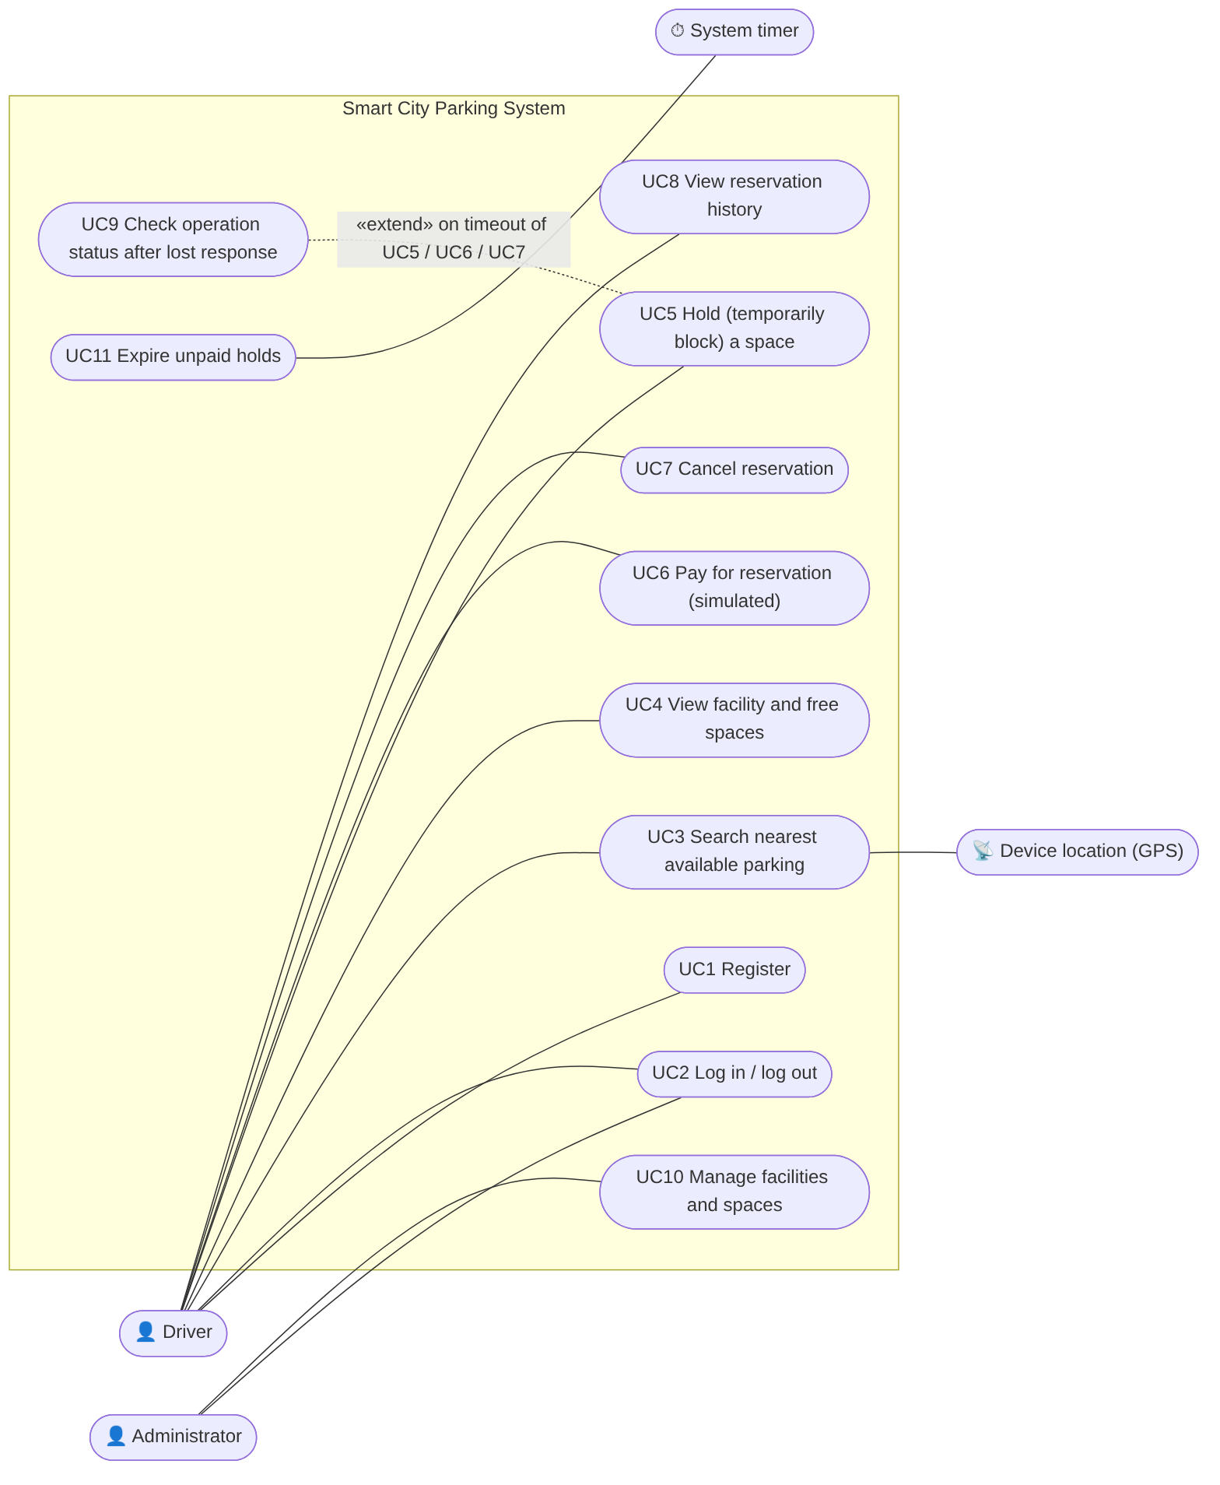
Use case diagram (editable source: docs/diagrams/01-use-case.mmd)
Actor | Responsibilities
Driver | Registers, logs in, searches for parking from the current position, holds a space, pays (simulated), cancels, views history.
Administrator | Maintains facilities and spaces (location, labels, prices, active flag).
Device location (GPS) | Supplies position, accuracy and observation time to the app.
System timer | Triggers the expiry of unpaid holds and the completion of finished reservations.

Use case | Main success scenario | Network-related extensions
UC3 Search | The app takes a fix (F3) → sends lat/lon/observedAt/period → the service returns facilities sorted by distance with generatedAt → the app caches and shows them. | Offline: cached list with its age (NS-04); delayed answer after movement: result rejected and query reissued (NS-05); stale fix (NS-06).
UC5 Hold | The driver selects a space and period → the app creates an operationId → the service checks availability and creates a HELD reservation (10 min) → the app shows a countdown. | Offline: blocked (NS-09); lost response: UC9 (NS-10, NS-11); double tap (NS-12); competing hold (NS-13).
UC6 Pay | The driver confirms → the service records a simulated payment and sets CONFIRMED in one transaction. | Lost response (NS-15); hold expires during delay (NS-16); decline and retry (NS-17).
UC7 Cancel | The driver cancels → status CANCELLED, space released. | Lost response / retry (NS-19); conflict with expiry (NS-20).
UC9 Check operation | After a timeout the app asks GET /operations/{id}; 200 → use the stored result; 404 → resend with the same id. | Used by UC5, UC6, UC7 and UC10 (NS-26).

4.2. Class Diagram
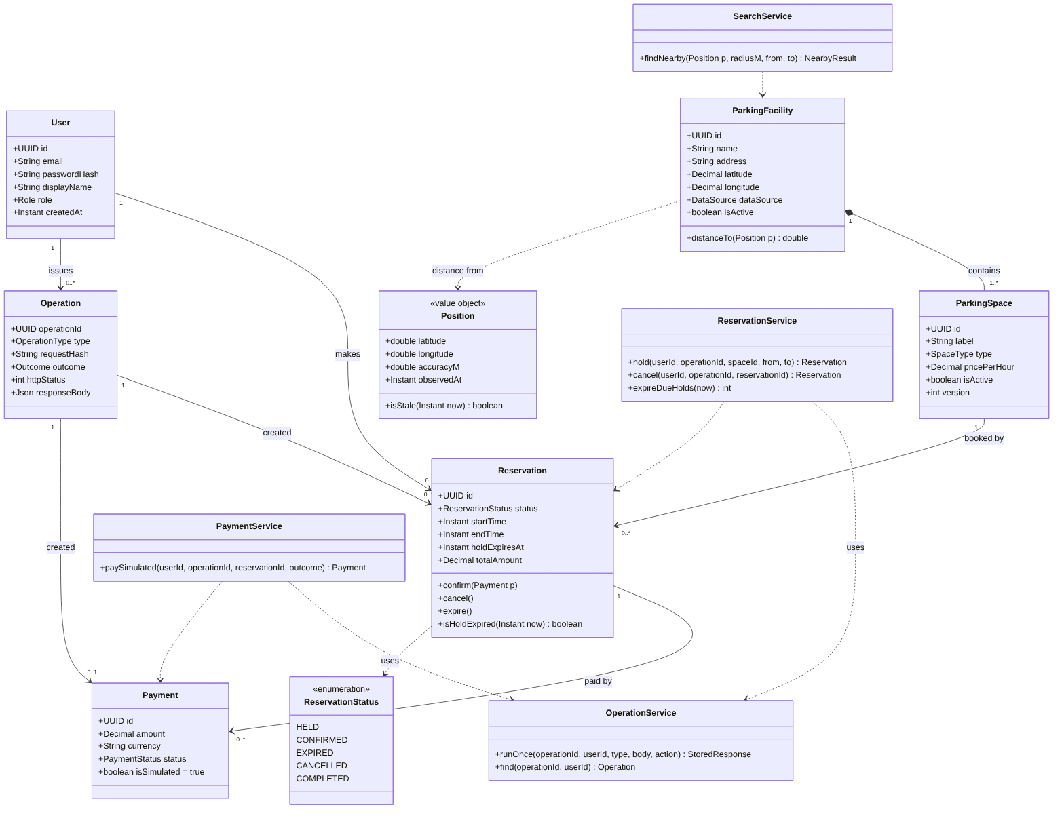
Class diagram (editable source: docs/diagrams/02-class.mmd)
The domain classes mirror the database tables. Position is a value object that always carries its observedAt, so a position can never be used without knowing how old it is. Responsibilities of the service classes:
- SearchService – location-dependent query and distance computation; never changes data.
- ReservationService – hold, cancel and expiry; relies on the exclusion constraint for competing requests.
- PaymentService – simulated payment and confirmation in one transaction.
- OperationService – executes a data-changing action exactly once per operationId, stores the response for replay and answers status queries.

4.3. State Diagram of a Reservation
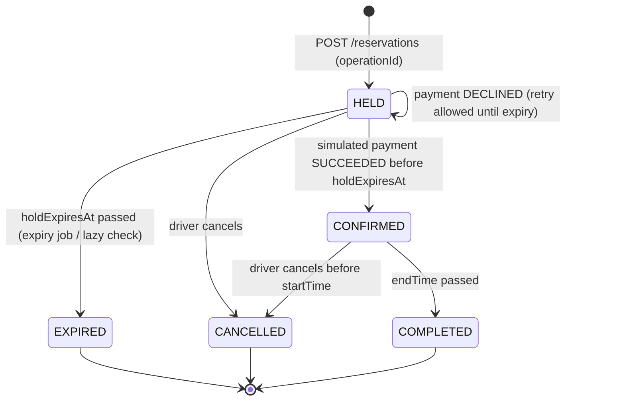
Reservation life cycle (editable source: docs/diagrams/07-state-reservation.mmd)

5. Database Design
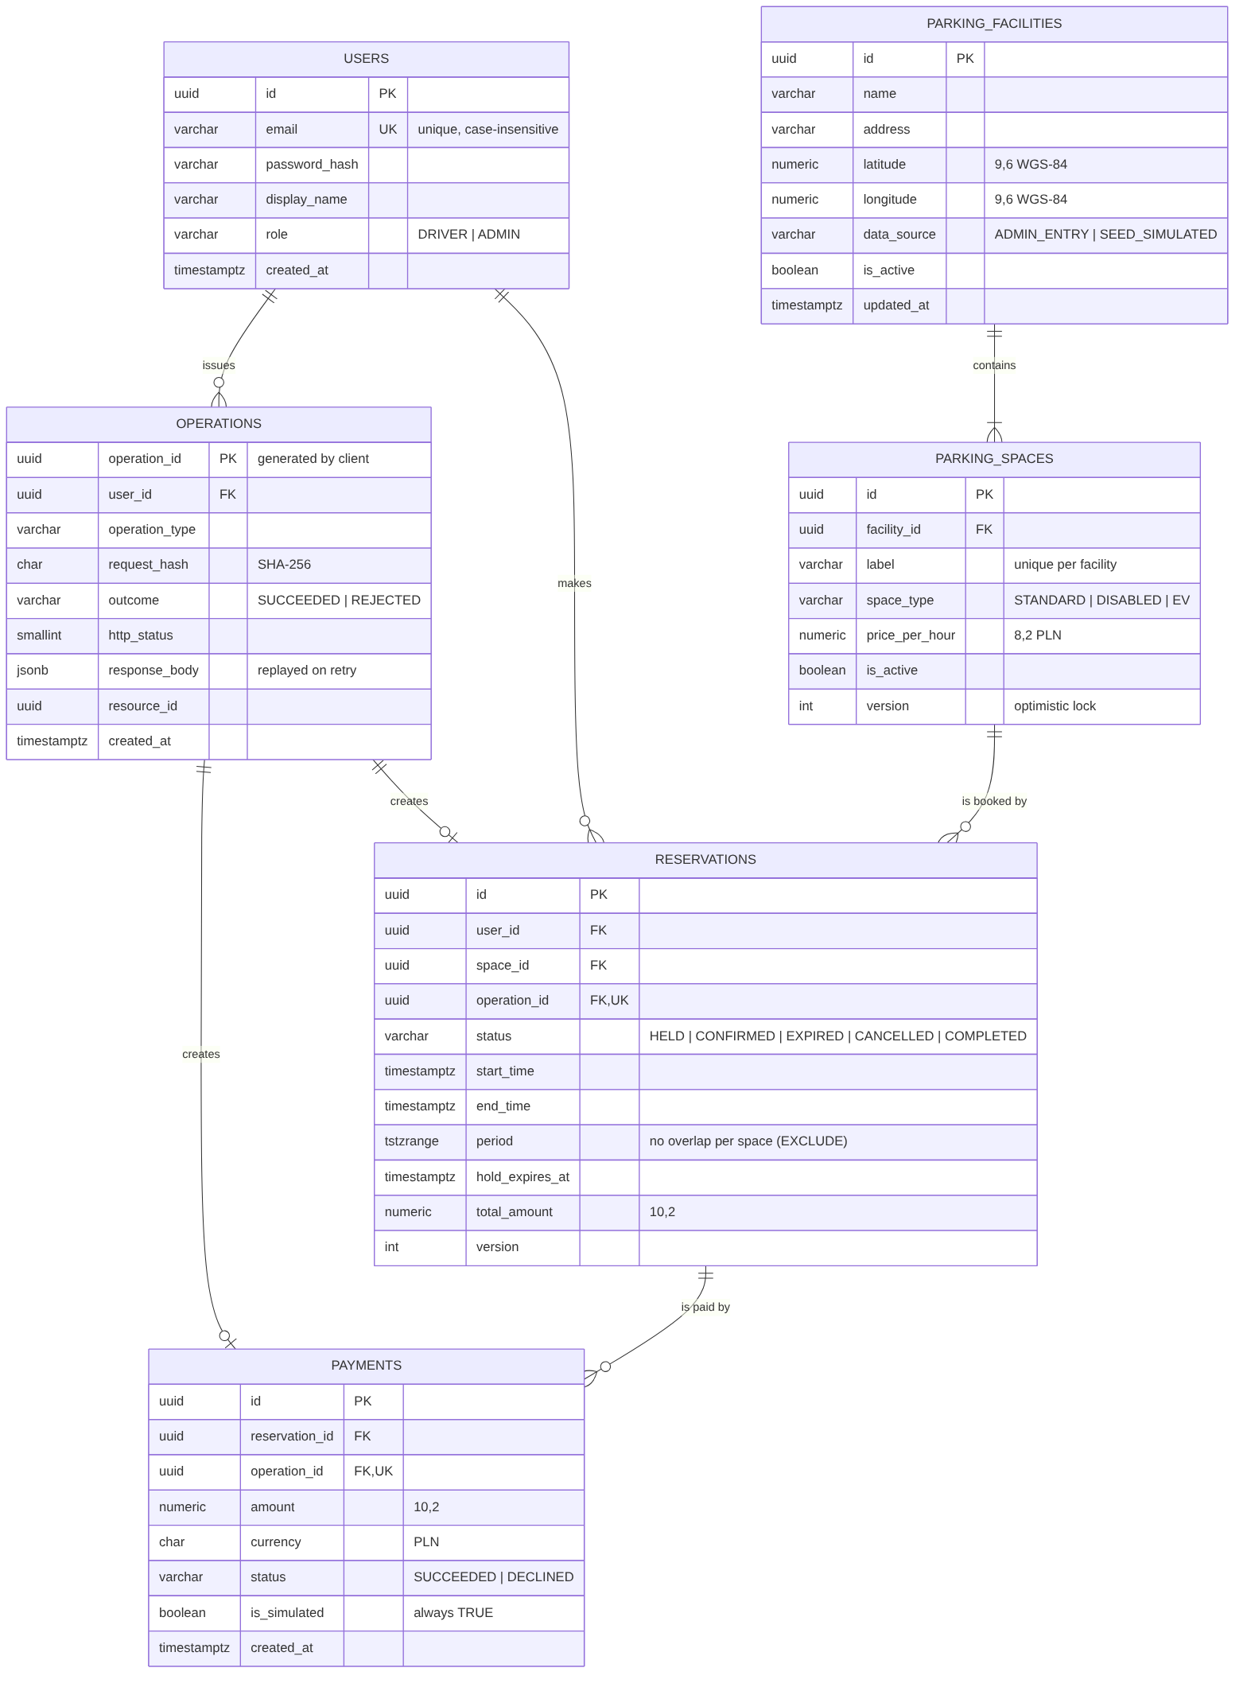
Entity-relationship diagram (editable source: docs/diagrams/03-erd.mmd; DDL: database/schema.sql)

5.1. Tables, Keys and Relationships
Table | Primary key | Foreign keys / unique keys | Relationship
users | id (UUID) | UNIQUE lower(email) | 1 user – 0..N reservations, 0..N operations
parking_facilities | id (UUID) | – | 1 facility – 1..N spaces
parking_spaces | id (UUID) | facility_id → parking_facilities; UNIQUE (facility_id, label) | 1 space – 0..N reservations
reservations | id (UUID) | user_id → users; space_id → parking_spaces; operation_id → operations (UNIQUE); EXCLUDE (space_id =, period &&) for HELD/CONFIRMED | 1 reservation – 0..N payments
payments | id (UUID) | reservation_id → reservations; operation_id → operations (UNIQUE); partial UNIQUE (reservation_id) WHERE status = SUCCEEDED | many declined attempts, one success
operations | operation_id (UUID, generated by the client) | user_id → users | 1 operation – 0..1 reservation or payment

5.2. Data Types and Constraints
Data | Type | Rule
Identifiers | UUID | Generated by the server (gen_random_uuid()), except operation_id, which the client generates
Coordinates | NUMERIC(9,6) | WGS-84 degrees (≈ 0.1 m precision); CHECK latitude −90..90, longitude −180..180
Money | NUMERIC(8,2) price per hour, NUMERIC(10,2) amounts | PLN; never floating point; ≥ 0; amount = price × duration, computed on the server
Time | TIMESTAMPTZ | Stored in UTC, displayed in Europe/Warsaw
Reservation period | TSTZRANGE [start, end) (generated column) | end > start, at most 24 h; half-open, so 10:00–12:00 and 12:00–14:00 do not overlap
Status values | VARCHAR + CHECK | Reservation: HELD, CONFIRMED, EXPIRED, CANCELLED, COMPLETED; Payment: SUCCEEDED, DECLINED
Stored response | JSONB | Exact response body replayed for a repeated operationId
Version stamp | INTEGER version | Optimistic locking for admin edits and reservation state changes
Simulated payment | BOOLEAN is_simulated | CHECK (is_simulated) – a real payment cannot be recorded
The schema was executed on PostgreSQL 16 and verified with database/tests/constraints_test.sql (Appendix B).

6. System Architecture

6.1. Modules and Their Interconnections
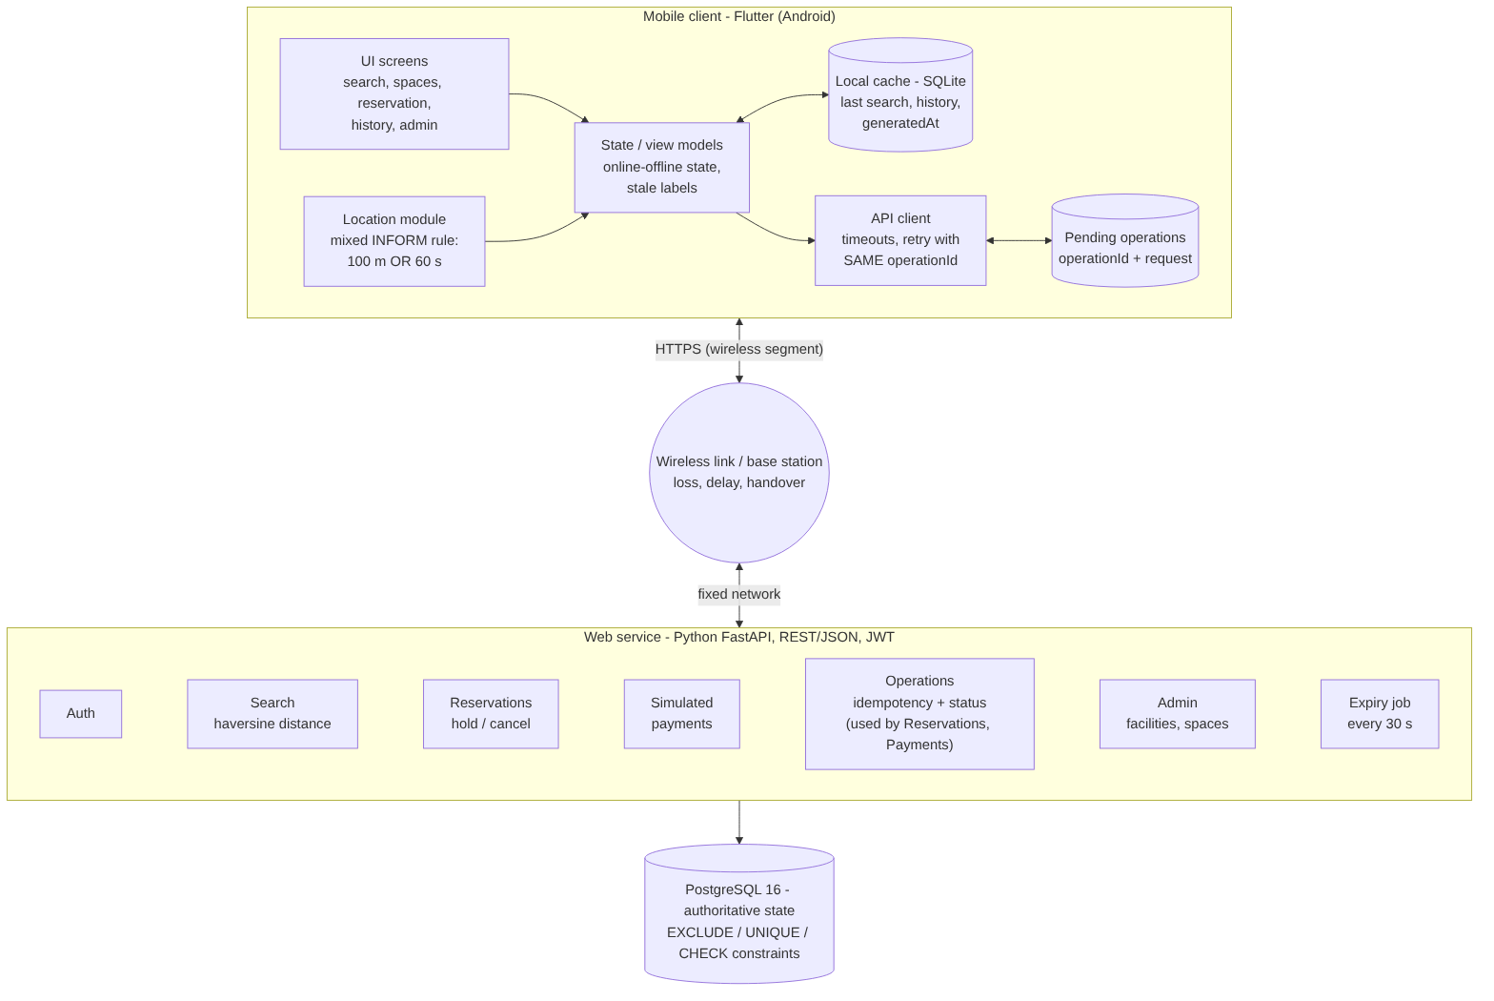
System architecture (editable source: docs/diagrams/04-architecture.mmd)
The architecture follows the path described in the lecture (slide 9): mobile client → wireless channel → base station (interface between the mobile client and the fixed network) → fixed network → web service → database, and back. The wireless segment is the expensive and unreliable part, so the design moves work to the fixed side: the service acts as the agent of the mobile client (slide 10), filtering and sorting the results on the server and sending only the short list the user needs.
Component | Responsibility
UI screens | Login/Register, Find parking, Facility spaces, Reservation (countdown, simulated payment), History, Admin
State / view models | Online/offline state, which buttons are enabled, stale labels
Location module | Mixed INFORM rule (100 m or 60 s), accuracy and observation time
Local cache (SQLite) | Last search results and history with generatedAt; read-only replica
Pending-operations store | operationId and original request of every sent, unresolved action
API client | Timeouts, read retries, recovery through /operations/{id}
Web service modules | Auth, Search, Reservations, Simulated payments, Operations, Admin, Expiry job
PostgreSQL | Single source of truth; constraints guarantee consistency

6.2. Logical Data Flow
Location-dependent search. If the answer arrives after the user has moved more than 100 m, the app applies the “reject the result and reissue the enquiry” solution for migration of responses (slides 17–18).
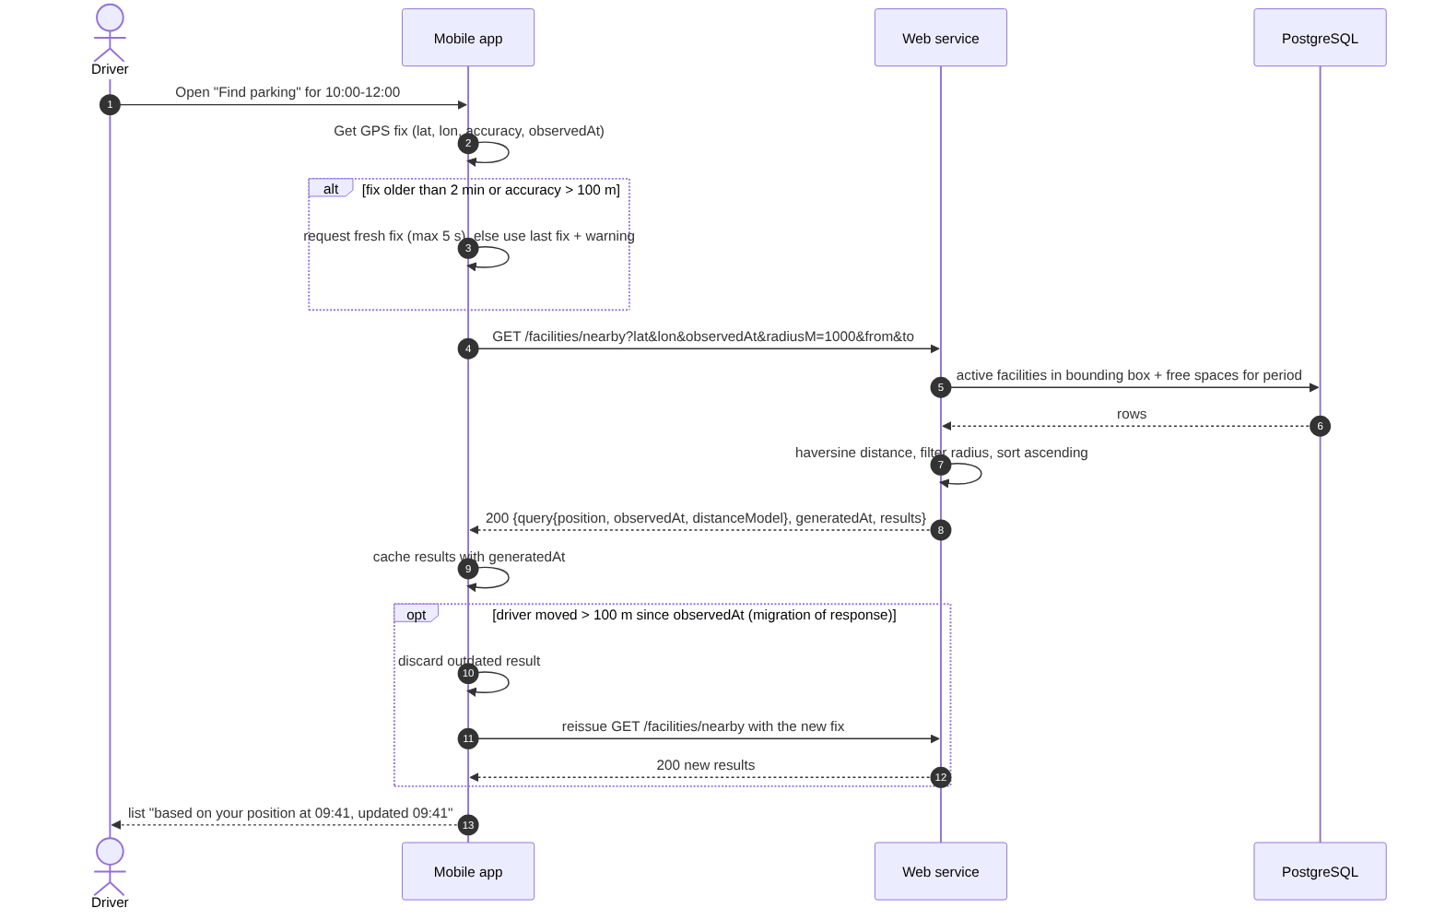
Search data flow (editable source: docs/diagrams/08-seq-search.mmd)
Hold with a lost response – processing succeeded, delivery failed. The database commit is the point after which the result exists even if the device never hears about it.
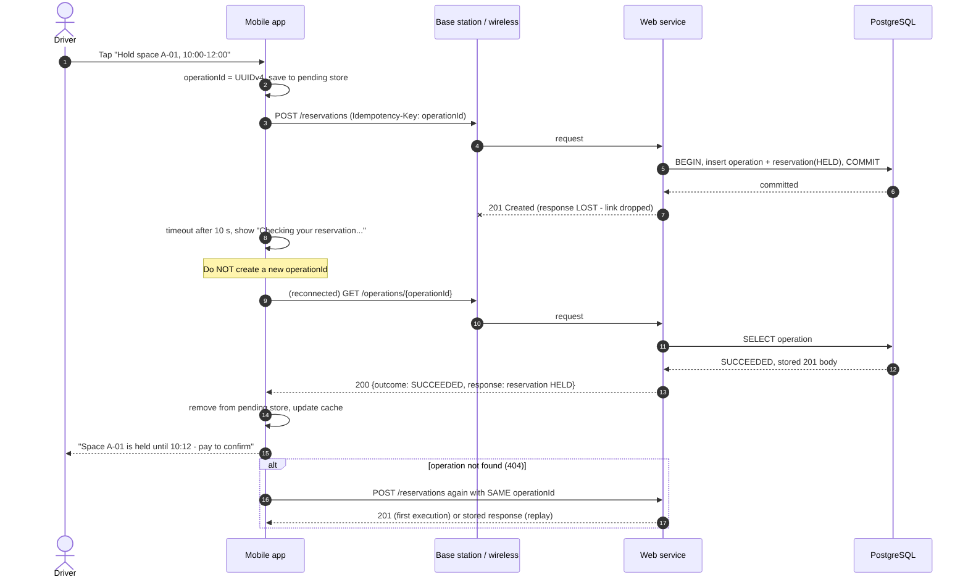
Hold with lost response (editable source: docs/diagrams/05-seq-hold-lost-response.mmd)
Competing data-changing requests.
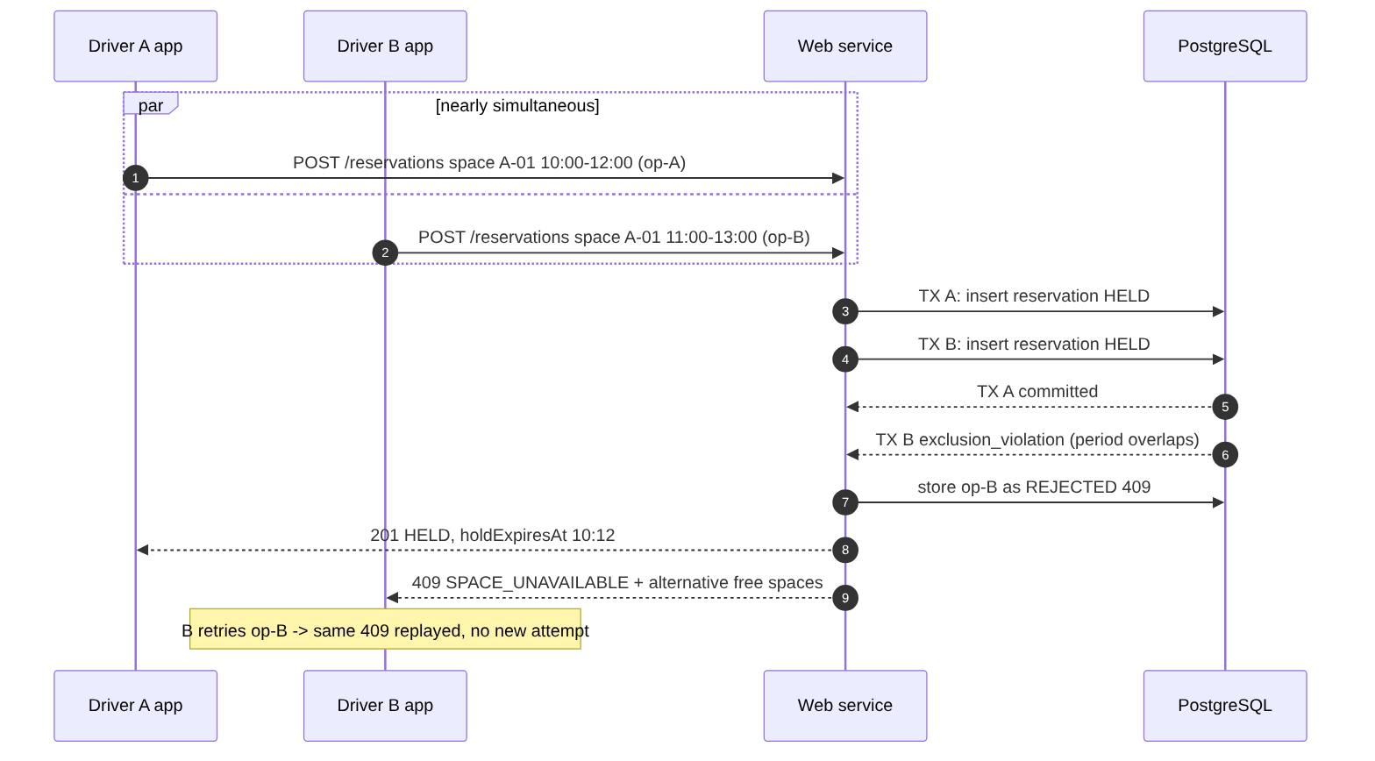
Competing holds (editable source: docs/diagrams/06-seq-competing-holds.mmd)

6.3. Web Service Operations (API Contract)
Base URL /api/v1, JSON, Authorization: Bearer <JWT>. Data-changing requests carry the header Idempotency-Key: <operationId>. Errors use one format: {"error": {"code", "message", "details"}}. The full contract is in api/openapi.yaml.
Method and path | Purpose | Main responses
GET /health | Service and database liveness | 200
POST /auth/register | Register a driver | 201, 409 EMAIL_TAKEN, 422
POST /auth/login | Obtain a JWT | 200, 401
GET /facilities/nearby | Nearest facilities with free spaces (query: lat, lon, observedAt, accuracyM, radiusM, from, to, limit) | 200 with query echo and generatedAt, 422
GET /facilities/{id}/spaces | Spaces and availability for a period | 200, 404
POST /reservations | Hold a space for 10 min | 201, 409 SPACE_UNAVAILABLE, 422
GET /reservations, GET /reservations/{id} | History; current authoritative state | 200, 404
POST /reservations/{id}/payment | Simulated payment → CONFIRMED | 200, 402 PAYMENT_DECLINED, 409 HOLD_EXPIRED / ALREADY_PAID
POST /reservations/{id}/cancel | Cancel | 200, 409 ALREADY_CANCELLED / INVALID_STATE
GET /operations/{operationId} | Was the operation executed? | 200 (stored result), 404 (not executed)
POST /admin/facilities, POST /admin/facilities/{id}/spaces, PATCH /admin/spaces/{id} | Administration | 201/200, 403, 409 VERSION_CONFLICT / LABEL_TAKEN
Representative request and response – search:
GET /api/v1/facilities/nearby?lat=51.7700&lon=19.4600&observedAt=2026-12-01T08:41:05Z
&accuracyM=15&radiusM=1000&from=2026-12-01T09:00:00Z&to=2026-12-01T11:00:00Z
200 OK
{ "query": { "position": {"lat": 51.77, "lon": 19.46, "accuracyM": 15,
"observedAt": "2026-12-01T08:41:05Z"},
"radiusM": 1000, "distanceModel": "STRAIGHT_LINE_HAVERSINE" },
"generatedAt": "2026-12-01T08:41:06Z",
"results": [ { "facilityId": "10000000-...-003", "name": "Łódź Fabryczna",
"distanceM": 622, "freeSpaces": 2, "minPricePerHour": 3.50 } ] }
Representative request and response – hold:
POST /api/v1/reservations
Authorization: Bearer eyJhbGciOi...
Idempotency-Key: 3b9d6f0e-2c4f-4f43-9d0a-1d3a2b7c9e11
{ "spaceId": "5f2a...", "startTime": "2026-12-01T09:00:00Z", "endTime": "2026-12-01T11:00:00Z" }
201 Created
{ "reservationId": "c0ffee00-...", "operationId": "3b9d6f0e-...", "status": "HELD",
"spaceLabel": "C-01", "holdExpiresAt": "2026-12-01T08:52:10Z",
"totalAmount": 7.00, "currency": "PLN" }
Representative request and response – recovery after a lost response:
GET /api/v1/operations/3b9d6f0e-2c4f-4f43-9d0a-1d3a2b7c9e11
200 OK
{ "operationId": "3b9d6f0e-...", "type": "HOLD_SPACE", "outcome": "SUCCEEDED",
"httpStatus": 201, "resourceId": "c0ffee00-...",
"response": { "reservationId": "c0ffee00-...", "status": "HELD",
"holdExpiresAt": "2026-12-01T08:52:10Z" } }

6.4. Duplicate Protection and Recovery after a Lost Response
Stable operation identity.
- Client. When the user expresses an intent (e.g. taps Hold), the app generates one operationId (UUID v4) and saves {operationId, method, path, body, createdAt} in the pending-operations store before sending. Every retry of this intent reuses the same operationId; a new intent always gets a new one.
- Server – first execution. The service computes request_hash = SHA-256(method + path + canonical JSON body). In one database transaction it performs the business change (e.g. inserts the HELD reservation) and inserts the operations row with the outcome, HTTP status and full response body. Either both are committed or neither (atomicity, slide 13).
- Server – repeated request. If the operations primary key already exists, the transaction is rolled back and the stored row is read: same user and same hash → the stored status and body are returned with header Idempotent-Replay: true; different hash → 422 IDEMPOTENCY_KEY_REUSED; different user → 404.
- Concurrent duplicates. If two copies arrive at the same time, the second insert waits on the primary-key index until the first transaction commits, then fails and is answered by replay (isolation). Only one execution is possible.
- Business rejections are recorded too. If a hold loses against a competing request (exclusion_violation) or a payment arrives after holdExpiresAt, the rejection (409) is stored with outcome REJECTED, so a retry receives the same answer instead of a new attempt.
- Second line of defence. reservations.operation_id and payments.operation_id are UNIQUE, the exclusion constraint prevents overlapping bookings, and the partial unique index allows only one successful payment per reservation.
Recovery after a lost response. After a connection error or a timeout the result is unknown, which is not the same as failed. The app shows “Checking your reservation…” and:
- When connectivity returns, it calls GET /operations/{operationId} (back-off 2, 4, 8 … max 60 s).
- 200 → the server executed the operation. The app uses the stored response exactly as if the original answer had arrived, updates the cache and removes the pending entry.
- 404 → the server never committed it. The app resends the original request with the same operationId (safe because of the rules above).
- 5xx / no connection → the entry stays pending; no new action on the same reservation is allowed until it is resolved.
- On every app start, all pending operations are resolved before new actions are allowed (NS-26).
- Operation records are kept for 7 days, longer than any realistic retry period (the hold itself lasts 10 minutes).
What to inspect after a successful database update whose response was lost: the operations row (outcome, http_status, response_body) and the business row that references it (reservations.operation_id or payments.operation_id). Their presence proves the change was applied exactly once.
Server-side rules that make retries safe.
- Hold: inside the transaction, overdue HELD reservations of that space are expired first (lazy expiry); the space must be active; amount = price per hour × duration; the exclusion constraint decides competing requests.
- Payment: SELECT … FOR UPDATE on the reservation; owner, status HELD and now() < hold_expires_at are checked with the server clock; the payment row and the status change to CONFIRMED are written in one transaction.
- Expiry job (every 30 s): HELD → EXPIRED when hold_expires_at < now(); CONFIRMED → COMPLETED when end_time < now(). State changes use a row lock and the version column, so a cancel and an expiry cannot both succeed (NS-20).

6.5. Relation to the Mobile-Database Concepts from the Lecture
Lecture concept (Lecture 1) | How the design applies it
Base station as the interface between the mobile client and the fixed network; problems of the mobile environment (slide 9) | Request path in Section 6.1; the wireless segment is treated as lossy and delayed in every scenario (Section 3.5).
Agent; transfer of traffic to the fixed network; less transmission in the wireless channel (slide 10) | The service filters, ranks and limits results on the fixed side; no background position uploads (N5).
INFORM strategy and reporting methods (slides 2–3) | Mixed rule on the client: new fix after 100 m or 60 s (Section 3.3).
SEARCH strategy (slides 4–5) | Not needed, because the service never initiates delivery; it becomes relevant only for the push-notification extension.
Location-dependent queries: nearest facility, objects within a distance, straight line vs street network (slide 6) | “Nearest” defined as straight-line haversine distance within a radius; street-network distance listed as an extension (Section 3.3).
Cost of a location-dependent query (slide 7); uncertain position as a circle (slide 8) | Limited radius and result count; accuracyM treated as an uncertainty circle (Section 3.3).
Mobile transactions: atomicity, consistency, isolation, coordinating server; longevity, vulnerability to errors, heterogeneity (slides 13–14) | One database transaction per operation; the service is the coordinating server; holds expire so a disconnected user cannot block a space for long; idempotent retries handle errors; REST/JSON for heterogeneous clients.
Long-term disconnections; version stamp (slide 15) | Cached data carries generatedAt and version; on reconnection the server state replaces the cache; data-changing actions are blocked while offline.
Data replication and migration (slide 16) | The local cache is a read-only replica of the user’s data; the server copy is authoritative.
Migration of responses: outdated result after the user moved (slides 17–18) | The response echoes the position and its time; if the user moved more than 100 m, the result is rejected and the query reissued (NS-05).

7. Project Implementation Plan
Stage | Description | Deadline | Responsible Person
1 | Requirements analysis: functions, requirements, network scenarios (Lab 1–2) | Week 2 | Yiğit Demir
2 | UML modelling: use cases, classes, data flows (Lab 3) | Week 3 | Yiğit Demir
3 | Database design (ERD), API contract, duplicate protection, architecture – Milestone M1 (Lab 4) | Week 4 (report uploaded before meeting 5) | Yiğit Demir
4 | Web service and database foundation: FastAPI project, DB connection, /health, schema migration, authentication (Lab 5) | Week 5 | Yiğit Demir
5 | Client–server prototype: search, spaces, hold, simulated payment, cancel, history, admin endpoints; Flutter screens – Milestone M2 | Weeks 6–8 | Yiğit Demir
6 | Network resilience: operationId store, /operations/{id} recovery, offline cache with ages, expiry job, fault injection; tests NS-01…NS-26 – Milestone M3 | Weeks 9–12 | Yiğit Demir
7 | Final system: polishing, automated tests, final documentation and defence | Weeks 13–15 | Yiğit Demir
Testing unreliable connectivity (prepared for M3): Android emulator network controls (airplane mode, latency and speed profiles), stopping the service during a request, and a development-only service setting FAULT_DROP_RESPONSE_AFTER_COMMIT that closes the connection after the commit with a given probability, so the lost-response scenarios can be repeated on demand.

8. Conclusions and Possible Extensions
Conclusions. The conceptual design separates what may be stale (search results, cached history, the user’s position) from what must be authoritative (holds, payments, cancellations). Stale data is always shown with its age; authoritative changes are made only by the server, in one transaction, under a stable operation identity. This lets the system tolerate the typical failures of the mobile environment – lost and delayed responses, retries, competing requests and long disconnections – without double bookings or double payments. Every failure case is written down as a testable scenario for the next milestones.
Possible extensions.
- Street-network distance (e.g. OSRM or pgRouting) instead of straight-line distance, with the distance model shown in the response.
- PostGIS spatial index (geography type, ST_DWithin) for a large number of facilities.
- Real occupancy data from sensors or a city open-data feed, with its own freshness timestamp.
- Push notification before a hold expires – this needs delivery to a moving device and would apply the INFORM/SEARCH trade-offs.
- Issuing the query for the estimated future position of a moving driver, or fragmenting large responses (alternative solutions for migration of responses, slide 18).
- “Data on air”: periodic broadcast of free-space counts for an area, which devices could receive in a low-power listening mode (slides 11–12).
- Geographically addressed messages, e.g. informing all drivers in an area about a closed car park (slide 19).
- Payment-provider sandbox instead of the internal simulation; web administration panel; rate limiting.
Assumptions and limitations. One city and one currency (PLN); disabled-badge spaces have price 0; availability is based only on reservations made in this system; only server time decides expiry.

9. Sources
- Course lecture Mobile databases (Lecture_1.pptx): INFORM and SEARCH strategies, item-dependent queries, queries and data services, transactions, disconnections, replication and migration, migration of responses, geographic addressing; laboratory brief (Project overview, Labs 1–4).
- PostgreSQL 16 Documentation – Range Types: https://www.postgresql.org/docs/16/rangetypes.html
- PostgreSQL 16 Documentation – Constraints (exclusion constraints): https://www.postgresql.org/docs/16/ddl-constraints.html
- R. Fielding, M. Nottingham, J. Reschke, RFC 9110: HTTP Semantics (idempotent methods): https://www.rfc-editor.org/rfc/rfc9110
- IETF HTTPAPI WG, The Idempotency-Key HTTP Header Field (Internet-Draft): https://datatracker.ietf.org/doc/draft-ietf-httpapi-idempotency-key-header/
- OpenAPI Specification 3.0.3: https://spec.openapis.org/oas/v3.0.3
- FastAPI documentation: https://fastapi.tiangolo.com/
- Flutter documentation: https://docs.flutter.dev/
- R. W. Sinnott, “Virtues of the Haversine”, Sky and Telescope, 68(2), 1984.
- Mermaid diagram syntax: https://mermaid.js.org/

Appendix A. Repository Structure and Revision
smart-city-parking/
├── README.md project, topic, technologies, startup steps
├── docker-compose.yml PostgreSQL 16 with schema + seed
├── api/openapi.yaml API contract
├── database/schema.sql DDL (tables, keys, constraints)
├── database/seed.sql simulated city data (Łódź)
├── database/tests/constraints_test.sql
├── docs/network-scenarios.csv scenario matrix (also .md)
├── docs/diagrams/*.mmd, *.png editable diagram sources + images
├── docs/report/ this report (source, DOCX, PDF)
├── docs/design-changes.md log of design changes since M1
├── service/ web service (from Lab 5)
└── mobile/ Flutter client (from M2)
Demonstrated revision for M1: tag m1 (commit 7ee147c) – https://github.com/yigitdemirr/smart-city-parking/tree/m1

Appendix B. Verification of the Database Design
database/tests/constraints_test.sql was run on PostgreSQL 16 after schema.sql and seed.sql:
OK 1: first hold accepted
OK 2: competing overlapping hold rejected (exclusion_violation)
OK 3: duplicate operation_id rejected (unique_violation) -> service replays stored response
OK 4: expired hold released the space
OK 5: second successful payment rejected
OK 6: is_simulated is forced to TRUE

Appendix C. Consistency Check: Requirements – Use Cases – API – Data – Scenarios
Requirement | Use case | API / component | Tables | Scenarios
F1 | UC1 | POST /auth/register | users | NS-01, NS-02
F2 | UC2 | POST /auth/login | users | NS-03
F3 | UC3 | client location module (observedAt, accuracyM) | – | NS-05, NS-06
F4 | UC3 | GET /facilities/nearby | parking_facilities, parking_spaces, reservations | NS-04 – NS-07
F5 | UC4 | GET /facilities/{id}/spaces | parking_spaces, reservations | NS-08
F6 | UC5 | POST /reservations | reservations, operations | NS-09 – NS-14
F7 | UC6 | POST /reservations/{id}/payment | payments, reservations, operations | NS-15 – NS-18
F8 | UC7 | POST /reservations/{id}/cancel | reservations, operations | NS-19, NS-20
F9 | UC8 | GET /reservations, GET /reservations/{id} | reservations | NS-21, NS-22
F10 | UC9 | GET /operations/{operationId} | operations | NS-10, NS-11, NS-15, NS-26
F11 | UC10 | POST /admin/facilities, POST /admin/facilities/{id}/spaces, PATCH /admin/spaces/{id} | parking_facilities, parking_spaces, operations | NS-24, NS-25
F12 | UC11 | expiry job (service-internal) | reservations | NS-16, NS-20, NS-23
F13 | all | client (cache, pending store) | local SQLite cache | NS-04, NS-09, NS-18, NS-21, NS-22, NS-26

