Connected Mobility Basics  
**REPORT** 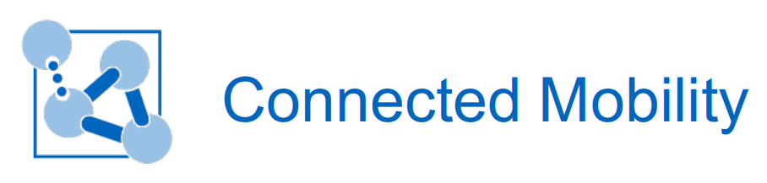

Assignment 2: TUM Mobility Model

Names: Ismail Muzhaqi, Matthias Mögerle, Nikolas Promponas-Kefalas  
 Date: 11.12.2015

horizontal line

# Tables of Content

# Abstract …………………………………………………………………………...……………….2

# Introduction ……………………………………………………………………………………...2

# Mobility Models ………………………………………………………………………………...3 - Simulation Design ………………………………..………………………………………..….3 - Mobility Model - Student ………………………………………..………………………...3 - Applicable Mobility Models …..………………………………..………………………...4

# The ONE Simulator and Simulation Implementation …..……………..……...7 - The ONE Simulator ……………………………………….…..…………………………..….7 - Implementation and Special Features …….…..……………………..………..….8

# Results of the simulation ………...……………………………….……………………...13

# Conclusion ………...……………………………….…………………………………...……...20

# References ………...……………………………….…………………………………...……...20

# 

# Abstract

Human behavior consists of many interesting features and characteristics, all of them could constitute subjects of extensive analysis and research. One of the many behavioral prisms that someone could take a look at, is the prism of mobility. Human mobility is a very popular research subject of the last years. Especially, there has been a constant effort to design a mobility model that best describes and analyzes all the characteristics of the human mobility. In this document we present an implementation of a mobility model for the Department of Mathematics and Informatics building, at Garching Campus. We describe the scenario of a full day in the building, and all the motifs that occur from everyday behavior. Accordingly we analyze all the characteristics from the scope of human mobility, and we refer to related mobility models that could be used in our case.

# Introduction

# The goal of this report is to describe the design and build of a mobility model for the faculty building of mathematics and computer science in Garching. The mobility model should be implemented by the use of the ONE simulator. The mobility model focus on a realistic movement of people inside and immediately around the building.

# To achieve this goal, we analyzed different movement patterns that exist in the university building. Furthermore, we matched them with the mobility models and approaches as discussed in the lectures. This knowledge was then be used to design our specific mobility model which we afterwards implemented in the ONE Simulator. At the end of this report we provide various results, calculated in the simulation.

# 

# Mobility Model

**Simulation Design**

After we gathered the basic knowledge of different movement model approaches, we analysed the daily behaviour of students to see for which actions what model could apply.

A usual day of a student starts with the action to go to the university by bike, by car or by public transportation. At the campus, students mainly have common habits and behaviours - which in our observation appear on a random regular basis and will be called state. Students are usually in a lecture, or studying at another place in the building. Other human needs are to eat and to go to the toilet. In addition, the social interaction at the university is very high. This is explicitly addressed by our simulation. Students have to do group assignments, go together to the Mensa or just meet for a short conversation after a lecture has taken place. The day at the university ends by going back home.

**Mobility Model - Student**

The student day dresses three main areas which can be seen in figure 1 and was introduced by the lecture of Connected Mobility Basics. These areas are now addressed in detail by the following paragraphs.

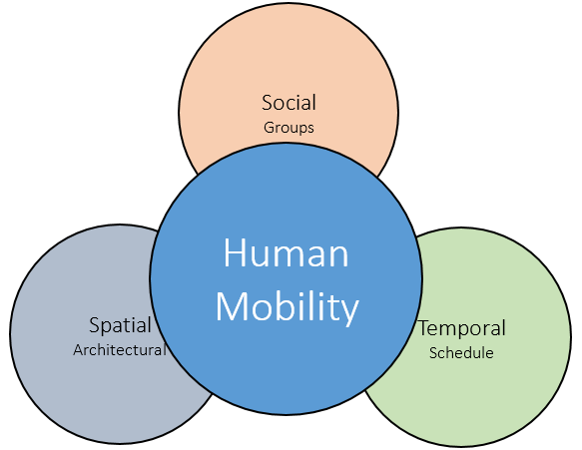

Figure 1: Areas contained by human mobility

- **Spatial:** This mainly address the architectural model of the building. The faculty building of computer science and mathematics contains university typical facilities. These are three lecture halls, several toilets, a cafeteria, many offices, as well as a library and many other places to study. Entrances are available to enter the building. The movement is heavily determined through the architectural environment - since students can’t walk through walls.

- **Temporal:** Each student signs up for classes and courses, for which lectures can be taken in lecture halls. Every student has its own schedule of lectures. This schedule is enriched with planned group exercises and tutorials. These three elements create a schedule which is mostly known when the student arrives at the university. This is the planned behaviour of a student.

The unforeseen or unplanned behaviour of a student is containing trivial things like to meet other friends (see social behaviour) and have a talk with them. It is possible to decide visiting the Mensa together to have lunch. Other unplanned events are going to the toilet and searching a room in the building.

- **Social:** As mentioned before, the social interaction between students is very high compared to working environments. It is quite common to meet friends while changing rooms or studying at the same places. Lectures enable students to come together on a regular basis and in same groups which creates networks between students. The amount of how many other students are known by student varies from his social interactivities. When we observed the movement of students we observed a very high rate of people moving in groups, mostly between two and six students.

**Applicable Mobility Models**

A lot of models for analyzing the different characteristics of the human mobility can be used in our case. Some of them focus on specific categories of characteristics, while other follow a more combinatorial approach.

From the models that are discussed in the lecture slides, we describe which of them could be applied to the human mobility movement in the faculty building.

**Location Preference**

SLAW  
SLAW[1] belongs to the ‘Location Preference’ category and applies to the mobility characteristics of this scenario, as it takes into account the concepts of Flight and Pause times, Bounded Mobility Areas, and Inter-contact times.

However, it doesn’t cover all the characteristics, does not suit our simulation as a stand-alone approach.

SMOOTH  
A more useful model from this category is *SMOOTH[*2], which shares more characteristics with the TUM scenario than SLAW. In SMOOTH, communities with different popularity levels are created, and nodes visit this communities based on popularity and distance. In addition, SMOOTH has also many input parameters in common with this scenario.

**Social Graph**

Community Based Model  
Since the TUM scenario contains some social behavior properties, we can also find applicable mobility models in this category, and one of them is a *Community Based Model* proposed by M.Musolesi[3]. The main characteristic of this model that are interesting in our case, is that the movements of the nodes are driven by social attractions.

Heterogenous Human Walk Model  
One more useful model that was discussed on the lecture is the *Heterogenous Human Walk Model* proposed by S.Yang[4]. This model synthetically constructs communities rather than detecting them, and can be very useful in our scenario.

**Agenda Modeling**

ParkSim  
Most of the characteristics of the FMI mobility model correspond to the ‘Agenda Modeling’ category, since the nodes of a university building usually follow a kind of schedule. Two of the models discussed in class share many elements with the FMI model, and one of them is *ParkSim*[5].

Many of the characteristics of ParkSim correspond to concepts of our mobility model. ParkSim introduces walking and activity areas in the model and an additional activity matrix that acts as a schedule. Finally the nodes move following shortest path routes with collision avoidance. All of the above are characteristics that are also included in our model (lecture halls and library as activity areas, room-plans as activity matrix, similar walking model).

Working Day Movement  
The second model from the ‘Agenda Modeling’ category that shares common features with ours, is the *Working Day Movement*[6]. After paying attention to several mobility models that are discussed on the lectures, we realised that the best approach would be to combine as many characteristics as possible in a single model. The Working Day Movement does exactly this, and for this reason it is the model that is the most applicable to our case.

Finally, the Working Day Movement model introduces the concepts of visiting many different places, and of using real maps for the model implementation/simulation.

**The ONE Simulator and Simulation Implementation**

**The ONE Simulator**

To simulate the mobility model within the faculty building, we have been advised to use the ONE Simulator[7] which was invented by Keränen, Ott and Kärkkäinen. The simulator contains nodes which following movement models and can be assigned to connectivity models. Between nodes, so called inter-node contacts are implemented. This approach is agent-based and evolve through regular updates per time increments. Various movement models are implemented, which focus on the transition from point A to a predefined point B. These are random-movements as well as movements on paths and within specific areas. Furthermore, routing functionalities and message handling is implemented, which is not required in terms of mobility movement.

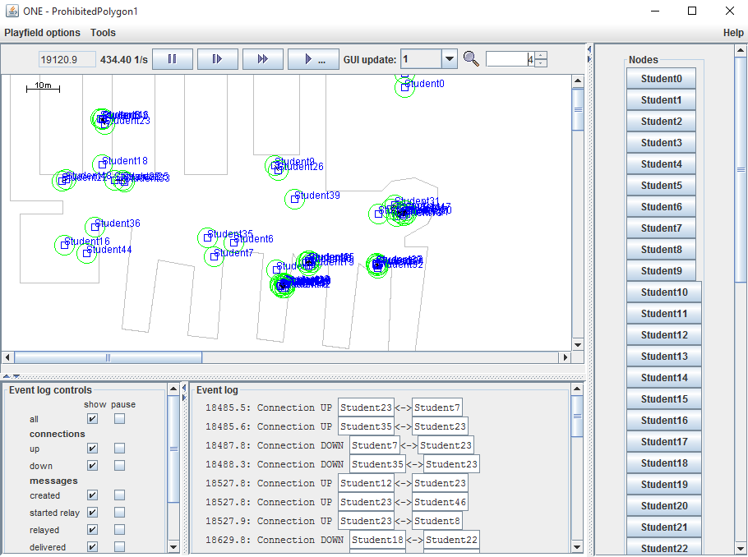

Figure 2 : Graphical User Interface of - The ONE Simulator

The simulation is equipped with a practical graphical user interface which displays the position of nodes within the simulation area, shown in figure 2. This visualization is one possibility to gather an overview and results of the simulation. In addition reports and outputs for post-processing tools are implemented. The fact that all report entities implemented in a separate module makes it very simple to adapt them to the outputs the user is interested which will be shown in the result section.

**Implementation and Special Features**

Based on the ONE Simulator, we designed our architecture and split the implementation into different modules as outlined in figure 3. The main elements of our movement model are spatial, temporal and social elements. These are guarded by the mobility model which contains the details about the implemented map and calculate movement paths from A to B in order to move around walls.

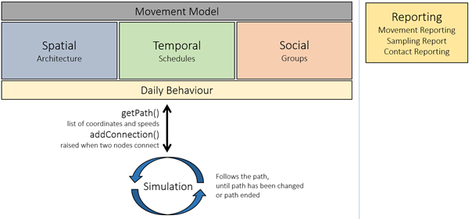

Figure 3: Architecture of Implementation Modules

Details of each module and specific knowledge about the implementation are addressed in the following paragraphs.

**Spatial:** The architecture of the building is generated through the map material OpenStreetMap. Unfortunately we did not have exact plans of the building. Considering this, we decided to only simulate the ground level. Because we focused on the behaviour of the nodes, we do not expect a tremendous influence the collected results.

**Movement Model:** Outside the building nodes are moving on given sectors to reach the metro station, parking spots or the Mensa. The faculty building itself is implemented as a polygon, which allows nodes to move freely. We decided against path based movements because in the building many different ways are possible and are selected individually. Path based movement does in our opinion suit best for streets networks. In our implementation, we added an algorithm to find best ways from one finger to the other. The movement model is checking if the node is in a finger of the building and wants to move to another finger as shown in figure 4. The movement model then calculates the path going from the current position to the entrance point of the source-finger and adding another point at the destination-finger. The last point in the path is set at the final destination within the finger. We did not add obstacles nor collision detection. To conclude, the movement model does get the source-coordinates and destination-coordinates from the model and calculates a path from source to destination.

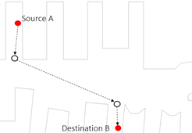

Figure 4: Movement from one finger to another finger

This path can always be changed whenever the node changes. For example when a node meets another node and decides to follow them to the Mensa instead to study.

**Temporal:** The students’ pre-planned schedule is influencing the movement of a student as well as his short term activities like waiting, going to the toilet or the Mensa. Therefore, our implementation is calculating random room plans at the start of the simulation. Afterwards, the student selects several lectures and work groups to his personal schedule. Based on this schedule the arrival and departure times are calculate.

This long term schedule is adapted due to many small interactions like meeting another student. The current interaction of a student is defined by its state. A student can only have one state at a time.

At first we list all the states which we defined to appear in the short term behaviour:

* **Freetime:** During this state the student moves from one point in the building to another. This could be because he is searching for someone like a professor, a room or some other student.
* **Toilet:** This state brings the student to the closest toilet in the building, where he will stay for a defined time.
* **Wait:** To simulate students waiting for the lecture hall after the end of a lecture, we introduced the wait state. The student waits for a random amount of time and probably connects to a group which is discussed in the social implementation.
* **Lunch:** Students randomly choose if they go to the cafeteria within the building or to the Mensa outside the building.
* **Study:** This state simulates the action to go to a place and study for some time.

Below we list all states related to the pre-defined schedule. Since these are predefined, they will be called whenever the scheduled time arises and transit nodes from their prior state to this scheduled state:

* **Idle:** The idle state is used before the student moves to the university and after the student departs from the university, as start and end state.
* **Arrival:** This state is responsible to let students arrive at the faculty building. The student arrives at one of four different locations and moves to the closest entrance. This simulates the ubahn, car and bike arrivals.
* **Departure:** Quite equivalent to arrival, during departure state the student moves from the building to the place where the student arrived.
* **Lecture:** As mentioned above, each student has its schedule containing lectures as well as group works. During the lecture state, the node moves to the right lecture hall. We assigned probabilities to come late, to go earlier and to leave for a short period of time.

The transitions between states are given by table 1. The lecture state, arrival state and departure state are not called by any other state. They are called through the events of the schedule.

|  |  |  |  |  |  |  |  |  |  |
| --- | --- | --- | --- | --- | --- | --- | --- | --- | --- |
| **To\From** | **Free**  **time**  **State** | **Idle**  **State** | **Toilet**  **State** | **Wait**  **State** | **Study**  **State** | **Lunch**  **State** | **Lecture**  **State** | **Arrival**  **State** | **Departure**  **State** |
| **Freetime**  **State** | 30 | 0 | 20 | 20 | 30 | 20 | 20 | 15 | 0 |
| **IdleState** | 0 | 0 | 0 | 0 | 0 | 0 | 0 | 0 | 100 |
| **ToiletState** | 5 | 0 | 0 | 20 | 15 | 20 | 15 | 5 | 0 |
| **WaitState** | 15 | 0 | 10 | 10 | 15 | 20 | 45 | 20 | 0 |
| **StudyState** | 40 | 0 | 60 | 40 | 30 | 40 | 10 | 45 | 0 |
| **LunchState** | 10 | 0 | 10 | 10 | 10 | 0 | 10 | 15 | 0 |

Table 1: Probability of state transitions

**Social** On campus and during studies, the social behaviour is very important and therefore focused on our mobility model. Students are in various lectures and meet different people. Therefore, the student usually knows more than one group and each group consists of several students. We evaluated each student is in average three groups containing in average five students. On campus the simulated students only connect to students which are in their groups. These groups also have group work meetings, so they meet some point for some time. It is possible to connect to a group at any time and disconnect from a group at any time which aims to provide a similar behaviour as in reality. The group always gets guided by a leader, who can also leave the group at any time. If so, another group member will be the new leader and guides the group.

**Additional Information:**

- We always simulate a complete day containing 24h (24*60*60 seconds).

- The class daily behaviour is the interface which is capable of spatial, temporal and social behavior. This enables the daily behaviour to calculate a decision to which position the student moves next.

- We did many adaptations in the ONE Simulator, because it only supported movements from A to B without any possibility to change the destination in between.

# 

# Simulation Results

The ONE Simulator provides us with numerous and different kind of reports. Each of these reports focuses on specific characteristics of the human mobility and mobile connectivity. For the purpose of this assignment, we decided that we should focus only in the mobility part, and take advantage of all the simulator classes that are meaningful to our mobility model.

In this section we describe all the characteristics we extracted by simulating our implemented scenario, and what kind of meta-information it is possible to acquire depending on these characteristics.

**Contacts Per Hour**

In this kind of report, the duration of the simulation (in seconds) is divided into hours, and for each hour of the simulation, the total number of connection establishments is recorded.

This information helped us understand the periods of time that the users are more active and moving around in large areas. For example, during lunch time (*see Plot X1, time 4-5*), users tend to either visit the MENSA or have lunch at the FMI cafeteria. In any case, they are more active than when they are attending a lecture. and as a result, they tend to establish more connections with other students – periodical behaviour. Another example is in the afternoon (*time 9-11*), when most of the students had their last lecture and are leaving the lecture halls to return home.

**Encounters vs Unique Encounters**

This report presents for each node in the simulation a) the total number of encounters with other nodes, and b) the number of distinct encounters with other nodes (i.e. how many different nodes).

The information in this report can be used in order to recognise which nodes are more ‘*social*’ than others, which in turn might reveal which nodes move the most around the simulation area. *(see plot 1)*

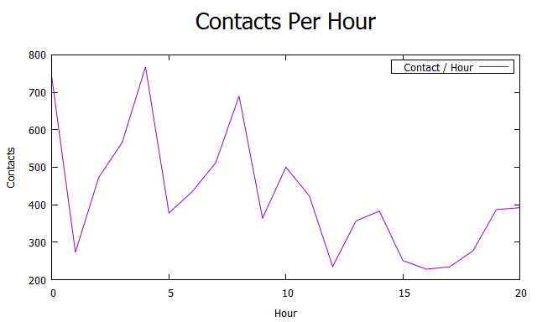*Plot 1: Contacts Per Hour*  
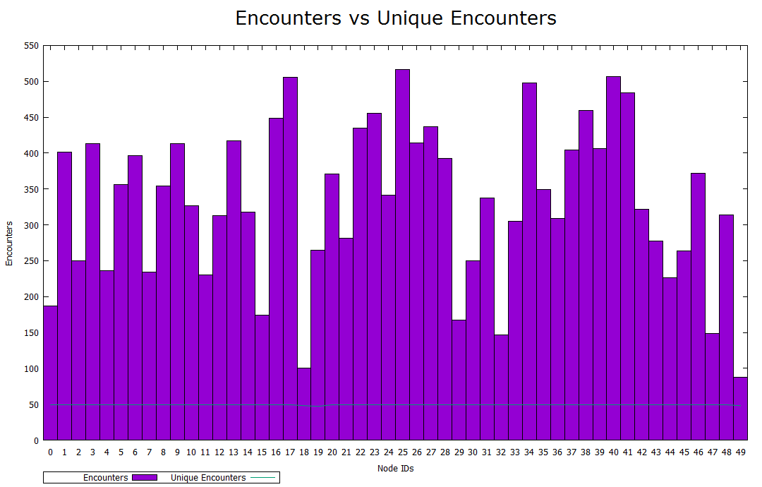

*Plot 2: Encounters vs Unique Encounters*

**Contact Times**

The information contained in this report is a distribution of the time that two arbitrary nodes of the simulation where in contact. In other words, it distributes the duration of any connection between any two different nodes.

From a statistical point of view, the Contact Times report revealed what is the usual duration for a connection between two nodes. *(see plot 3.1 and 3.2)*

*\*Plot 3.1: X-axis was shortened for clarity, there are values available for up to ~32000 seconds.*

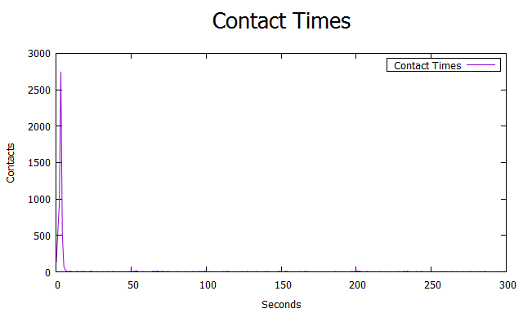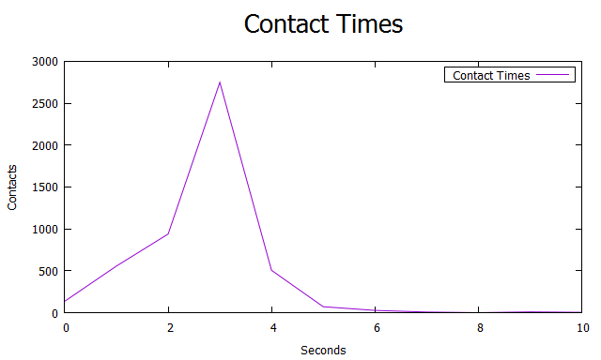

*Plot 3.1 & 3.2: Contact Times & Magnified Version*

**Inter-Contact Times**

The Inter-Contact time between two nodes A and B, is the duration between 2 consecutive connections between them, i.e. how much time takes before 2 nodes meet again with each other. This report is similar to “Contact Times” report, but it contains a distribution of inter-contact times. *(see plot 4.1 and 4.2)*

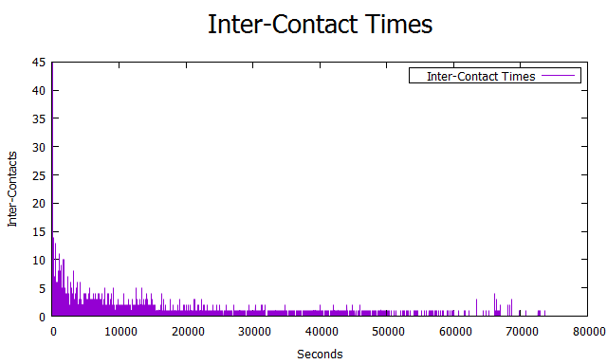

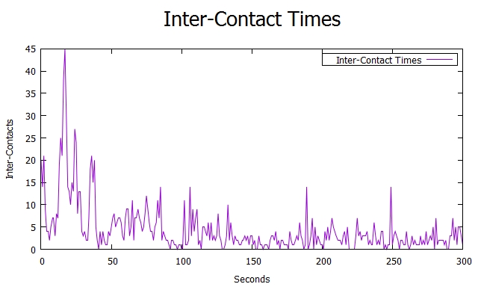

*Plot 4.1 & 4.2: Inter-Contact Times & Magnified Version*

**Contacts During an Inter-Contact Time**

If *T* is the inter-contact time between two nodes *A* and *B*, then this report counts how many contacts *A* and *B* had with other nodes, during this time *T*.

In other words this information refers to how many other nodes have a contact with A and B, before A and B meet again. The information is exported in the form of a distribution.

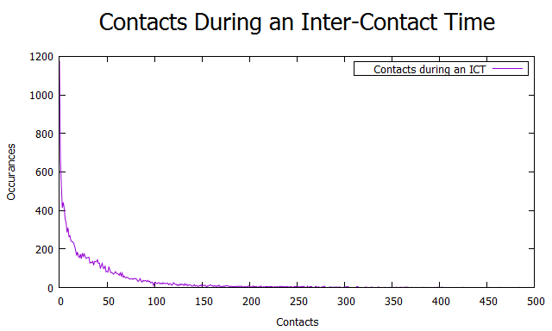

*Plot 5: Contacts During an Inter-Contact Time*

**Total Contact Time**

In this report, the simulation total time is divided into intervals of *X* seconds, and for every interval it calculates the total contact time of all active connections. In the end, the information for the time is presented in an accumulative way.

By observing *plot 6*, we realised that the accumulated time increases more rapidly during rush hours, or during times where the users are more social and carefree (e.g. lunch time).

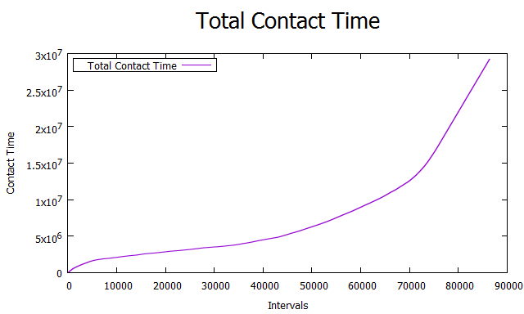

*Plot 6: Total Contact Time*

**Node Density**

This report ‘*slices*’the simulation area into an *A x B* grid, and then it takes *N* samples of the simulation, equally distributed in time. In our case, we use this report to export an average density based an all *N* samples.

We used these results to create a *heat map* of the node distribution in the simulation area. With the help of this map the lecture halls as well as study places are clearly visible.

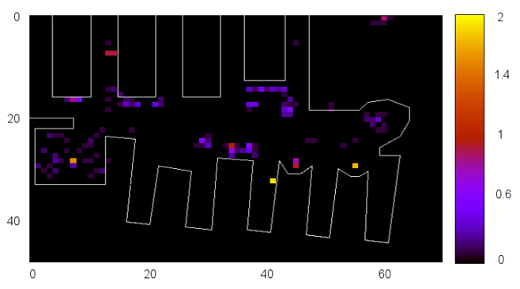

*Plot 7: Node Density (heat map)*

# Conclusion

In our approach we focused on students moving within the “Faculty of Mathematics and Informatics” building . It was shown that it is reasonable to perform the simulation with the use of individual agent-based behavior. Our approach considers spatial,temporal and social influences. Each student follows an explicit schedule and derives his behavior during the day by small adaptions. We introduced the concept of states, to represent different activities like arrival state, study state, and toilet state. Social actions are triggered by the intersection of two students which then decide if they join some group behaviour. The implementation of our model shows a behaviour, which is suiting the real world observations. Due to time restrictions we were not able to focus on every detail of the scenario. In a more extensive approach, architectural details like obstacles could be added, and real data of lectures could be used. Finally, we are confidentthat our simulator provides a solid framework to analyze the human movement within the faculty building, while focusing on social behaviour of students.

**References**

1. Kyunghan Lee, Seongik Hong, Seong Joon Kim, Injong Rhee and Song Chong.   
   SLAW: A Mobility Model for Human Walks. *IEEE INFOCOM* ,2009
2. Aarti Munjal, Tracy Camp, and William C. Navidi.  
   SMOOTH: A Simple Way To Model Human Mobility. *ACM MSWiM* , 2011
3. Mirco Musolesi and Cecilia Mascolo. Designing Mobility Models based on Social Network Theory. *ACM SIGMOBILE* , 2007
4. Shusen Yang, Xinyu Yang, Chao Zhang and Evangelos Spyrou. Using Social Network Theory for Modeling Human Mobility. *IEEE Network*, 2010
5. Vladimir Vukadinovic, Fabian Dreier and Stefan Mangold. A Simple Framework to Simulate the Mobility and Activity of Theme Park Visitors. *WSC*, 2011
6. Frans Ekman, Ari Keränen, Jouni Karvo and Jörg Ott. Working Day Movement Model.  
   *ACM MobilityModels*, 2008
7. Ari Keränen, Jörg Ott, Teemu Kärkkäinen. The ONE Simulator for DTN Protocol Evaluation, Helsinki University of Technology (TKK)