QUESTION 1

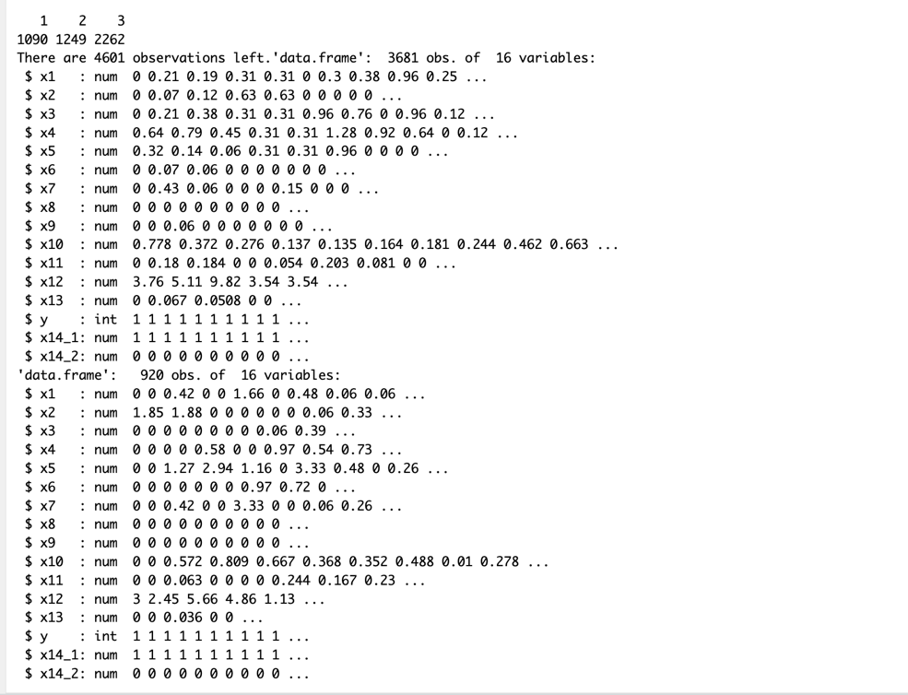

QUESTION 2

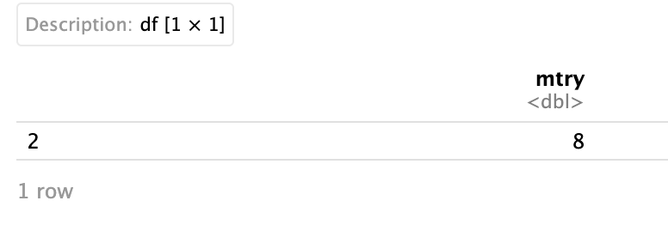

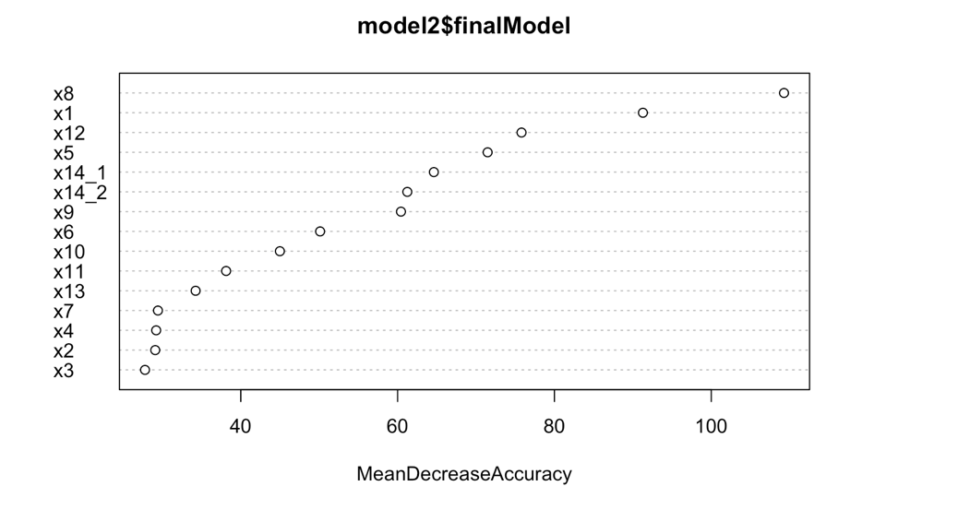

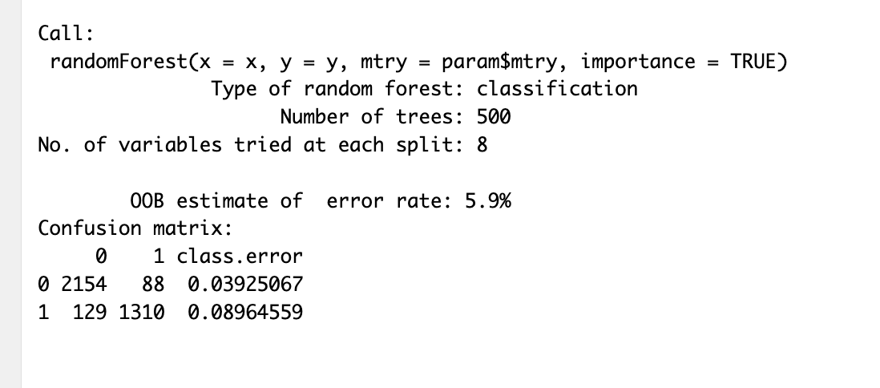

QUESTION 3

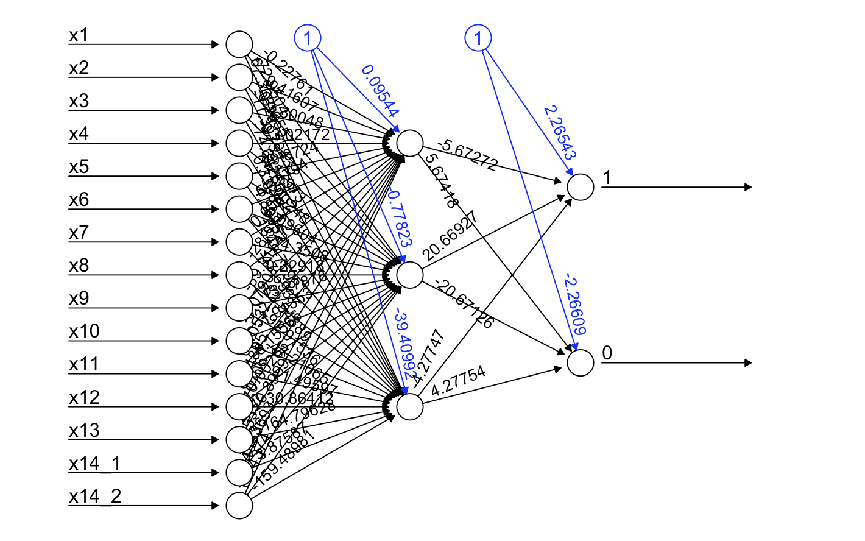

QUESTION 4

QUESTION 5

QUESTION 6

QUESTION 7

IT JUST DOESN’T WORK, GETS STUCK

QUESTION 8

QUESTION 9

QUESTION 10

