PROJECT / RELEASE
Project Design Document
TEAM G2
Robert Jakopović <rj4612@rit.edu>
Nik Kaučić <nk5431@rit.edu>
Frane Gobin <fg1754@rit.edu>
Yiğit Koşar <yk8290@rit.edu>
Acar Ozbahceci<ao3101@rit.edu>

Project Summary

Schema2Script is a Java program with a split and choose design that translates conception-based schema definitions in the form of JSON or XML into runable SQL DDL scripts: MySQL, PostgreSQL, and Oracle. The project is aimed at automatizing the process of translating abstract schema definitions into a concrete SQL script capable of being executed directly on a relational database server. The system adheres to a clean extensible architecture with clearly defined components: parsers are used to convert input files into an intermediate representation of a neutral architecture: a SchemaModel, then that model is converted into SQL by generators and the overall interaction is driven by the controller. The most recent release of the system includes a complete Swing-based graphical interface, and replaces console-based workflow with a graphical interface. The model-driven interface allows the user to upload schema files, view the results of parsing, edit both tables and fields directly in the interface, and create SQL scripts dynamically. As each and every parser gives a single SchemaModel, and each and every generator takes that very model, the application remains format-independent, database-independent, and simple to extend. Adding a new SQL generator or parser only involves the addition of the corresponding interfaces, and does not involve the controller or core logic. Schema2Script has since become a full featured, easy to use schema design and DDL generator with the addition of visual schema editing and real time SQL output.

Design Overview

It is designed on the foundation of the basic object-oriented principles, high cohesion, low coupling, and strict separation of concerns. The Parsing logic is implemented as the interface of the SchemaParser and the XML and JSON implementations are chosen via the ParserFactory. The SQL generation is modeled by the interface SqlGenerator whereby MySQL, PostgreSQL and Oracle concrete generators are available. The SqlGeneratorFactory makes sure that the choice of the generator is decoupled well with the controller. The main component of the application is the Pattern of the workflow with the view, parser subsystem, and generator subsystem, the coordinator of all these subsystems is the SchemaController. Once the user loads a file using the Swing UI, the controller forwards the task of parsing to the corresponding one, which creates a single SchemaModel. This model is the one-and only source of truth in the rest of the application as the user can visually edit tables, fields and schema attributes without having to re-parse the original file. Creating SQL The controller reads the edited SchemaModel in the view and then uses the factory to choose the appropriate generator to convert the internal model into executable SQL, based on the generator concrete logic. This output is sent back to the UI and as well stored to disk under target/generated/ schema.sql. The new Swing interface (SchemaSwingView, SchemaFrame) provided a nice separation between UI and logic by using a common interface, SchemaView. This decoupling enables replacement of the UI layer (e.g. a web interface) in the future, with no application logic modifications. Refactoring of the system between Milestones 1 and 3 has seen a system that is more maintainable, testable and extensible; with all the major responsibility of parsing and generating being delegated to factories and more adapter-style interfaces than constituted by the controller.

Overall System Structure
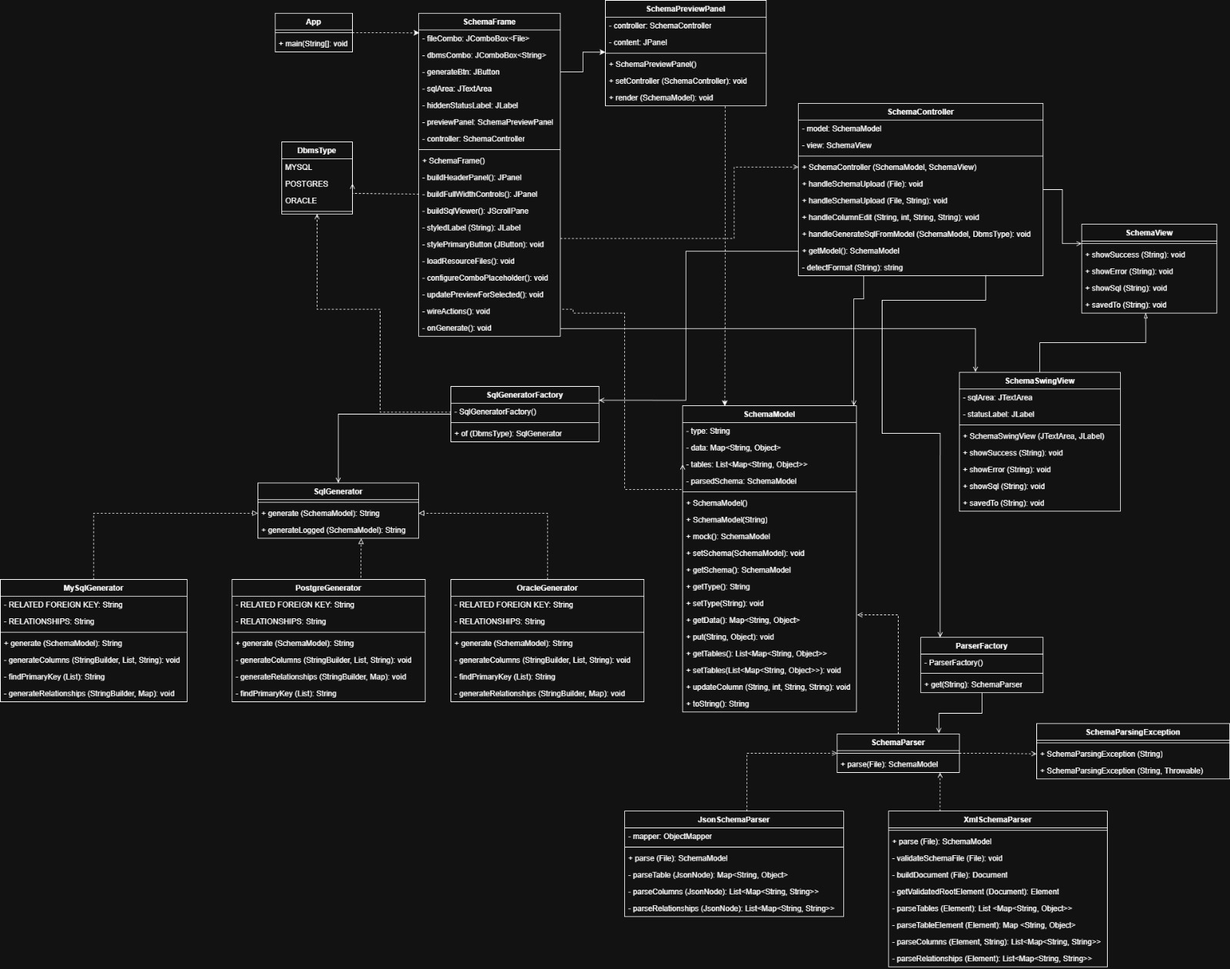

The class diagram illustrates the complete architecture of the Schema2Script system, capturing all major components involved in schema parsing, schema modeling, visual editing, and SQL generation. The model follows a modular, interface-driven structure designed around separation of concerns and extensibility.

At the core of the system is the SchemaController, which coordinates communication between the view layer, the parsing subsystem, and the SQL generation subsystem. The controller maintains a central SchemaModel instance representing the currently loaded or edited schema. It exposes methods for handling file uploads, applying edits received from the GUI, selecting the target DBMS, and initiating SQL generation. The controller acts as the mediator between user actions and backend functionality.

The view layer consists of three main classes:

SchemaFrame, which serves as the primary Swing window and provides UI components for file upload, schema editing, DBMS selection, and SQL output

SchemaSwingView, which implements the SchemaView interface and defines the methods used to update the GUI (showing SQL output, success/error messages, and saved-file notifications)

SchemaPreviewPanel, which displays the current schema visually and communicates user edits back to the controller

These components collectively support interactive schema editing while remaining decoupled from the application logic through the shared SchemaView interface.

The model layer is represented by the SchemaModel class. It stores schema information in a neutral and uniform structure, including tables, columns, data types, and relationships. All parsing results and GUI edits flow into this model, which becomes the single source of truth for the entire system. The controller retrieves and modifies this model during parsing, editing, and SQL generation operations.

The parsing subsystem is defined by the SchemaParser interface, which standardizes how schema files are transformed into a SchemaModel. Two concrete implementations exist: JsonSchemaParser and XmlSchemaParser, each responsible for reading and processing their respective file formats. The ParserFactory determines which parser to return based on the input file type, enabling easy extensibility if additional formats are added in the future. Errors during parsing are represented by the SchemaParsingException class.

On the output side, the SQL generation subsystem follows a parallel architecture. The SqlGenerator interface defines the contract for generating DDL scripts from a SchemaModel. Three implementations—MySqlGenerator, PostgreGenerator, and OracleGenerator—handle DBMS-specific SQL syntax. These classes generate tables, columns, primary keys, and foreign key relationships according to each database’s rules. The SqlGeneratorFactory is responsible for selecting the appropriate generator based on the user’s DBMS choice.

Finally, the App class contains the main entry point for launching the application and initializing the GUI.

Overall, the class diagram demonstrates a clean and well-structured architecture with strong separation of responsibilities. The use of interfaces and factories allows the system to remain highly extensible, enabling straightforward addition of new input formats or database targets without modifying existing logic. The design also promotes testability and maintainability through well-defined subsystem boundaries.

Sequence Diagram

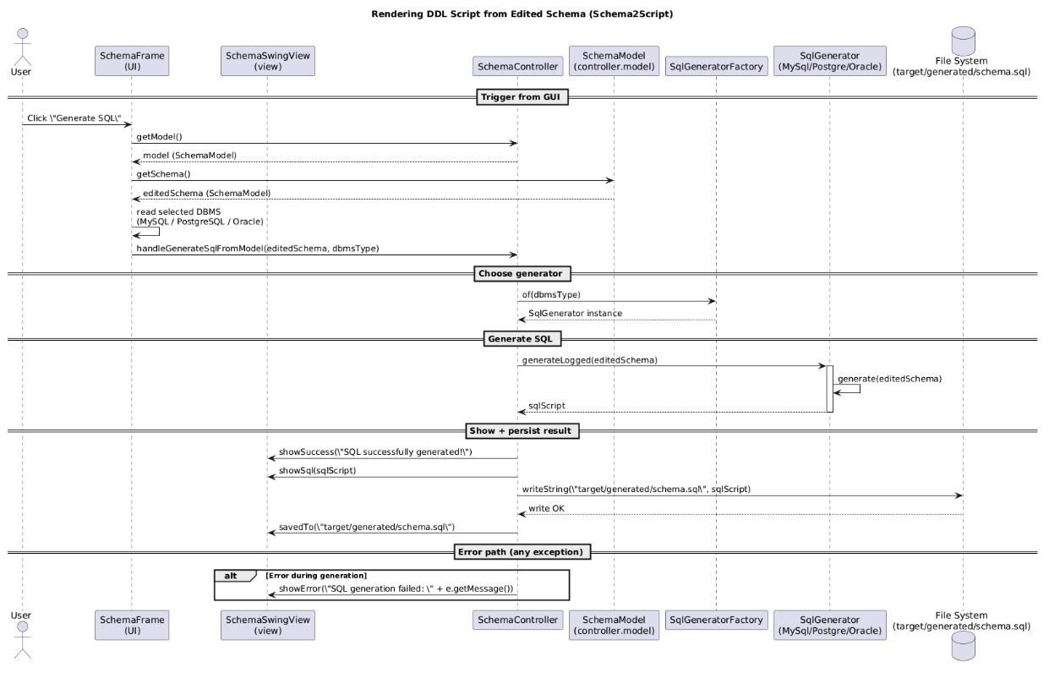

The sequence diagram shows the entire sequence of events that results in the creation of a DDL script based on the visually modified schema of Swing interface. The process starts with the user clicking on the Generate SQL option that causes the schemaframe to make a request to the controller to retrieve the existing SchemaModel. Since the schema has been altered visually in the editor, the model that was retrieved incorporates all the changes applied by users like the addition of tables, the fields, or even altered data types. Once the model is received, the GUI retrieves the desired database system (MySQL, PostgreSQL or Oracle) depending on the selection of the user and sends both the schema and the selected DBMS to the controller through handleGenerateSqlFromModel.

When this request is received, the controller is used to select the generators by invoking the SqlGeneratorFactory which returns the concrete implementation of the SqlGenerator type of a chosen DBMS. This guarantees that the controller is database-agnostic, and adheres to the factory-based extensible architecture deployed throughout the system. After the appropriate generator is instantiated, the controller invokes the generateLogged method that transforms the unified SchemaModel into a complete SQL script. At this point, the generator takes all of the schema elements such as tables, columns, constraints, and relationships and lists them together into legitimate DDL statements.

When the generation is successfully complete, the generated SQL script is returned to the view layer where it is immediately shown in GUI to the user. The output also endures by the controller by storing the script in the project folder within target/generated/schema.sql where a user can access the file directly off disk. In the event of any kind of exception during the selection of a generator, the SQL generation or the writing of a file the controller switches to the other error path, and provides a comprehensive message to the GUI through showError. This guarantees clarity of feedback and stability of the system. In general, the sequence shows the proper separation of the responsibilities among the view, controllers, factories, and generators and the model-driven architecture that drives SQL output generation in the last release of Schema2Script.

