DSA210 Final Report

Analyzing the Relationship Between Player Performance and Market Value
Yiğit Ulusoy
Sabancı University – DSA210 Introduction to Data Science
Spring 2025–20261. Introduction and Motivation
In modern football, player market values are influenced by various factors such as performance statistics, age, popularity, club reputation, league quality, and player potential. Among these variables, attacking performance is often considered one of the most important indicators affecting player valuation.
This project aims to analyze whether football players with stronger attacking performance also tend to have higher market values. The study focuses especially on goals, assists, and total goal contributions (G+A) in order to understand how offensive productivity affects market value.
The project combines exploratory data analysis, statistical analysis, hypothesis testing, and machine learning methods to investigate the relationship between player performance and player market valuation.
2. Data Source and Collection
The dataset used in this project was created by combining football player performance statistics with player market value information.
Player performance statistics for Premier League attacking players during the 2025/2026 season were obtained from publicly available football statistics datasets shared on GitHub.
Player market values were collected from Transfermarkt.
The two datasets were manually combined and organized in Microsoft Excel before preprocessing and analysis.
The final dataset includes variables such as:
- Goals (Gls)
- Assists (Ast)
- Goal Contributions (G+A)
- Minutes Played (Min)
- Match Appearances (MP)
- Starts
- Age
- Market Value
The market value variable originally existed in text format using symbols such as “€m” and “€k”. These values were converted into numerical form during preprocessing in order to perform statistical analysis and machine learning operations.
Missing values and invalid numerical entries were removed before the analysis stage.

3. Data Preparation and Preprocessing
Several preprocessing operations were applied before analysis:
- Market value values were converted into numerical format.
- Relevant columns were converted into numeric variables.
- Missing values were removed using dropna().
- Numerical variables were standardized before machine learning analysis using StandardScaler.
The preprocessing stage ensured that the dataset became suitable for statistical analysis and predictive modeling.

4. Exploratory Data Analysis (EDA)
The exploratory data analysis stage focused on understanding the relationship between attacking performance and player market value.
Pearson correlation analysis, scatter plots, and logarithmic visualizations were used to analyze relationships between variables.

4.1 Performance vs Market Value
The first analysis examined the relationship between attacking contribution (G+A) and market value.
The Pearson correlation coefficient showed a moderate positive relationship between attacking performance and market value.
Players with higher goals and assists generally tended to have higher market values.

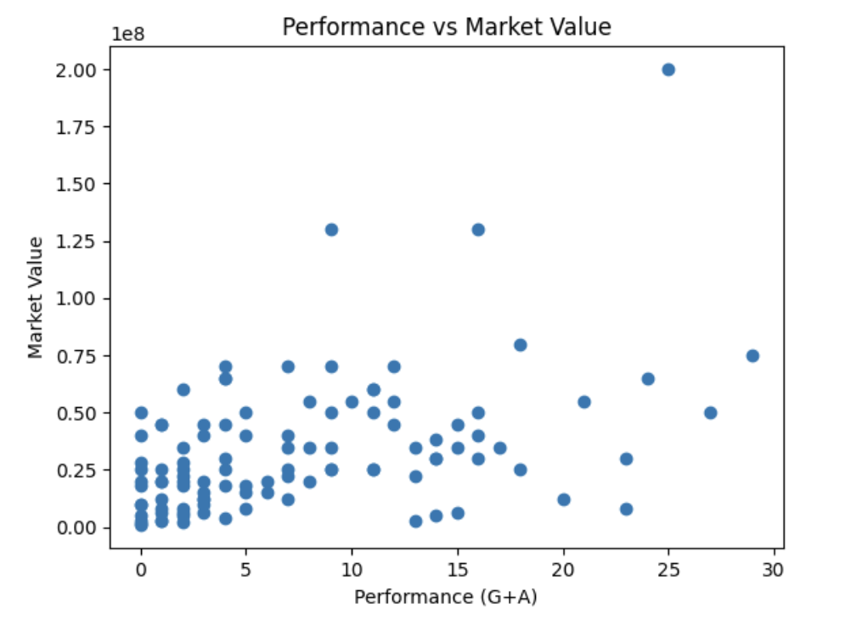

4.2 Log-Log Relationship Analysis
A log-log visualization was created to reduce the effect of extreme values and improve visibility of the relationship between variables.
The logarithmic scaling made the positive trend between attacking performance and market value more visible.
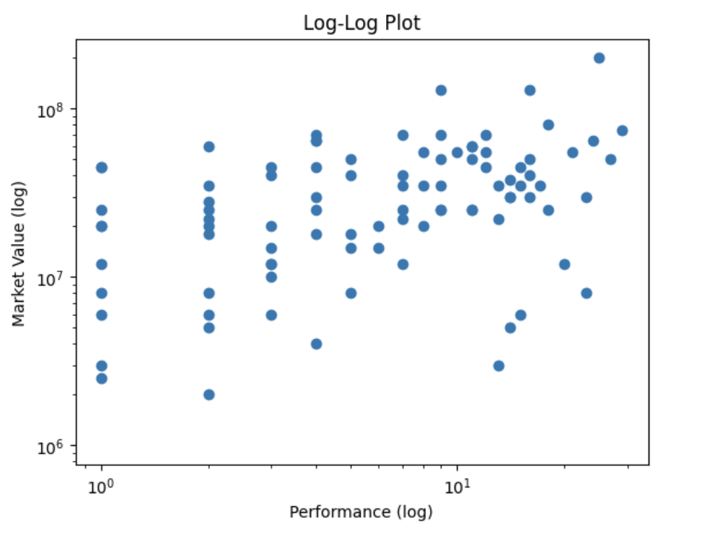

4.3 Age vs Market Value
The relationship between age and market value was analyzed separately.
The analysis showed that age alone is not a strong predictor of market value. Although younger players occasionally had higher market values, the overall relationship appeared relatively weak compared to attacking performance.
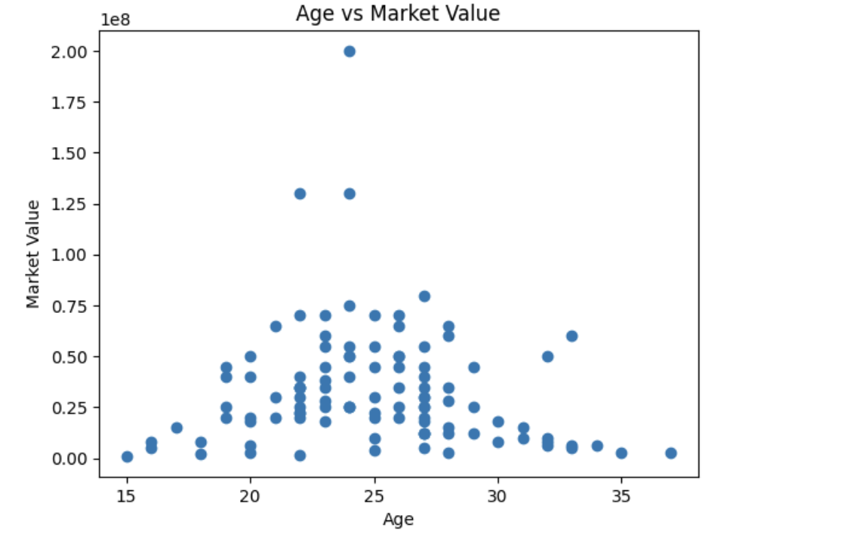

5. Hypothesis Testing
Three main hypotheses were tested using Pearson correlation analysis.

Hypothesis 0
H0: There is no significant relationship between attacking performance (G+A) and player market value.
H1: There is a significant relationship between attacking performance (G+A) and player market value.
The p-value obtained from the analysis was significantly smaller than 0.05.
The correlation coefficient was approximately 0.44, indicating a moderate positive relationship between attacking performance and market value.
Therefore, the null hypothesis was rejected.
This result indicates that attacking performance has a statistically significant relationship with player market value.

Hypothesis 1
H0: Age has no significant relationship with player market value.
H1: Age has a significant relationship with player market value.
The analysis produced a relatively high p-value.
Therefore, the null hypothesis could not be rejected.
This suggests that age alone does not significantly explain player market value within this dataset.

Hypothesis 2
H0: Minutes played have no significant relationship with player market value.
H1: Minutes played have a significant relationship with player market value.
The analysis showed a weak negative relationship between minutes played and market value.
Although the relationship was statistically significant, the correlation remained relatively weak.

6. Machine Learning Analysis
Machine learning methods were used to predict player market values using football performance statistics.
The project primarily used Linear Regression and Random Forest Regressor models.
The selected features included:
- Goals
- Assists
- Goal Contributions (G+A)
- Minutes Played
- Match Appearances
- Age
The dataset was split into training and testing sets before model evaluation.
6.1 Linear Regression
A Linear Regression model was used to predict player market values based on football statistics.
Before training the model, the numerical variables were standardized using StandardScaler.
The model achieved a moderate R² score, which means that performance statistics can explain part of the changes in player market values. However, market value is also affected by many other external factors.
The Mean Absolute Error results showed that prediction errors were still noticeable.

6.2 Random Forest Regressor
A Random Forest Regressor model was also tested in order to compare model performance.
The Random Forest model performed slightly better than the Linear Regression model.
This suggests that the relationship between football statistics and market value may not be completely linear.
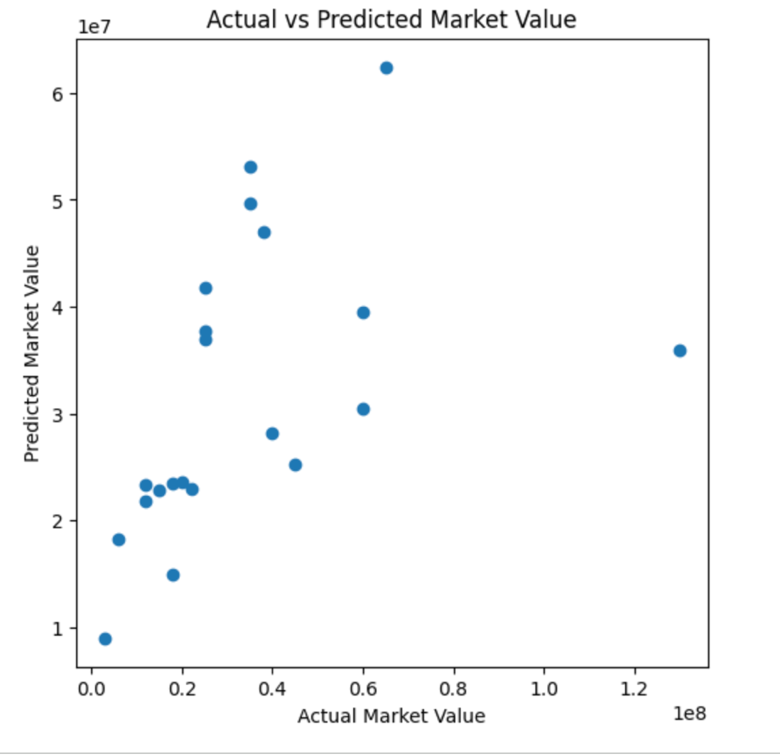

The scatter plot compares actual market values with the values predicted by the machine learning model.
Although prediction errors are still visible, the model captures part of the relationship between player performance and market value.

6.3 Feature Importance Analysis
Feature importance analysis was conducted using the Random Forest model.
The results showed that attacking contribution variables had the strongest effect on market value predictions.
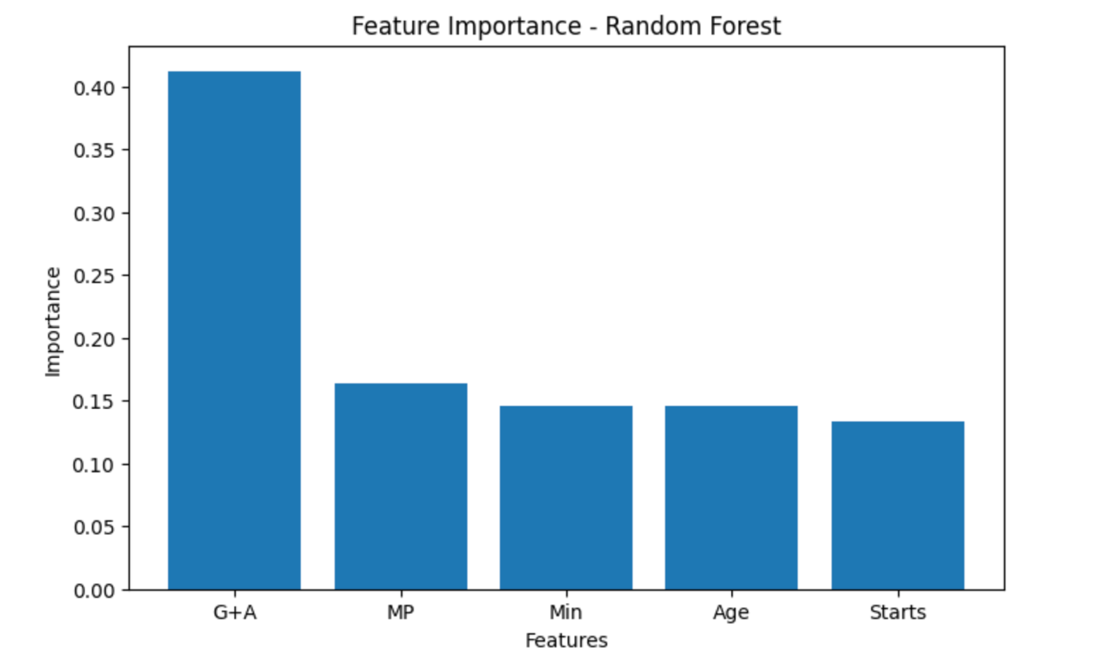

The analysis showed that G+A had the highest contribution among the selected variables.

7. Findings
The project produced several important findings:
- Attacking performance has a moderate positive relationship with player market value.
- Goals and assists are among the strongest predictors of market value.
- Age alone is not a strong determinant of valuation.
- Machine learning models can partially predict player market values using football statistics.
- Random Forest slightly outperformed Linear Regression, suggesting the existence of non-linear relationships.
Overall, the project supports the idea that offensive productivity plays an important role in determining player market value.

8. Limitations and Future Work
This project focused only on players from a single Premier League season.
Several important external variables were not included in the analysis, such as:
- Club reputation
- Popularity
- Injury history
- International performance
- Transfer history
- Contract duration
Future studies may include:
- Multiple seasons
- Additional leagues
- Defensive statistics
- More advanced machine learning models
- Larger datasets
These additions could improve prediction performance and provide a more comprehensive understanding of football player valuation.

9. Conclusion
This project examined the relationship between football player performance and market value using statistical analysis and machine learning methods.
The results showed that attacking statistics such as goals, assists, and G+A are related to higher market values. On the other hand, age alone did not show a strong relationship with market value.
The machine learning models were able to partially predict player market values, although other external factors also affect player valuation.
Overall, the analysis suggests that offensive performance plays an important role in determining the market value of football players.

10. Technologies and Libraries Used
The project was implemented using Python and several data science libraries:
- pandas
- numpy
- matplotlib
- scipy
- scikit-learn
- openpyxl
The analysis was conducted using Google Colab and GitHub.

