The shortage is counted as NDC level
  - TODO: define at drug_identifier level

- Pie chart (percentage): Note that this aggregate over all years, so if an NDC is in shortage for 5 years, it get counted 5 times here. If you compare the graph by ApplType (p1) with the bar chart below, you will find that NDA has a higher percentage overall but has lower count each year. This implies that NDA are in shortage longer ANDA. This will be address in the graphs in section 3.
  - TODO: make changes so that the unit of observations is not NDC but drug_identifier
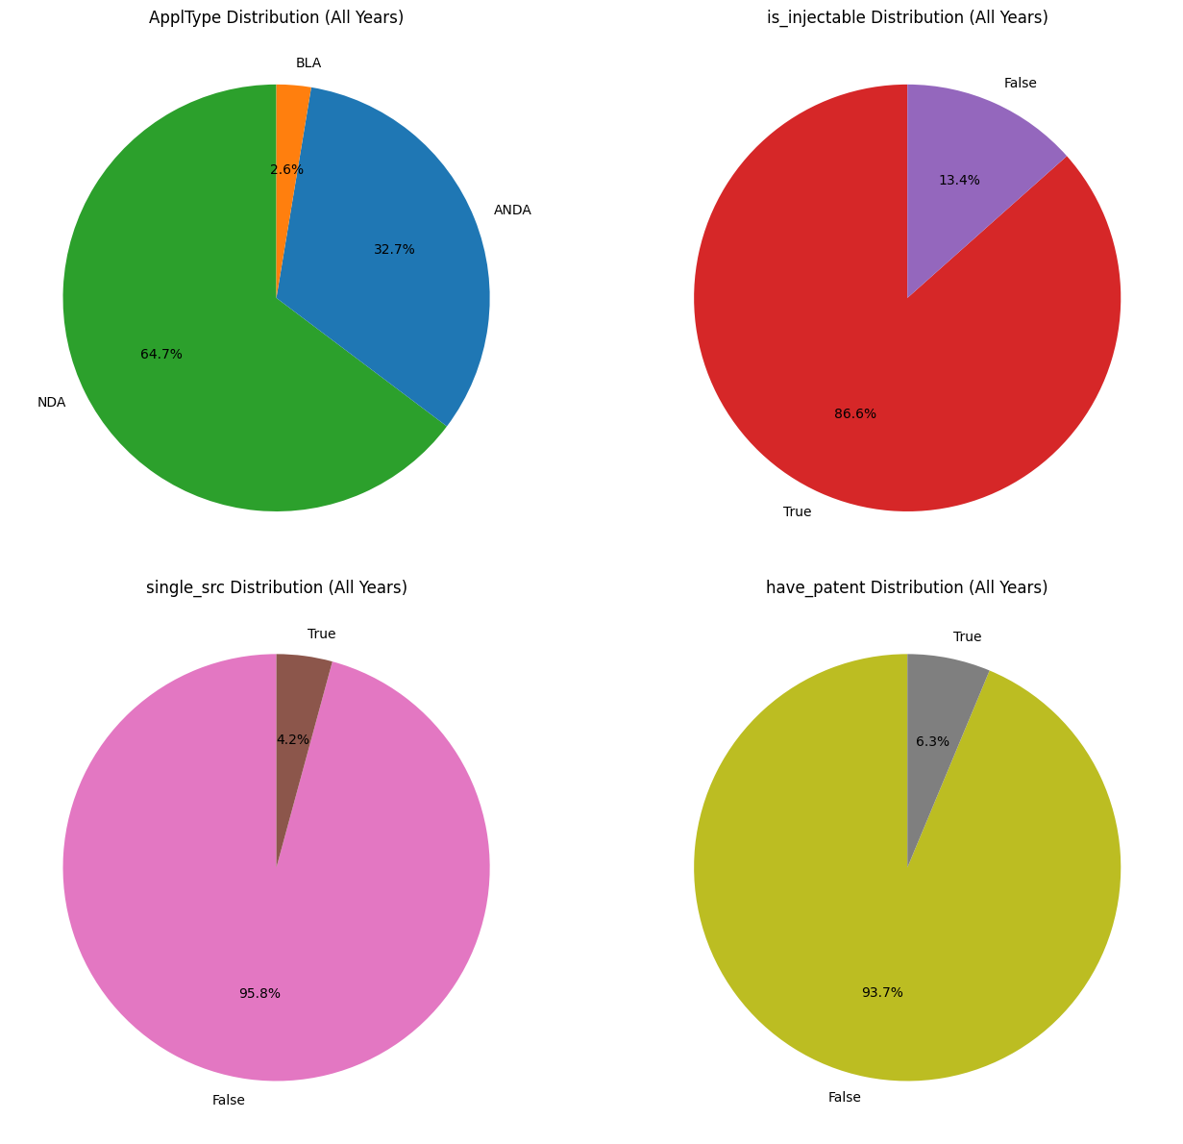
- Bar chart (count) 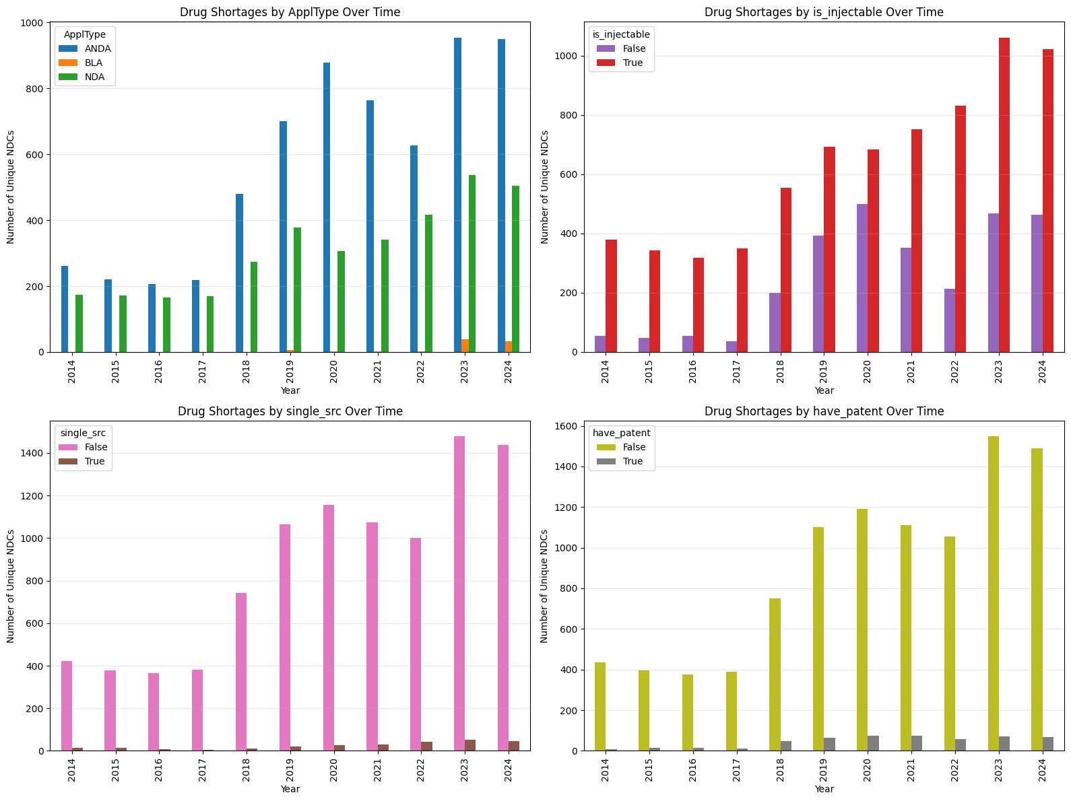

- Median age of shortage – You can see NDA has longer shortage (p4)
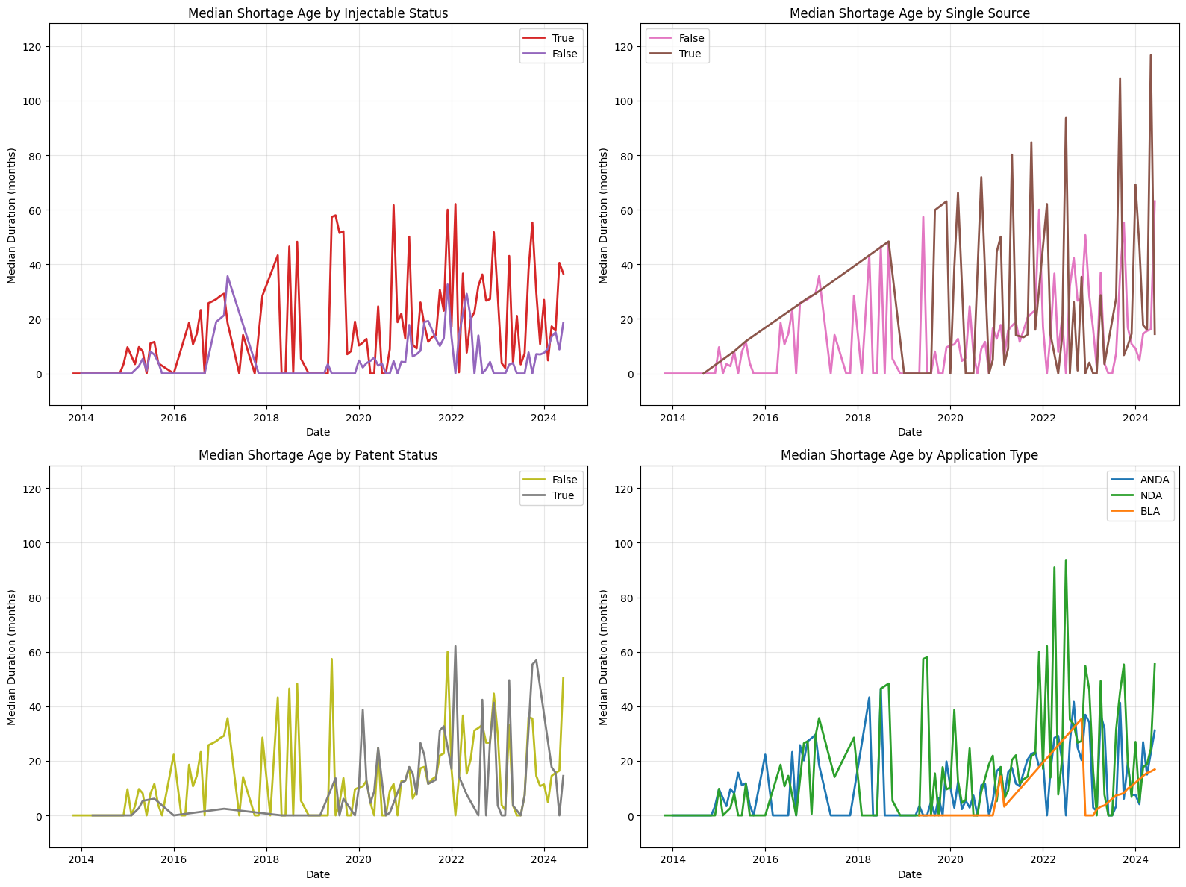

- Chronic shortage (> 24 months)
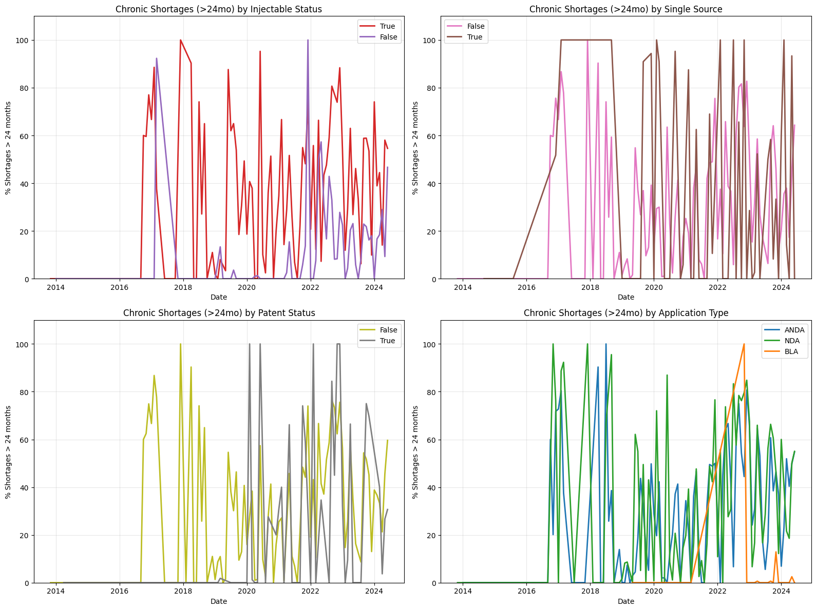

- New shortage each month
