1. Create a Fraction class that has 2 private fields as shown:

class Fraction

{

private int num;

private int den;

}

* 1. Write all the necessary constructors to create the Fraction object.
  2. Complete the definitions of the following methods for the Fraction class:

1. The instance toString() method to return a String representing the implicit Fraction object. If both num and den are negative numbers, return a String representing a positive fraction object.
2. The accessor methods that return the values of the instance variables.
3. The instance method size() that return, a double, the magnitude to a Fraction object.
4. The instance method larger() that uses the size method to compare two Fraction objects. It returns a reference to a Fraction object, the larger of the two (or the first if they have the same size).
5. The **class** method product() should have two Fraction parameters. It should return a value of type Fraction, the product of the parameters passed to it.
6. The **class** method sum() that add two Fraction objects and places the sum in a return fraction.
7. The instance method reduce() to reduce the fraction to its lowest term.
8. Write a main program to test the Fraction class and
9. Create a method getFraction(). It prompts the user for the fields of two fractions and returns new Fraction objects.
10. Create an equals() method that return true if and only if the fields of the implicit Fraction object are identical to those of other.

Example output:

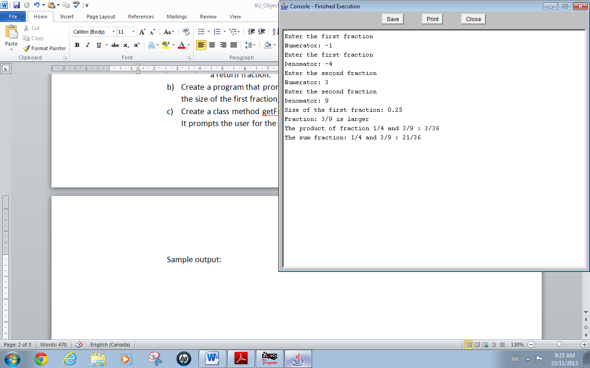

Save your program as Project2_yourName.java

(Solution: FractionObject)