1. Question 1

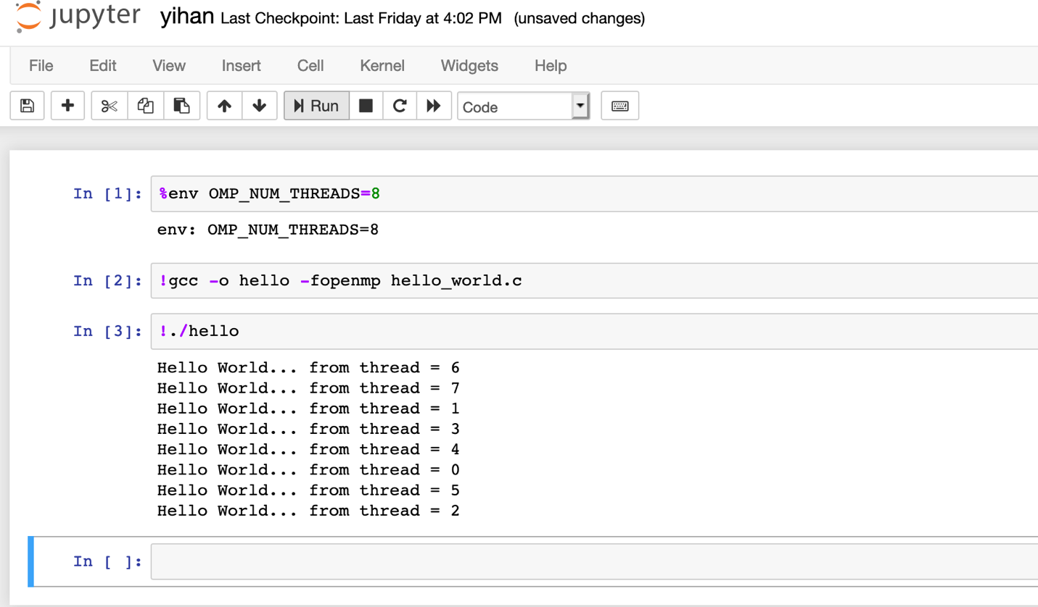

1. Question 2

|  |  |  |
| --- | --- | --- |
| Code | Number of threads | Execution Time taken (s) |
| ./pi 10000 | 1 | 0.000147 |
| ./pi 10000 | 2 | 0.000187 |
| ./pi 10000 | 4 | 0.000232 |
| ./pi 10000 | 8 | 0.000500 |
| ./pi 50000 | 1 | 0.000659 |
| ./pi 50000 | 2 | 0.000442 |
| ./pi 50000 | 4 | 0.000492 |
| ./pi 50000 | 8 | 0.000739 |

**./pi 10000 1, 2, 4, 8 threads results**

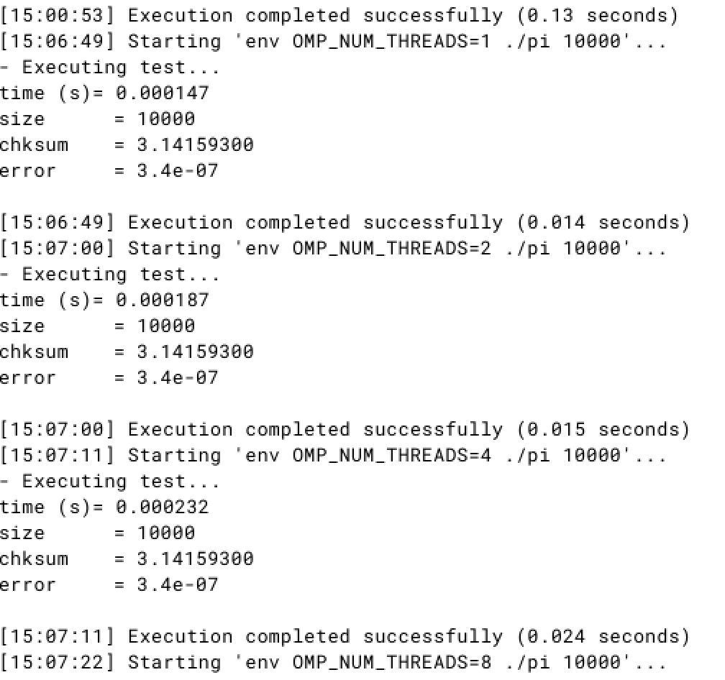

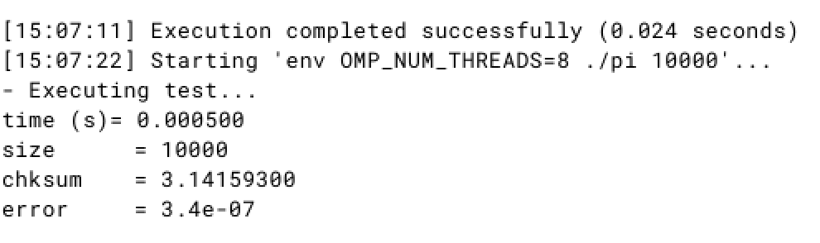

**./pi 50000 1, 2, 4, 8 threads results**

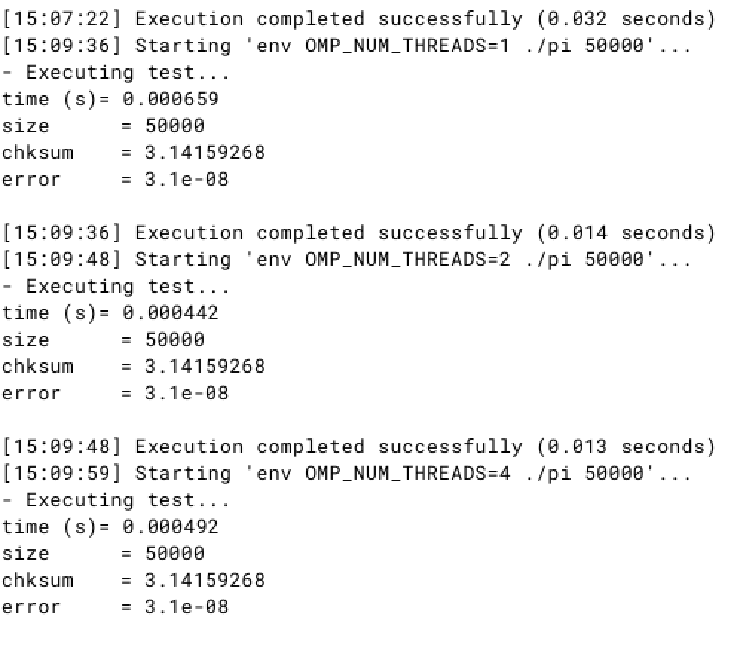

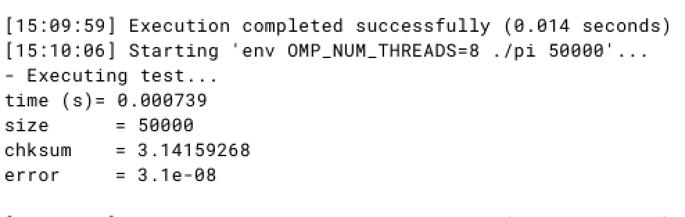

1. Question 3

|  |  |  |
| --- | --- | --- |
| Code | Number of threads | Execution Time taken (s) |
| ./dotproduct 500000 | 1 | 0.001953 |
| ./dotproduct 500000 | 2 | 0.001088 |
| ./dotproduct 500000 | 4 | 0.001127 |
| ./dotproduct 500000 | 8 | 0.001556 |
| ./dotproduct 15000 | 1 | 0.000043 |
| ./dotproduct 15000 | 2 | 0.000190 |
| ./dotproduct 15000 | 4 | 0.000236 |
| ./dotproduct 15000 | 8 | 0.000713 |

**./dotproduct 500000 1, 2, 4, 8 threads result.**

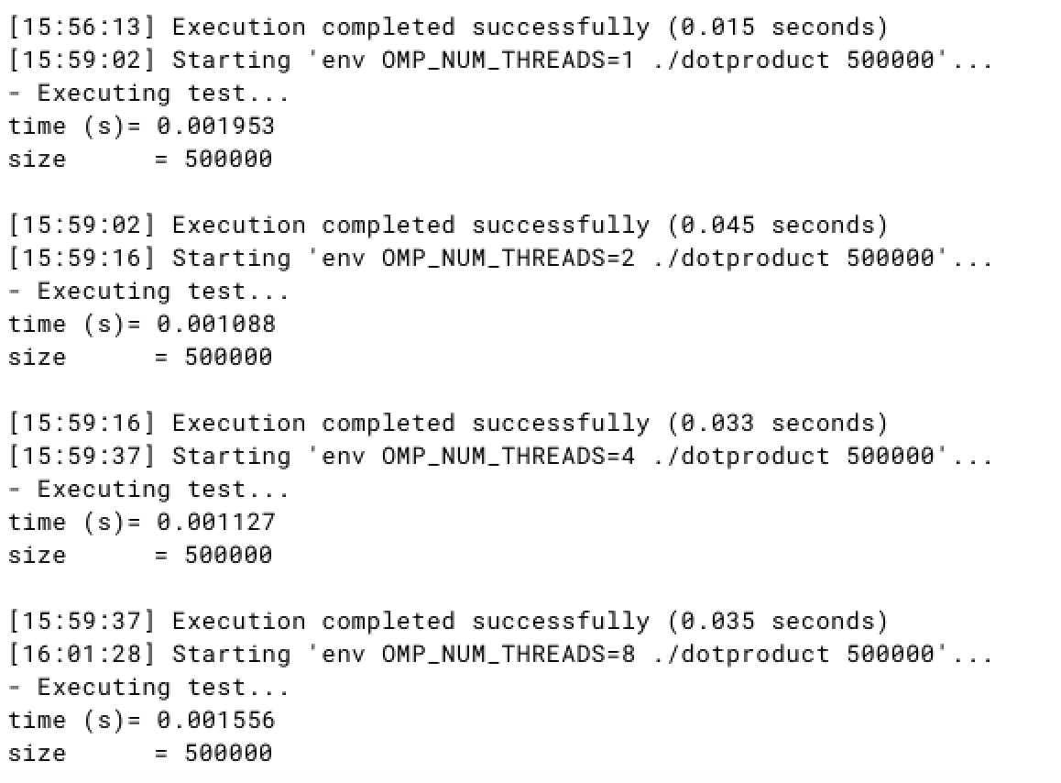

**./dotproduct 15000 1, 2, 4, 8 threads result.**

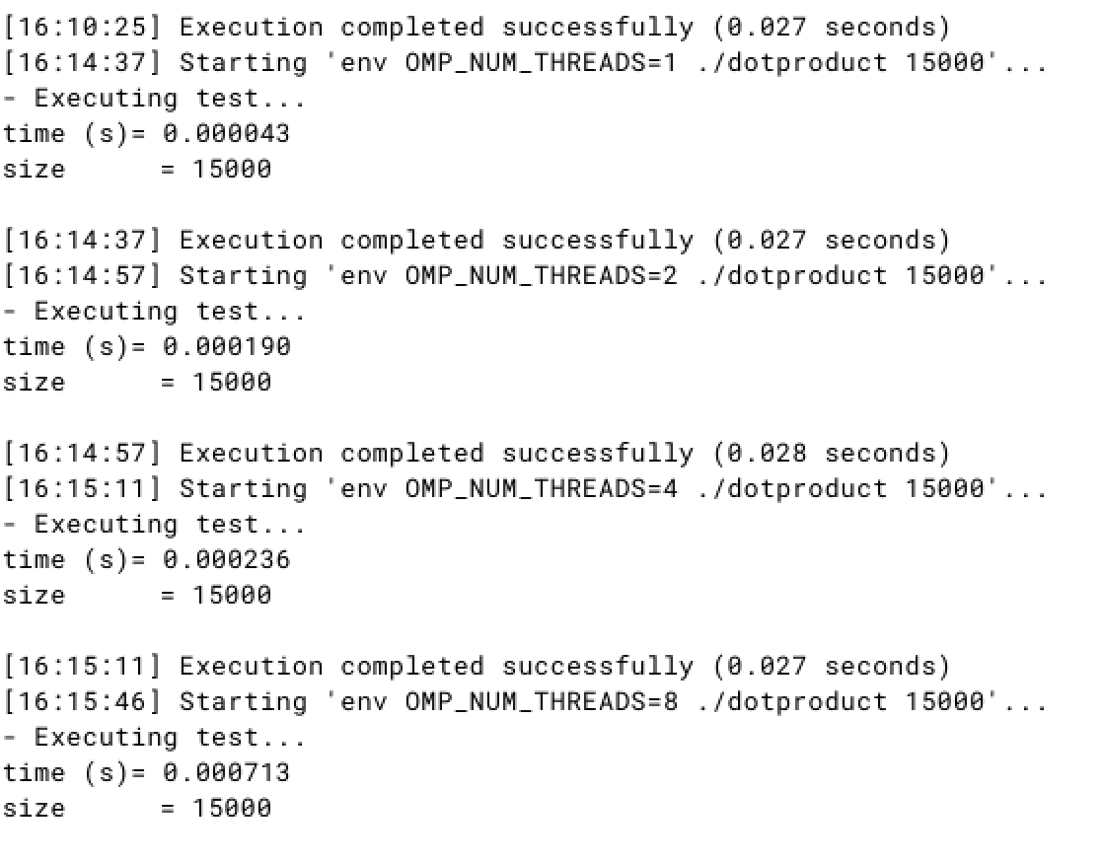

1. feedback
   1. Pros:
      1. It can auto detect which part of sequential code can be parallelized.
      2. It is very easy to change the sequential code to parallelized code.
      3. Most user interface is clear and easy to use.
   2. Cons:
      1. It is a little bit confusing about versions of code, such as which version of code will be stored.
      2. I sometimes lost original version of code accidently after I parallelized.
      3. Can we have an easier way to change OMP thread number, not just through the run time command?