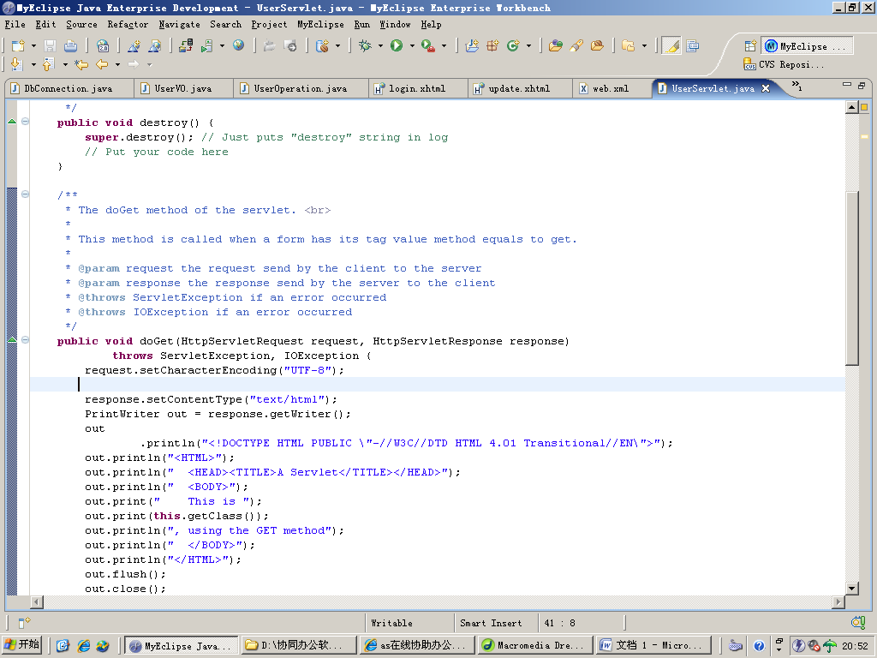

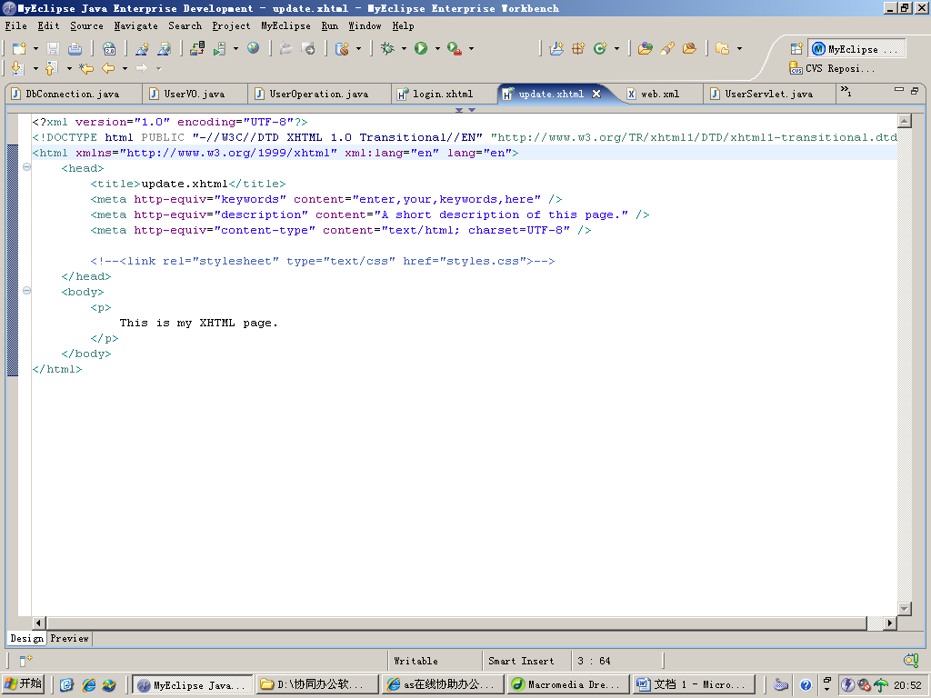

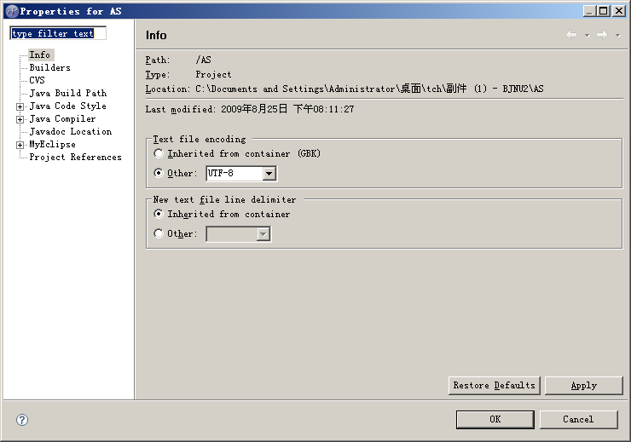

**数据库写入 set**

**读出的get**

**setUpdateUser**

**setAddUser**

**getLoginCheck**

**add**

**del**

**update**

**get**

**getUserList**

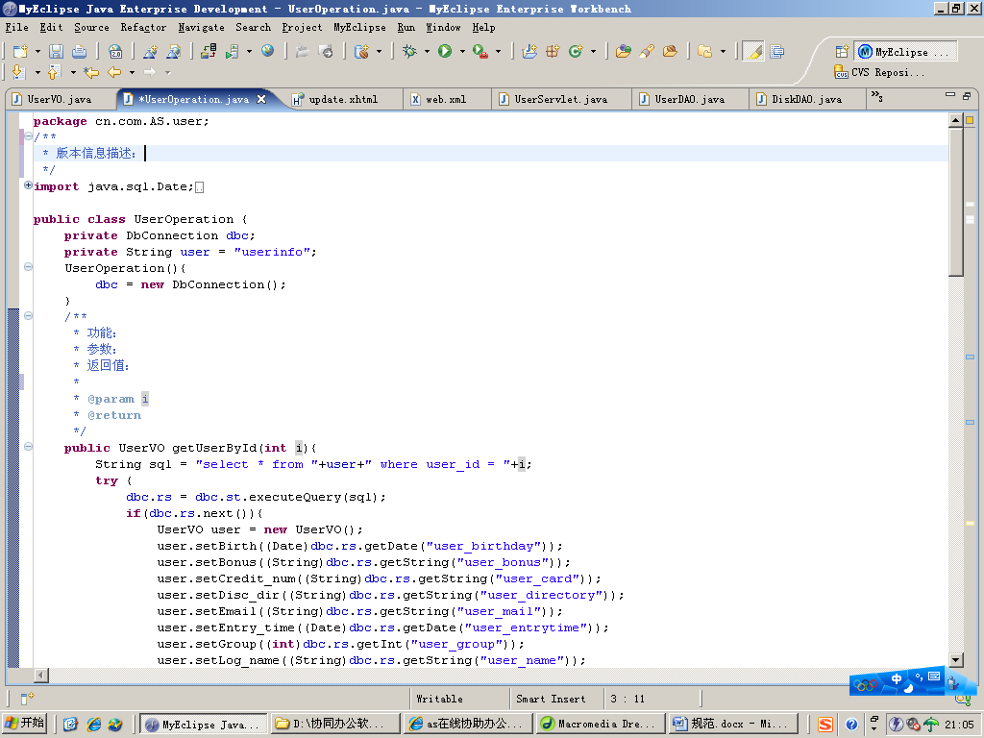

**Servlet 路径**

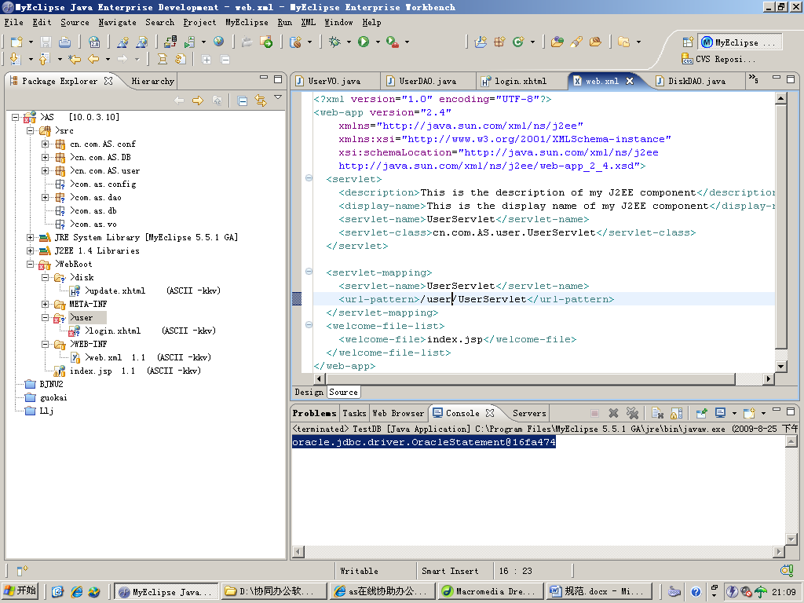

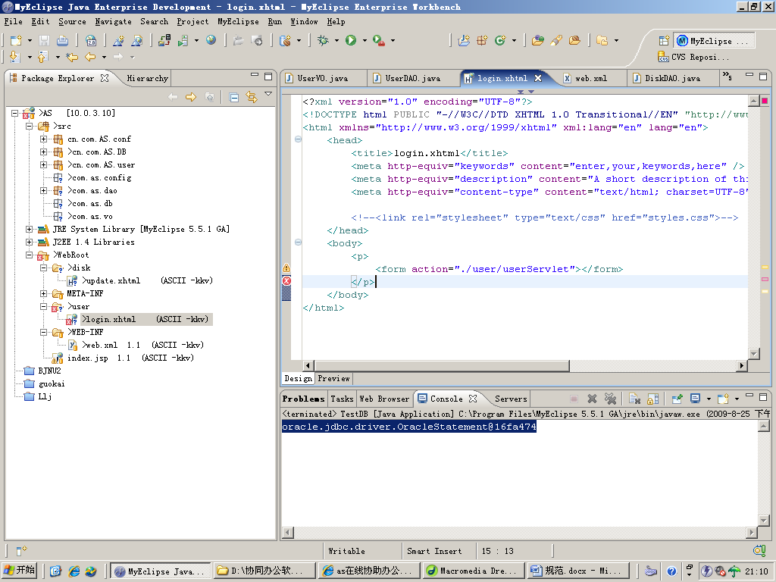

**Session{**

**User_name**

**User_id**

**Role_id**

**}**

**触发器**

**插入的时候**

**Insert into dept values(null,’人事部’,’北京师范大学’);**

**Seq.nextval已经被触发器实现**

**CLOB**

**X:Rs.getString(“dept_intro”);**

**Clob clob = rs.getClob(“dept_intro”);**

**Char[] char = clob.xxxCharactStream(char);**

**String res = new String(char);**

**<%= res %>**

**Clob -> String**

**Encapsulate: com.as.function: md5, Convert_to_string**