This is a Web Application that only Javascript。The topic is “TodoList”。
Skill：
forepart：Bootstrap、JQuery
back：Node.js、Koa
template engine：nunjucks

npm install
node app.js

screenshot：
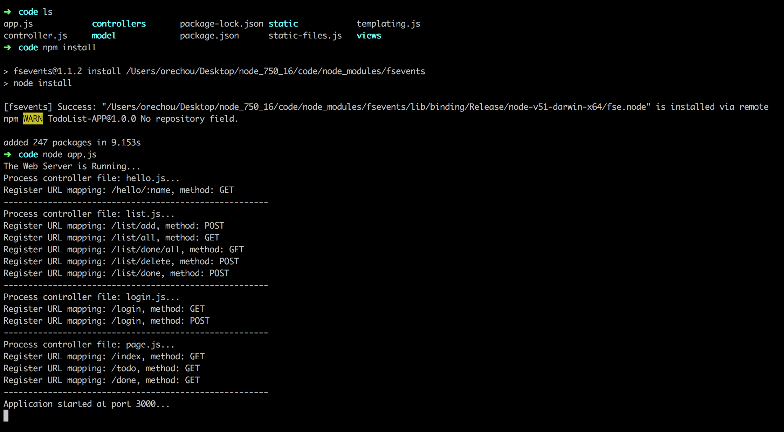

the use of APP screenshot：
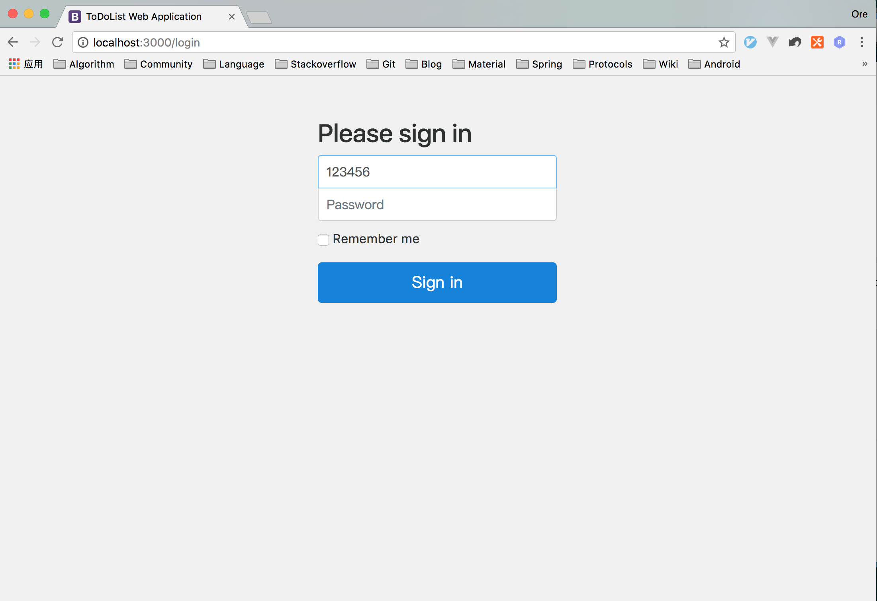
webpage：http://localhost:3000/login username：123@qq.com, password：123456
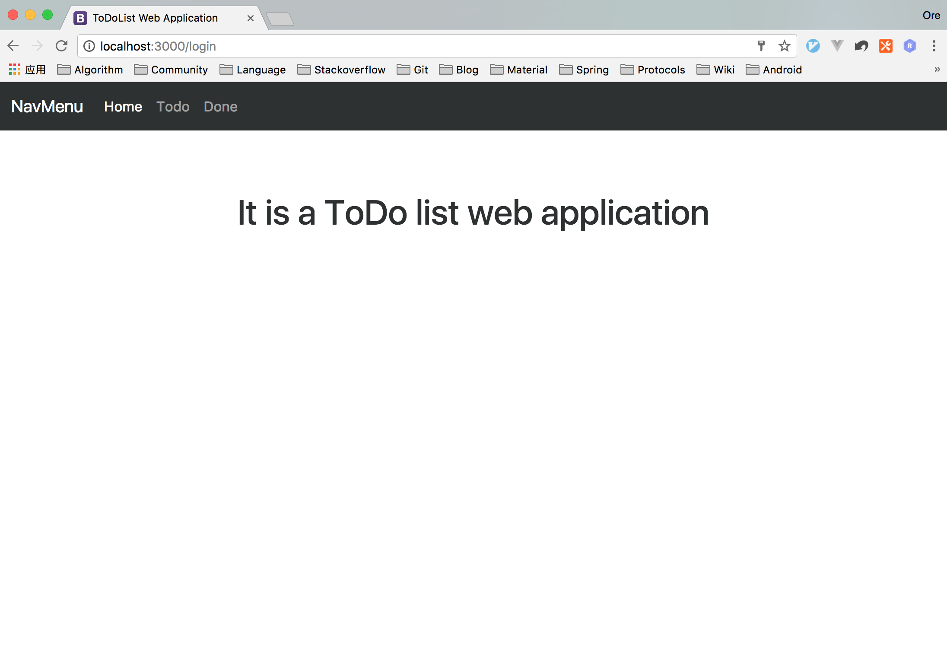
home page
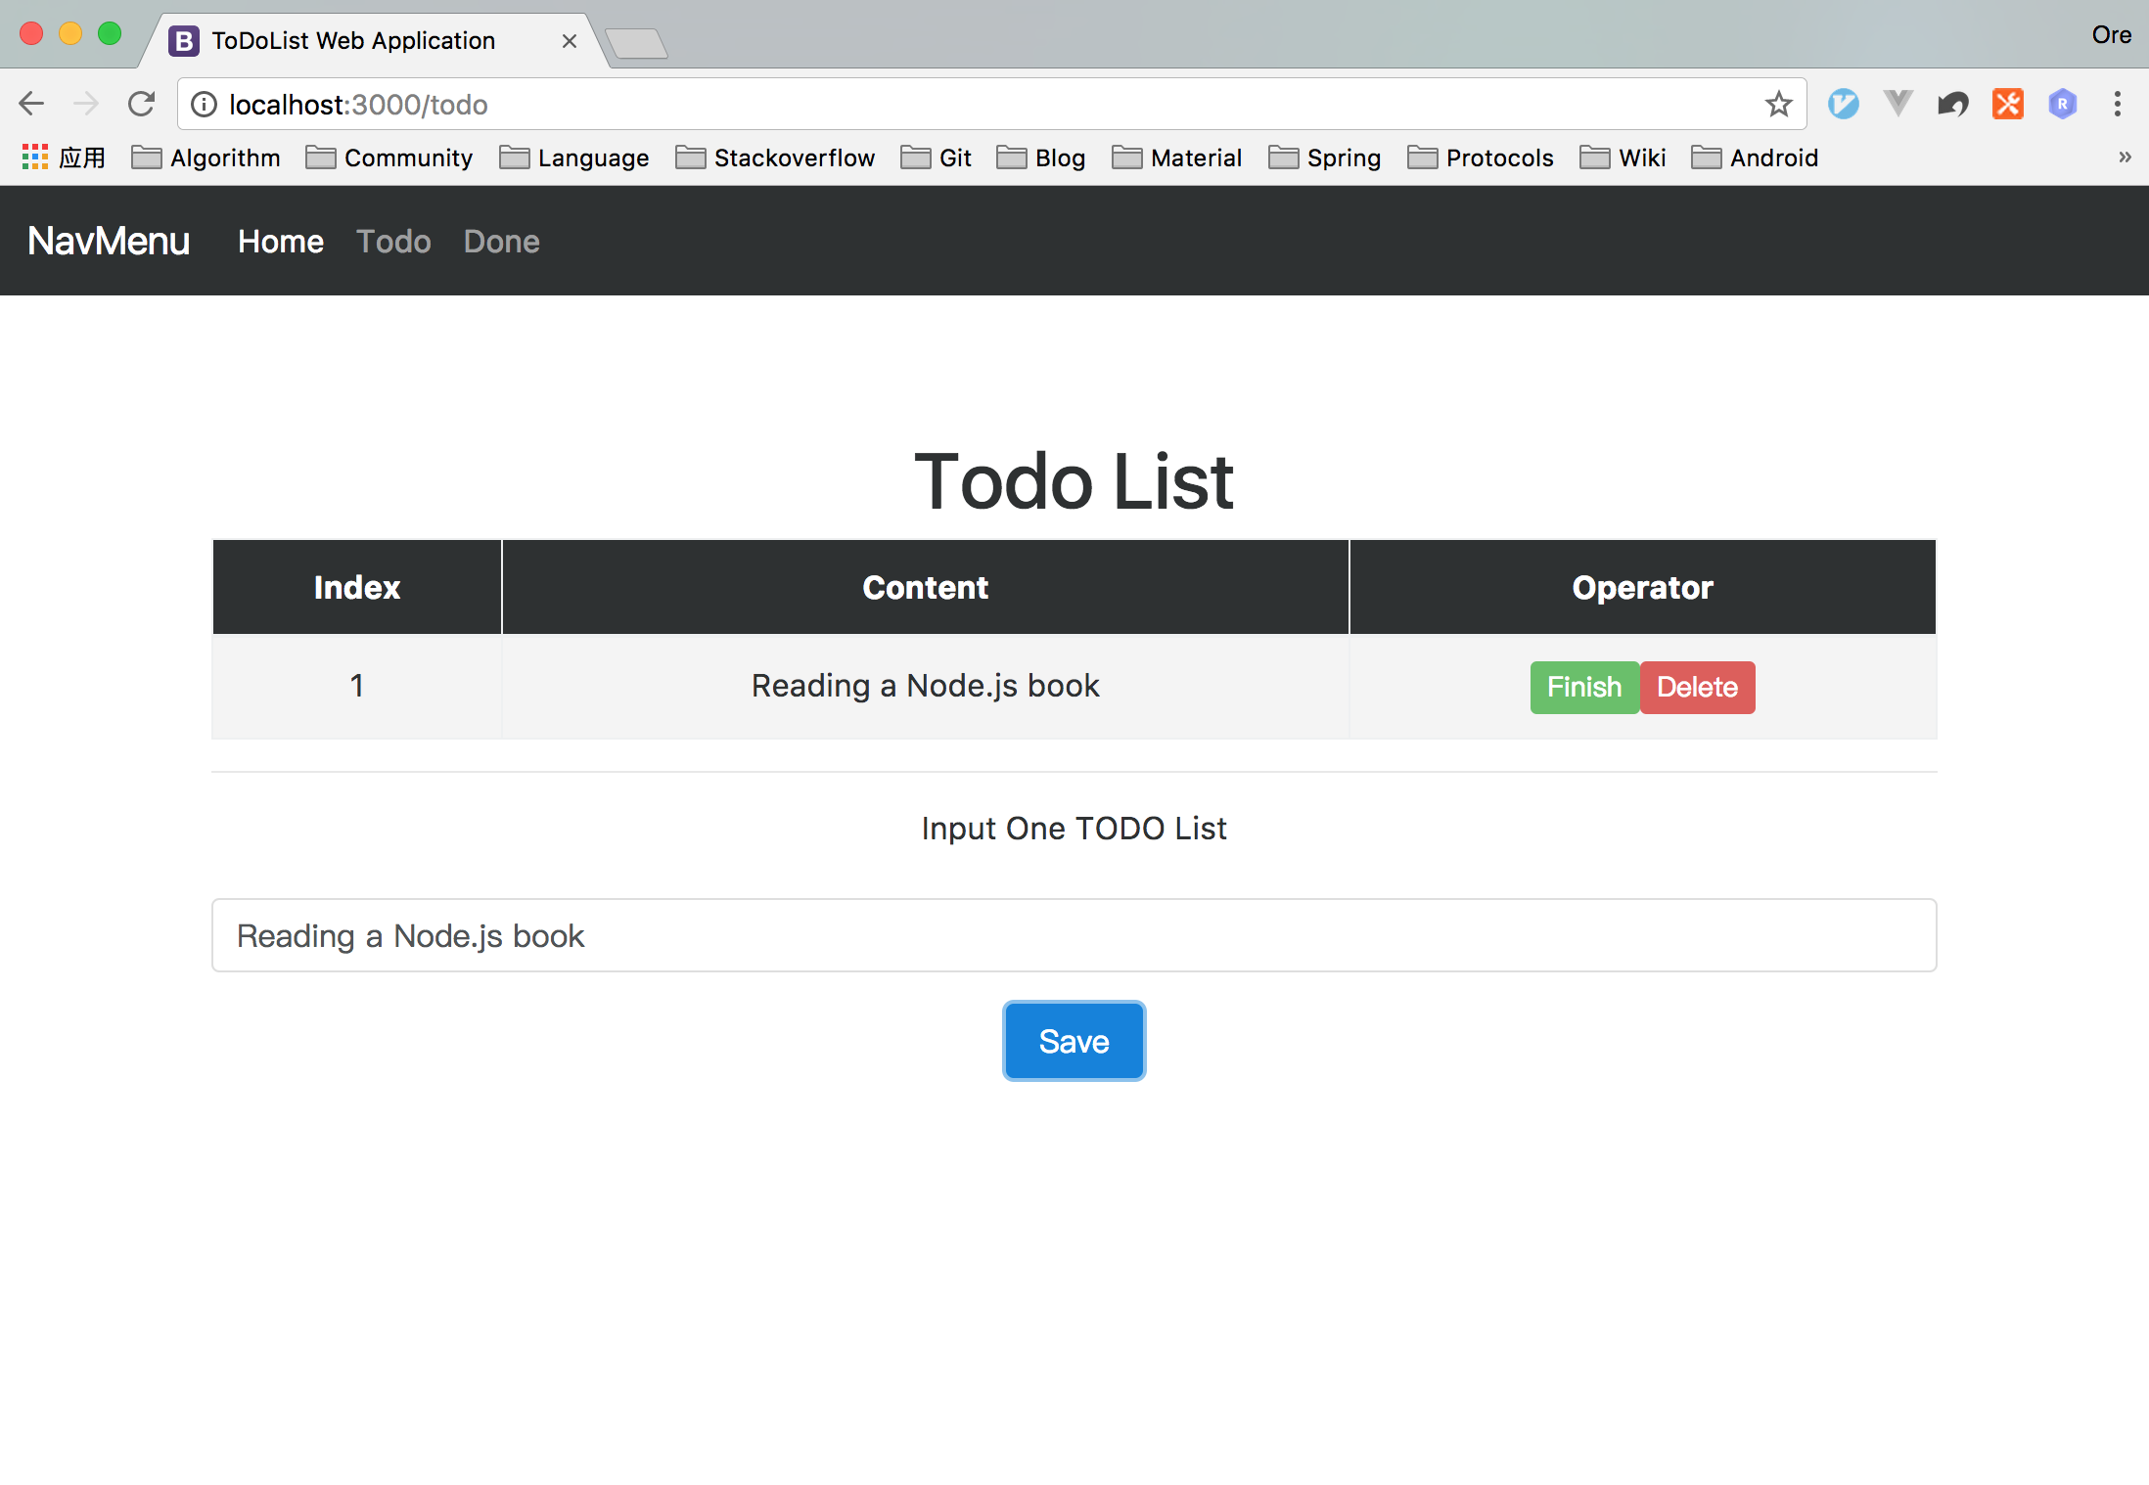
input a “todolist”，click “Finish”to show “TODOlist”is done。”Delete”means to delete the “todolist”.
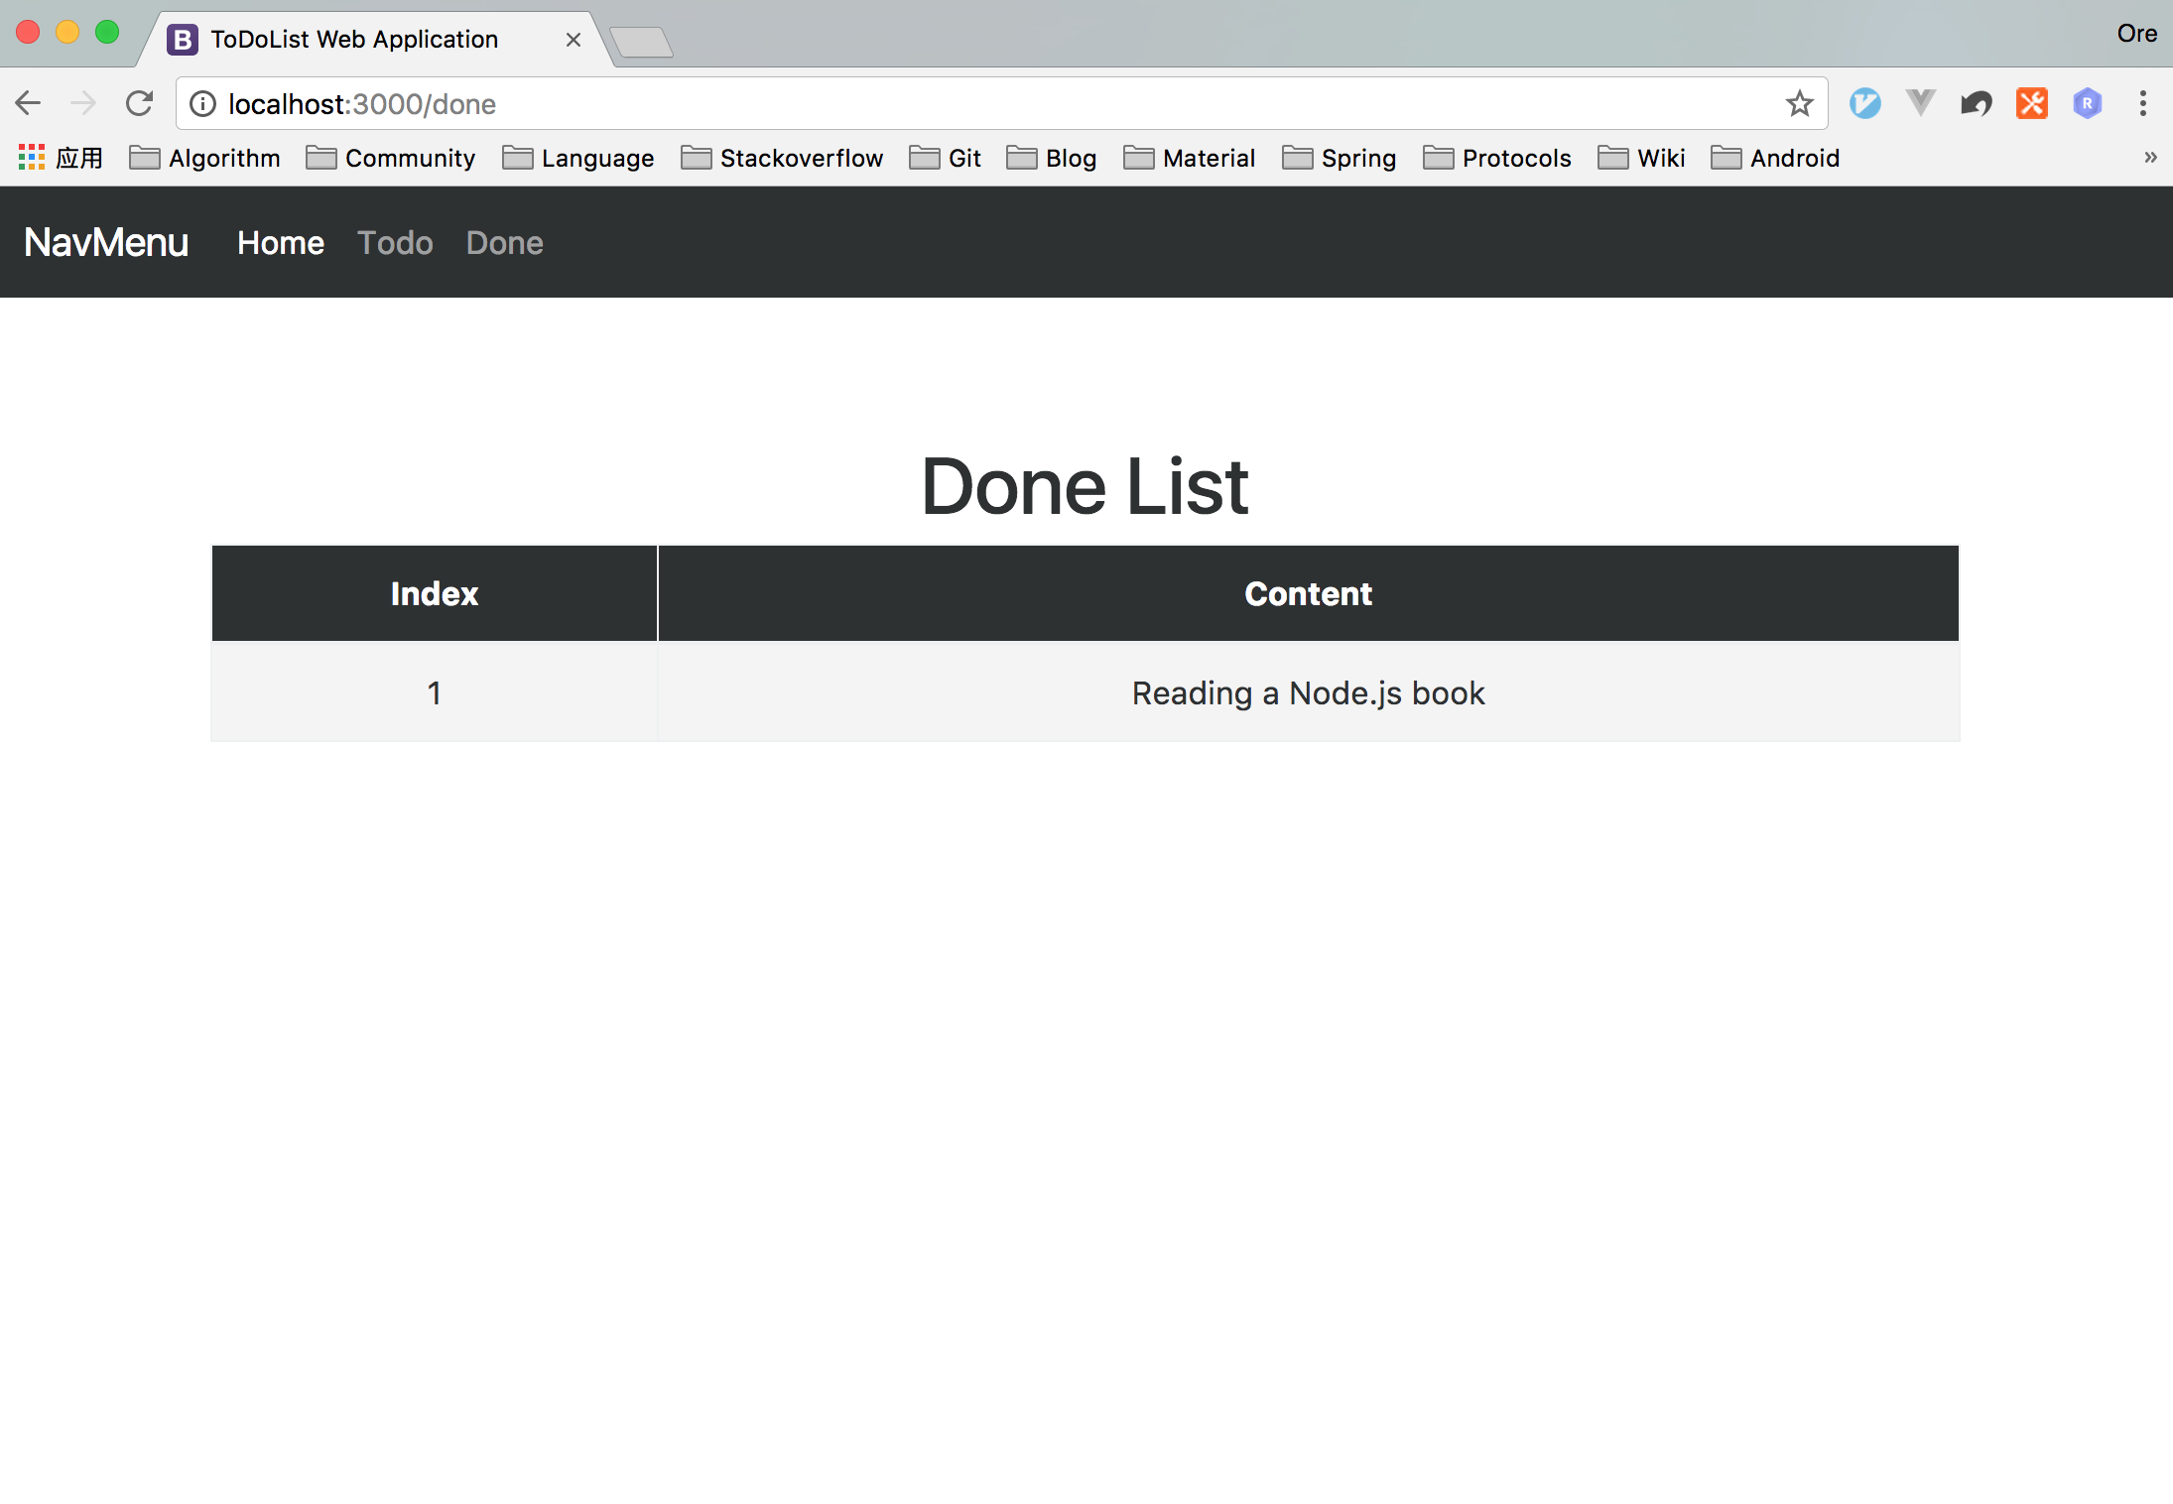
the finished “todolist” will show on the “done list”.

（Tips: All data will be saved, restart the sever would delete the data）

