**2-18.**colds=200,colds and exercise=45,colds and no exercise=155,employees=1000,exercixe=500

(a)P(colds)=2000/1000=0.2 (b)P(colds|exercise)=P(colds∩exercise)/P(exercise)=[(200/1000)*(45/200)]/[500/1000]

(c)P(colds|noExercise)=P(colds∩noExercise)/P(noExercise)=[(200/1000)*(155/200)]/[(500/1000)]

(d)P(colds|exercise)=0.9<>P(colds)=0.2, Exercising and getting a cold is dependent

**2-21.**P(Abu∩B)=(1/2)*(20/40)=0.25, P(Abu∩F)=(1/2)*(20/40)=0.25, P(EI∩B)=(1/2)*(32/40)=0.4, P(EI∩F)=(1/2)*(8/40)=0.1

P(Abu|B)=P(Abu∩B)/P(B)=0.25/(0.25+0.4)=0.3846, P(EI|B)=P(EI∩B)/P(B)=0.4/(0.25+0.4)=0.61538

**2-22.**P(2B∩Abu)=(1/2)*(20/40)*(20/40)=0.125,P(2B∩EI)=(1/2)*(32/40)*(32/40)=0.32,P(EI|2B)=(0.32)/(0.125+0.32)=0.719

**2-26.**(a) (P(D∪S)=(0.9+0.95)-(0.9*0.95)=0.995,(b)P(D∩S)=0.9*0.95=0.855,(c)Yes,assumed events are independent,

P(D∩S)=P(D)*P(S) **2-40** μ=457000,90%接近2倍σ，所以以95%查Z值，查詢Z(1.64)=0.9495,Z(1.65)=0.9505，取bar(1.64+1.65)/2=1.645,因為Z=(X-μ)/σ，所以σ=(X-μ)/Z=(46000-457000) /1.645 = 1823.87

**2-44.**Possion distribution,λ=5 per day,P(x)=[( λ^x)*(e^-λ)]/(x!) =[( 5^x)*(e^-5)]/(x!) =[( 5^x)*(0.0067)]/(x!)

P(0)=0.00067*(5^0/0!) = 0.0067, P(1)=0.00067*(5^1/1!) = 0.0335, P(2)=0.00067*(5^2/2!) = 0.08375, P(3)=0.00067*(5^3/3!) =0.13958,

所以P(x>3)=1-[P(0)+P(1)+P(2)+P(3)]=0.73647 **2-48.**Win-right 80% : P(W∩right)=(1/2)*(80/100)=0.4(Win), Win-wrong 20% : P(W∩wrong)=(1/2)*(20/100)=0.1(Lose)。Lose-right 90% : P(L∩right)=(1/2)*(90/100)=0.45(Lose), Lose-wrong 10% : P(L∩wrong)

=(1/2)*(10/100)=0.05(Win)。結論P(win|Predictd Win)=0.4/(0.4+0.05) = 0.89, P(Lose|Predictd Win)=0.45/(0.1+0.45) = 0.82。

**2-55.** 1 call 4 min =>1/4 call per min,Exponential distribution, μ=1/4 permin,P(X<=t)=1-e(^-μt)=1-(e^-t/4),(a)P(X<=3)=1-e^(-3/4)=0.528,

,(b)P(X<=4)=1-e^(-4/4)=0.632, (a)P(X<=5)=1-e^(-5/4)=0.713,P(X>5)=1-P(X<=5)=1-0.713=0.287

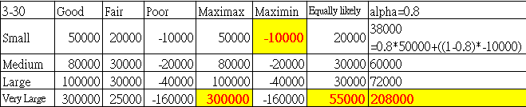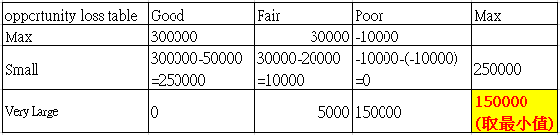

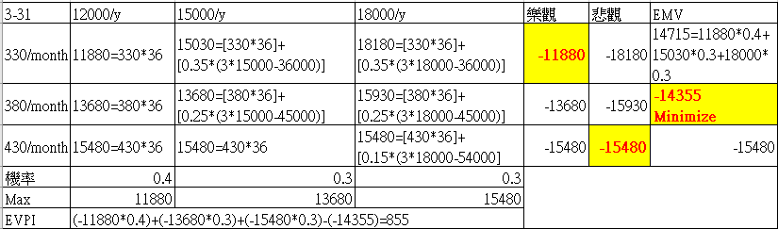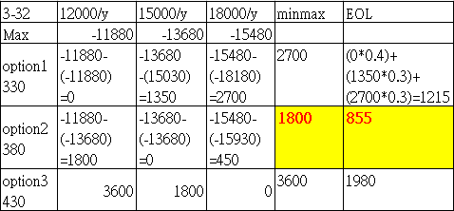

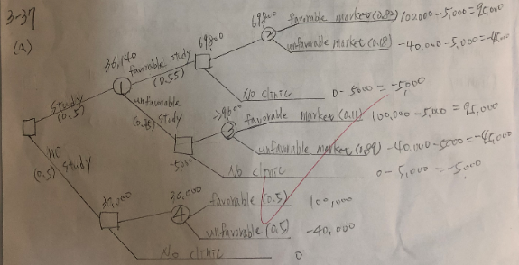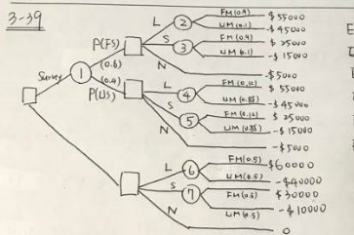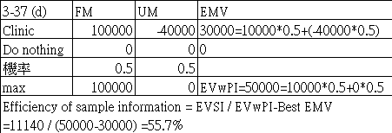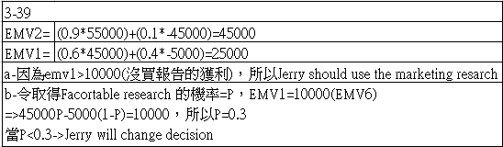

3-37-b-EMV1=(0.55*69800)+(0.45*-5000)=36140。c-ESVI=[(EVA1)36140]+5000-30000=11140。

 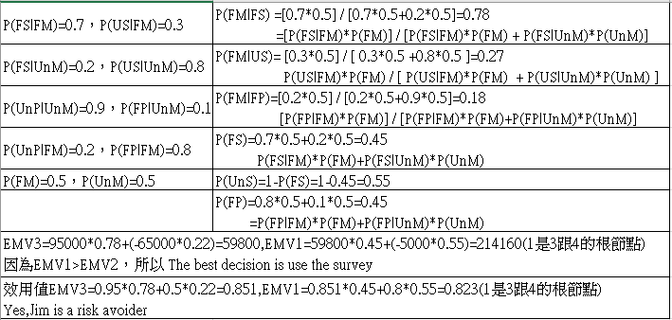

**5-35**-(B)Seasonal index Q1=Sum(Seasonal ratio Q1)/3,0.882+0.885+0.88/3=0.882,Q2=Sum(Seasonal ratioQ2)/3,0.987+0.985+0.973/3=0.982

Q3=Sum(Seasonal ratioQ3)/3,0.969+0.983+0.962/3=0.971,Q4=Sum(Seasonal ratioQ4)/3,1.156+1.142+1.173/3=1.157

(C)令X=number of periods,Y=Deseasonalized data，Y=b0+b1X,X bar=8.5，Y bar=268.993，Σ(X-Xbar * Y-Ybar )=1245.762，

Σ(X-Xbar)^2=340,b1=Σ[(X-Xbar)*(Y-Ybar)] / Σ(X-Xbar)^2=1245.762/340=3.664

b0=Ybar - b1*Xbar=268.993-3.664*8.5=237.779，Y=237.779+3.664X

(D)(Y5,Q1)=237.779+3.664*17=300.067*0.882=264.66,(Y5,Q2)=237.779+3.664*18=303.73*0.982=298.26

(Y5,Q3)=237.779+3.664*19=307.395*0.971=298.48,(Y5,Q4)=237.779+3.664*20=311.059*1.157=359.9

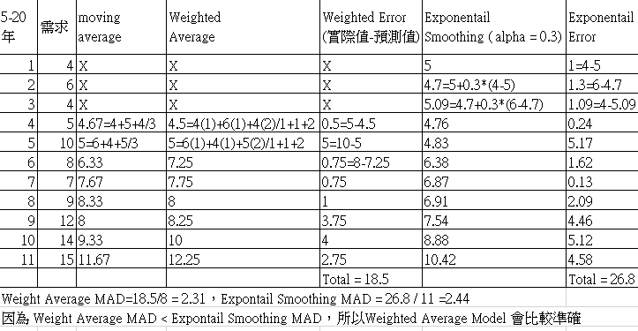 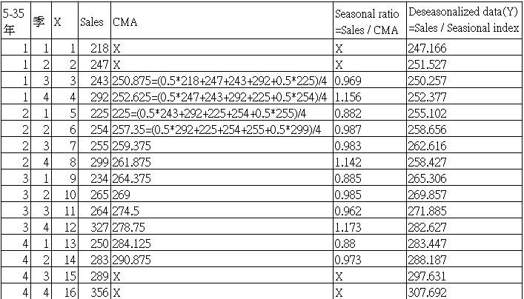

**5-37.** (a) Y=bo+b1X,令X=period,Y=Sales，經計算X bar=8.5,Y bar=194.75,Σ[(X-X bar)^2]=340,Σ(X-X bar)*(Y- Y bar)=-114,代入b1公式，b1=-114/340=-0.335,b0=194.75-(-0.335)*8.5=197.598,Y=197.598-0.335X。

Y5Q1=197.598-0.335*17=191.903,Y5Q2=197.598-0.335*18=191.568,Y5Q3=197.598-0.335*19=191.233,Y5Q4=197.598-0.335*20=190.898

結論：由斜率趨勢線得知，銷售趨勢漸漸(b)Y1=b0+b1X，令X=period,Y1=Deseasonalized data，經計算 X bar=8.5，Y1 bar=195.458，b1=747.301/340=2.198,b0=195.458-2.198*8.5=176.775,Y1=176.775+2.198X，由斜率趨勢線得知，銷售趨勢逐漸上升。

(c) a 與 b的趨勢線最大差異於a結果是受季節性影響，b是去除季節性因素的結果。

