10-14

Trapeze Investments is a venture capital firm that is currently evaluating six different investment opportunities. There is not sufficient capital to invest in all of these, but more than one will be selected.

A 0–1 integer programming model is planned to help determine which of the six opportunities to choose. Variables X1, X2, X3, X4, X5, and X6 represent the six choices. For each of the following situations, write a constraint (or several constraints) that would be used.

(a) At least three of these choices are to be selected.

(b) Either investment 1 or investment 4 must be undertaken but not both.

(c) If investment 4 is selected, then investment 6 must also be selected. However, if investment 4 is not selected, it is still possible to select investment 6.

(d) Investment 5 cannot be selected unless investments 2 and 3 are both also selected.

(e) Investment 5 must be selected if investments 2 and 3 are both also selected

https://slideplayer.com/slide/5272547/

https://www.coursehero.com/file/24311194/Chapter-10-solutionsdocx/

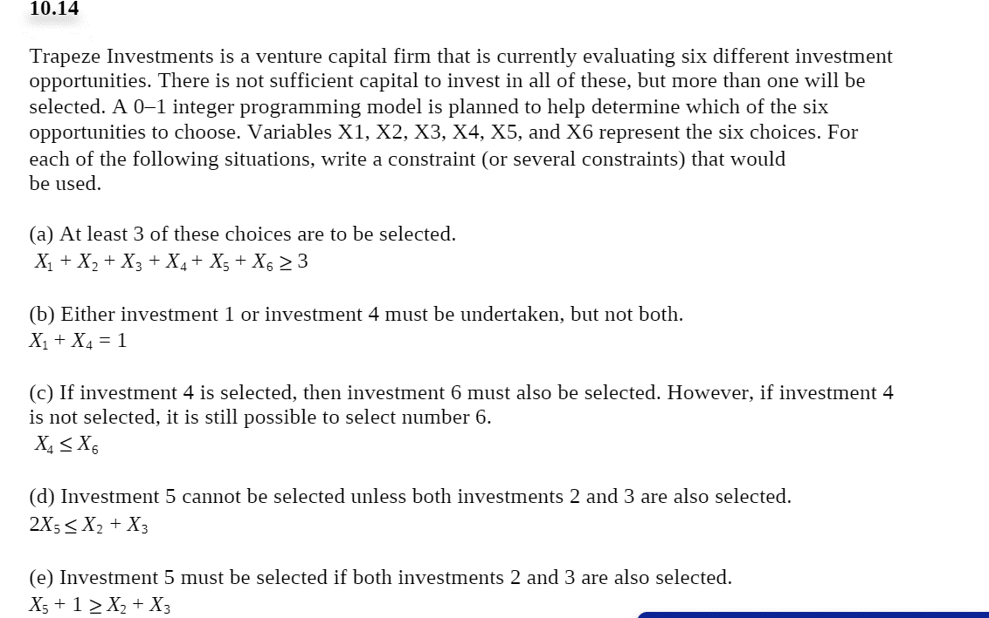

10-16

Formulate this as a 0–1 programming model to minimize the total number of towers required to cover all the areas. Solve this using a computer. 10-16 Innis Construction Company specializes in building moderately priced homes in Cincinnati, Ohio. Tom Innis has identified eight potential locations to construct new single-family dwellings, but he cannot put up homes on all of the sites because he has only $300,000 to invest in all projects. The following table shows the cost of constructing homes in each

area and the expected profit to be made from the sale of each home. Note that the home-building costs differ considerably due to lot costs, site preparation, and differences in the models to be built. Note also that a fraction of a home cannot be built.

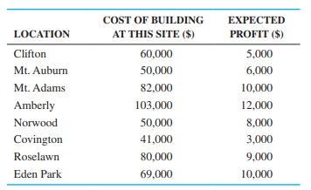

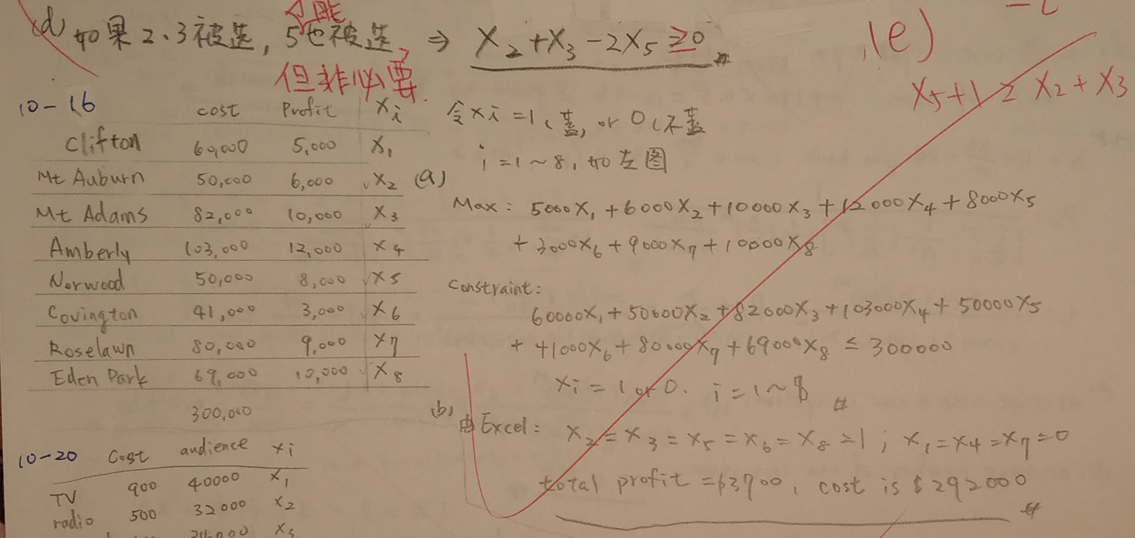

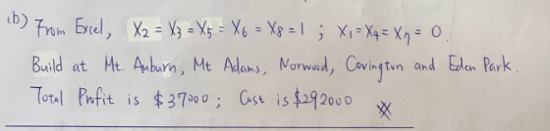

10-20

The campaign manager for a politician who is running for reelection to a political office is planning the campaign. Four ways to advertise have been selected: TV ads, radio ads, billboards, and social media advertising buys. The costs of these are $900 for each TV ad, $500 for each radio ad, $600 for a billboard for 1 month, and $180 for each buy on social media (approximately 40,000 unique impressions). The audience reached by each type of advertising has been estimated to be 40,000 for each TV ad, 32,000 for each radio ad, 34,000 for each billboard, and 17,000 for each social media buy. The total monthly advertising budget is $16,000. The following goals have been established and ranked:

1. The number of people reached should be at least 1,500,000.

2. The total monthly advertising budget should not be exceeded.

3. Together, the number of ads on either TV or radio should be at least 6.

4. No more than 10 ads/buys of any one type should be used.

(a) Formulate this as a goal programming problem.

(b) Solve this using computer software.

(c) Which goals are exactly met and which are not?

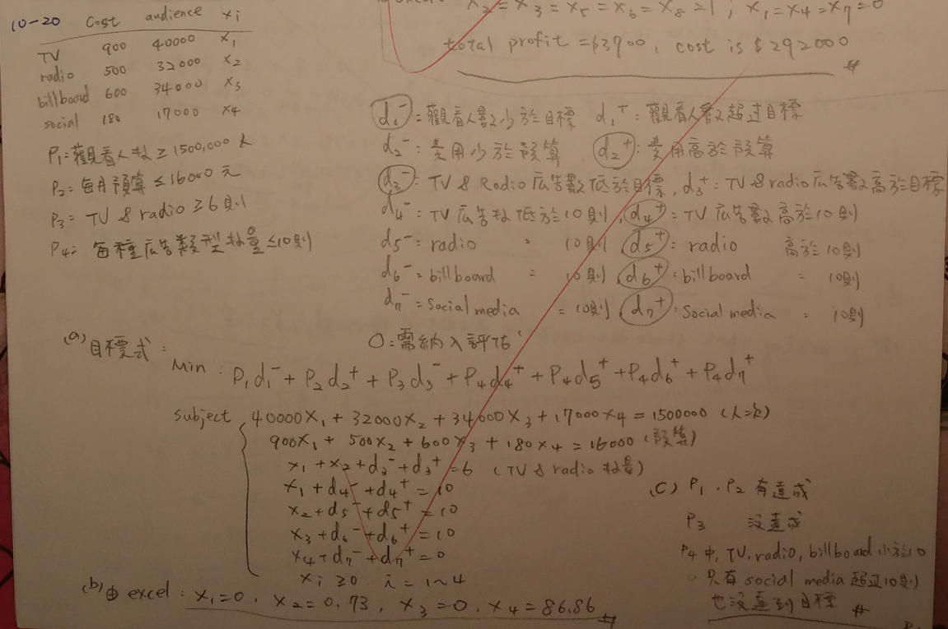

10-30

Pat McCormack, a financial advisor for Investors R Us, is evaluating two stocks in a particular industry. He wants to minimize the variance of a portfolio consisting of these two stocks, but he wants to have an expected return of at least 9%. After obtaining historical data on the variance and returns, he develops the following nonlinear program:

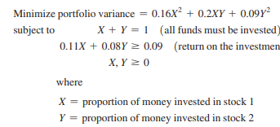

Solve this using Excel and determine how much to invest in each of the two stocks. What is the return for this portfolio? What is the variance of this portfolio?

