4-13

Students in a management science class have just received their grades on the first test. The instruct Students in a management science class have just received their grades on the first test. The instruct

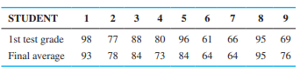

1. Develop a regression model that could be used to predict the final average in the course based on the first test grade.
2. Predict the final average of a student who made an 83 on the first test.
3. Give the values of r and r2 for this model. Interpret the value of r2 in the context of this problem.

4-14

Using the data in Problem 4-13, test to see if there is a statistically significant relationship between the grade on the first test and the final average at the 0.05 level of significance. Use the formulas in this chapter and Appendix D.

4-21

The following data give the starting salary for students who recently graduated from a local university and accepted jobs soon after graduation. The starting salary, grade-point average (GPA), and major (business or other) are provided.

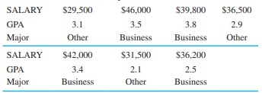

(a) Using a computer, develop a regression model that could be used to predict starting salary based on GPA and major.

(b) Use this model to predict the starting salary for a business major with a GPA of 3.0.

(c) What does the model say about the starting salary for a business major compared to a nonbusiness major?

(d) Do you believe this model is useful in predicting the starting salary? Justify your answer, using information provided in the computer output.

4-22

The following data give the selling price, square footage, number of bedrooms, and age of houses that have sold in a neighborhood in the past 6 months. Develop three regression models to predict the selling price based upon each of the other factors individually. Which of these is best?

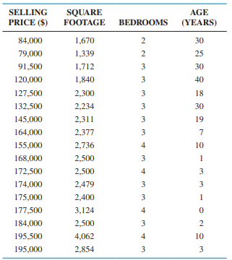

4-23

Use the data in Problem 4-22 and develop a regression model to predict selling price based on the square footage and number of bedrooms. Use this to predict the selling price of a 2,000-square-foot house with three bedrooms. Compare this model with the models in Problem 4-22. Should the number of bedrooms be included in the model? Why or why not?

4-24

Use the data in Problem 4-22 and develop a regression model to predict selling price based on the square footage, number of bedrooms, and age. Use this to predict the selling price of a 10-year-old, 2,000-square-foot house with three bedrooms.

4-31

The number of victories (W), earned run average (ERA), runs scored (R), batting average (AVG), and on-base percentage (OBP) for each team in the American League in the 2012 season are provided in the following table. The ERA is one measure of the effectiveness of the pitching staff, and a lower number is better. The other statistics are measures of the effectiveness of the hitters, and a higher number is better for each of these.

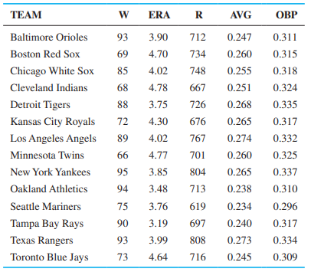

(a) Develop a regression model that could be used to predict the number of victories based on the ERA.

(b) Develop a regression model that could be used to predict the number of victories based on the runs scored.

(c) Develop a regression model that could be used to predict the number of victories based on the batting average.

(d) Develop a regression model that could be used to predict the number of victories based on the on-base percentage.

(e) Which of the four models is better for predicting the number of victories?

(f) Find the best multiple regression model to predict the number of wins. Use any combination of the variables to find the best model.