5-17

Data collected on the yearly demand for 50-pound bags of fertilizer at Wallace Garden Supply are shown in the following table. Develop a 3-year moving average to forecast sales. Then estimate demand again with a weighted moving average in which sales in the most recent year are given a weight of 2 and sales in the other 2 years are each given a weight of 1. Which method do you think is better?

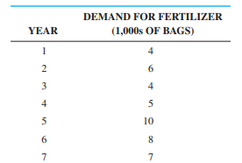

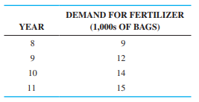

5-20

Use exponential smoothing with a smoothing constant of 0.3 to forecast the demand for fertilizer given in Problem 5-17. Assume that last period’s forecast for year 1 is 5,000 bags to begin the procedure. Would you prefer to use the exponential smoothing model or the weighted average model developed in Problem 5-17? Explain your answer.

5-35

A major source of revenue in Texas is a state sales tax on certain types of goods and services. Data are compiled, and the state comptroller uses them to project future revenues for the state budget. One particular category of goods is classified as Retail Trade. Four years of quarterly data (in $1,000,000s) for one particular area of southeast Texas follow:

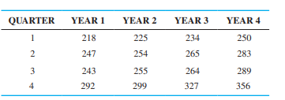

1. Compute a seasonal index for each quarter based on a CMA.
2. Deseasonalize the data, and develop a trend line on the deseasonalized data.
3. Use the trend line to forecast the sales for each quarter of year 5.
4. Use the seasonal indices to adjust the forecasts found in part (c) to obtain the final forecasts

3-37

Trevor Harty, an avid mountain biker, always wanted to start a business selling top-of-the-line mountain bikes and other outdoor supplies. A little over 6 years ago, he and a silent partner opened a store called Hale and Harty Trail Bikes and Supplies. Growth was rapid in the first 2 years, but since that time, growth in sales has slowed a bit, as expected. The quarterly sales (in $1,000s) for the past 4 years are shown in the table below:

(a) Develop a trend line using the data in the table. Use this to forecast sales for each quarter of year 5. What does the slope of this line indicate?

(b) Use the multiplicative decomposition model to incorporate both trend and seasonal components into the forecast. What does the slope of this line indicate?

(c) Compare the slope of the trend line in part (a) to the slope in the trend line for the decomposition model that was based on the deseasonalized sales figures. Discuss why these are so different and explain which is the better one to use.

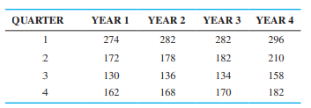

5-44

The following table gives the average monthly exchange rate between the U.S. dollar and the euro for 2009. It shows that 1 euro was equivalent to 1.289 U.S. dollars in January 2009. Develop a trend line that could be used to predict the exchange rate for 2010. Use this model to predict the exchange rate for January 2010 and February 2010

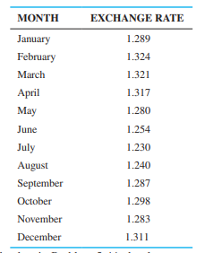

5-45

For the data in Problem 5-44, develop an exponential smoothing model with a smoothing constant of 0.3. Using the MSE, compare this with the model in Problem