<https://www.studocu.com/da/document/syddansk-universitet/strategi-og-marked/game-of-strategy-ch-10-solutions/7003409>

第十章

U1.

Two people, Baker and Cutler, play a game in which they choose and divide a prize. Baker decides how large the total prize should be; she can choose either $10 or $100. Cutler chooses how to divide the prize chosen by Baker; Cutler can choose either an equal division or a split where she gets 90% and Baker gets 10%. Write down the payoff table of the game and find its equilibria for each of the following situations: (a) When the moves are simultaneous.

(b) When Baker moves first.

(c) When Cutler moves first.

(d) Is this game a prisoners’ dilemma? Why or why not?

**Answer：**

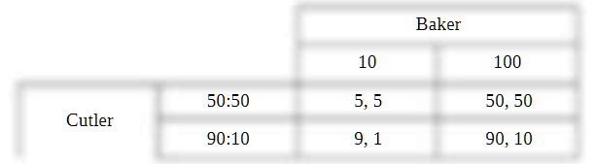

Both players have 90:10 for Cutler and 100 for Baker. Therefore, the equilibriumconsists of these two strategies, and the payoffs are 90 to Cutler, 10 to Baker, (a) regardless of whether themoves are simultaneous or sequential, and in the latter case, (b, c) regardless of the order of moves. (d)But this is not a prisoners’ dilemma; the outcome cannot be Pareto bettered. (Moral: Not every game withdominant strategies for both players is a prisoners’ dilemma.)

**U2.** Consider a small town that has a population of dedicated pizza eaters but is able to accommodate only two pizza shops, Donna’s Deep Dish and Pierce’s Pizza Pies. Each seller has to choose a price for its pizza, but for simplicity, assume that only two prices are available: high and low. If a high price is set, the sellers can achieve a profit margin of $12 per pie; the low price yields a profit margin of $10 per pie. Each store has a loyal captive customer base that will buy 3,000 pies per week, no matter what price is charged by either store. There is also a floating demand of 4,000 pies per week. The people who buy these pies are price conscious and will go to the store with the lower price; if both stores charge the same price, this demand will be split equally between them.

(a) Draw the game table for the pizza-pricing game, using each store’s profits per week (in thousands of dollars) as payoffs. Find the Nash equilibrium of this game and explain why it is a prisoners’ dilemma.

(b) Now suppose that Donna’s Deep Dish has a much larger loyal clientele that guarantees it the sale of 11,000 (rather than 3,000) pies a week. Profit margins and the size of the floating demand remain the same. Draw the payoff table for this new version of the game and find the Nash equilibrium.

(c) How does the existence of the larger loyal clientele for Donna’s Deep Dish help “solve” the pizza stores’ dilemma?

**Answer：**

**(a)Each pizza store has a dominant strategy to price medium, so the unique** Nashe quilibrium of the game is (Low, Low). However, both stores prefer the outcome in which both price high, so this is a prisoners’ dilemma:(a)Each pizza store has a dominant strategy to price medium, so the unique Nashe quilibrium of the game is (Low, Low). However, both stores prefer the outcome in which both pricehigh, so this is a prisoners’ dilemma:

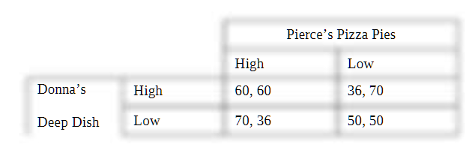

(b)Pierce’s dominant strategy is still Low but Donna’s dominant strategy is now High. Theunique Nash equilibrium is (High, Low). There is no dilemma in this version of the game:(b)Pierce’s dominant strategy is still Low but Donna’s dominant strategy is now High. Theunique Nash equilibrium is (High, Low). There is no dilemma in this version of the game:

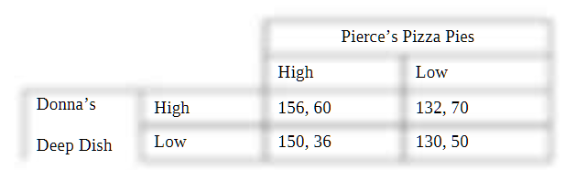

(c) Donna plays a leadership role here. The captive market for Donna’s is so large now that if Donna’s lowers its price, what it loses on the captive market outweighs what is gained by garnering thefloating demand. Switching from High to Low for Donna’s means giving up $2 profit on 11,000 pies($22,000) in order to get $10 profit on half of the floating demand, or 2,000 pies ($20,000). The decreasein price is not worth it; the gain from the move is exceeded by the loss. It is now better to maintain thehigh price, thereby taking the cooperative stance in the game

**S1.** “If a prisoners’ dilemma is repeated 100 times, and both players know how many repetitions to expect, they are sure to achieve their cooperative outcome.” True or false? Explain and give an example of a game that illustrates your answer

**Answer：**

False. The players are not assured that they will reach the cooperative outcome. Rollback reasoning shows that the subgame-perfect equilibrium of a finitely played repeated prisoners’ dilemma will entail constant cheating

**S2.** Consider a two-player game between Child’s Play and Kid’s Korner, each of which produces and sells wooden swing sets for children. Each player can set either a high or a low price for a standard two-swing, one-slide set. If they both set a high price, each receives profits of $64,000 per year. If one sets a low price and the other sets a high price, the low-price firm earns profits of $72,000 per year, while the high-price firm earns $20,000. If they both set a low price, each receives profits of $57,000.

(a) Verify that this game has a prisoners’ dilemma structure by looking at the ranking of payoffs associated with the different strategy combinations (both cooperate, both defect, one defects, and so on). What are the Nash-equilibrium strategies and payoffs in the simultaneous-play game if the players meet and make price decisions only once?

(b) If the two firms decide to play this game for a fixed number of periods—say, for 4 years—what would each firm’s total profits be at the end of the game? (Don’t discount.) Explain how you arrived at your answer.

(c) Suppose that the two firms play this game repeatedly forever. Let each of them use a grim strategy in which they both price high unless one of them “defects,” in which case they price low for the rest of the game. What is the one-time gain from defecting against an opponent playing such a strategy? How much does each firm lose, in each future period, after it defects once? If r = 0.25 (x= 0.8), will it be worthwhile for them to cooperate? Find the range of values of r (or x) for which this strategy is able to sustain cooperation between the two firms.

(d) Suppose the firms play this game repeatedly year after year, neither expecting any change in their interaction. If the world were to end after 4 years, without either firm having anticipated this event, what would each firm’s total profits (not discounted) be at the end of the game? Compare your answer here with the answer in part (b). Explain why the two answers are different, if they are different, or why they are the same, if they are the same.

(e) Suppose now that the firms know that there is a 10% probability that one of them may go bankrupt in any given year. If bankruptcy occurs, the repeated game between the two firms ends. Will this knowledge change the firms’ actions when r 5 0.25? What if the probability of a bankruptcy increases to 35% in any year?

(a)

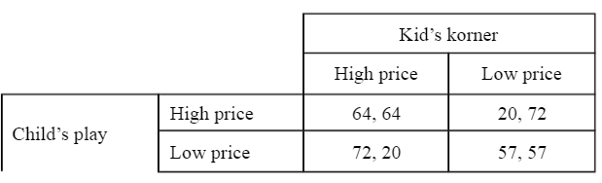

The payoffs are ranked as follows: high payoff from cheating (72) > cooperative payoff (64) > defect payoff (57) > low payoff from cooperating (20). This conforms to the pattern in the text so the game is a prisoners’ dilemma, as can also be seen in the payoff table given below

If the game is played once, the Nash equilibrium strategies are (Low, Low) and payoffs are (57, 57).

(b) Total profits at the end of four years = 4  57 = 228. Firms know that the game ends in

four years so they can look forward to the end of the game and use rollback to find that it’s best to cheat

in year 4. Similarly, it is best to cheat in each preceding year as well. It follows that it is not possible to

sustain cooperation in the finite game.

(c) The one-time gain from defecting = 72 – 64 = 8. Loss in every future period = 64 – 57 =

7. Cheating is beneficial here if the gain exceeds the present discounted value of future losses or if 8 >

7/r. Thus, r > 7/8 (or d > 8/15) makes cheating worthwhile, and r < 7/8 lets the grim strategy sustain

cooperation between the firms in the infinite version of the game. If r = 0.25, cooperation can be

sustained.

(d) Total profits after four years = 4  64 = 256. With no known end of the world, the firms

can sustain cooperation if r < 7/8 as in part (c). This answer is different from that in part (b) because the

firms see no fixed end point of the game and can’t use backward induction. Instead, they assume the game

is infinite and use the grim strategy to sustain cooperative outcome

If the game is played once, the Nash equilibrium strategies are (Low, Low) and payoffs are (57, 57).

(b) Total profits at the end of four years = 4  57 = 228. Firms know that the game ends in

four years so they can look forward to the end of the game and use rollback to find that it’s best to cheat

in year 4. Similarly, it is best to cheat in each preceding year as well. It follows that it is not possible to

sustain cooperation in the finite game.

(c) The one-time gain from defecting = 72 – 64 = 8. Loss in every future period = 64 – 57 =

7. Cheating is beneficial here if the gain exceeds the present discounted value of future losses or if 8 >

7/r. Thus, r > 7/8 (or d > 8/15) makes cheating worthwhile, and r < 7/8 lets the grim strategy sustain

cooperation between the firms in the infinite version of the game. If r = 0.25, cooperation can be

sustained.

(d) Total profits after four years = 4  64 = 256. With no known end of the world, the firms

can sustain cooperation if r < 7/8 as in part (c). This answer is different from that in part (b) because the

firms see no fixed end point of the game and can’t use backward induction. Instead, they assume the game

is infinite and use the grim strategy to sustain cooperative outcome

(B) Total profits at the end of four years = 4 X 57 = 228. Firms know that the game ends in four years so they can look forward to the end of the game and use rollback to find that it’s best to cheat in year 4. Similarly, it is best to cheat in each preceding year as well. It follows that it is not possible to sustain cooperation in the finite game

(c)

The one-time gain from defecting = 72 – 64 = 8. Loss in every future period = 64 – 57 = 7. Cheating is beneficial here if the gain exceeds the present discounted value of future losses or if 8 > 7/r. Thus, r > 7/8 (or d > 8/15) makes cheating worthwhile, and r < 7/8 lets the grim strategy sustain cooperation between the firms in the infinite version of the game. If r = 0.25, cooperation can be sustained.

(d)

Total profits after four years = 4 x64 = 256. With no known end of the world, the firms can sustain cooperation if r < 7/8 as in part (c). This answer is different from that in part (b) because the firms see no fixed end point of the game and can’t use backward induction. Instead, they assume the gameis infinite and use the grim strategy to sustain cooperative outcome

(e)

A 10% probability of bankruptcy translates into a 90% probability that the game continues, so p = 0.9. Then, for r = 0.25 (d = 0.8), R = 39%. This rate would need to exceed 7/8 before cheating was worthwhile, so the firms will still cooperate in this case. For a 35% probability of bankruptcy, p = 0.65 and R = 92%, so if bankruptcy becomes more certain, cheating becomes worthwhile