Network Management Web Server and DNS Quiz
ID_____________________Name_______________________

Assume you are a DNS manager of gov.tw. A machine ip: 127.0.0.1 is used to control this domain and machine’s domain name is dns.gov.tw. In this organization, a few machines have assigned domain names, i.e. ftp.org.tw, mail.org.tw. dns.org.tw.
The mapping of these domain names and IP are:
ftp.org.tw : 140.11.1.1
mail.org.tw: 123.1.2.3
www.org.tw has the same ip address with mail.org.tw
dns.org.tw: 127.0.0.1
Please also set your email username@org.tw can direct to mail.org.tw

Recently, an election activity is coming soon. An organization named “central election commission” is established whose domain name will be cec.org.tw. It asks to control its domain by its own machine whose ip is: your own machine ip(192.168.123.x) with domain name “ns.cec.org.tw”.

Please set up the domain name server for Org with the requirement described in description.

We will suggest you to disable SELinux control

Assume you are Apache Web Server Manager：
- Personal Web page setting, please allow users having their own web pages in “www” folder under their home directories. Please use testuser to make sure your setting working properly. http://localhost/~testuser/ to confirm that you can see the directory file list if no default web page(25%)
- Apache supports a function that some file names can be active when this directory is assigned in URL. Please assign “hello.html”, “indexfile.html” in order for user homepage directory. Please create “/home/testuser/www/indexfile.html” first to test it works. After that, create “/home/testuser/www/hello.html” to confirm hello.html content can be displayed (25%)
- Please set URL http://localhost/mnt/ to show “/mnt” content. And if no “hello.html” and “indexfile.html” in this directory, http://localhost/mnt/ should not show the directory file list. (15%)
- Please assign http://localhost/secure/ to allow ttuser with password: ttuser to access this folder. (35%)

1.編輯 name 檔(正查及反查)
cd /var/named
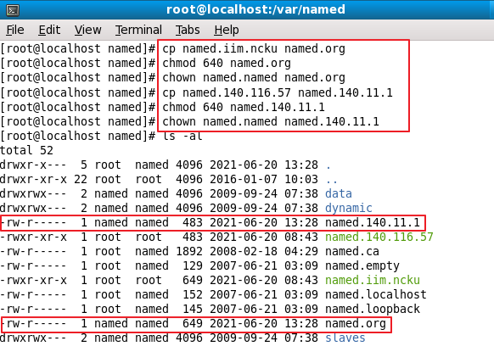
File：named.org
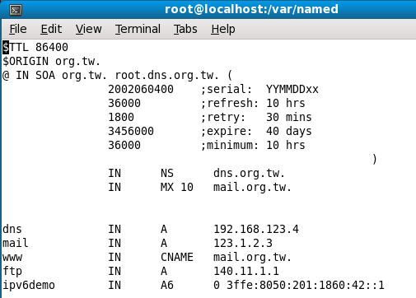
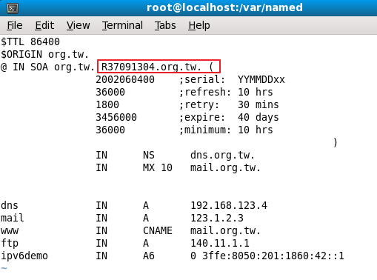

File：named.140.11.1
只需設 ftp 的反查，因140開頭的ip只有ftp
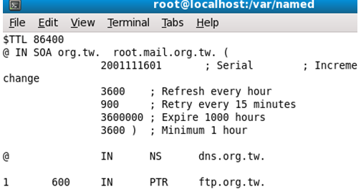

2.編輯 zone
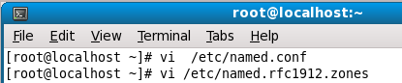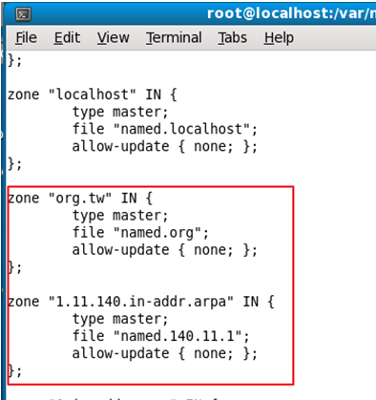
3.重啟
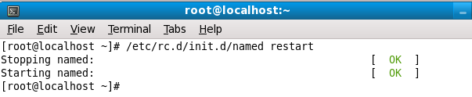
- 驗證

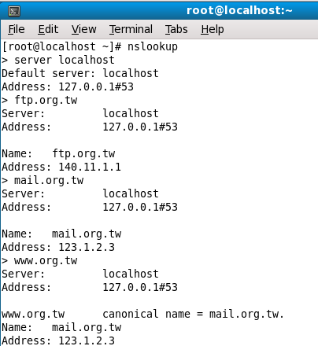
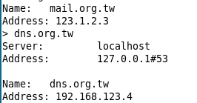

反查驗證
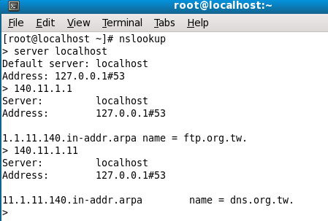

- Web Server：
1.

1.1 先備份資料
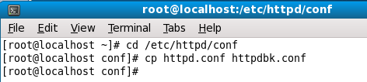
1.2改 /etc/httpd/conf/httpd.conf
將 UserDir disabled marked起來
將 UserDir unmarked，且路徑改為 www
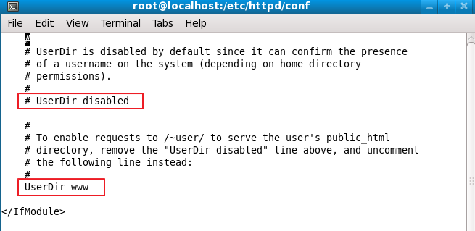
1.3以下紅框程式碼 unmarked，且修改Directory 路徑，改為 /home/*.www
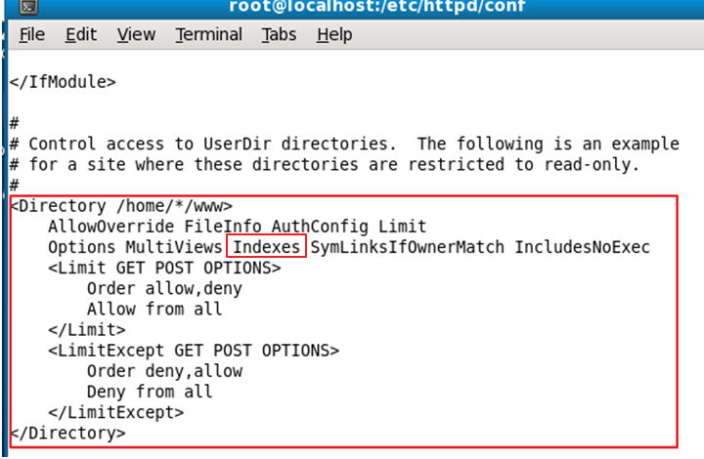

1.4重啟伺服器
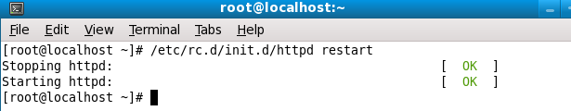
1.5 /test 底下新增 www資料夾(使用TEST帳號建立WWW目錄)
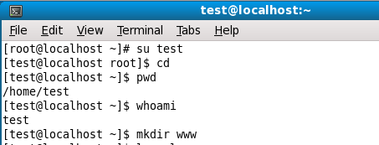
1.6 在 /home/test/www目錄下，新增 index.html檔
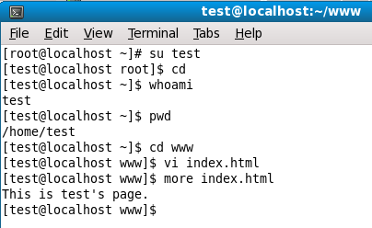

1.7 test資料夾權限，以利apatch能夠讀取
chmod 755 test
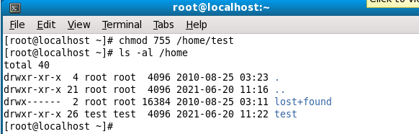

1.8 將System → Administration →SELinux Management
System Default Enforcing Mode 設為 Disabled
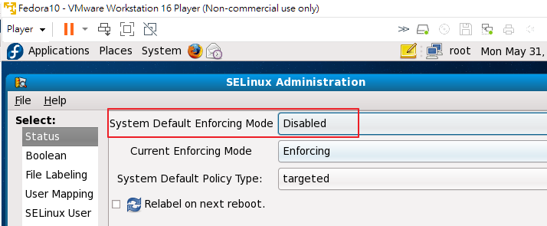

1.9 擁有自己帳號的網頁
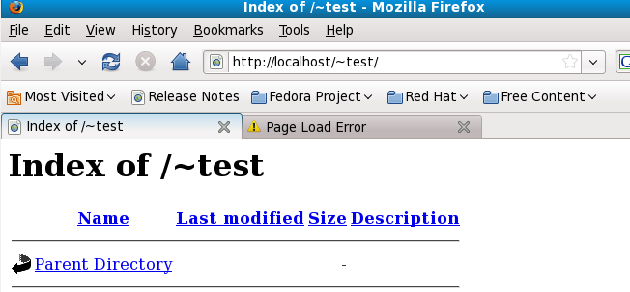

2
2.1 在 /home/test/www 目錄下，新增 indexfile.html及hello.html
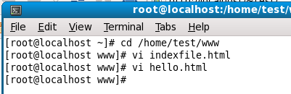
2.2 編輯/etc/httpd/conf/httpd.conf
修改 DirectoryIndex，加入 hello.html indexfile.html
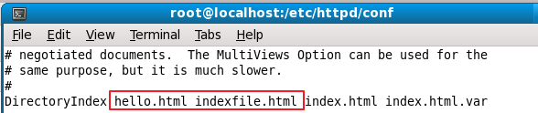
2.3重啟Server
2.4 驗證indexfile.html
先將 hello.html 重新命名，mv hello.html he.html
然後再驗證網頁，會跳到 indexfile.html
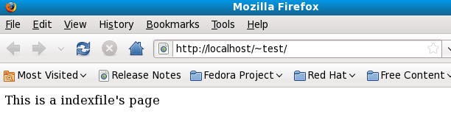
2.5 驗證 hello.html
將 he.html重新命名為hello.html
然後再驗證網頁，會跳到hello.html
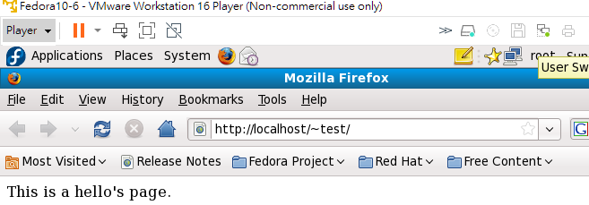
3
3.1 編輯 /etc/httpd/conf/httpd.conf
編輯 Alias區塊(複製Alias程式)
Alias /mnt/ (說明：別名) /mnt/ (路徑)
Directory /mnt
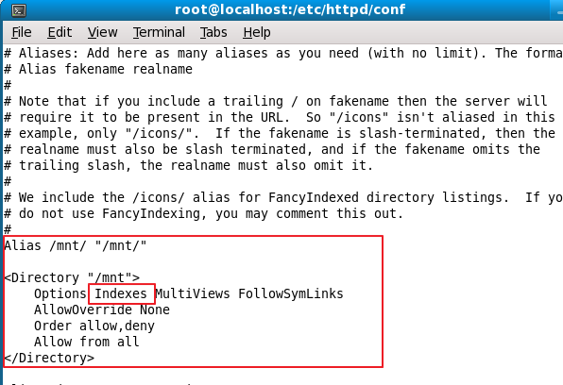
3.2 重啟Server
3.3 驗證(無hello.html 及 indexfile.html)
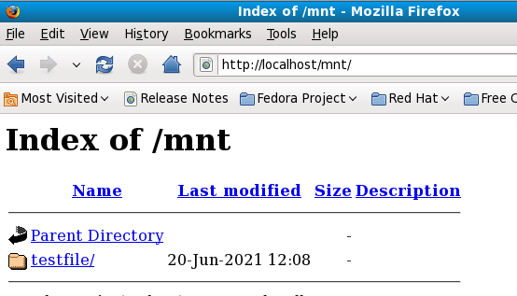
3.4 驗證(有hello.html)
在 /mnt目錄下新增hello.html
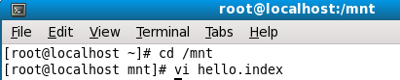
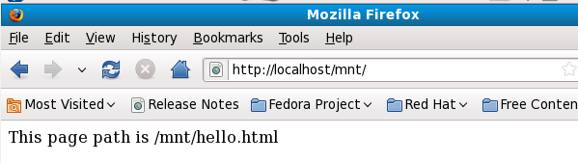
3.5 驗證(有indexfile.html)
暫時先將 hello.html rename h.html => mv hello.html h.html
在/mnt目錄下，新增 indexfile.html
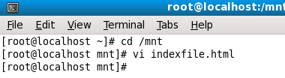
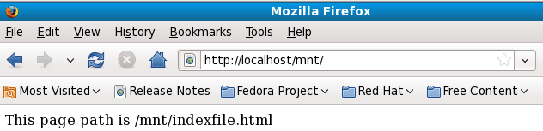

4
4.1 在 /var/www/html 目錄下，新增 secure 資料夾
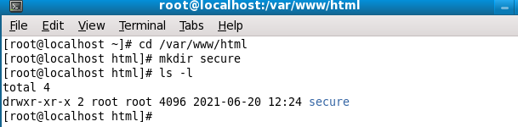
4.2 在 /var/www/html/secure/目錄下，新增 .htaccess
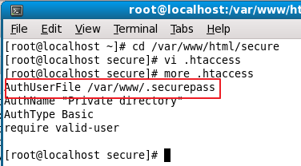
  - 在 /var/www 目錄下(路徑是依照上圖AuthUserFile)，建立帳號密碼檔
語法：htpasswd -c .securepass ttuser
密碼：ttuser
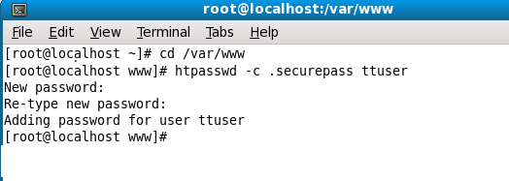
  - 編輯 /etc/httpd/conf/httpd.conf
將 AllowOverride 設為 All
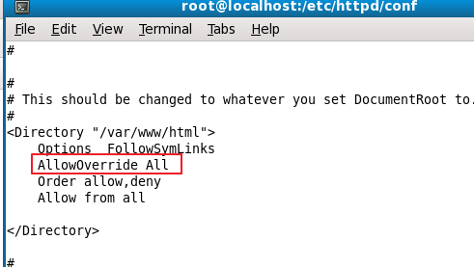

  - 重啟 Server

  - 驗證網頁
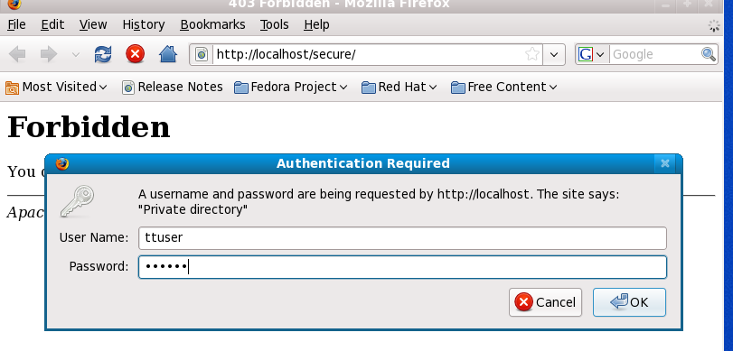

4.5 建立 hello.html
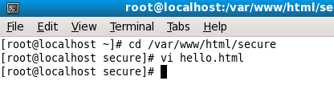
4.6 網頁會自動導向 hello.html
