  For office use only
  T1 | ________________
  T2 | ________________
  T3 | ________________
  T4 | ________________
  Team Control Number
  1920744
  Problem Chosen
  B
  For office use only
  F1 | ________________
  F2 | ________________
  F3 | ________________
  F4 | ________________
2019
MCM/ICM
Summary Sheet
(Your team's summary should be included as the first page of your electronic submission.)
Type a summary of your results on this page. Do not include the name of your school, advisor, or team members on this page.
Configurations of Drones and Delivery Locations for Disaster Relief
Summary
With the increasing demand for disaster relief, drones are playing a more important role. In our paper, we work out an efficient way to place drones and medical packages and plan best routes.
The first stage, we determine the way to pack drones and medical packages by using dynamic programming algorithm, abstracting a bin packing problem. According to different dimensions of drones, containers, drone cargo bays, and medical packages, we can derive a model that minimize the space utilization. Considering the flight distances and capabilities of drones, we give an optimized choice of combining different types of drones.
The second stage, we consider the situation as a route inspection problem. Through traversing the graph and applying corrections, we find two points to distribute DroneGo disaster response system according to the distances between anticipated delivery locations. Here to meet the requirements of real situation, we make some corrections to the optimized results. By the way, we also consider the routes for assessing highways and roads.
The third stage, we analyze the given and related data and make a schedule through adjusting weighted value of highways, roads and towns. By linear programming, we traverse the graph. To make sure that every drone can be communicated on time, we introduce tethered drone to help send and receive radio signals. To ensure that every big residential locations and most small villages can receive disaster relief, we assess the highways and roads to help ground disaster relief system transportation. It loses some efficiency, but it still works well in distributing medical packages. Every drone has its own schedule, maximize the rate of utilization.
Remarkably, we analyze the strengths and the weaknesses of our model and come up with some promotions. They can be referred in future research of disaster relief response system.
Finally, applying our model to a common situation, we verify the universality and feasibility of our model. By changing parameters and testing it in the real situation 14 years ago, our model still predicts the best delivery location and assessment of highways and roads. Last but not least, we prepare a demo for the CEO of Help, Inc.
Key words: Bin Packing Problem, Dynamic Programming, Route Inspection Problem, Drone Fleet Distribution, Minimum Spanning Tree, Minimum Weighted Value
Contents
I. Introduction 3
1.1 Background 3
1.2 Literature Review 3
1.3 Our Works 3
II.Restatement and Analysis of the Problem 4
2.1 Restatement of the Problem 4
2.2 Analysis of the Problem 4
III. Assumptions 4
III. Glossary & Symbols 5
4.1 Glossary 5
4.2 Symbols 5
V. Models 6
5.1 Packing Configuration for Drones and Medical Packages 6
5.1.1 Model Method 6
5.1.2 Model Establishment 6
5.1.3 Results 7
5.2 Locations to Position Cargo Containers 8
5.2.1 Model Method 8
5.2.2 Model Establishment 8
5.2.3 Results 8
5.3 Configurations, Flight Plan, Schedule, and Routes 10
5.3.1 Model Preparation 10
5.3.2 Model Establishment 10
5.3.3 Results 11
VI. Sensitivity Analysis 12
6.1 Changing Parameters 12
6.2 Expanding into Other Areas 12
VII. Conclusion 12
7.1 Strengths and Weaknesses 12
7.1.1 Strengths 12
7.1.2 Weaknesses 12
7.2 Promotion 13
VIII. Memo 13
IX. References 14
X. Appendices 14
10.1 Appendix I – Pseudo Code of Route 14
10.2 Appendix I – Pseudo Code of Packing 15

- Introduction
1.1 Background
Nowadays, with the trend of global warning, catastrophes like hurricanes are becoming more serious, so as the problem of disaster relief. As the technology of unmanned aerial vehicles develops, disaster relief organizations attach importance to the use of drones. Compared with traditional aircrafts and rotorcrafts like helicopters, the use of drones is more flexible and safer. They can operate in very poor remote or insecure regions without risking pilots’ life or under unstable weather conditions.
However, similar to other transportation and communication facilities, there are still many constraints like the range of radio signals for telecommunication in their applications, so we need to plan reasonable routes to keep in contact with drones. Besides, the relief goods resources are limited, so we need to optimize the packing configuration. What’s more, drones are required to both distribute medical packages and assess main highways and roads, which means a plan for routes is necessary.
1.2 Literature review
Unmanned aerial vehicles are receiving increased attention by humanitarian organizations as they can help overcoming last-mile distribution problems, i.e., inaccessibility to cut-off regions (Boualem et al., 2018) [1]. When it comes to pack several different types of cuboids in a big cuboid, there are many candidate algorithms such as backtracking algorithm, first-fit algorithm, and exact algorithm. Since the efficiency of these algorithms is not determined, dynamic programming seems to be a reasonable candidate.
It is also possible to refer to the post-processing algorithm that transforms the model outputs into routes with delivery and pickup instructions for materials and people (Linet, 2011) [2]. The number of vehicles travelling between different nodes can be selected to start the procedure of analyzing the minimum of the sum of the product of flight time between different nodes and the number of vehicles traversing the district between them.
1.3 Our work
Firstly, we analyze the data and load drones in ISO dry cargo containers by linear programming. Taking the performance characteristics and configurations capabilities of drones and flight distances into consideration, we choose a combination of different types of drones and determine how many of each type of drones in the drone fleet.
Secondly, we estimate the demand for medicine, the time needed to reconnoiter roads, the duration of the disaster exerting influence on the region, and the extent of the disaster’s negative impact on the roads.
Thirdly, to assure the reliability of telecommunication and ensure that the number of people getting help is maximized, we make corrections on the optimizing model depending on the algorithm that minimize the sum of distances between different locations.
Finally, we expand our model to another disaster relief sample and verify the insensitivity of slight changes on containers’ dimensions and the distribution of locations.
- Restatement and Analysis of the Problem
2.1 Restatement of the problem
As is required by the problem, we need to arrange drones, medical packages and dry containers not only to carry medical packages but also to investigate highways and roads.
The problem can be divided into three missions:
- Arrange drones and medical packages in given cargo containers.
- Find a position or positions to settle DroneGo disaster response system.
- Provide the packing configuration, routes, a schedule, and a flight plan for every drone in the drone fleet.
2.2 Analysis of the problem
During the drone fleet’s flight, the drones need to visit all the locations. Hence, some of the neighboring locations can be visited by a single drone. It can be referred that some of the delivery locations are too far away from others, so as the telecommunication stations. Considering the limit of the flight time of different types of drones, even though some configuration can minimize the sum of travelling distance, some locations cannot be visited. Because the longer journey that the drones need to make, the higher cost of time and money, we need to draw circles that overlap the area in need to determine the best choice. These locations must be inside the circles.
Meanwhile, the configuration of drones and medical packages in task 1 and task 2 in the description of the problem is related to task 3. After the dry cargo containers arrive the expected destination, the medical packages in one drone can be moved to another drone or be exchanged with another drone to follow the anticipated flight schedule.
- Assumptions
To make necessary simplification and simulate the reality as much as possible, we assume that the medical packages are originally loaded in drone cargo bays when being transported by the ISO dry cargo containers to improve space utilization. Besides, to minimize the waste space, we assume that medical packages can be laid on all the sides. That is to say, the original length, width, and height can be redefined according to the dimensions of drone cargo bays. However, since the geometrical shape of drones is not symmetrical, the orientation of drones cannot be reversed or overturned.
On the other hand, considering the limited range of telecommunication, we assume that we need to add at least one tethered drone to the drone fleet. As is known to us, tethered drone onboard communication system has electric multi-rotor drone platform, TD-LTE communication system integrated ground process unit (Lei et al., 2016) [3]. The tethered drones only carry radio frequency channel, minimizing the payload. Hence, taking the factor of communication distance into consideration, we use two tethered drones.
In addition, since the area of the island of Puerto Rico is just about 9104 square kilometers [4], we assume a linear relationship between the distance and the latitude-longitude.
- Glossary & Symbols
4.1 Glossary
Table 1 Glossary
Term | Explanation
Great point | The best locations that is the most optimized by analyzing our model
Reference circle | Circles that is drawn according to the flight radius of drones to help determine great points
Data | Data that describes the positions of anticipated delivery locations from the description of the problem or related references

4.2 Symbols
Table 2 Symbols and their definitions
Symbol | Definition | Unit
i | The ID of medical package | 0
j | The orientation of medical package | 0
l | The length of the original oriented medical package | inch
w | The width of the original oriented medical package | inch
h | The height of the original oriented medical package | inch
L | The length of the redirected medical package | inch
W | The width of the redirected medical package | inch
H | The height of the redirected medical package | inch
y | The sum of the drones in the drone fleet | 0

- Models
  - Packing Configuration for Drones and Medical Packages
5.1.1 Model Method
To find the best packing configuration for drones and medical packages, there are some algorithms like backtracking algorithm, first-fit algorithm, and exact algorithm, but none of them is proved to be the most efficient. We use dynamic programming to solve this problem. This algorithm cost less time relatively. It usually disassembles original problems to several simpler sub-problem.
5.1.2 Model Establishment
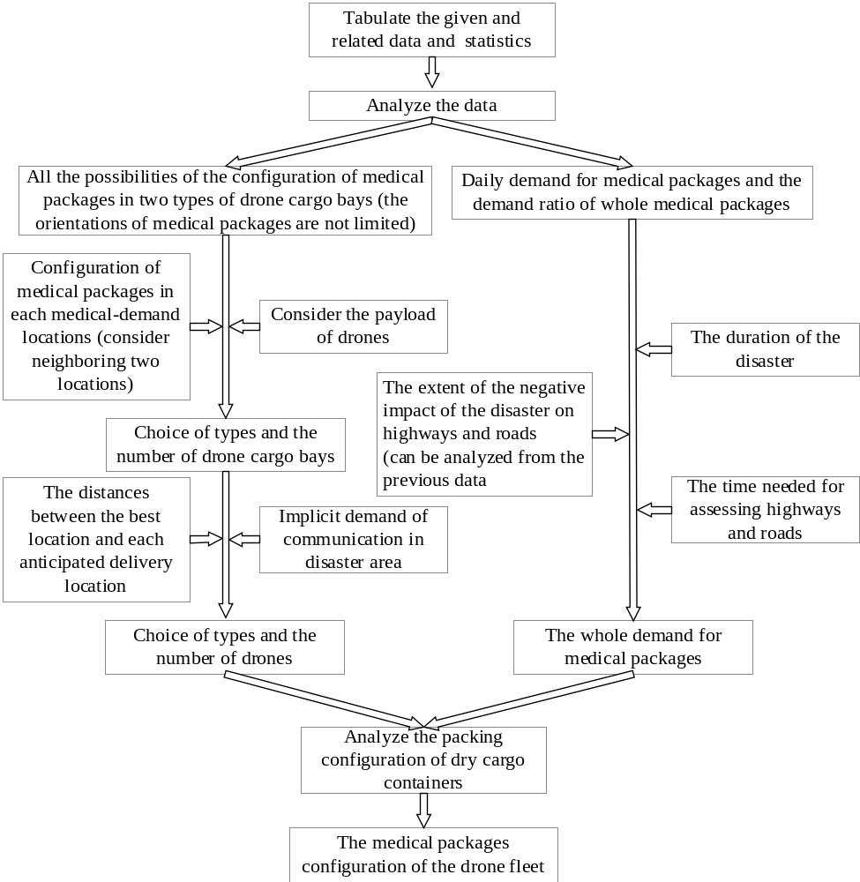
Figure 1 Packing configuration for drones and medical packages
Taking the previously stated constraint conditions into consideration, we have

Besides, we have

5.1.3 Results
Table 3 The results of the model parameter value table
Location | Cargo Bay Type | Drone Type
 | Type 1 | B
  Caribbean Medical Center
  Fajardo
 | Type 1 | B
Hospital HIMA San Pablo | Type 1 | B
Hospital Pavia Santurce San Juan | Type 2 | F
Puerto Rico Children's Hospital  Bayamon | Type 2 | F
Hospital Pavia Arecibo Arecibo | Type 1 | B
Great Point | N/A | H Tethered

  - Locations to Position Cargo Containers
5.2.1 Model Method
By linear programming, we traverse the graph. Most generally, the sum of the distances between the great point and anticipated delivery locations should be as small as possible. However, Hospital Pavia Arecibo that is located at the corner of the island cannot be connected. Hence, through adding a correction, we construct three points instead of two points to help connect Hospital Pavia Arecibo. It fits with the principle of humanism that is prior to high-efficiency.
To construct and locate the three points, firstly, to set out from the great point 1 drones can deliver medical packages to two points in a single flight while the overlapped area of the great point 1 and the great point 2 is minimal. The great point is located in the extension cord of the ligature of the two points.
5.2.2 Model Establishment
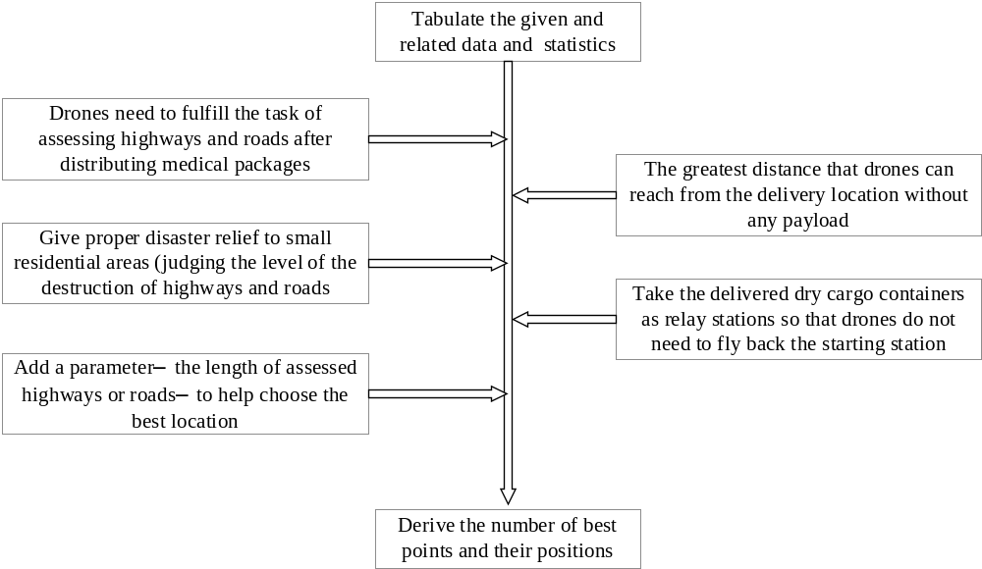
Figure 2 Locations to Position Cargo Containers
5.2.3 Results
Table 4 The latitude-longitude Coordinates of Locations and Their Distances
Location A (latitude, longitude) | Location B (latitude, longitude) | Distance (km/mile)
-65.98, 18.31 | -65.65, 18.33 | 34.904 km / 21.688 miles
-65.98, 18.31 | -66.03, 18.22 | 11.314 km / 7.03 miles
-65.98, 18.31 | -66.07, 18.44 | 17.295 km / 10.747 miles
-65.98, 18.31 | -66.16, 18.40 | 21.471 km / 13.341 miles
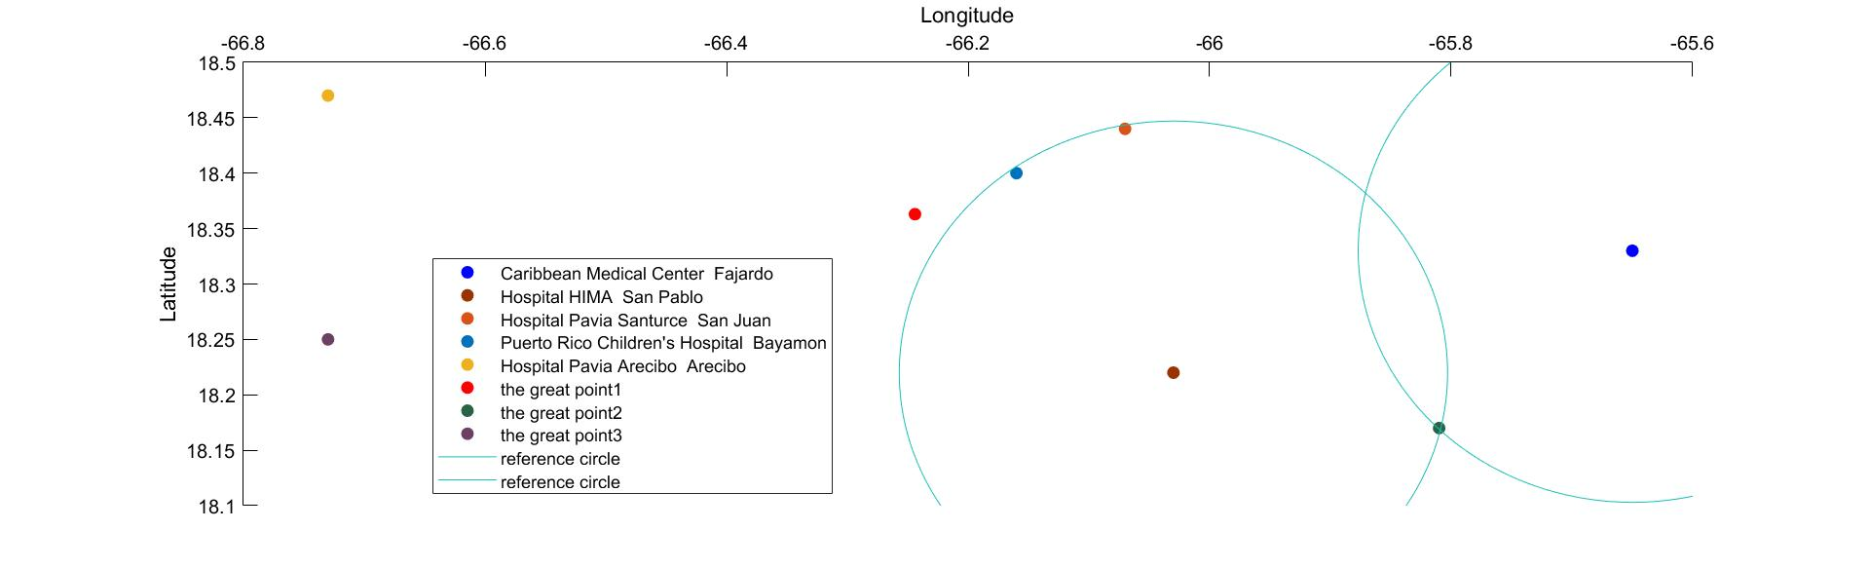
Figure 3 Dyed Locations
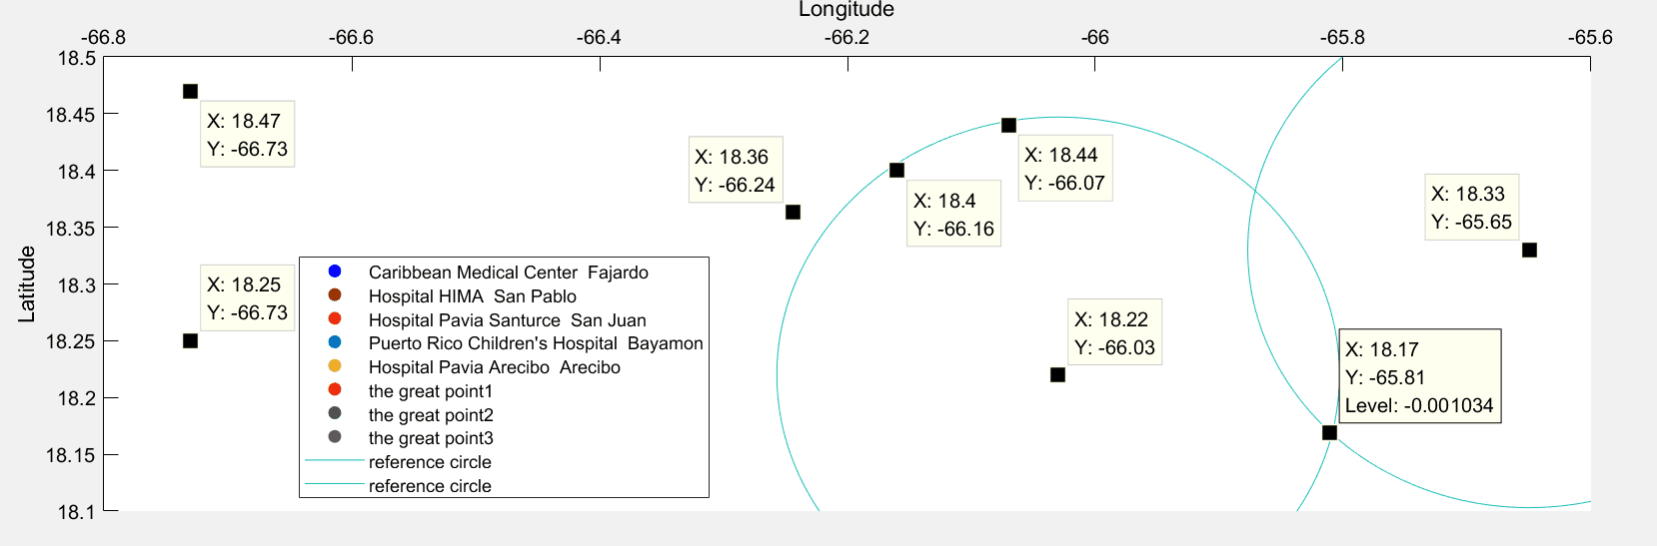
Figure 4 Latitude-longitude Coordinates of Locations
As is shown in the two figures, we find two delivery locations. The radii of the circles are the flight radii of drones. The great point 2 is one of the intersections of the two reference circles. Two of the delivery locations are positioned at the centers of the two reference circles. Caribbean Medical Center Fajardo and Hospital Pavia Santurce San Juan are just near the edge of one of the reference circles. As for Hospital Pavia Arecibo that is located at the corner of the island, the great point 3 is the nearest delivery location.
To assess the highways and roads that are located in the south part of the island and minimize the overlapped area of the great point 1 and the great point 2, the great point 2 are the lowest point that have the greatest distance between it and the two delivery locations that is 25 kilometers.
Having determined the location of the great point 1 and the great point 2, the great point 3 is designed to deliver medical packages to Hospital Pavia Arecibo and is as low as possible on the map to assess as many highways and roads as possible.
  - Configurations, Flight Plan, Schedule, and Routes
5.3.1 Model Method
This problem can be viewed as a TSP (Travelling Salesman Problem), also known as CPP (Chinese Postman Problem). To adjust parameters, we introduce KM (Kuhn-Munkras) algorithm. It is a kind of binary match, particular in minimum weight.
Besides, we abstract the problem that the intersections of highways or roads are considered as nodes. Then, we can apply MST (Minimum Spanning Tree) algorithm to determine the flight distance.
5.3.2 Model Establishment
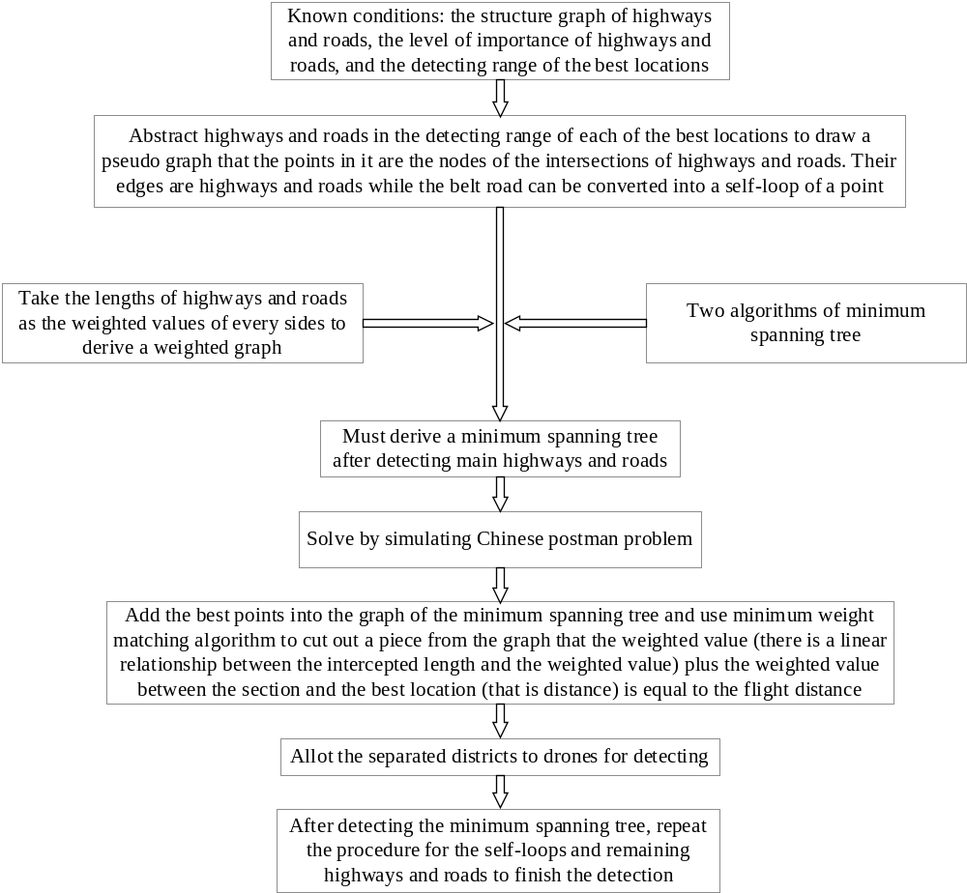
Figure 5 Configurations, Flight Plan, Schedule, and Routes
5.3.2 Results
Table 5 The results of the Configurations, Flight Plan, Schedule, and Routes
Great Point | Drones’ Type | Type of Drone Cargo Bay | The Number of Drone Cargo Bay | Medical Packages Payload
1 | F | 2 | 1 | MED1*3,MED2*2,MED3*2
2 | B | 1 | 1 | MED1*1,MED3*1
2 | B | 1 | 1 | MED1*2
2 | B | 1 | 1 | MED3*1
3 | B | 1 | 1 | MED1*1
(continued)
Arriving Schedule | Returning Schedule | Departure Frequency | Delivery Route
8:00~8:12 | 8:15~8:27 | Every 10 minutes | Point 1→(18.40,-66.16)→(18.44,-66.07)→Point 1
8:00~8:20 | 8:15~8:43 | Every 11 minutes | Point 2→(18.33,-65.65)→Point 2
8:00~8:20 | 8:15~8:43 | Every 12 minutes | Point 2→(18.22,-66.03)→Point 2
8:00~8:20 | 8:15~8:43 | Every 13 minutes | Point 2→(18.22,-66.03)→Point 2
8:00~8:20 | 8:15~8:43 | Every 14 minutes | Point 3→(18.47,-66.73)→Point 3
The result of traversing the graph is shown below:
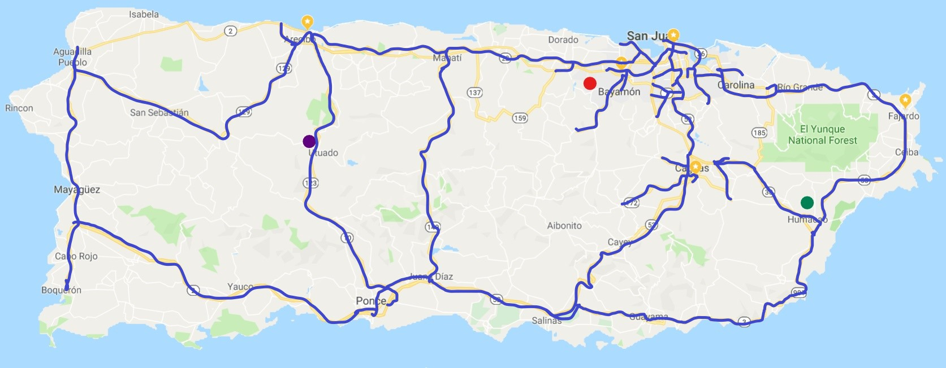
Figure 5 Processed and Inked Routes for Delivery [5]
- Sensitivity Analysis
  - Changing Parameters
As is analyzed before, we try to move each anticipated delivery locations for one percent of the length of the island, finding that all the three great points’ locations do not change for more than one percent of the length of the island. It means that our model is not sensitive to the slight change to delivery locations.
  - Expanding into Other Areas
To verify the universality of our model, we test out model on the map of Florida Peninsula in September 2005. The result turns out to be suitable well although the peninsula is much broader than Puerto Rico. Setting delivery locations in Broward, Miami-Dade and Jacksonville, medical packages can be delivered to near towns like Orange, Hillsborough and Duval.
- Conclusion
  - Strengths and Weaknesses
7.1.1 Strengths
- Our algorithm has fast operating speed and high efficiency.
- We make proper simplification to the model so that it works well.
- Our model can be applied widely. It can be applied in another problem through just adjusting some parameters.
- The result contains some minor factors to improve the flexibility of our model.
7.1.1 Weaknesses
- Some of the process in our model is inaccurate. For example, our data does not rely on the accurate distance between two locations.
- We make some assumptions that may influence on the result of our model.
- Our judgement about the best locations may need simulation of programming to support mathematical theorems.
  - Promotion
- Algorithms
It may help inspect and promote our model by trying other algorithms like exact algorithm to pack drones and medical packages.
- Data Visualization
Some data in the charts or tables are not perceptual enough. Visualized data graph will help show the results of our model.
- Image Process
During the process of traversing graph, we can extract the highways, roads, and towns from the map by binarization and data interpolation.
- Memo
To: CEO
From: Team # 1920744
Date: January 29, 2019
Subject: Model result, conclusion and proposal
I am glad to give you our results of model.
The starting time of the drone fleet is influenced by weather conditions. If the weather is sunny and breezeless, the drones are going to take off from the delivery location at 8 o’clock. Every drone can be recycled after executing a mission.
The tethered drones are used to advance the ability of communication and improve communication conditions since communication base station are sometimes corrupted or disconnected. Using video function boarded on the other types of drones, the image signals can be easily sent to tethered drones and ground base stations to help your incorporation to assess the conditions of highways and roads. We can provide you with a schedule, the configurations of medical packages and drones, delivery routes, and drones’ flight plan as is shown in the model.
We designed the configurations of packing medical packages and drones in the ISO standard dry cargo containers. Medical packages will be previously packed in the drone cargo bays when being transported. The result turns to be optimistic: we just need at least 6 drones to visit all the delivery locations. By referring the schedule, it is not difficult to arrange drones to visit these places daily.
We provide you with three best locations to position DroneGo disaster relief system. None of the resources will be wasted. The geographical relationship among the three locations are well-designed to deliver medical packages and drones. They can also assess the conditions of highways and roads by the way.
We can conclude that you need to choose certain number of type B, F and H tethered drones to finish your mission. The departure time of drones are all limited in the range of 10 minutes to 15 minutes. Although this model has some weaknesses and need to be promoted, it can now perfectly meet the requirements of conveying DroneGo disaster relief system.
Our proposal is that you can ship DroneGo disaster relief system and construct a recent base in each delivery locations. Then, dispatch drones as the schedule and the flight plan show. You can adjust the distribution of medical packages according to the latest news of disaster relief situation. After the video data is collected, analyze it and dispatch cars and lorries to deliver medical packages more conveniently.
If there is any problem about this solution, please let me know. We hope that our solution can help your incorporation and people in disaster areas.
Yours,
Team # 1920744
- References
[1] Boualem Rabta, Christian Wankmüller, Gerald Reiner. A drone fleet model for last-mile distribution in disaster relief operations. 9020 Klagenfurt am Wörthersee – Austria: Department of production management and logistics, Alpen-Adria-Universität Klagenfurt, Universitaetsstr, 2018.
[2] Linet Ozdamar. Planning helicopter logistics in disaster relief. The United States: Springer-Verlag, 2011.
[3] Liu Lei, Li Jingfeng, Wang shuo. Tethered drones onboard communication system. China: Communication Design and Application, 2016. Print.
[4] Puerto Rico, https://en.wikipedia.org/wiki/Puerto_Rico.
[5] Google Map.
- Appendices
  - Appendix I – Pseudo Code of Route
Initialize image;
Set thresholds;
Read image;
Bound=transpose.bound;
For i=1:length
For j=1:width
If image>0
Count=count+1;
End if
End for
End for
X=loc2pix.length;
Y=loc2pix.width;
For i=y-radius:y+radius
For j=x-radius:x+radius
If i>=shape.length or j>=shape.width
Continue;
If DistanceArea.[x,y,i,j]<=radius*radius and image[i,j]>0
Pont.append[j,i];
End if
End for
End for
T=(val-min)-(max-min);
If t<0 or t>1
Return 0;
End if
Return (1-t)*(val-min)+t*(max-val);
  - Appendix II – Pseudo Code of Packing
Mat=zeros(len, wid, hei);
For i=lengthmin:lengthmax
For j=widthmin:widthmax
For k=heighmin:heightmax
Sum=sum+mat[x+i][y+j][z+k];
End for
End for
End for
If x+length<=len and y+width<=wid and z+height<=hei
If sum==0
Return true;
Return false;
For i=lenmin:lenmax
For j=lenmin:lenmax
If i>j
If len[i][0]<=len[j][0] or len[i][0]==len[j][0]
Swap(len[i],len[j]);
End if
End if
End for
End for
Return lem;
N=0;
Flag=0;
While n<len(A)
Mat=A[n];
Flag=false;
For dim=lenmin:lenmax
X=dim[0];
Y=dim[1];
Z=dim[2];
If x+mat[0]<=len and z+mat[2]<=hei
Flag=true;
Break;
End if
End for
If flag==false
If len==0 or len==length
Reset(x,y,z,);
Hei=hei+mat[2];
Len=mat[0];
Flag=true;
Else if hei<height
Hei=height;
Len=length;
N=n-1;
End if
Else
For dim=lenmin:lenmax
X=dim[0];
Y=dim[1];
Z=dim[2];
If x==len and y==0
Flag=true;
Len=len+mat[0];
Break;
End if
End for
If flag==false
X=len;
N=n-1;
End if
End if
If flag==true
For i=lenmin:lenmax
If len[i]=[x,y,z]
Len.pop[i];
Break;
End if
End for
While x>0
If sum==0
X=x-1;
Y=y-1;
Z=z-1;
End if
End loop
End if
For i=min(len[0]):max(len[0])
For j=min(len[1]):max(len[1])
For k=min(len[2]):max(len[2])
Mat[x+i][y+j][z+k]=n+1;
End for
End for
End for
End loop
Pont.append(x,y,z);
Pont.Sort;
Flag=flag+1;
N=n+1;
Return flag;

