Abstract

The objective of this project is to study simple pendulum and construct a strictly isochronous pendulum. We start our work from a basic mathematical pendulum. In this part, we initially recall the theorem of simple pendulums’ period and verify it by conducting an experiment and having mathematical calculations. Through the experiment result, we figure out the impact of the initial displacement of the pendulum.   
 Based on the result, we further study how to make the period of a single pendulum independent of its initial displacement. Finally, we calculate and construct a Huygens pendulum that is absolutely isochronous.

Introduction

Background

Pendulum has always been a common physical model. It is simple and is often used to keep time. A pendulum is an object that swings back and forth around a suspension point, and its period is generally closely related to the shape, size and mass distribution of the object.

Mathematical pendulum is one of the simplest pendulum in particle vibration system. If a particle is tied to one end of a string that cannot be extended and the other end is fixed, it is called a simple pendulum or mathematical pendulum. For the small amplitude oscillation (inclination angle is less than 5°) of a single pendulum, we usually regard it as the simple harmonic oscillation, whose period T is heavily related to the length l and the gravitational acceleration g, but not related to its initial displacement and the mass of the object.

However, the basic formula of period only applies to oscillations at very small angles. When the amplitude is large, the initial position of the pendulum will have a great influence on the period, thus affecting the accuracy of timing. Therefore, the absolute isochronous pendulum needs to be constructed by improving the structure of single pendulum. Christian Huygens found that when the trajectory of the mass center of the pendulum was the wheel line, the single pendulum would be isochronous. So he built the earliest isochronous pendulums by changing the length of their cycloids by adding plates with specific curves on either side of the pendulum.

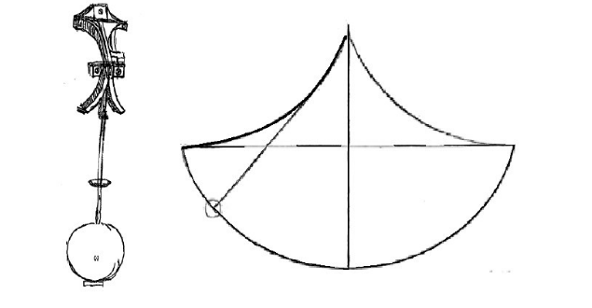

Objective

Calculate the relationship between the initial displacement and the period of a single pendulum mathematically.

Conduct an experiment to verify our calculation result.

Calculate and construct a tautochronous pendulum.

Conclusion

In this project we explored simple pendulum and isochronous pendulum.We began our project from the calculation about the period of mathematical pendulum. Base on the obtained result, we conducted an experiment and verified that the initial displacement do have certain effect on the oscillation period of the pendulum.

Besides, we further study how to make the period of a single pendulum independent of its initial displacement. By adding two plates on the sides, we altered the length of the pendulum to make it isochronous. Through calculation, we got the curve function of the plates and constructed a mathematical model of Huygens pendulum which is absolutely isochronous.

In the future research, we may continue this topic and exploring it further by building and analyzing the real Huygens pendulum to study how to make real pendulum isochronous, that is, to eliminate the influence of external factors such as the rotation of the earth.