Given the equation $\frac{d^{2}s}{{dt}^{2}}=-ks$, now we want to find a parametrization of this cycloid.

The second law gives us:

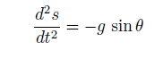

Combining these two equations

s=g/K sinθ

Differentiate the equation

ds = g/K cosθ dθ (1)

On the other hand, ds= $\sqrt{{(\frac{dx}{dt})}^{2}+{(\frac{dy}{dt})}^{2}}dθ$. And Since the normal component of the speed is 0:

$\frac{dx}{dt}sinθ=\frac{dy}{dt}cosθ$ (2)

Combining the two equation, we get ds = dx / cos θ,

$$\frac{ds}{dt}=\frac{dx}{cosθdt}$$

substitute (1) into it

$$\frac{dx}{dt}=\frac{g}{2k}(1+cos2θ)\frac{dθ}{dt}$$

From equation(2) we get

$$\frac{dy}{dt}=\frac{g}{2k}sin2θ\frac{dθ}{dt}$$

Multiply both sides with dt and integrate both sides, we get

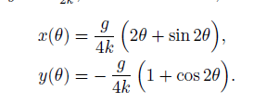

Now we can show such curve is a cycloid