**Apparatus**

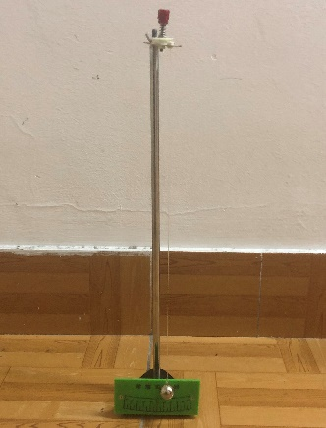

The pendulum we use is like the photo above. There is a screw on top of the equipment which is used to adjust the length of the string.

What’s more, an iron ball is hung at the tail of the string to move in the trajectory of a circular arc.

A ruler and an angle gauge is used to measure the string length and the tilt angle.

**Experiment**

In this experiment we make several trials with the pendulum.

By the equation:

$$T=2π\sqrt{\frac{l}{g}}(1-\frac{{θ_{0}}^{2}}{16})$$

We can see that the period of the pendulum depends on the length of the string and the initial tilt angle.

**Ⅰ.** **Procedure 1**

First, we control the tilt angle to be the same, so that we can get the relation between period and string length.

We define the initial angle to be 45˚ and adjust the string length. Then we release the ball and begin to take the period when it pass the equilibrium point the second time.

We take 10 periods to minimize the error.

The table below shows the relation between period and string length

\begin{table}[H]

\centering

\begin{tabular{|c|c|c|c|}}

\hline

n & θ(˚)±1(˚) & L(m)±0.01(m) & 10T(s)±0.01(s) &*uT*

\hline

1 & 45 & 0.54 & 14.91 & 2.93×10-3

\hline

2 & 45 & 0.58 & 15.18 & 2.83×10-3

\hline

3 & 45 & 0.60 & 15.86 & 2.78×10-3

\hline

4 & 45 & 0.68 & 16.30 & 2.61×10-3

\hline

5 & 45 & 0.70 & 16.88 & 2.57×10-3

\hline

6 & 45 & 0.72 & 16.95 & 2.54×10-3

\end{tabular}

\caption{Table 1: Period vs. length}

\end{table}

**Ⅱ. Procedure 2**

Then we make another trial on the relation between the period and the initial tilt angle by control the string length at the same.

Fix the screw on the top to fix the string length. Then change the initial angle to release the ball.

The table below shows the relation between period and angle.

\begin{table}[H]

\centering

\begin{tabular{|c|c|c|c|}}

\hline

n & L(m)±0.01(m) & θ(˚)±1(˚) & 10T(s)±0.01(s) &*uθ*

\hline

1 & 0.60 & 15 & 15.18 & 8.88×10-4

\hline

2 & 0.60 & 30 & 15.53 & 1.78×10-3

\hline

3 & 0.60 & 45 & 15.58 & 2.66×10-3

\hline

4 & 0.60 & 60 & 15.78 & 3.55×10-3

\hline

5 & 0.60 & 75 & 15.93 & 4.44×10-3

\hline

6 & 0.60 & 90 & 16.07 & 5.33×10-3

\end{tabular}

\caption{Table 2: Period vs. *θ0*}

\end{table}