

83186710

YIHUA ZHOU

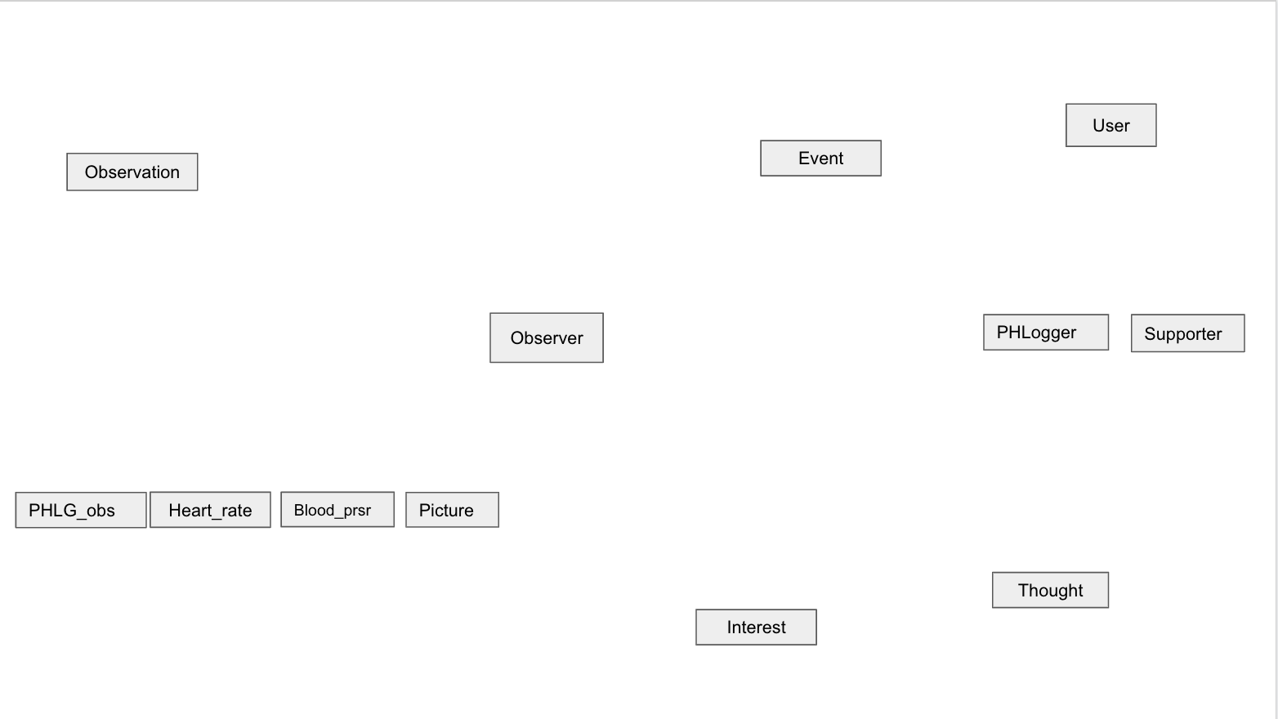

Text Value

Enter Time

Start Time

Systolic Pressure

Diastolic Pressure

Role

Primary Phone Number

Postal Code

State

Street Address

City

PHL ID

Password

Email Address

End Time

Original value

Event Name

Residence Address

Name

Phone Number

Thought Number

Textual Description

Date

Topic

Name

Description

Label

Image

Rate

AD Hoc Comment

Event ID

Kind

Manufacturer

Model

Software system Name and Version

Observer ID

End Time

Start Time

Observation ID



A given observation is either observed by an observer or recorded(manually) by a user

So:

Observation set A not overlaps Observation set B

Observation sets A and B are total participation

PHLogger overlaps Supporter

PHLogger and Supporter cover user

A

P

1

Offered

M

P

About

K

L

Membered In

ISA

ISA

1

N

N

Happened

1

N

Owned

1

1

B

Observed

P

Indicated

1

Recorded