**Assignment Final Project Report**

Student Name : Yi-Huei Ho

Student ID : 0116074

Student email address : [ann09285734@gmail.com](mailto:ann09285734@gmail.com)

**[10%] Introduction [ at least 100 words]**

**WORD COUNT: 110**

In this assignment, the program consists of C++ code and asm code. The program is called through the C main function, and the assembly procedures will be called while the program is being executed. There are two parts of this system. One is that the user can show my student ID and control the moving direction or the color of it. The other part is that the user can change the color of the background image, or play a little game to reconstruct the image. In the game, the image is divided to 8 cells with grids, and the user can select two sub-images in the grid and swap them.

**[10%] Structure Chart [ at least 10 components]**

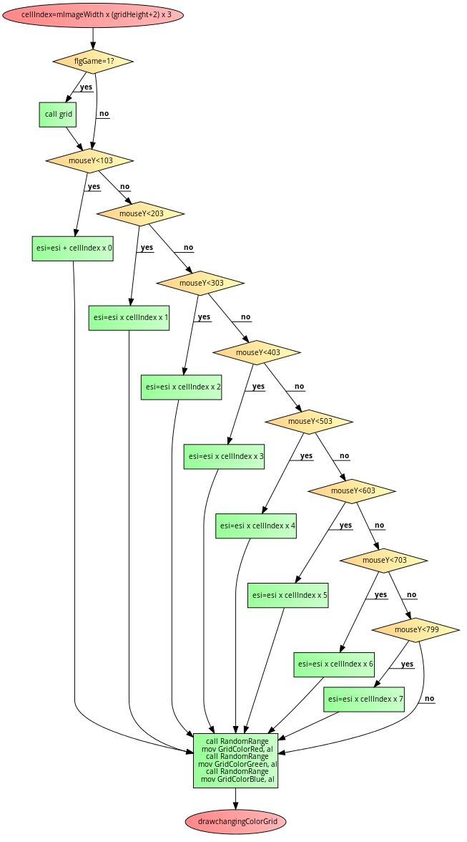

**[10%] Flow Chart**

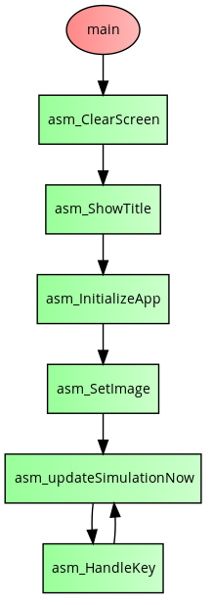Main: updateGame:

Update image:

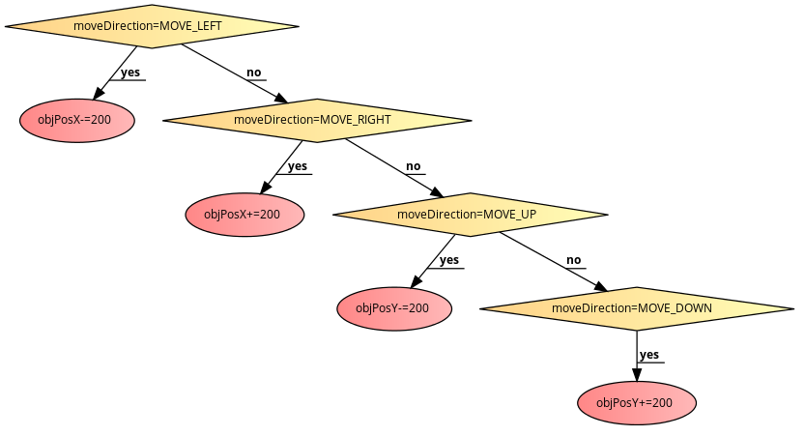

**[10%] System Architecture [at least 100 words]**

**WORD COUNT: 126**

They are two parts in this program, one part is C++ code and one part is asm code. 10 files are written in C++, including 5 header files. The C++ files respectively handle image, openGL, shape, particle system and the main process. In the asm file, they are many procedures which deal with the key usage, dialogue box, colors of objects, position of objects, position of image, color of image pixels and particle systems. Some procedures are called by C main function to return information such as the color of the objects, position of the objects, number of the objects, and the color of the pixel. Some information such as the database of the original image and mouse event are pass by C main function too.

**[30%] The approach [ at least 300 words]  
WORD COUNT: 430**

一開始先把我的姓名學號信箱以及key usage指令存在CaptionString和MessageString中，再呼叫MsgBox來顯示。接著讀取鍵盤輸入，若鍵盤輸入＂i＂則會顯示/隱藏我的學號。我先將學號用bitmap的方式存成七個數字的map。接著讀取bitmap，若等於1就將位置資訊依序存入objPosX和objPosY中，接著再將它們顯示出來。若鍵盤輸入”a”/”d”我就會將objPosX減100/加100；若鍵盤輸入”w”/”s”我則會將objPosY減100/加100，來讓學號移動。接著background image的部分，一開始就先將影像的資訊存在mImagePtr0中，若鍵盤輸入”g”我會將mImagePtr0中每個pixel的r,g,b值=r+g+b/3；若鍵盤輸入”m”就將r,g值交換。鍵盤輸入”p”之後可以進入遊戲。我先計算每個cell總共佔掉array多少格存到cellindex中，這樣之後若要對第n個cell做事情，只要先mov esi, mImagePtr0，再將esi+cellindex*n即可找到起始位置。滑鼠按下的時候，根據mouseY來判斷是在哪一個cell，再將那個cell的邊框用一直random給顏色值的方式讓他閃爍。滑鼠按下第二次之後就可以交換兩個的內容。若鍵盤輸入”o”，我分七個步驟來讓subimage重新排序。第一個cell會跟下面其他7個的其中一個交換；第二個cell在和下面其他6個中的一個交換；第三個cell在和下面其他5個中的一個交換，依此類推。

**[20%] Discussion/Experiments [ at least 200 words]**

**WORD COUNT: 201**

The final project is far more complicated and difficult than the assignments that we did before. Though it’s quite similar with the third assignment that we have to deal with the objects and the background images, there are something new such as the mouse event and we have more things to do about the image. I think the most difficult part of this assignment is to divide the image to 8 cells with grid, and change the sub-image that the user selected. At first, it is really complicated to calculate the pixels’ positions of different cells, and I spent a lot of time to try it. But after I figured out the rule, it’s much easier to do it. The only thing is that, the code is really long and complex, so it’s really important to be patient and that my thought should be very clear. Some of my friends did not finish this assignment because they think it is too difficult. However I think that as long as we concentrate and don’t be impatient to try it, it is not that hard. And I really had a sense of accomplishment after I finished it, it is really a cool project.

**[10%] Conclusion [ at least 100 words]**

**WORD COUNT: 112**

Finishing this assignment is another breakthrough to me. It’s a really large and complicated system to implement it. Thought I spent almost one week to finish it, I think it’s really worthy. It’s the final project and I really learn a lot in this semester. Every time I did the assignment I think it’s difficult but also interesting too. I really gratitude professor’s teaching and I like assembly programing after I took the course. Now I can use assembly language to write some little games, change the color of an image, deal with mouse event and even swap the pre-images of an image. It’s really cool and fun to study assembly language.