Command DOT_P

Dot Precision – Z motion from moving to DispGap until UpGap is interpolated by Motion Card

Type 1: External Pump Operation (HM, PP, Timed)

Disp Gap

Dn Wait

Start Delay

Dispense

Trig

Off

On

End Delay

Post Wait

Ret Gap

Up Gap

Home

Ret Wait

Up Wait

Pump

(Time Mode)

Off

On

Note 1: Pump Dispense time is less the Needle at Disp Gap.

Note 2: Pump Dispense time is more than DnWait + StartDelay + EndDelay + PostWait. Material is dispensing while moving up.

Note 1

Dn Wait

Start Delay

Post Wait

Ret Wait

Up Wait

Note 2

End Delay

Z Pos

Pump

(Purge Mode)

Off

On

Dispense Time

Dispense Time

External Pump Timing Chart

Type 2: SynchroPulse (SP) Operation

Disp Gap

Dn Wait

Dispense Time

Dispense

Off

On

Post Wait

Ret Gap

Up Gap

Home

Ret Wait

Up Wait

Z Pos

Note:

If (StartDelay > 0) Dispense Time = StartDelay

Else Dispense Time = SP DispTime.

Note

SynchroPulse Timing Chart

Type 3: Time Pressure (TP) Operation

Disp Gap

Dn Wait

Dispense

Off

On

Post Wait

Ret Gap

Up Gap

Home

Ret Wait

Up Wait

Z Pos

Start Delay

End Delay = 0

Dn Wait

Ret Wait

Up Wait

Start Delay

End Delay > 0

End Delay

Dispense while moving Up

End Delay implemented after RetGap.

Time Pressure Timing Chart

Command LINE_MULTI

|  |  |  |
| --- | --- | --- |
|  | Line Count | Define the total number of lines. |
| Line No  – Position of the Selected Line No.  Line 0 | Current selected Line No. |
| Pos XY | Position of the Selected Line.  Line 0 is the MoveTo Position. |
| Length | Length of the Selected Line.  Line 0 has not value. |
| Disp | Set the Selected Line Dispense On/Off |
| Model No | Model No of the Selected Line. |
| OK | Confirm and update settings and close window. |
| Cancel | Discard settings and close window. |

Disp Gap

Dn Wait

Post Wait

Ret Gap

Up Gap

Home

Z Pos

Start Delay

End Delay = 0

Ret Wait

Up Wait

End Delay > 0

End Delay

XY Pos

M0, DispGap

M1, DispGap

M1, LineSpeed

M2, LineSpeed

M2, DispGap

M3, DispGap

M4, DispGap

M3, LineSpeed

M4, LineSpeed

Line 1

Line 2

Line 3

Line 4

Line 0

Dispense

Off

On

Disp 1 > 0

Disp 2 > 0

Disp 3 > 0

Disp 4 > 0

LINE_MULTI Timing Chart

Command LAYOUT

1. Select Wafer Mode True.
2. Enter maximum Column and Row Count.
3. Enter Top Left Indice(TLI), Top Right Indice(TBI) and Bottom Left Indice(BLI).
4. Set TLI -> TRI -> BLI in sequence.
5. Select PreMap out of edge.

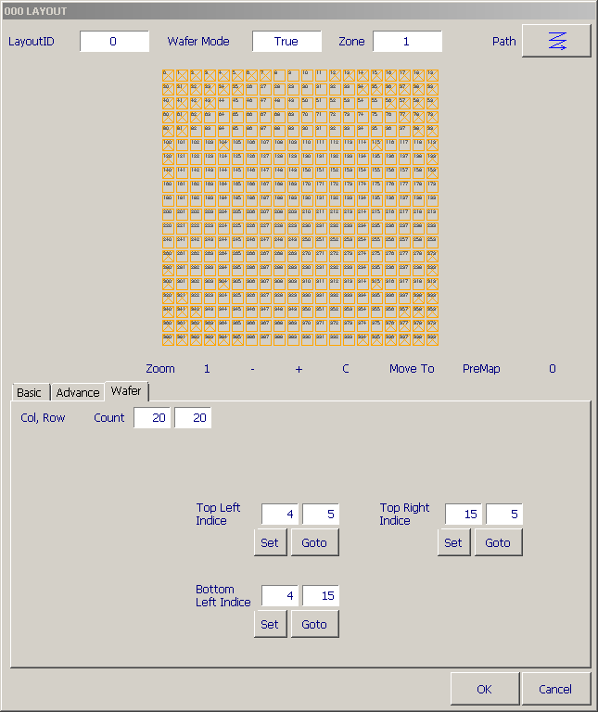

Top Right Indice

Top Left Indice

Top Bottom Indice

0

20

20

0

Column ->

Row

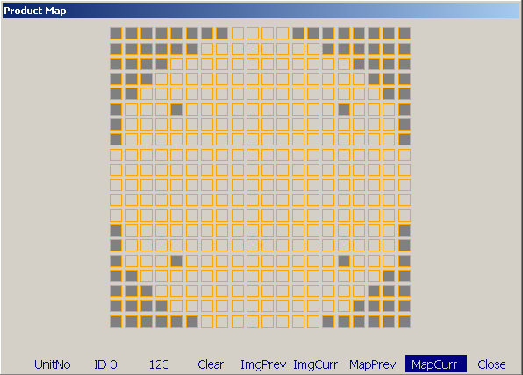

Wafer Layout