**Appendices**

**Appendix 1 : Pictures**

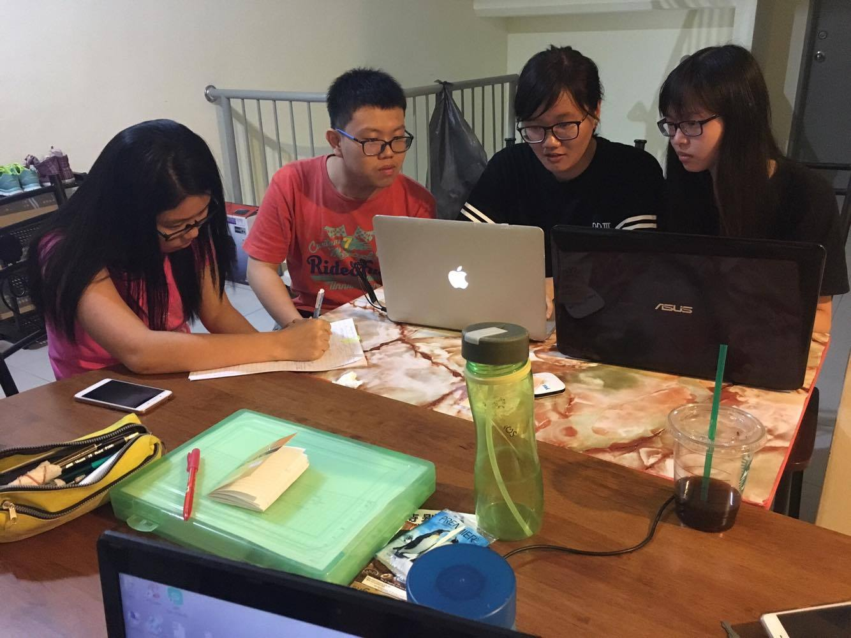

Figure 1: Members are discussing and working on the proposal.

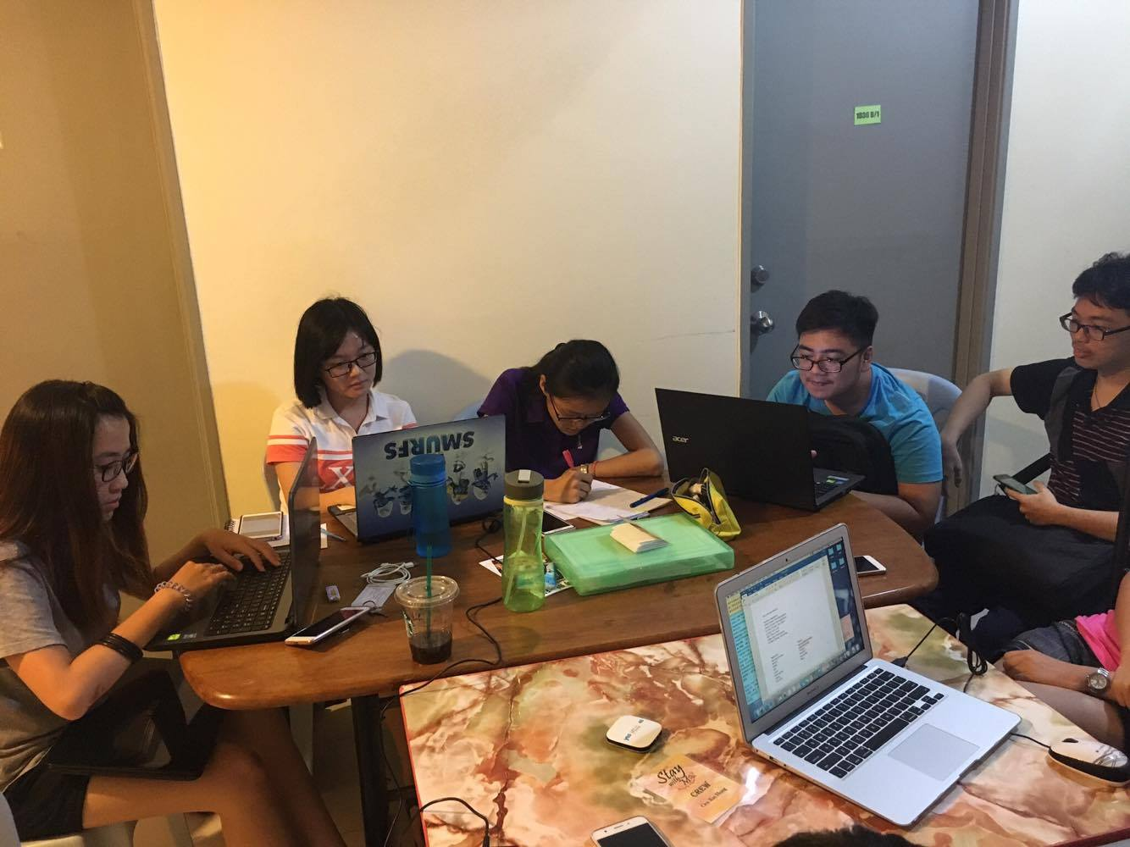

Figure 2: Members are discussing and working on the proposal.

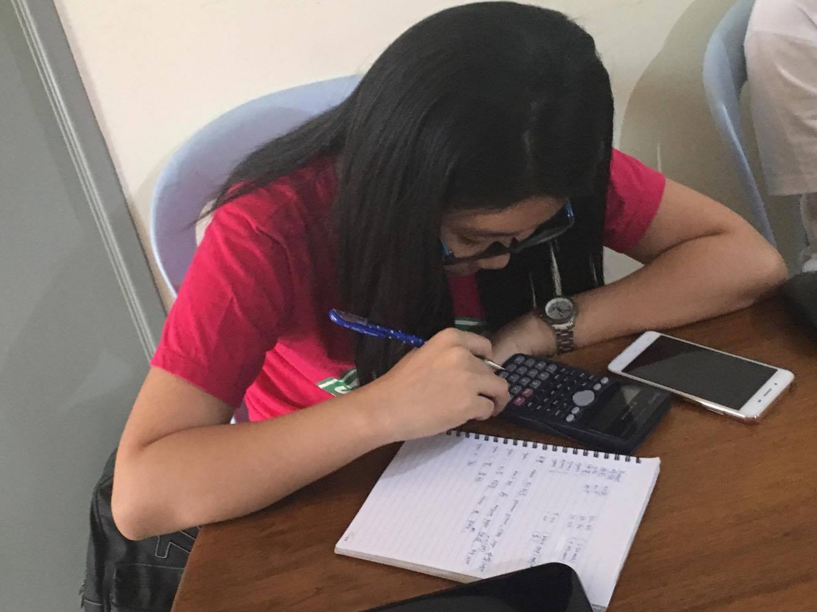

Figure 3: Our treasurer is trying to calculate the budget for the project.

**Appendix 2 : Information from the meeting**

Program flow on 19/11/2016 Saturday (Week 5)

9am-9.40am: Registration

9.40am-9.50am: Opening ceremony

9.50am-10.10am: Morning exercise

10.10am-12.10pm: Talk + demo

12.10pm-1pm: Lunch

1pm-1.30pm: Drama

1.30pm-3pm: Station games

3pm-3.30pm: Closing + prize giving+ photo

|  |  |  |
| --- | --- | --- |
| ***Date/Time*** | ***Activities*** | ***Others*** |
| 19 November 2016 (Saturday) |  |  |
| 9.00 am - 9.40 am | Registration | -Registration form (Participant’s name-BM, BC), Guardian’s contact number, class, things requirement, any allergy, any vegetarian)  -pen (4)  -subgroup (8 colour papers)  -committees (how many people?) |
| 9.40 am - 9.50 am | Opening ceremony | -cut ribbon (how many people, who cut?)  -scissors (how many?)  -committees (how many people?)  -souvenir for headmaster |
| 9.50 am - 10.10 am | Morning Exercise | -song (what song, how many?)  -who guide? (how many people?)  -divide in large group or small group? |
| 10.10 am - 12.10 pm | Talk | -demo  -speaker (microphone)  -microphone (how many?)  -souvenir for speaker |
| 12.10 pm - 1.00 pm | Lunch | -committees (preparation of station games and drama), (others stay at canteen)  -after lunch, bring participants go back to the hall  -need to sing some song? |
| 1.00 pm - 1.30 pm | Drama | -committees (preparation for station games and drama)  -some committees follow the group that have been assign |
| 1.30 pm - 3.00 pm | Station games | -be careful (committees and participants)  -PA system (one person) (responsible for record time)  -try the games, materials and props (set up one week before the event)  -every committee need to know all the rules of the games and how to play the games (preparation for any eventualities) |
| 3.00 pm - 3.30 pm | Closing ceremony | -prize giving (bookmark)  -leader bring all group members up stair to take photo  -group photo taking section |

**Appendix 3 : Station Games Details**

|  |  |  |
| --- | --- | --- |
| **No** | **Games** | **Description** |
| 1 | “Drawings transferred” | A person in the group will be given a noun and he or she is required to preset the noun in a picture. After that, he or she is required to show the drawing to the following person and this will continue until the last person. Hence, the last person will need to guess the noun that presented by the drawing. Group that can successfully guess the most correct noun will be the winner for this station. |
| 2 | “Box Walk” | There will be a box which consists of 9 blocks. Hence, 5 participants in a group will be blinded, while the other 5 group members will need to aid the blinded members to walk into the 9 blocks in the box. Any group that can form a line (either vertical, horizontal, or diagonal) will reconsidered as winner. |
| 3 | “Mixed Beans” | Countless green beans and red beans will be mixed together in a bowl. The participants are given a straw to pick the red beans and move them to another empty bowl prepared. Any green beans that is transferred to the empty bowl will be treated as a penalty. Group with the most red beans and least green beans will be the winner for this station. |
| 4 | “Gestures Guess” | A sentence will be given to a group, which requires few group representatives to act the sentence via their body movement without giving any verbal. Hence, the remaining group members are required to guess the complete sentence without any error. Group which can answer the most sentences will be the winner for this station |

**Appendix 4 :Station Game Schedule**

|  |  |  |  |  |  |  |  |  |
| --- | --- | --- | --- | --- | --- | --- | --- | --- |
|  | “Drawing Transferred” | | “Box Walk” | | “Mixed Beans” | | “Gesture Guess” | |
| Team 1 | Team 2 | Team 1 | Team 2 | Team 1 | Team 2 | Team 1 | Team 2 |
| Round 1 | 1 | 5 | 2 | 6 | 3 | 7 | 4 | 8 |
| Round 2 | 2 | 6 | 1 | 5 | 4 | 8 | 3 | 7 |
| Round 3 | 3 | 7 | 4 | 8 | 1 | 5 | 2 | 6 |
| Round 4 | 4 | 8 | 3 | 7 | 2 | 6 | 1 | 5 |