**Practical 3 extra exercises**

A movie theater only keeps a percentage of the revenue earned from ticket sales. The remainder goes to the distributor. Write a program that calculates a theater’s gross and net box office profit for a night. The program should ask for the name of the movie, and how many adult and child tickets were sold. (The price of an adult ticket is rm6.00 and a child’s ticket is RM3.00). It should display a report similar to the following:

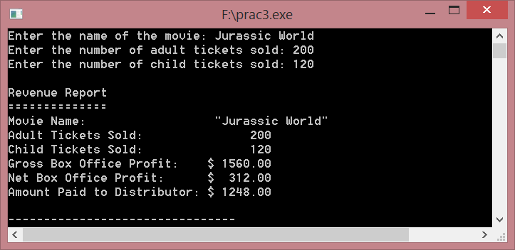

Assume the theater keeps 20% of the gross box office profit.

Q2. Write a program that will convert US dollar amounts to Japanese Yen and to euros, storing the conversion factors in the constant variables YEN_PER_DOLLAR and EUROS_PER_DOLLAR. Use the following exchange rates.

1 dollar = 123.65 yen

1 dollar = 0.90 euros

Q3. Write a program that asks the user for an angle, entered in radians. The program should then display the sine, cosine, and tangent of the angle. The output should be displayed in fixed-point notation, rounded to four decimal places of precision.