**Practical 3 extra exercises solution**

A movie theater only keeps a percentage of the revenue earned from ticket sales. The remainder goes to the distributor. Write a program that calculates a theater’s gross and net box office profit for a night. The program should ask for the name of the movie, and how many adult and child tickets were sold. (The price of an adult ticket is rm6.00 and a child’s ticket is RM3.00). It should display a report similar to the following:

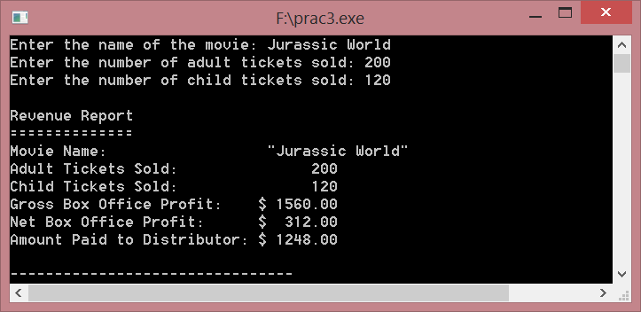

Assume the theater keeps 20% of the gross box office profit.

#include <iostream>

#include <string>

#include <iomanip>

using namespace std;

int main()

{

// Constants

const double PERCENTAGE_KEPT = 0.2; // Percentage kept by theater

const double ADULT_PRICE = 6.0; // Adult ticket price

const double CHILD_PRICE = 3.0; // Child ticket price

// Variables

string movieName; // The name of the movie

doublenetProfit; // The theater's net profit

doublegrossProfit; // The theater's gross profit

double distributor; // The amount paid to distributor

intadultTickets; // The number of adult tickets sold

intchildTickets; // The number of child tickets sold

// Get the name of the movie.

cout<< "Enter the name of the movie: ";

getline(cin, movieName);

// Get the number of adult tickets sold.

cout<< "Enter the number of adult tickets sold: ";

cin>>adultTickets;

// Get the number of child tickets sold.

cout<< "Enter the number of child tickets sold: ";

cin>>childTickets;

// Calculate gross profit.

grossProfit = (adultTickets * ADULT_PRICE) +(childTickets * CHILD_PRICE);

// Calculate the net profit.

netProfit = PERCENTAGE_KEPT * grossProfit;

// Calculate the distributor's profit.

distributor = grossProfit - netProfit;

// Display the report.

cout<< "\nRevenue Report\n"

<< "==============\n"

<< "Movie Name: "<< "\"" <<movieName<< "\"" <<endl

<< "Adult Tickets Sold: " <<setw(8) <<adultTickets<<endl

<< "Child Tickets Sold: " <<setw(8) <<childTickets<<endl

<< fixed <<showpoint<<setprecision(2)<< "Gross Box Office Profit: $"

<<setw(8) <<grossProfit<<endl

<< "Net Box Office Profit: $" <<setw(8) <<netProfit<<endl

<< "Amount Paid to Distributor: $" <<setw(8) << distributor <<endl;

return 0;

}

Q2. Write a program that will convert US dollar amounts to Japanese Yen and to euros, storing the conversion factors in the constant variables YEN_PER_DOLLAR and EUROS_PER_DOLLAR. Use the following exchange rates.

1 dollar = 123.65 yen

1 dollar = 0.90 euros

#include <iostream>

#include <iomanip>

using namespace std;

int main()

{

// Constants

const double YEN_PER_DOLLAR = 123.65;

const double EUROS_PER_DOLLAR = 0.90;

double dollars; // Amount of US dollars

double yen; // Amount of Japanese Yen

double euros; // Amount of Euros

// Get the amount of dollars

cout<< "Enter a dollar amount: ";

cin>> dollars;

// Perform the conversions.

yen = dollars * YEN_PER_DOLLAR;

euros = dollars * EUROS_PER_DOLLAR;

// Display the results.

cout<< "\nCoversion Results\n"

<< "-----------------\n"

<< fixed <<showpoint<<setprecision(2)

<<yen<< " Yen\n"

<<euros<< " Euros\n\n";

return 0;

}

Q3. Write a program that asks the user for an angle, entered in radians. The program should then display the sine, cosine, and tangent of the angle. The output should be displayed in fixed-point notation, rounded to four decimal places of precision.

#include <iostream>

#include <cmath>

#include <iomanip>

using namespace std;

int main()

{

double angle; // To hold the angle

// Get the angle in radians from the user.

cout<< "Enter an angle in radians: ";

cin>> angle;

// Display the sine, cosine, and tangent of the angle.

cout<<setprecision(4) << fixed <<showpoint

<< "\nSine: " <<setw(8) << sin(angle)

<< "\nCosine: "<<setw(8) << cos(angle)

<< "\nTangent: "<<setw(8) << tan(angle)

<<endl<<endl;

return 0;

}