Practical 1 (answers)

- Write a program that produces the following output:

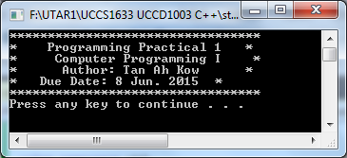

- Write a program that produces the following output:

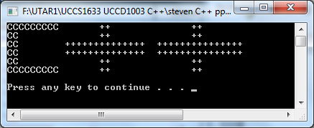

- Compile the program and observe the output.

#include <iostream>
using namespace std;
int main()
{
int num1;
int num2;
int num3;
int average;

num1 = 125;
num2 = 28;
num3 = -25;
average = (num1 + num2 + num3) / 3;

cout << "num1 = " << num1 << endl;
cout << "num2 = " << num2 << endl;
cout << "num3 = " << num3 << endl;
cout << "average = " << average << endl;
system("pause");
return 0;
}

- Repeat exercise 3 by declaring num1, num2 and num3, and average of type double. Store 75.35 into num1, -35.56 into num2, and 15.76 into num3.

- Debug the program.

#include <iostream>;
using namespace std
int main()
{
int length
int width
int area
int perimeter

cout << Enter the length:
cin >> length
cout << endl

cout << Enter the width:
cin >> width
cout << endl

area = length * width
perimeter = 2 * (length + width)

cout << Area = << area << endl
cout << "Perimeter = " << endl
syetem("pause")
return 0
}

- Compile the program and observe the output.

#include <iostream>
#include <string>
using namespace std;

int main()
{
string name;
double studyHours;

cout << "Enter first name: ";
cin >> name;
cout << endl;

cout << "Enter study hours: ";
cin >> studyHours;
cout << endl;

cout << "Hello, " << name << "! On Saturday, you "
<< "need to study " << studyHours
<< " hours for the exam." << endl;
system("pause");
return 0;
}

- Write a program that prompts the user to enter five test scores and then prints the average test scores. (Assume that the test scores are decimal numbers).

