Practical 1 (answers)

- Write a program that produces the following output:

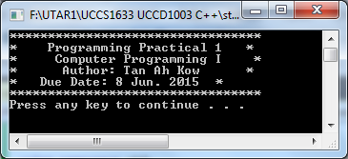

Answer
#include <iostream>
using namespace std;
int main()
{
cout << "*********************************" << endl;
cout << "* Programming Practical 1 *" << endl;
cout << "* Computer Programming I *" << endl;
cout << "* Author: Tan Ah Kow *" << endl;
cout << "* Due Date: 8 Jun. 2015 *" << endl;
cout << "*********************************" << endl;
system("Pause");
return 0;
}

- Write a program that produces the following output:

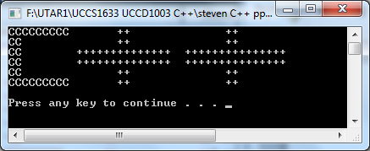

Answer

#include <iostream>
using namespace std;
int main()
{
cout << "CCCCCCCCC ++ ++" << endl;
cout << "CC ++ ++" << endl;
cout << "CC ++++++++++++++ +++++++++++++++" << endl;
cout << "CC ++++++++++++++ +++++++++++++++" << endl;
cout << "CC ++ ++" << endl;
cout << "CCCCCCCCC ++ ++" << endl;
cout << endl;
system("pause");
return 0;
}

- Compile the program and observe the output.

#include <iostream>
using namespace std;
int main()
{
int num1;
int num2;
int num3;
int average;

num1 = 125;
num2 = 28;
num3 = -25;
average = (num1 + num2 + num3) / 3;

cout << "num1 = " << num1 << endl;
cout << "num2 = " << num2 << endl;
cout << "num3 = " << num3 << endl;
cout << "average = " << average << endl;
system("pause");
return 0;
}

Answer

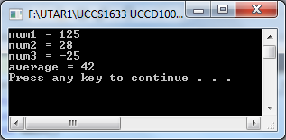

- Repeat exercise 3 by declaring num1, num2 and num3, and average of type double. Store 75.35 into num1, -35.56 into num2, and 15.76 into num3.

Answer

#include <iostream>
using namespace std;

int main()
{
double num1;
double num2;
double num3;
double average;

num1 = 75.35;
num2 = -35.56;
num3 = 15.76;
average = (num1 + num2 + num3) / 3;

cout << "num1 = " << num1 << endl;
cout << "num2 = " << num2 << endl;
cout << "num3 = " << num3 << endl;
cout << "average = " << average << endl;
system("pause");
return 0;
}

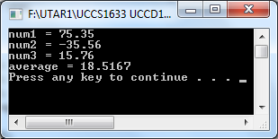

- Debug the program.

#include <iostream>;
using namespace std
int main()
{
int length
int width
int area
int perimeter

cout << Enter the length:
cin >> length
cout << endl

cout << Enter the width:
cin >> width
cout << endl

area = length * width
perimeter = 2 * (length + width)

cout << Area = << area << endl
cout << "Perimeter = " << endl
syetem("pause")
return 0
}

Answer

#include <iostream>
using namespace std;
int main()
{
int length;
int width;
int area;
int perimeter;

cout << "Enter the length: ";
cin >> length;
cout << endl;

cout << "Enter the width: ";
cin >> width;
cout << endl;

area = length * width;
perimeter = 2 * (length + width);

cout << "Area = " << area << endl;
cout << "Perimeter = " << perimeter << endl;
system("pause");
return 0;
}

- Compile the program and observe the output.

#include <iostream>
#include <string>
using namespace std;

int main()
{
string name;
double studyHours;

cout << "Enter first name: ";
cin >> name;
cout << endl;

cout << "Enter study hours: ";
cin >> studyHours;
cout << endl;

cout << "Hello, " << name << "! On Saturday, you "
<< "need to study " << studyHours
<< " hours for the exam." << endl;
system("pause");
return 0;
}

Answer

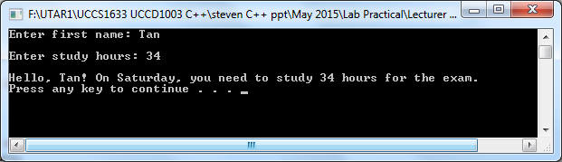

- Write a program that prompts the user to enter five test scores and then prints the average test scores. (Assume that the test scores are decimal numbers).

Answer

#include <iostream>
using namespace std;
int main()
{
double test1, test2, test3, test4, test5;

double average;

cout << "Enter five test scores: ";
cin >> test1 >> test2 >> test3 >> test4 >> test5;
cout << endl;

average = (test1 + test2 + test3 + test4 + test5) / 5.0;

cout << "Average test score: " << average << endl;
system("pause");
return 0;
}

