Practical 4

- If x = -4, y = 5 and z = 0, determine whether the following expressions is (1) or (0) by
showing the steps:

a) ! ( 2 + 7 * y >= z – 4 )
b) true || false && true
c) y – 2 * z < x * 2 / 3

- Write a C++ statement that prints the message “Pass” if the variable marks is within the range 50 to 100.

- Write a C++ statement that prints the message “Invalid marks” if the variable marks is not within the range of 0 to 100.

- Write a program that would get three (3) inputs of numbers from user. With reference to the numbers:
  - Determine the largest and smallest number
  - Determine the average of the numbers
  - Determine the total number of odd or even number

- Write a program that is able to determine the cost of freight/delivery based on distance and weight. The charges are as shown the table below:
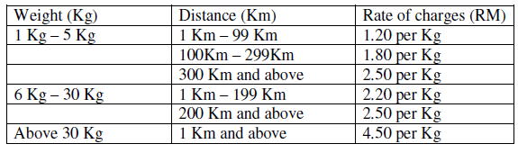

The program should prompt the user for the weight and distance in order to determine the respective rate per Kg. The calculation of total cost is based on the rate per Kg multiply by the total Kg. The program should also display output of calculations accordingly.

- Rewrite the following code using a ternary conditional expression:

if (value == ‘A’)
cout << “Value is A”;
else
cout << “Value is not A”;

- Rewrite the following code fragment using switch statement:

if (grade = = ‘A’ || grade = = ‘a’)
++count_A;
else if (grade = = ‘B’ || grade = = ‘b’)
++count_B;
else if (grade = = ‘C’ || grade = = ‘c’)
++count_C;
else if (grade = =‘D’|| grade = =‘d’|| grade = =‘F’|| grade = =‘f’)
{
++other;
cout << “Lower grade.\n”;
}
else
cout << “Incorrect grade entered.\n”;

