Practical 5 (answers)

- Compare and contrast post increment and pre increment.

++num1: pre increment. Increment shall be performed before any other operations within the line.
Example: ++n – 1 (n shall be added with a value of 1 before the subtraction operation)

num1++: post increment. Increment shall be performed after any other operations within the line.
Example: n++ – 1 (Operation of subtraction shall be performed first before the n value will be added with 1)

- Identify if below statements are valid expressions.

  - for (sum = 0, i = 3; i<10; i++)
  - while (counter = 0, num <= 0)
  - for (i=0, j=4; i<8; i++)
  - do { …

}while (num = 7, num<10);

Answer
- Valid
- Valid
- Valid
- Valid but may be an infinite loop.

- Determine the output of the below fragment

a. #include <iostream>
using namespace std;

int main()
{
int x=2, y=3, i;

for(i=0; i<5; i++)
{
x = x++ + y++;
y = ++y + ++x;
cout << x << "\t" << y << "\n";
}

return 0;
}

Answer

7 12
21 35
58 95
155 252
409 663

b. #include <iostream>
using namespace std;

int main()
{
int x=0;

do {
cout << x << endl;
x++;

if (x >=10) break;

} while ( x < 100);

cout << "End of testing\n";

return 0;
}

Answer
0
1
2
3
4
5
6
7
8
9
End of testing

- Determine the output for the below program segments without using C compiler.

    - y = 8;
while (y>7)
{
cout << y << endl;
}

Answer
8 but prints endlessly.

ii. for (k = 10; k > 8;)
{
cout << k << endl;
}

Answer
10 but prints endlessly.

iii. z = 3;
do {
cout << z << endl;
}while (z<9);

Answer
3 but prints endlessly.

  - Rewrite the missing “loop update” in the above program segments.

Answer

    - y = 8;
while (y>7)
{
cout << y << endl;
y--;
}

    - for (k = 10; k > 8; k--;)
{
cout << k << endl;
}

iii. z = 3;
do {
cout << z << endl;
z++;
}while (z<9);

- Write a C++ that would prompt the user on the total number of double values that he/she wants to enter to the system. If user input 10, then the program needs to input 10 doubles values. Calculate the total of the 10 inputs and display the outcome.

Answer
#include <iostream>
#include <iomanip>
using namespace std;

int main()
{
int nd, cnt = 1;
double total = 0.0;
double num;

cout << "Please enter the number of double values that you want to input : \n";
cin >> nd;

while (1 <= nd)
{
cout << "Please enter the number " << cnt << " double value : ";
cin >> num;
total = total + num;
nd--;
}

cout << "The total is : " << total << endl;
system("pause");
return 0;
}

- Generate following outcome using nested-for loop

(i) 12
1234
123456
12345678

Answer
#include <iostream>
#include <iomanip>
using namespace std;

int main ()
{
for (int a = 1 ; a <= 4 ; a++)
{
for (int b = 1 ; b <= a * 2; b++)
cout << b;
cout << endl;
}

system ("pause");
return 0;
}

(ii) &&&&&
&&&&
&&&
&&
&

Answer
#include <iostream>
using namespace std;

int main ()
{
for (int a = 5 ; a >= 1 ; a--)
{
for (int b = 1 ; b <= a ; b++)
cout << "&";
cout << endl;
}

system ("pause");
return 0;
}

- Explain the following type of loops:
(i) Control Controlled loop
(ii) Sentinel Controlled loop
(iii) Flag Controlled loop

Answer:
(i) The number of iterations is control the Counter (N). Normally used when the number of repetitions are known in advance.

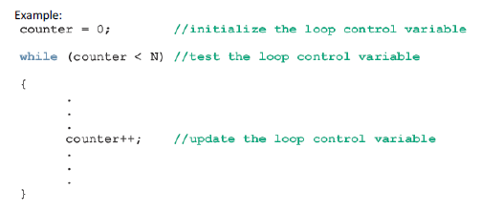

(ii) Number of iterations is unknown but the last entry (Sentinel value) is known in order to stop the iterations.

Example:
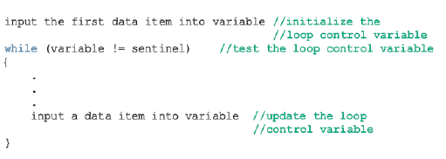

(iii) Flag or Boolean value to stop the iterations. So long as the Boolean is fulfilled the iteration stops.

Example:
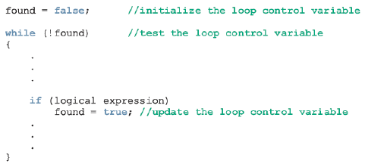

- Write a C++ program that is able to perform summation of value input by user.
For example : 5 = 5 + 4 + 3 + 2 + 1 (Display the steps and outcome accordingly)

Answer
#include <iostream>
#include <iomanip>
using namespace std;

int main()
{
int val = 0, sum = 0;

cout << "Please enter a value for summation calculation : \n";
cin >> val;
cout << val << " = ";

while (val >= 1)
{
if (val == 1)
cout << val << endl;
else
cout << val << " + ";

sum = sum + val;
val--;
}
cout << "The sum is " << sum << endl;

system("pause");
return 0;
}

- Write a program that asks the user to enter some positive integer numbers and end the input with -1. The program will display total numbers entered, largest number, smallest number, total of the numbers, and the average as shown in the following output.

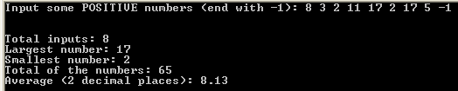

Answer
#include <cstdlib>
#include <iostream>
#include <iomanip>

using namespace std;

int main()
{
int count = 0;
int n;
int sum = 0;
int largest;
int smallest;

cout << "Input some POSITIVE numbers (end with -1): ";
cin >> n;

while (n != -1){

if (count == 0) {
largest = smallest = n;
}
if (n>largest) {
largest = n;
}
if (n<smallest) {
smallest = n;
}
sum += n;
count++;

cin >> n;

}
//cin.get(ch);

cout << endl << endl;
cout << "Total inputs: " << count << endl;
cout << "Largest number: " << largest << endl;
cout << "Smallest number: " << smallest << endl;
cout << "Total of the numbers: " << sum << endl;
cout << fixed << showpoint;
cout << setprecision(2);
cout << "Average (2 decimal places): " <<
static_cast<double>(sum) / count << endl;

system("PAUSE");
return 0;
}

- Explain with codes the difference between Post Test Loop and Pre Test Loop

Answer:
Post-Test Loop
The statement executes first, and then the expression is evaluated. The statement
would be executed at least once.
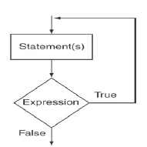

Pre-Test Loop
The statement shall only be executed once the expression is evaluated to be true.

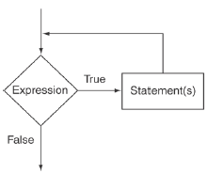

- Differentiate between continue statement and break statement applying in a
loop.

Answer:
break:
When used in a loop it would terminate the execution of the loop.

#include <iostream>
using namespace std;

int main ()
{
for (int a = 1; a <= 5 ; a++)
{
if (a == 3)
break;
cout << a << endl;
}

system ("pause");
return 0;
}

The loop is stopped on execution of 3rd loop as the break statement is executed. The output of the program is :
1
2
(The 3 cycle of iteration is being braked therefore the cout would not display 3)

continue:
When used in a loop, it would skip one iteration. The current iteration is skipped.

#include <iostream>
using namespace std;

int main ()
{
for (int a = 1; a <= 5 ; a++)
{
if (a == 3)
continue;
cout << a << endl;
}

system ("pause");
return 0;
}

The loop would only stop for one cycle or iteration. The outcome of the program is
1
2
4
5
3 is missing because the 3rd iteration was interrupted before the cout.

