Practical 6

- What will be the output for the following code, if the input for a=3, b=5, c=4 and d=6?

int main ( )
{
...

...

r = strange (a, b);
s = strange (r, c);
k = strange (strange (s, d), strange (4, 2));
u = strange (r, s+3);

cout << r << " " << s << " " << k << " " << u << endl;
}

int strange (int x, int y)
{
int t;
int z;

t = x+y;
z = x*y;

return (t+z);
}

- Determine the value of each of the following expressions.
  - abs(-4)
  - fabs(10.8)
  - fabs(-2.5)
  - pow(3.2, 2)
  - pow(2.5, 3)
  - sqrt(25.0)
  - sqrt(6.25)
  - pow(3.0, 4.0)/ abs(-9)
  - floor(28.95)
  - ceil(35.2)

- Write a program that is able to determine total pay of wages for an employee based on the total hours worked per week. Given that the pay rate is RM6.00 / hour. If the employee works more than 30 hours, he/she is allowed to claim for overtime. The rate for each additional hour contributed by the worker after 30 base hours is 3 times of the based hours (6.00/hour * 3). Your program should include two functions namely

BasePay(hours contributed with no overtime) and
OverTime(hours contributed after the base of 30 hours)

Both the functions need to accept the necessary argument and return the result accordingly.

- Write a program that gets an input of character from user. Create a function
named vowel that accepts char that entered by user as argument and return a
Boolean value to indicate whether the character passed to the function is a vowel character.

Character checked must be case sensitive. Display the outcome of the program in the main function.

- Write a complete program that reads in the lengths of the two sides of a right
triangle (a and b). The length of the hypotenuse (h) is then calculated and displayed.
a
b
h

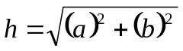

Note: To compute use the cmath library functions.

Sample output:

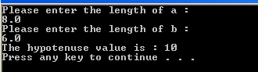

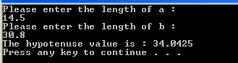

- Write a program that allows the user to calculate commission. The commission is calculated using a function. If the user calls the function 3 times, the total commission earned shall be accumulated in a total. The calculation of commission is the total sales multiply by 12%. (Note: Demo your program with calling of your function for 3 times).

  - Implement your solution using a global variable (total)

  - Implement your solution using a reference variable (&total)

(Kindly ask your students to observe the difference of each implementation)

