Practical 8

- If the below arrays are to be printed out, what will be the output produced:

  - int numbers [6] = {0,1,4,3,2,7};
  - int numbers [6] = {0,1,2,3,4};
  - int numbers [6] = {0,0,0,0,0,0};
  - int numbers [6] = {0};
  - int numbers [ ] = {6, 4, 5, 7};

- Write declaration of array for the below cases:
- Array to store 5 numbers of student id and student cgpa;
- Array to store 10 employee details, such as emp_id, dept_id, salary and age
- Array to store 20 types of whiteboard (whiteboard id) that differs in terms of its’ length and width.

- Write a ‘loop’ statement to print out the below array and determine the output of the fragment:

for (int i = 0; i<10; i++)
{
score[i] = i+23;
}

- Write a program that accepts up to 20 integers test scores in the range of 0 to 100 from the user and stores them in an array. The main should report how many perfect scores were entered (i.e. scores of 100), using a value-returning countPerfect function to help it.

- Write a program that is able to prompt user to enter eight (8) integer values. The program shall store all the values entered onto an array. The program then should replace all the odd number values found in the array with the value -111. Display the
results of before and after changes of the array.

- Write a program that shall prompt the user to enter 10 character values. All the character values shall be stored onto an array. Determine how many of the
characters entered are in uppercase, lowercase and is a digit.

- Given that the following are the marks of a particular student: 70, 62, 72, 89, 90, 56, 40, 13, 16, 99. Store all the values onto an array. Write a program is able to determine the total grades that he / she obtain. In the sequence of how many As , Bs, Cs or Fs obtained. The grades are determined using the table below:

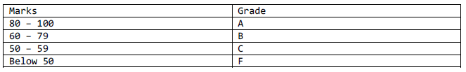

Sample output:
Number of A: 3
Number of B : 3
Number of C : 1
Number of F : 3

- Write a program that will store the integer values onto two arrays:
Array 1: 10, 12, 15, 89, 90, 56, 45, 103, 116, 99
Array2: 17, 29, 91, 92, 176, 265, 299, 212, 345, 348

Add the elements of both arrays in accordance to index/subscript and store the outcome onto another array in accordance to index as well.
For example array1[8] + array2[8] and store the outcome onto result[8].

