- Registration Module
User interface design Screen Shot:
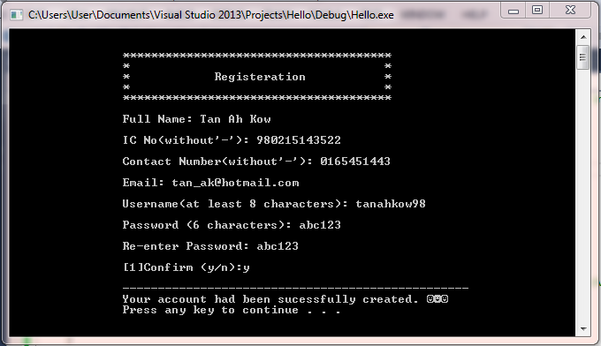
Test Plan and Results:
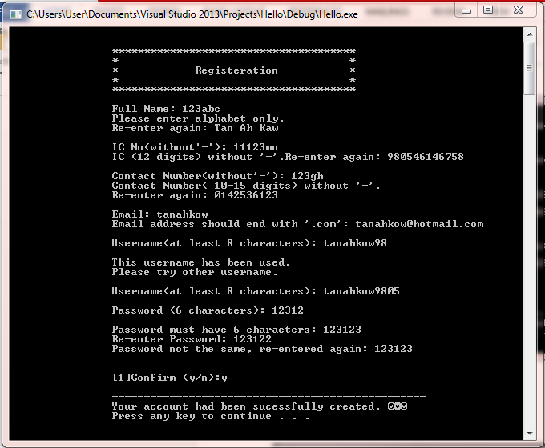
Description:
This registration module allow user to register a new account by key in their personal data, including their full name, identity card number (ic number), contact number and E-mail address. When the user enter their information, this program will validate it. As an example, for the full name, only alphabet are allowed to key in; for the ic number, user are restricted to insert only 12 digits (without ‘-’); for contact number, user are restricted to insert 10 to 15 digits (without ‘-’); for E-mail address, it must end with ‘.com’. If the user does not do so, the program will prompt the requirement for every input and ask the user to key in their information again. Besides, username and password are also needed in the registration module. For the username, at least 8 characters are required, if the username is used by others, the program will request the user to key in another username. For the password, user are restricted to insert 6 characters only, if the user key in more than that or less than that, the user will be request to key in again. The password will be request to key in twice in order to confirm the user’s password. If both of the password are different, the program will request the user to re-enter the password.
Specialty & Limitation of the program:
One of the specialty of the register module is it can create different file for different user to save their information permanently. This action could prevent any data lose and call the data easily. Other than that, it can ensure that all of the information entered is valid. This can solves a lot of unwanted problems from retrieving the invalid names in future.
The limitation of the program is it could only validate the E-mail address by requesting for an input end with ‘.com’, it can’t validate for every types of E-mail address such as Yahoo, Hotmail, Gmail and so on.
Self-Review and Future Improvement:
As the developer for the program, I am responsible for the flow of the program by taking in only the valid input for every information, and notify the user when he or she enter the invalid input by prompt them to re-enter the particular data which is valid.
For future improvement, I will try to open a file that save all of the type of E-mail address that will check the valid input for E-mail address to against the only limitation for this module.
Flow Chart

- Login Module
User interface design Screen Shot:
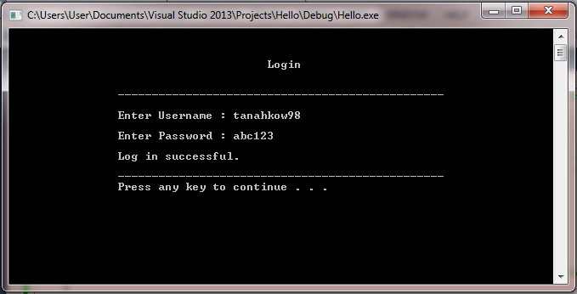

Test Plan and Results:
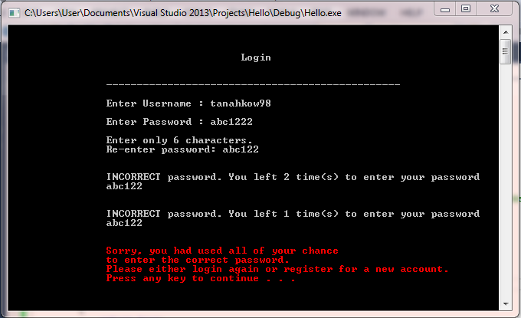

Description:
For this login module, user allowed to login with their own account. The input required is username and password. For the username, if the user key in the incorrect username, the program will prompt the user that the account does not exist and will request user to register for a new account. For the password, if the password entered is incorrect, the program given only two more chances to enter the correct password, if all the chances had been used, the program will request the user to either login again or register for a new account.

Specialty & Limitation of the program:
The specialty of the login module is it take role as a strong security system. The program will call an input file by using the username entered by user only, which can protect the privacy of the user as different user has different file to save their personal data, and prevent the leaking of user’s information.
The limitation of the program is it can only request the user to either login again or register for a new account instead of directly lock the account temporary.

Self-Review and Future Improvement
As the developer of this program, I am responsible for the safety of the program to allow the user feel relieve while using the Hotel Reservation System. The program will only allow the user to log in if the username and the password saved in the respective file are matched.
For future improvement, I will try to modify the program which allow it to lock the file of the account once all the chances for enter the correct password had been used, this will improve the security of the program, which indirectly create a stronger security system.

Flow Chart

- Search Module
User interface design Screen Shot:
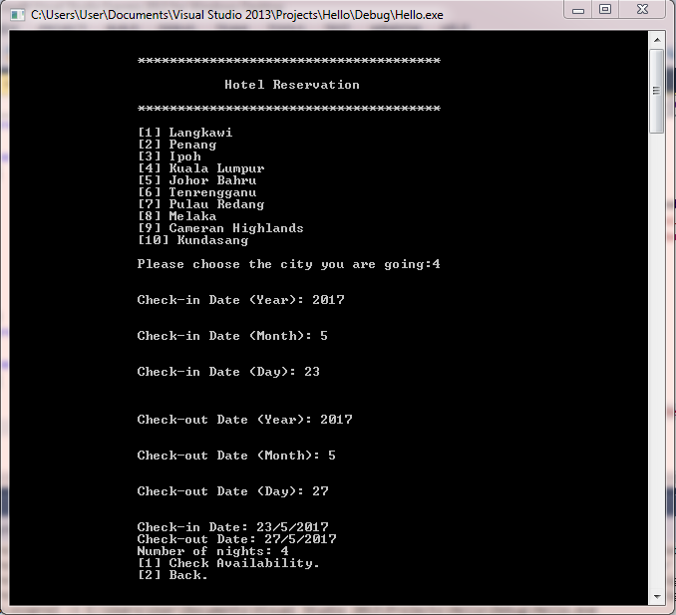

Test Plan and Results:
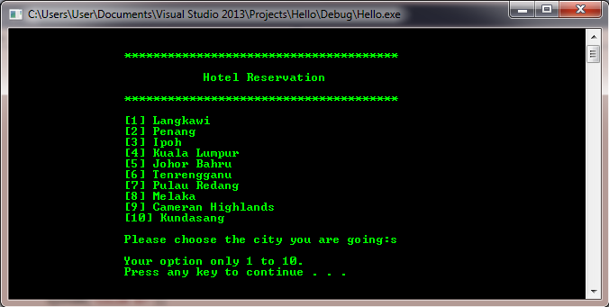

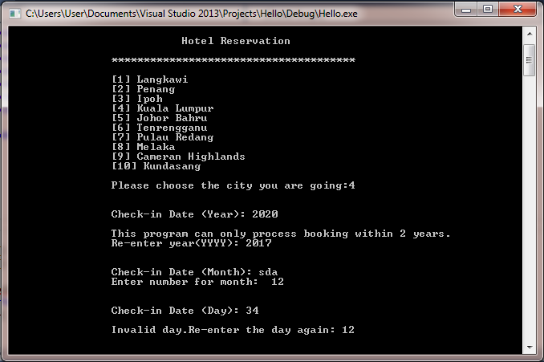
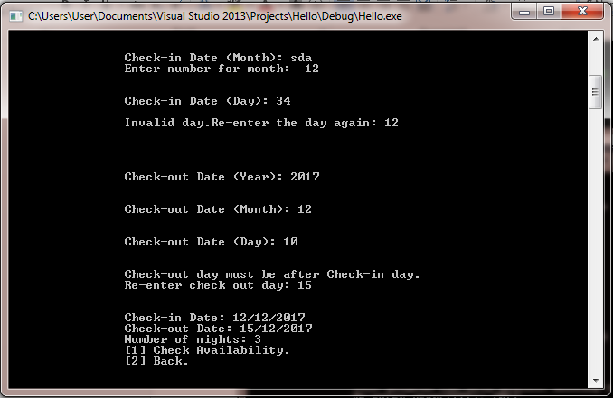

Description:
For this search module, user allowed to choose the destination of their trip, enter their check-in date and check-out date for the hotel. The choices for the destination are only the places that the hotels located, user required to enter their choice by enter only the number. The program will request the user to re-enter their choice if their input is invalid. For the date, the program will validate the input if non-digit value had been entered; validate the ‘year’ if the input is before this year; validate the ‘month’ if the input is more than 12; validate the ‘day’ for different month. For the check-out date, the program will validate if the check-out date entered is before the check-in date. Moreover, the program will then calculate the number of nights that the user reserves for the hotel, if the number of nights is more than 15 nights, the program will request the user to contact with customer service center by calling the contact number given.

Specialty & Limitation of the program:
One of the specialty of this search module is it could validate the date entered by the user for different month as different month has different number of days. As an example, February 2018 has 29 days and February 2019 has only 28 days. Besides, the program also ensure a valid input for both the choice of the places and the confirmation.
The limitation of the program is it can only validate the date day by day, month by month and year by year instead of validate all together. This will make the program seems longer and more complicated.

Self-Review and Future Improvement:
As the developer of the program, I take my responsible to notify the user if he or she enter an invalid date and prompt them to re-enter the date which is valid. Moreover, I need to inform the user about the number of nights that he or she reserved for.
For future improvement, I will try to include more choices, places for the user to select. Besides, I will put more effort to modify the validation of the date to allow the user enter the date easier.

Flow Chart

- View Module
User interface design Screen Shot:
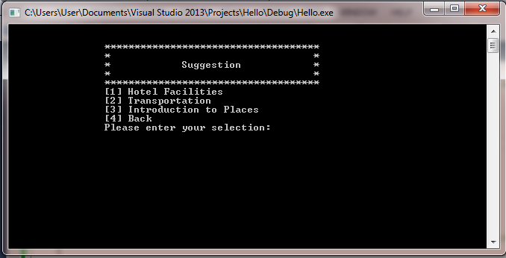

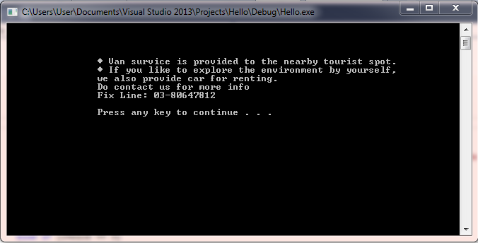
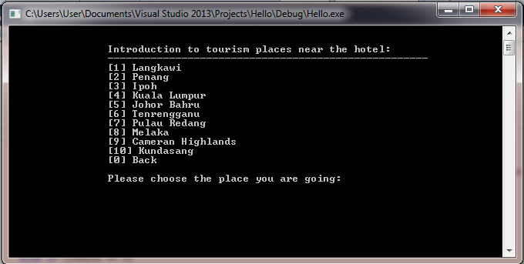

By choosing option 6
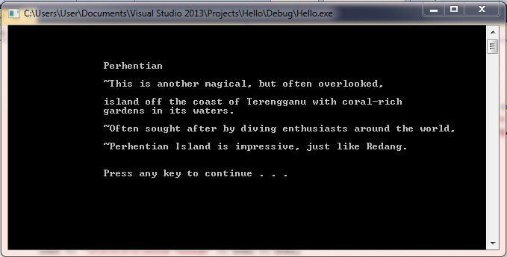

Test Plan and Results:
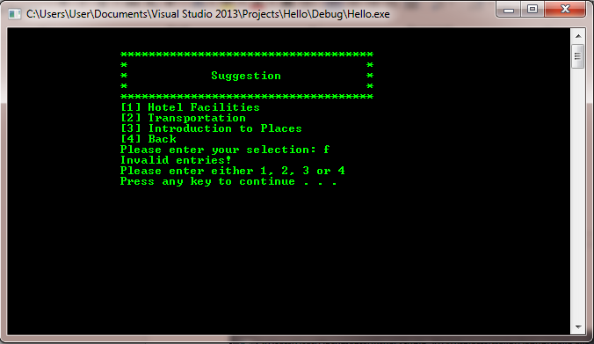

Description:
For the view module, user could choose four options. Option 1 will lead the user to have a brief information about the hotel; option 2 will show the user about the transportation provided by the hotel; option 3 will introduce to the user that the tourism place that near the hotel for respective places. Besides, the program also ensure a valid input for all the input entered, and only 1, 2, 3, 4 is valid for the page of “suggestion”, else the program will prompt the user that his or her input is invalid. For option 3, inside the page of “Introduction to Places”, only 0 to 10 is valid input, else the program will also prompt the user that the input is invalid and request for re-enter.

Specialty & Limitation of the program:
The specialty of this view module is it could save the work and time for the user who are planning to have a trip, as the program will introduce the tourism place and the transport provided to the user which saving their time for researching.
The limitation of the program is it is less attractive as it contains too much words for suggestion, and due to the limitation of C++, it will be more boring as it can’t insert picture with the scenery of places.

Self-Review and Future Improvement:
As the developer of the view module, I am liable to establish a simple, understandable and interesting program for user. Besides, the information supplied to user must be adequate and trustable.
For future improvement, I wish I could able to display the scenery of places even by using coding, which could improve the program by modifying it becomes more interesting.

Flow Chart

- Payment module
User interface design Screen Shot:
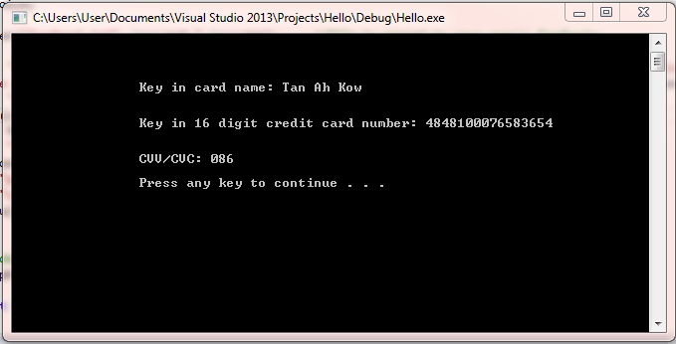

Test Plan and Results:
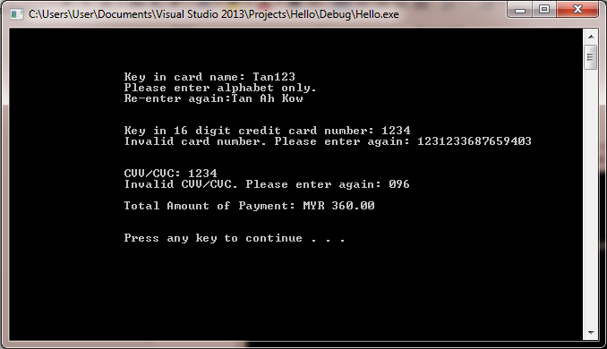

Description:
For the payment module, the user is allowed to enter their card name, credit card number and the CVV or CVC code, the program will then display the total amount paid and also the booking number to the user. On the other hand, the program could validate the card name to enter only alphabet; validate the credit card number must be only 12 digits; validate the CVV or CVC code must be only 3 digits. If the input is invalid, the program will prompt the user to re-enter the valid input.

Specialty & Limitation of the program:
The specialty of the payment module is it could allow user to pay their hotel reservation fees by credit card via online instead of paying by cash, and the user can arrange, manage financially and estimate their spending before travelling. This action could prevent the user to bring too many cash along with them during their trip.
The limitation of the program is it can accept all the credit card number either exist or non-exist, as the program could not compare the input with exist credit card number.

Self-Review and Future Improvement:
As the developer of the program, I have the liability to alleviate unnecessary problem for the user, indirectly increase the confidence of the user when using the Hotel Reservation System. Besides, I can’t validate whether the credit card number is exist or not.
Thus, for the future improvement, I will try to include every valid credit card number from every bank system, which could enhance the function of this payment module.

Flow Chart

- Feedback module
User interface design Screen Shot:
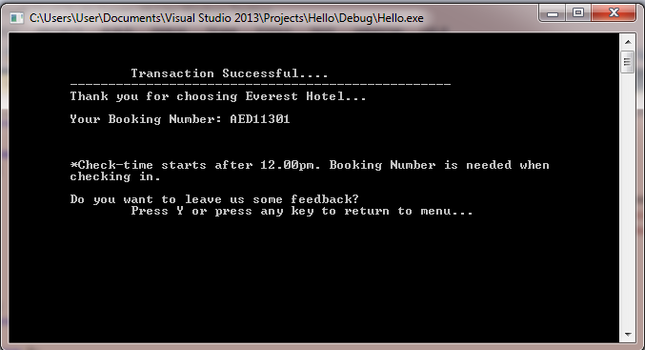

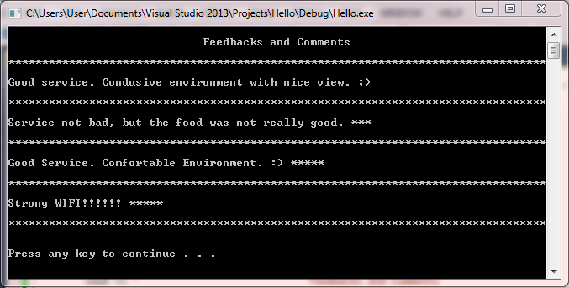

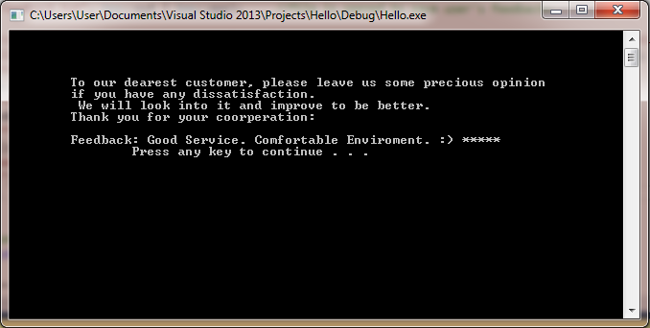
Description:
For the feedback module, user is allowed to enter their feedback. The program will accept every input, no data validation is inserted in this feedback module and it could save every feedback into a file named “feedback.txt” for the customer service of the hotel could have a look of their feedback.
Specialty & Limitation of the program:
The specialty of the feedback module is to allow user to provide feedback base on any impression about the hotel service for future improvement of the hotel, and allowing other customers to have preview of the hotel.
The limitation of the program is it will display all the feedback that saved inside the file exclude the user who wrote it, which indirectly decrease the authenticity of the feedback.
Self-Review and Future Improvement:
As the developer of the feedback module, I bear the responsibility to accept all the impression without any changes from the user include good and bad. At the same time, I must display the feedback to other customer for them to preview the hotel.
For the future improvement, I will try to display the feedback together with the name of the customer who entered it.
Flow Chart

- Update module
User interface design Screen Shot:
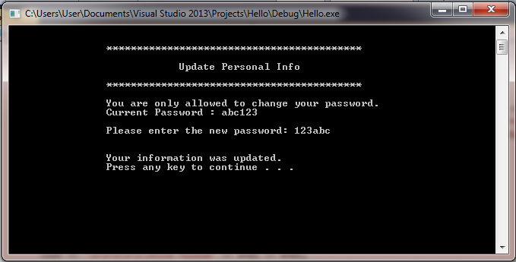

Description:
For the update module, user is required to enter their current password and allowed to make a change for their password by enter a new password. The program will call the file base on the username that the user enter, and get the current password from the file. If the password entered is different with the current password in the file, the program will request the user to key in the correct current password. To update the new password is just to replace the old password.

Specialty & Limitation of the program:
One of the specialty of the update module is it could allow the user to update their own password which increase the safety of their personal data indirectly. Other than that, the program will display the personal data of the user.
The limitation of the program is it only allow user to update their password, if other information is incorrect, then it will be incorrect forever.

Self-Review and Future Improvement:
As the developer of the program, I am responsible to the safety of the user by notify the user to re-enter the current password if the password and the username does not match, until the correct current password is entered.
For future improvement, I will try to improve the update module by increase the amount of data that can be update by user such as contact number and E-mail address.

Flow Chart

- Reservation Module
User interface design Screen Shot:
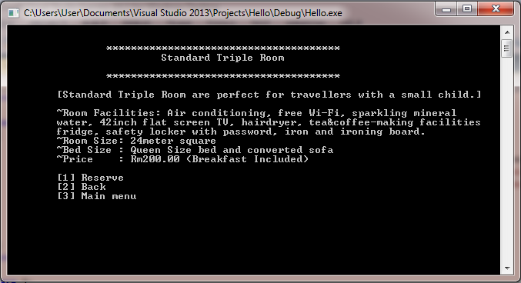

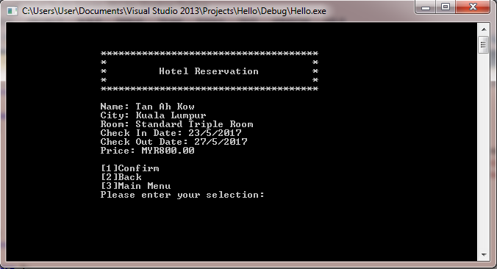

Test Plan and Results:
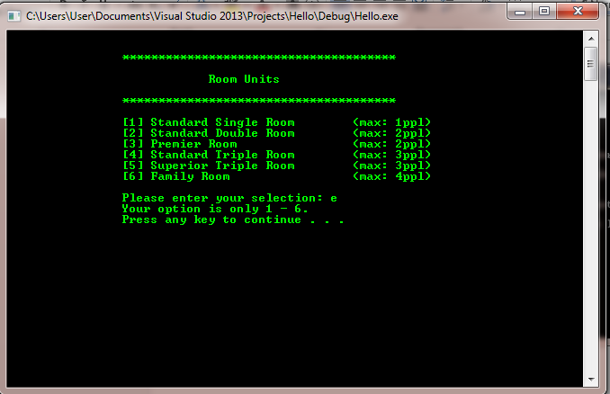

Description:
For the reservation module, the user is allowed to enter the choice of the room that he or she wants to reserve, and the program will display his or her information include full name, the destination, choice of room, check-in and check-out date, and also the total price for the hotel room. Moreover, the program will validate the input of the choice of room which the user can only enter digits 1 to 6.
Specialty & Limitation of the program:
The specialty of the reservation module is it prompt the user the details for every hotel room which offer the user to have a brief understanding for every hotel room before he or she makes decision, to ensure them have no regret for choosing our hotel room.
The limitation for the program is it has only six choice of rooms are allowed to be chosen, some of the user may not satisfy with the hotel rooms provided.
Self-Review and Future Improvement:
As the developer of the program, I assume the responsibility of the contentment of our customer which I must provide more and more types of hotel room, and make the reservation of the hotel room as simple as possible, just by a clicking.
Thus, for future improvement, I will try to increase the choice of hotel rooms and simplify the step to reserve a hotel room.

Flow Chart

- Discount Module
User interface design Screen Shot:
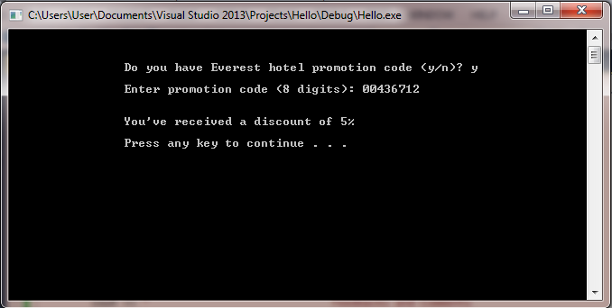

Test Plan and Results:
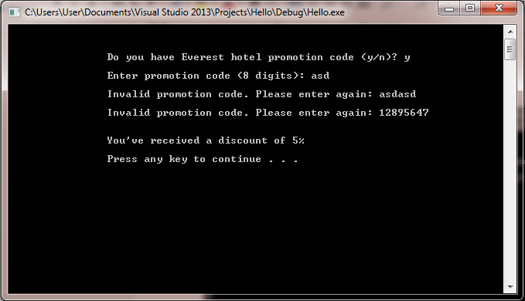

Description:
For the discount module, user is required to enter an 8 digits promotion code to get a 5% promotion. The program will validate the input and request the user to key in only 8 digits number, and the program will calculate the total price with a 5% discount.

Specialty & Limitation of the program:
The specialty of the program is it could give a discount for any user who have the promotion code that release from the company of the hotel, which could increase the revenue of the hotel.
The limitation of the program is any 8 digits promotion code is accepted for the system.

Self-Review and Future Improvement:
As the developer of the discount module, I bear the liability of the profit and the advantages of the company, the amount of the release of code must be limited.
Therefore, for future improvement, I will try to create a file that save all the promotion code the released to the market, and the file will be opened in the discount module to validate the input by the user.

Flow Chart

