**The Application of Linear System**

The systems of first-order differential equation can be applied to solve many real world problems. In this paper, we will discuss on three areas which are pond pollution, price forecasting, and love affairs.

1. **Pond Pollution**

Systems of first-order ODE can be used to estimate the amount of pollutant in the connected ponds and determine the long time behavior of the pond pollutant. The diagram below shows three ponds connected with streams.

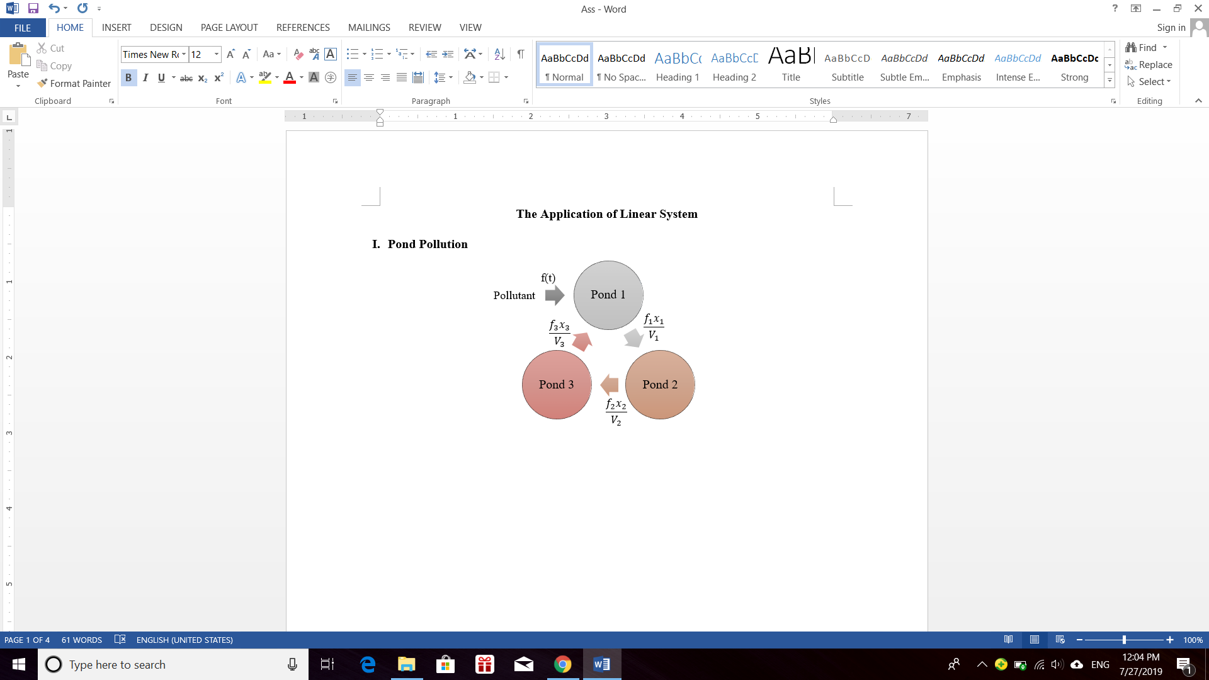

Let $f(t)$ = pollutant flow rate to pond 1 (lb/min).

$f_{i}$ = pollutant flow rates out of pond *i*, *i* = 1, 2, 3 (gal/min).

$V_{i}$ = volumes of pond *i*, *i* = 1, 2, 3 (gal).

$x_{i}(t)$ = amount of pollutant in pond *i*, *i* = 1, 2, 3 (lbs).

From the diagram, we get

${x^{'}}_{1}\left(t\right)=f\left(t\right)+\frac{f_{3}}{V_{3}}x_{3}\left(t\right)-\frac{f_{1}}{V_{1}}x_{1}\left(t\right)$

${x^{'}}_{2}\left(t\right)=\frac{f_{1}}{V_{1}}x_{1}\left(t\right)-\frac{f_{2}}{V_{2}}x_{2}\left(t\right)$

${x^{'}}_{3}\left(t\right)=\frac{f_{2}}{V_{2}}x_{2}\left(t\right)-\frac{f_{3}}{V_{3}}x_{3}\left(t\right)$

Given that $\frac{f_{i}}{V_{i}}=0.001, i=1,2,3$,

and let $f\left(t\right)=0.125 lb/min$ for the first 2880 minutes, after that $f\left(t\right)=0$.

Due to the uniform mixing, there will be $\left(0.125\right)\left(2880\right)=360$ pounds of pollutant uniformly deposited. Each pond will contain 120 pounds of pollutant.

Knowing that $x_{1}\left(0\right)=x_{2}\left(0\right)=x_{3}\left(0\right)=0$.

The problem for the first 2880 minutes is

${x^{'}}_{1}\left(t\right)=0.125+0.001x_{3}\left(t\right)-0.001x_{1}\left(t\right)$

${x^{'}}_{2}\left(t\right)=0.001x_{1}\left(t\right)-0.001x_{2}\left(t\right)$

${x^{'}}_{3}\left(t\right)=0.001x_{2}\left(t\right)-0.001x_{3}\left(t\right)$

$x_{1}\left(0\right)=x_{2}\left(0\right)=x_{3}\left(0\right)=0$

Arrange into matrix form,

$X^{'}=\left(\begin{matrix}-0.001 & 0 & 0.001 \\ 0.001 & -0.001 & 0 \\ 0 & 0.001 & -0.001\end{matrix}\right)X+\left(\begin{matrix}0.125 \\ 0 \\ 0\end{matrix}\right)$

After solving the problem, we get the general solution

$$x_{1}\left(t\right)=e^{-\frac{3t}{2000}}\left(\frac{125\sqrt{3}}{9}\sin\left(\frac{\sqrt{3}t}{2000}\right)-\frac{125}{3}\cos\left(\frac{\sqrt{3}t}{2000}\right)\right)+\frac{125}{3}+\frac{t}{24} \\ x_{2}\left(t\right)=-\frac{250\sqrt{3}}{9}e^{-\frac{3t}{2000}}\sin\left(\frac{\sqrt{3}t}{2000}\right)+\frac{t}{24} \\ x_{3}\left(t\right)=e^{-\frac{3t}{2000}}\left(\frac{125}{3}\cos\left(\frac{\sqrt{3}t}{2000}\right)+\frac{125\sqrt{3}}{9}\sin\left(\frac{\sqrt{3}t}{2000}\right)\right)+\frac{t}{24}-\frac{125}{3}$$

When $t=2880 minutes$,

$x_{1}\left(2880\right)=162.30$, $x_{2}\left(2880\right)=119.61$, $x_{3}\left(2880\right)=78.08$

The pond 1, 2, and 3 will have 162.30 lbs, 119.61 lbs, and 78.08 lbs of pollutant respectively.

1. **Forecasting Prices**

Price forecasting is always a great concern for a company. By using the system of first-order differential equation, the price can be forecasted easily. The example below is regarding to the price forecasting of salon shampoo.

Let $x(t)$ = price of salon shampoo at time $t$.

$P(t)$ = production at time $t$.

$S(t)$ = sales at time $t$.

$I(t)$ = inventory at time $t$.

Since price and sales of the salon shampoo, the equation of $P\left(t\right)$ and $S(t)$ are given in term of price,

$P\left(t\right)=4-\frac{3}{4}x\left(t\right)-8x^{'}\left(t\right)$ (1)

$S\left(t\right)=15-4x\left(t\right)-2x^{'}\left(t\right)$ (2)

The system of DE is given as below

$x'\left(t\right)=k(I\left(t\right)-I_{0})$ (3)

$I'\left(t\right)=P\left(t\right)-S\left(t\right)$ (4)

Substitute (1), (2), and (3) into (4),

$x^{'}\left(t\right)= kI\left(t\right) -{ kI}_{0}$

$I^{'}\left(t\right)=\frac{13}{4}x\left(t\right)-6kI\left(t\right) +6{kI}_{0}-11$

Given $k=1, I_{0}=50, x\left(0\right)=10, I\left(0\right)=7$,

$x^{'}\left(t\right)= I\left(t\right) - 50$

$I^{'}\left(t\right)=\frac{13}{4}x\left(t\right)-6I\left(t\right) +289$

After solving the system, we obtain the solution

$x\left(t\right)=\frac{44}{13}+\frac{86}{13}e^{-13t/2}$

$I\left(t\right)=50-43e^{-13t/2}$

For long run, $t→∞$

$\lim_{t→∞}{x}\left(t\right)=\frac{44}{13}≈3.39$ $\lim_{t→∞}{I}\left(t\right)=50$

The price of the salon shampoo will be $3.39, while the inventory will be 50 units of salon shampoo in the long run.

1. **Love Affair**

In 1988, [Steven Strogatz](https://en.wikipedia.org/wiki/Steven_Strogatz) illustrated systems of coupled ODE to investigate the time-evolution of a love affair between two people. In the model, Romeo is a fickle lover. Romeo dislikes Juliet when she loves him, but loves her when she loses interest. On the other hand, Juliet loves Romeo when he loves her, and dislikes him when he hates her.

A simple model is given

$R'=-J$

$J'=R$

Let $R(t)$ = Romeo’s feelings for Julie at time t.

$J(t)$ = Julie’s feelings for Romeo at time t.

(positive value of $R$ and $J$ indicate love, negative values indicate hates, 0 indicates indifferent. )

$\left[\begin{matrix}R' \\ J'\end{matrix}\right]=\left[\begin{matrix}0 & -1 \\ 1 & 0\end{matrix}\right]\left[\begin{matrix}R \\ J\end{matrix}\right]$

$\left|A-Iλ\right|=\left|\begin{matrix}-λ & -1 \\ 1 & -λ\end{matrix}\right|=\left(λ^{2}+1\right)=0$

$λ=±i$

For $=i$,

$\left[\left.\begin{matrix}-i & -1 \\ -1 & -i\end{matrix}\right|\begin{matrix}0 \\ 0\end{matrix}\right]$

$\left(-i\right)k_{1}-k_{2}=0$

Let $k_{1}=1$, then $k_{2}=-i$

$X=c_{1}\left(\left[\begin{matrix}1 \\ 0\end{matrix}\right]\cos{t}-\left[\begin{matrix}0 \\ -1\end{matrix}\right]\sin{t}\right)e^{0t}+c_{2}\left(\left[\begin{matrix}0 \\ -1\end{matrix}\right]\cos{t}+\left[\begin{matrix}1 \\ 0\end{matrix}\right]\sin{t}\right)e^{0t}$

Given $R(0)$ = 10, $J(0)$ = 0,

$\left[\begin{matrix}10 \\ 0\end{matrix}\right]=c_{1}\left[\begin{matrix}1 \\ 0\end{matrix}\right]+c_{2}\left[\begin{matrix}0 \\ -1\end{matrix}\right]$

$c_{1}=10$, $c_{2}=0$

We obtain the general solution

$X=10\left(\left[\begin{matrix}1 \\ 0\end{matrix}\right]\cos{t}-\left[\begin{matrix}0 \\ -1\end{matrix}\right]\sin{t}\right)$

$R\left(t\right)=10\cos{(t)}$

$J\left(t\right)=10\sin{(t)}$

Substitute $t$ from 0 to 11, we get

|  |  |  |  |  |  |
| --- | --- | --- | --- | --- | --- |
| Month | Romeo | Juliet | Month | Romeo | Juliet |
| 0 | 10.0000 | 0 | 1 | 5.4030 | 8.4147 |
| 2 | -4.1615 | 9.0930 | 3 | -9.8999 | 1.4112 |
| 4 | -6.5364 | -7.5680 | 5 | 2.8366 | -9.5892 |
| 6 | 9.6017 | -2.7942 | 7 | 7.5390 | 6.5699 |
| 8 | -1.4550 | 9.8936 | 9 | -9.1113 | 4.1212 |
| 10 | -8.3907 | -5.4402 | 11 | 0.0443 | -9.9999 |
| 12 | 8.4385 | -5.3657 |  |  |  |

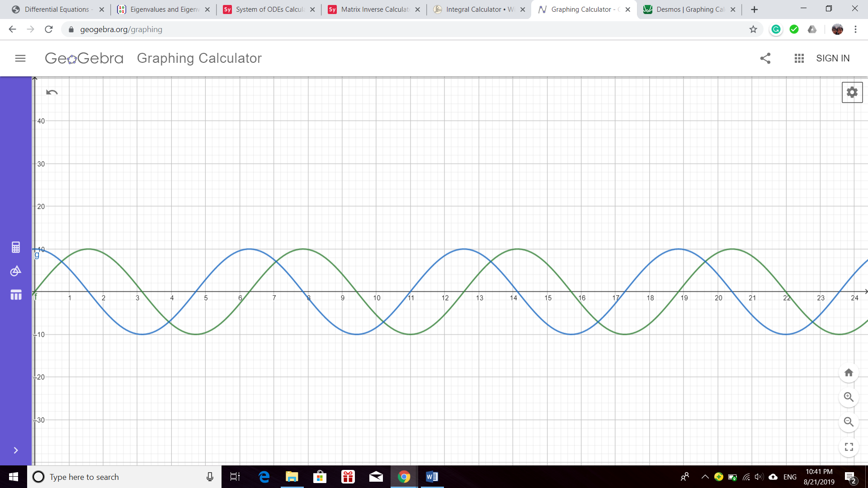

Romeo

10 cos (t)

Juliet

10 sin (t)

We found that it is a never ending cycle of love and hate.

**Reference**

*Systems of Differential Equations* [PDF]. (n.d.). Utah Math Department. Retrieved from http://www.math.utah.edu/~gustafso/2250systems-de.pdf

*Linear Systems of Differential Equations* [PDF]. (n.d.). University of North Carolina Wilmington. Retrieved from http://people.uncw.edu/hermanr/mat361/ODEBook/ Systems.pdf