**1.0 INTRODUCTION**

1.1 Background

Life expectancy is one of the major key indicators of population health condition and economic development of a country. Life expectancy at birth reflects the overall mortality level of a population. In this research, the objective of Global Health Observatory (GHO) data repository under World Health Organization (WHO) is to find out the factors that are related to the health status. This data set was related to life expectancy, health factors, and economic factors from 193 countries in the world. The sampled data was collected from year 2000 until year 2015. In this assignment, we retrieved some information from this data set and use this information to do some non-parametric tests.

1.2 Motivation

In this study, we wish to compare the Malaysia economy with Indonesia and Singapore since these two countries are located very closely to Malaysia. On the other hand, we wish to know whether there are relationships between life expectancy and GDP, life expectancy and BMI in year 2015. According to Jessica and Arun (2018), health’s condition for residents of a nation is crucial for country economic growth, because health directly reflects the life expectancy and population of the country. This is because those countries having higher income usually will have better health facilities or infrastructures and the quality of public health will be improved. Besides, researchers are also interested to know whether the life expectancy in every continent having the same median and which continents have the different life expectancy with others.

1.3 Objectives

1. To determine whether there is an increasing or decreasing trend of gross domestic product (GDP) in Malaysia, Singapore, and Indonesia from year 2000 to 2015.
2. To determine the existence of relationship between the countries’ life expectancy and the countries’ average body mass index (BMI) in 2015.
3. To determine the existence of relationship between the countries’ life expectancy and countries’ GDP in 2015.
4. To determine whether there is a difference in median life expectancy in different continents in year 2015.
5. To determine whether which continents having different life expectancy in year 2015.

**2.0 METHODOLOGY**

A statistical software (R studio) was used throughout the entire study. Before constructing non-parametric test, data cleaning and wrangling were performed in order to acquire the desired information from the downloaded data set.

*2.1 Cox-Stuart Test*

The test was used to test for the trend of gross domestic product (GDP) for three different continents from 2000 to 2015. The three continents are Malaysia, Singapore and Indonesia.

*2.2 Spearman Rank Correlation Coefficient*

This test was used to achieve two objectives. First, it was used to determine whether there is a direct relationship between the countries’ average Life Expectancy and average body mass index (BMI) in year 2015. After that, it was used again to test if there is a direct relationship between countries’ average Life Expectancy and gross Domestic Product in year 2015. The Spearman Rank Correlation Coefficient, $r_{s}$ was contructed to determined the strength of relationship between the two variables.

*2.3 Kruskal-Wallis Test*

Kruskal-Wallis Test was used to determine whether there is a difference in median of life expectancy for different continent. The types of continents that were used to compared in this test is Africa, Asia, Europe, North America, Oceania, and South America.

**3.0 RESULTS AND ANALYSIS**

*3.1 Cox-Stuart Test*

H0 : There is no trend on GDP for Malaysia from year 2000 to year 2015.

H1 : There is a trend on GDP for Malaysia from year 2000 to year 2015.

*Appendix I* shows that the *p-value* = 0.7266 which is not significant at α = 0.05. Therefore, we do not reject the null hypothesis. There is insufficient evidence to conclude that there is a trend on GDP for Malaysia from year 2000 to year 2015 at α = 0.05.

H0 : There is no trend on GDP for Singapore from year 2000 to year 2015.

H1 : There is an upward trend on GDP for Singapore from year 2000 to year 2015.

*Appendix I* shows that the *p-value* = 0.035156 which is significant α = 0.05. Therefore, we reject the null hypothesis. There is sufficient evidence to conclude that there is an upward trend on GDP for Singapore from year 2000 to year 2015 at α = 0.05.

H0 : There is no trend on GDP for Indonesia from year 2000 to year 2015.

H1 : There is an upward trend on GDP for Indonesia from year 2000 to year 2015.

*Appendix I* shows that the *p-value* = 0.0039062 which is significant α = 0.05. Therefore, we reject the null hypothesis. There is sufficient evidence to conclude that there is an upward trend on GDP for Indonesia from year 2000 to year 2015 at α = 0.05.

*3.2 Spearman Rank Correlation Coefficient*

X: Countries’ average life Expectancy in year 2015.

Y: Countries’ average body mass index (BMI) in year 2015.

H0 : X and Y are independent

H1 : There is a direct relationship between X and Y

*Appendix II* shows the *p-value* = 2.623× ${10}^{-13}$ which is significant at α = 0.05. Therefore, we reject the null hypothesis. There is sufficient evidence to conclude that there is a direct relationship between countries’ life expectancy and countries’ average body mass index (BMI) in year 2015. Moreover, from the result shown, $r_{s}=0.5829$ which indicates there is a moderate positive correlation between the countries’ life expectancy in 2015 and the countries’ average body mass index (BMI) in year 2015.

X: Countries’ average life Expectancy in year 2015.

Y: Countries’ Gross Domestic Product in year 2015.

H0 : X and Y are independent

H1 : There is a direct relationship between X and Y

*Appendix II* shows the *p-value* = 1.307× ${10}^{-12}$ which is significant at α = 0.05. Therefore, we reject the null hypothesis. There is sufficient evidence to conclude that there is a direct relationship between countries’ life expectancy and countries’ gross domestic product in year 2015. Moreover, from the result shown, $r_{s}=0.5683$ which indicates there is a moderate positive correlation between the countries’ life expectancy in 2015 and the countries’ gross domestic product in 2015.

*3.3 Kruskal-Wallis Test*

Mi : Median of life expectancy for continent i.

i = 1-Africa, 2-Asia, 3-Europe, 4-North America, 5-Oceania, 6-South America

H0 : M1 = M2 =M3 =M4 =M5 =M6

H1: At least one pair of Mi ≠ Mj exists

*Appendix III* shows that test statistic in this test is 73.137 which is relatively larger than χα2 = 11.07 at 0.05 significance level. Therefore, we reject the null hypothesis. There is sufficient evidence to conclude that there is a difference in median of life expectancy for continent *i* where *i* = 1-Africa, 2-Asia, 3-Europe, 4-North America, 5-Oceania, 6-South America. As we found that there is a difference in median of life expectancy for different continent, multiple comparison was constructed to determine which countries’ life expectancy are significant different. If the observation difference is larger than critical difference, then this shows that there is a significantly difference in comparison pairs. *Appendix III* shows that Africa-Asia, Africa-Europe, Africa-North America, Africa-South America, and Asia-Europe are significantly difference.

**4.0 CONCLUSION**

Based on the result and analysis, there is no trend for gross domestic product (GDP) in Malaysia form year 2000 to 2015 as illustrated by the result from Cox-Stuart Test. However, there is an increasing trend for GDP in Singapore and Indonesia from 2000 to 2015. There are few factors causing no trend for GDP in Malaysia from year 2000 to 2015, the two main factors are inflation and oil price. Inflation will cause the living cost to increase and uncertainty in the future investment projects which in turn imposes negative externalities in the economy (Gokal & Hanif, 2004). From year 2000 to 2015, there is an increase of OPEC crude oil price (Average annual OPEC crude oil price, 2019). Mork (1989) figured out that there is an asymmetric relationship between oil price and economic growth as oil price increase will lead to larger impact on GNP growth compared to a fall in oil price.

Besides, from the result of Spearman Rank Correlation Coefficient, there is a direct relationship between life expectancy and BMI in year 2015. This was due to people in underdeveloped countries had a lower BMI and suffering from malnutrition, they tended to have diseases caused by a lack of essential vitamins and minerals such as scurvy, rickets and beriberi which will shorten their life expectancy. The result of Spearman Rank Correlation Coefficient also shows that there is a direct relationship between life expectancy and GDP. This is because higher income can result in better access to housing, education and health services that tend to improve health, lower rates of mortality and higher life expectancy (Audre Biciunaite, 2014).

Lastly, Kruskal-Wallis Test has shown that there is a statistically significant difference between median of life expectancy for continent *i* where *i* = 1-Africa, 2-Asia, 3-Europe, 4-North America, 5-Oceania, 6-South America. Multiple comparison shows that life expectancy in Africa has statistically significant difference to other continents. This is due to factors of disease, injury and violence. There was an epidemic of infectious diseases such as HIV/Aids and tuberculosis beside non-communicable diseases like stroke, heart disease, diabetes, chronic lung disease and cancer which seem to be popular in Africa the past few decades (Chelsea Geach, 2014). Other than that, the lives of mother and children were taken during perinatal and maternal conditions that resulted in death occurring around childbirth (Chelsea Geach, 2014).

**REFERENCES**

Chelsea Geach (2014, December 22). Four reasons for SA’s low lifeexpectancy*. IOL News.*

Retrieved from <https://www.iol.co.za/news/south-africa/western-cape/four-reasons-for-sas-low-life-expectancy-1798106>

Gokal, V., & Hanif, S. (2004). Relationship between inflation and economic growth

(WorkingPaper). Economics Department, Reserve Bank of Fiji. Retrieved from <http://rbf.gov.fj/docs/2004_04_wp.pdf>

Jessica Y Ho and Arun S Hendi. (2018, August 15). *Recent trends in life expectancy across high income countries: retrospective observational study*. Retrieved from <https://doi.org/10.1136/bmj.k2562>

Kumar Rajarshi (2017). Kaggle: Life Expectancy (WHO). Retrieved from

<https://www.kaggle.com/kumarajarshi/life-expectancy-who>

Mork K. A., (1989), Oil and the macroeconomy when prices go up and down: An extension

of Hamilton’s results. *Journal of Political Economy*, 97(3), 740-744.

Statista (2019). *Average annual OPEC crude oil price from 1960 to 2019 (in U.S. dollars per*

*barrel).*Retrieved from <https://www.statista.com/statistics/262858/change-in-opec-crude-oil-prices-since-1960/>

**APPENDIX I**

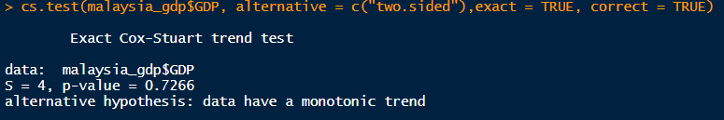

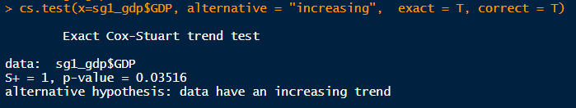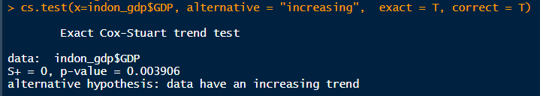

**APPENDIX II**

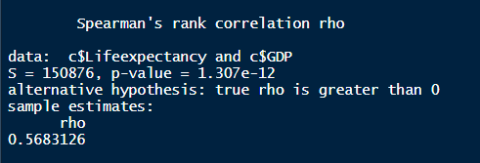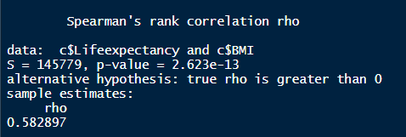

**APPENDIX III**

