UNIVERSITI TUNKU ABDUL RAHMAN

ACADEMIC YEAR 2019/2020

JANUARY 2020 TRIMESTER

FINAL ASSESSMENT

**ANSWER SCRIPT**

**Candidate is required to fill in ALL the information below:**

|  |  |  |  |
| --- | --- | --- | --- |
| Name : (as stated in Student Identity Card) | Ngu Yi Hui | | |
| Faculty /Institute/ Centre: | FSc | Programme : | Statistical Computing And Operations Research |
| Index No. (in numbers) : | A00082DBSCF | Index No. (in words) : | A Zero Zero Zero Eight Two DBSCF |
| Course Code : | UDPS2013 | Course Description : | Numerical Methods |
| Submission Date : | 12th MAY 2020 | Time : | 9am - 11am |

|  |  |  |
| --- | --- | --- |
| **QUESTION NUMBER** | **FOR EXAMINER’S USE ONLY** | |
| **MARKS** | |
| **Internal** | **External** |
| Q1 |  |  |
| Q2 |  |  |
| Q3 |  |  |
| Q4 |  |  |
| **TOTAL MARKS** |  |  |



**DECLARATION STATEMENT**

I, Ngu Yi Hui (Name), Student ID No. 18ADB01438, hereby solemnly and fully declare and confirm that during my programme of study at Universiti Tunku Abdul Rahman, I shall abide and comply with all the rules, regulations and lawful instructions of Universiti Tunku Abdul Rahman and endeavour at all times to uphold the good name of the University.

I hereby declare that my submission for this Final Assessment is based on my original work, not plagiarised from any source(s) except for citations and quotations which have been duly acknowledged. I am fully aware that students who are suspected of violating this pledge are liable to be referred to the Examination Disciplinary Committee of the University.

|  |  |
| --- | --- |
| Programme: | Statistical Computing And Operations Research |
| (Digital) Signature: | HUI |
| Student’s I.C / Passport No.: | 991110-14-6378 |
| Index No: | A00082DBSCF |
| Date of Submission: | 12th MAY 2020 |

Index Number (in figure): A00082DBSCF Course Code: UDPS2013 Page: 3

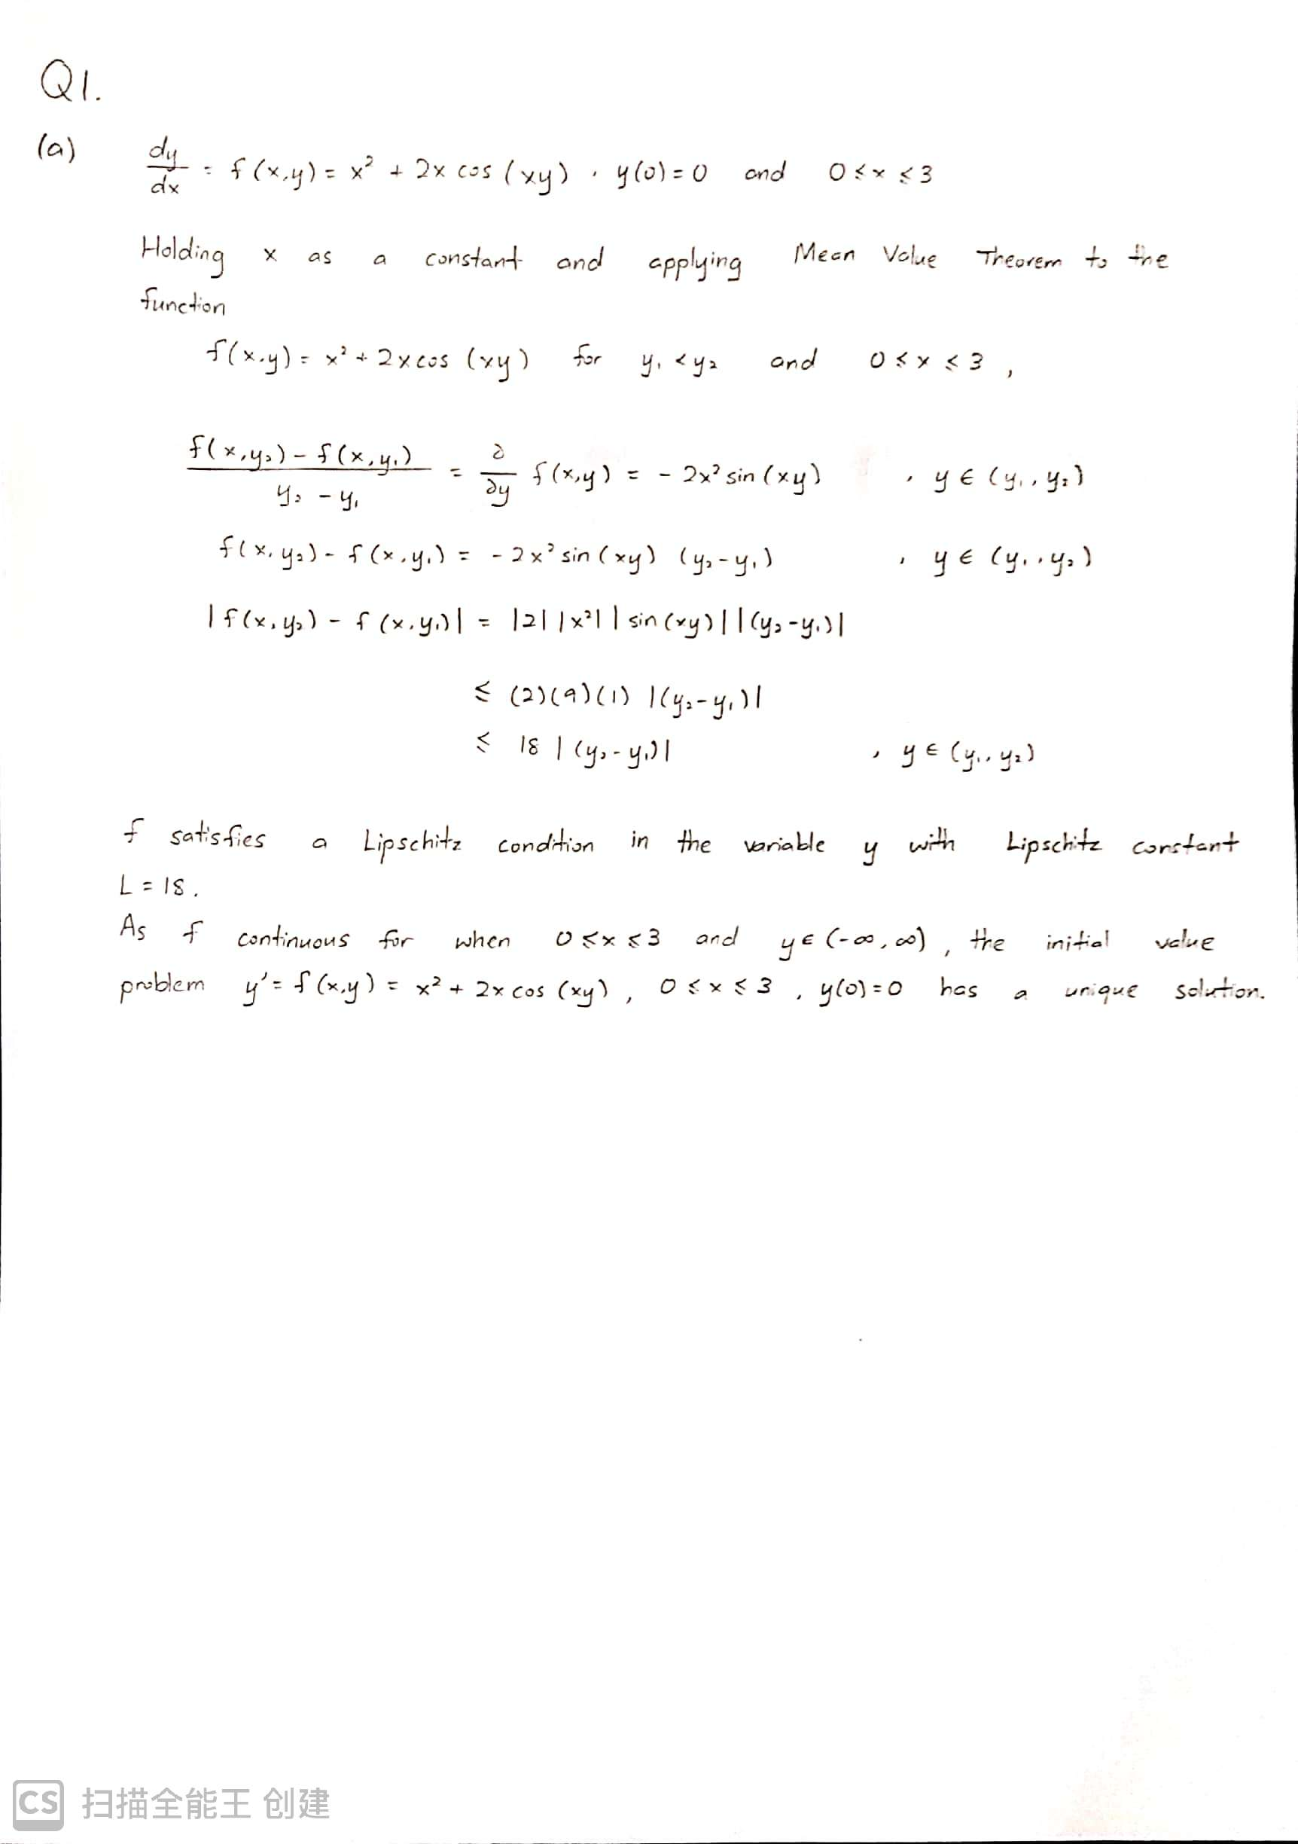

Index Number (in figure): A00082DBSCF Course Code: UDPS2013 Page: 4

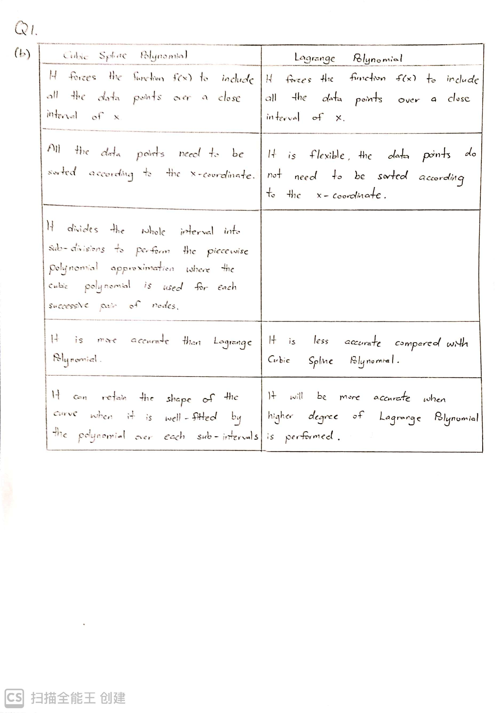

Index Number (in figure): A00082DBSCF Course Code: UDPS2013 Page: 5

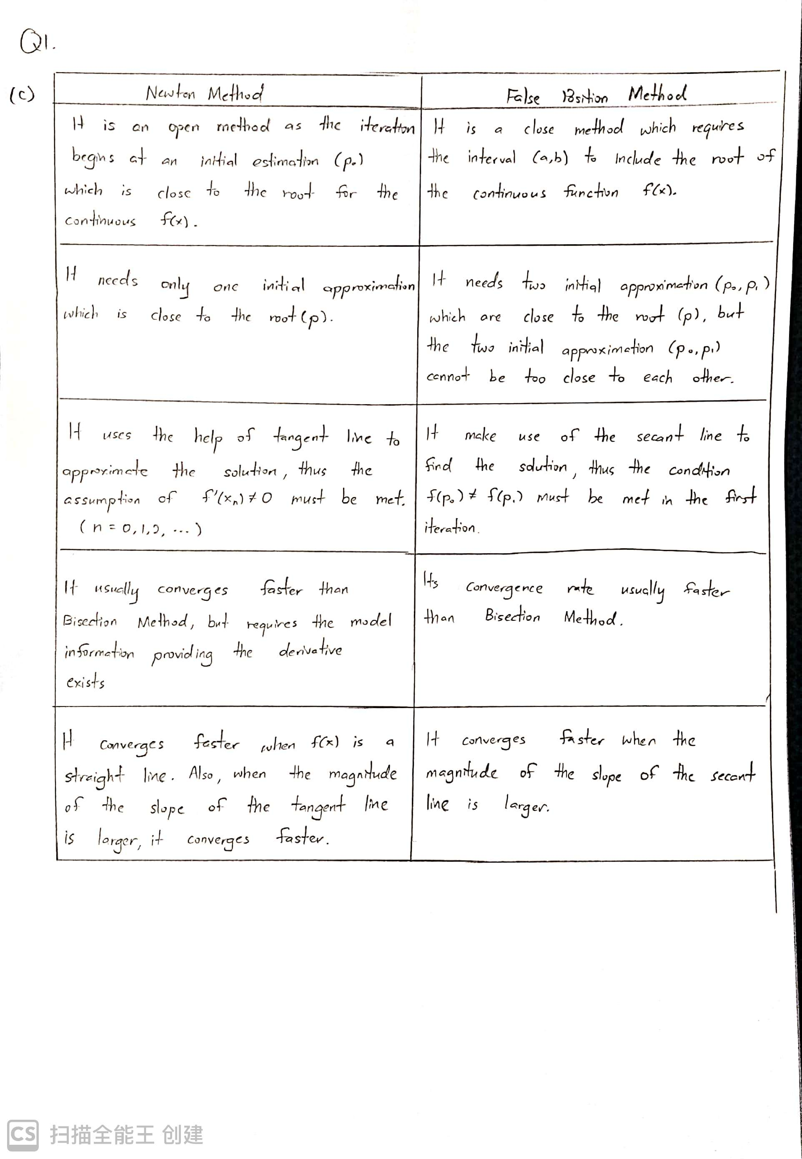

Index Number (in figure): A00082DBSCF Course Code: UDPS2013 Page: 6

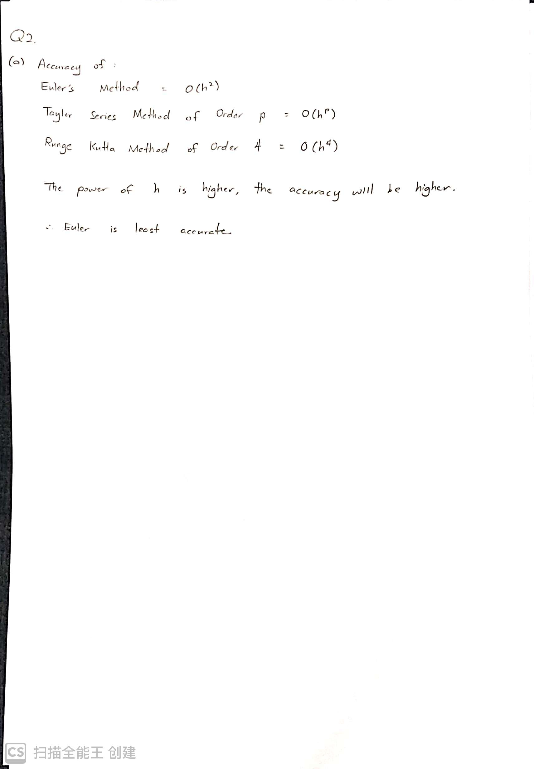

Index Number (in figure): A00082DBSCF Course Code: UDPS2013 Page: 7

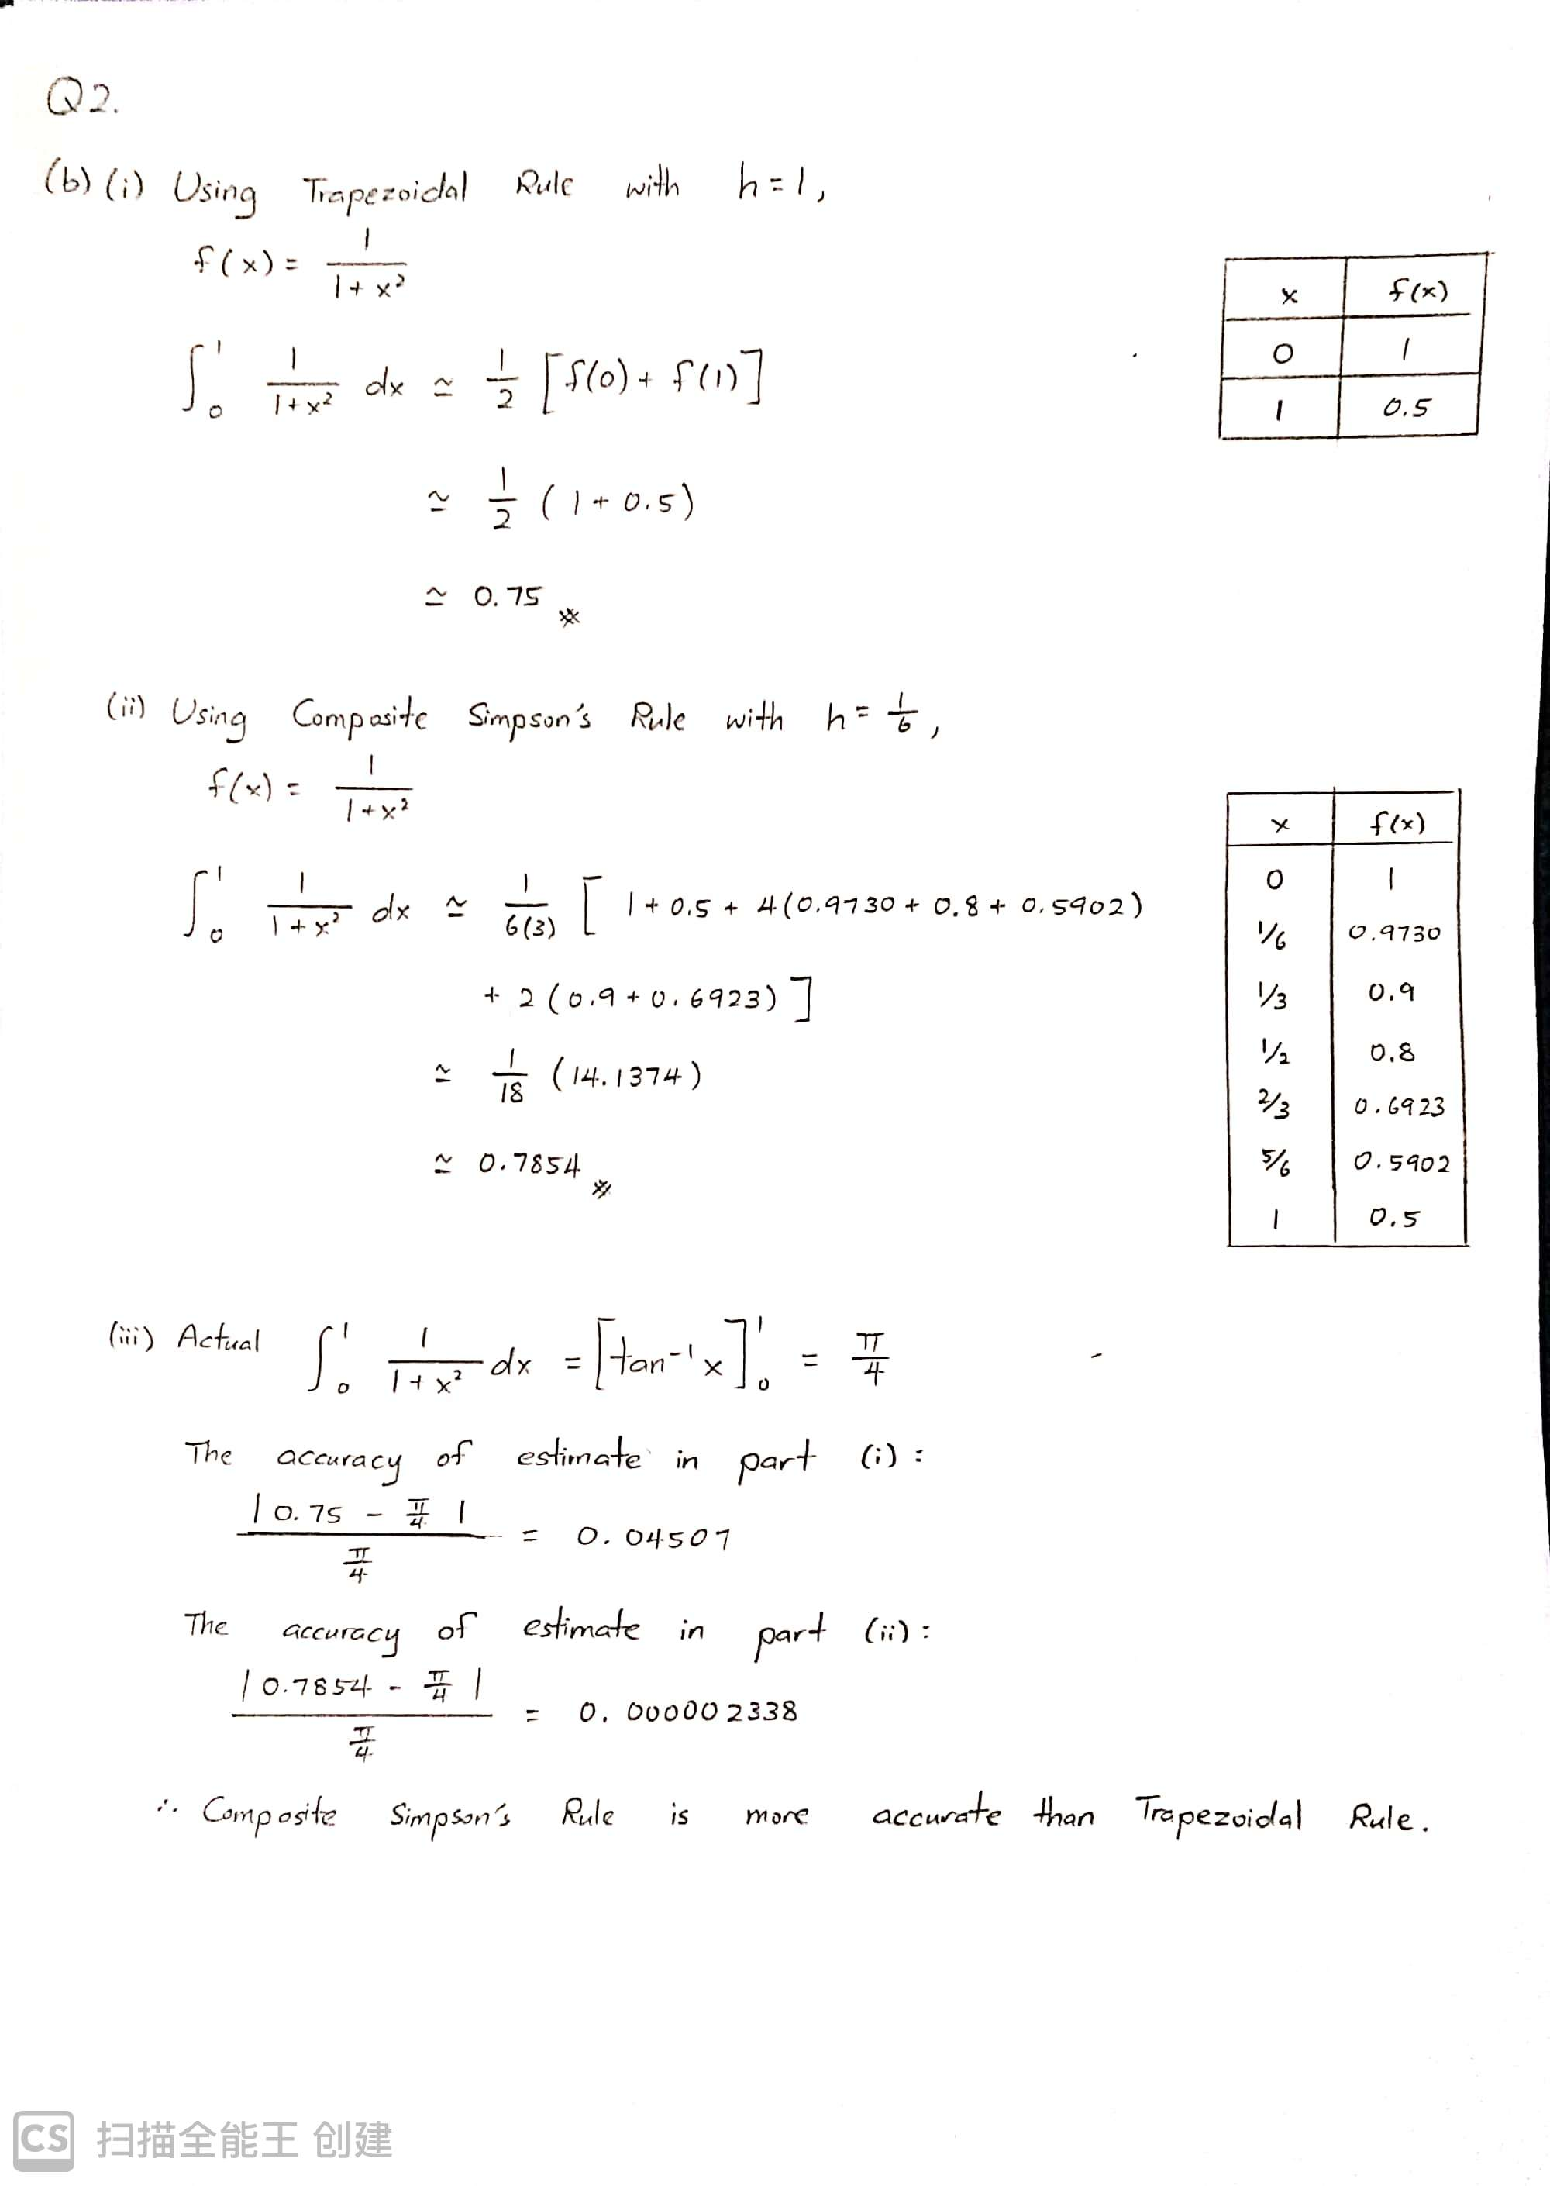

Index Number (in figure): A00082DBSCF Course Code: UDPS2013 Page: 8

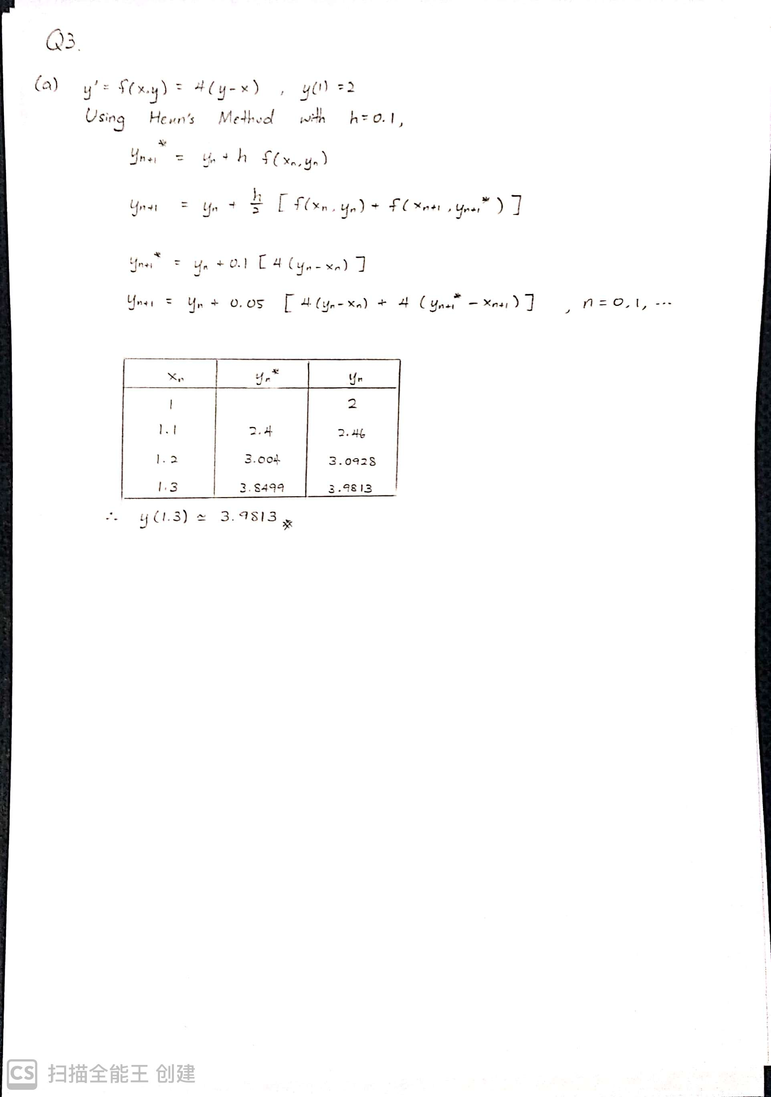

Index Number (in figure): A00082DBSCF Course Code: UDPS2013 Page: 9

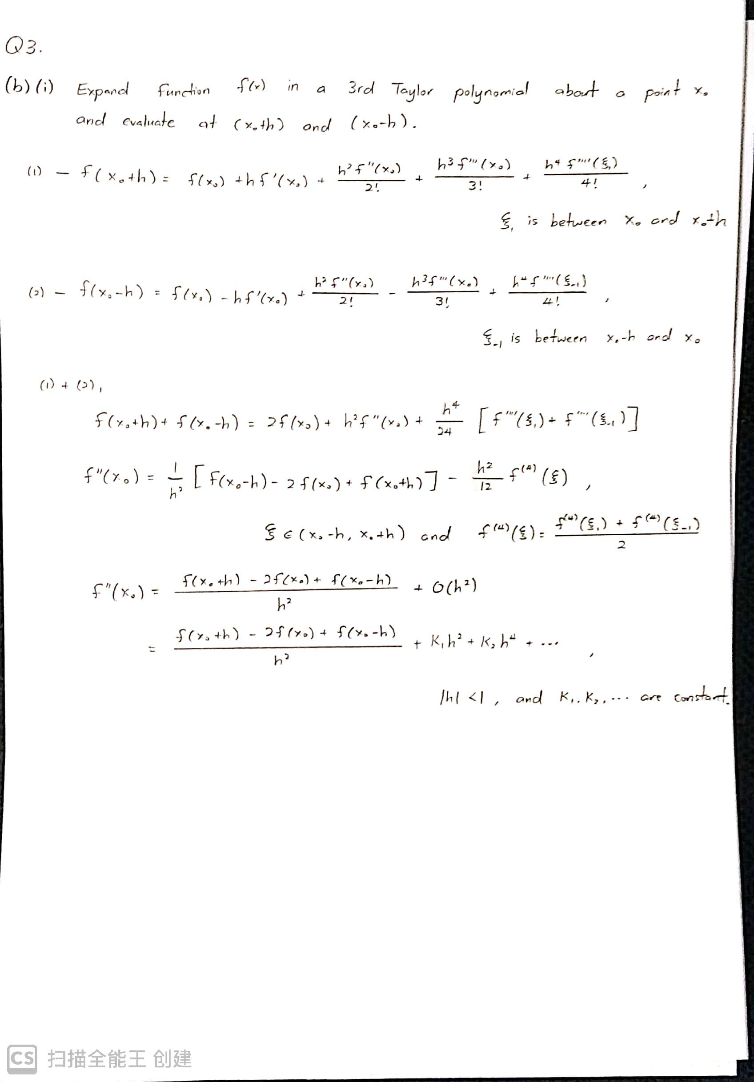

Index Number (in figure): A00082DBSCF Course Code: UDPS2013 Page: 10

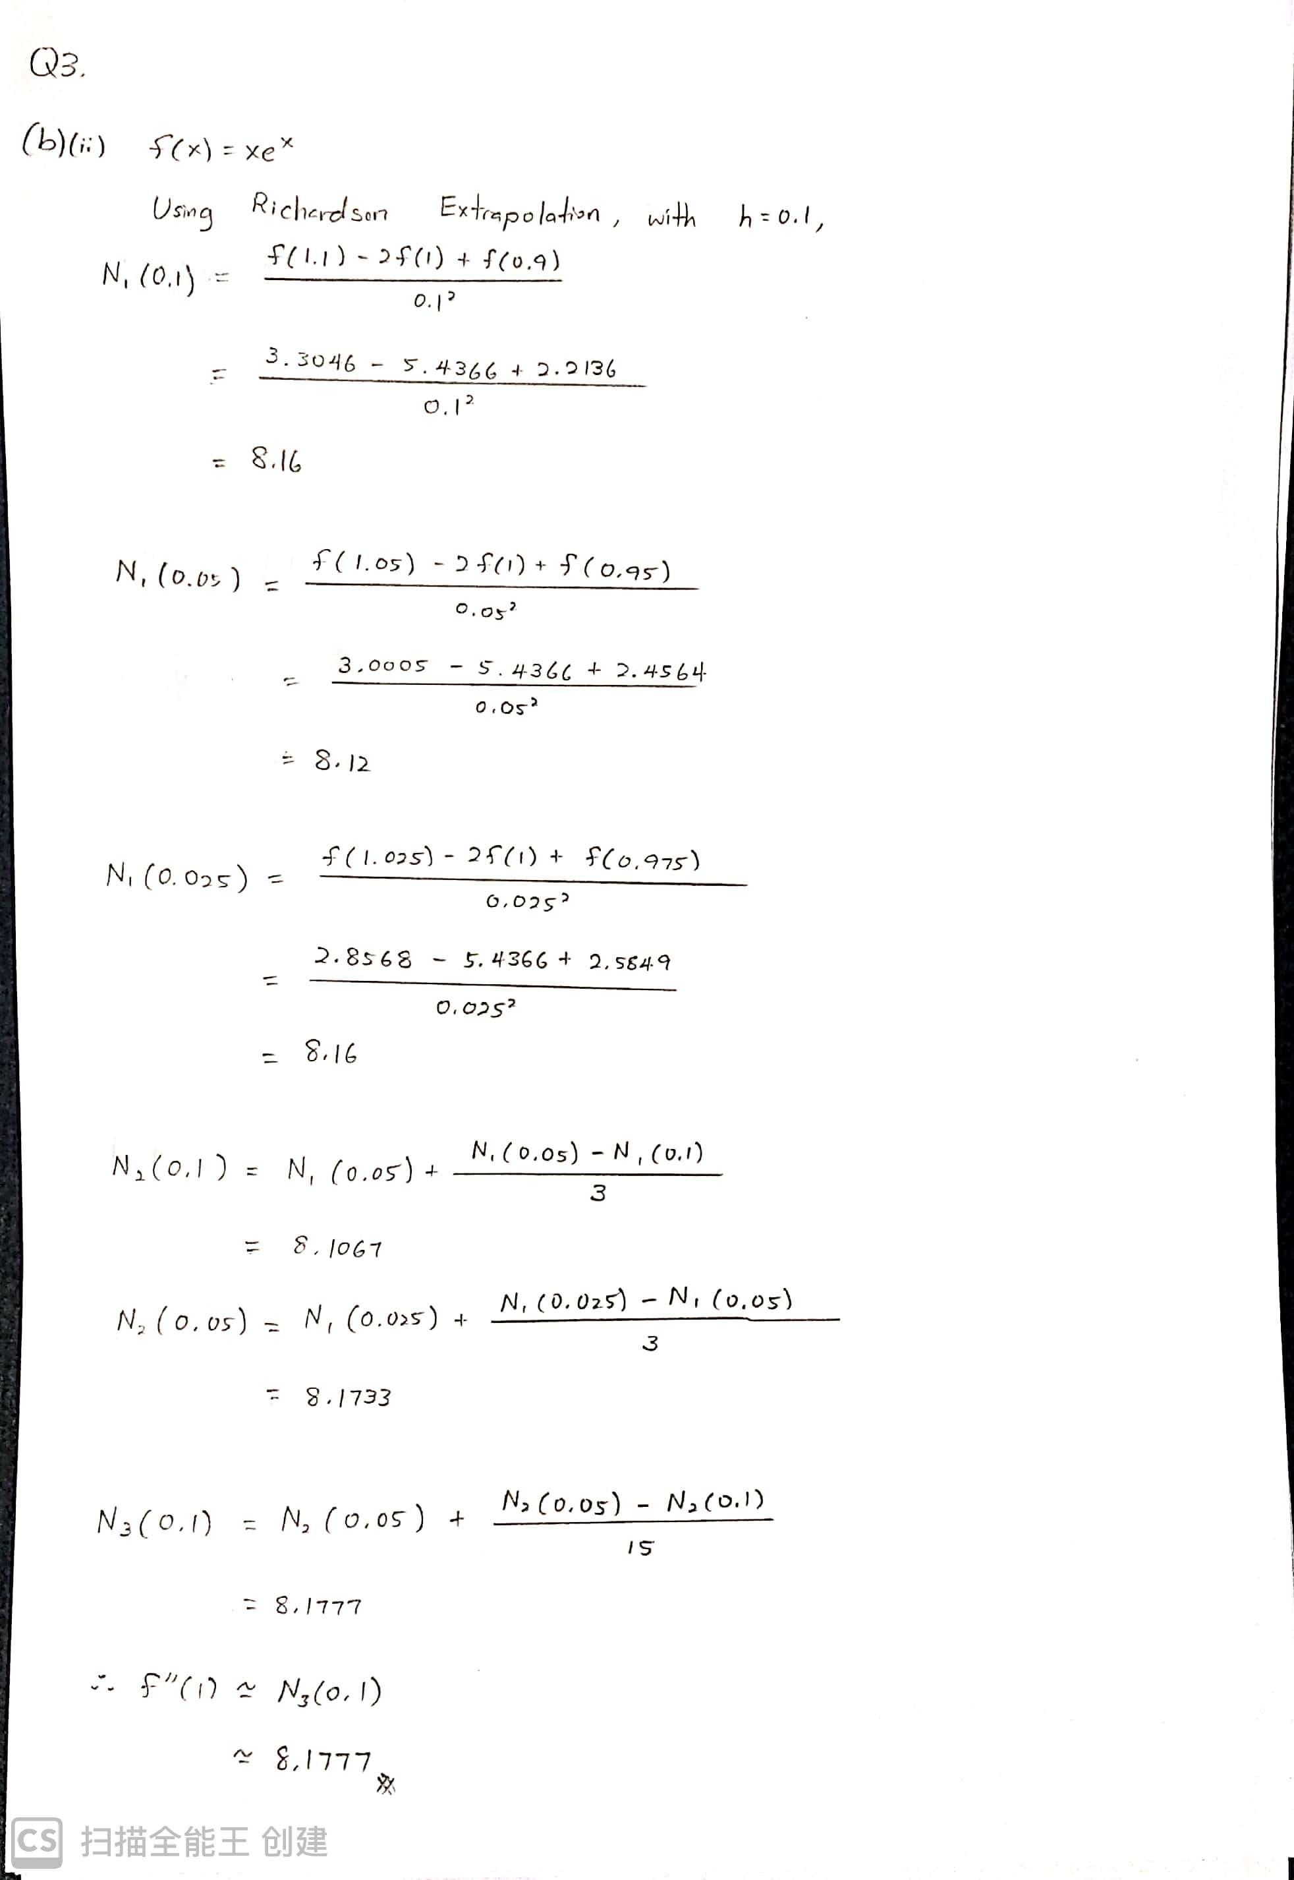

Index Number (in figure): A00082DBSCF Course Code: UDPS2013 Page: 11

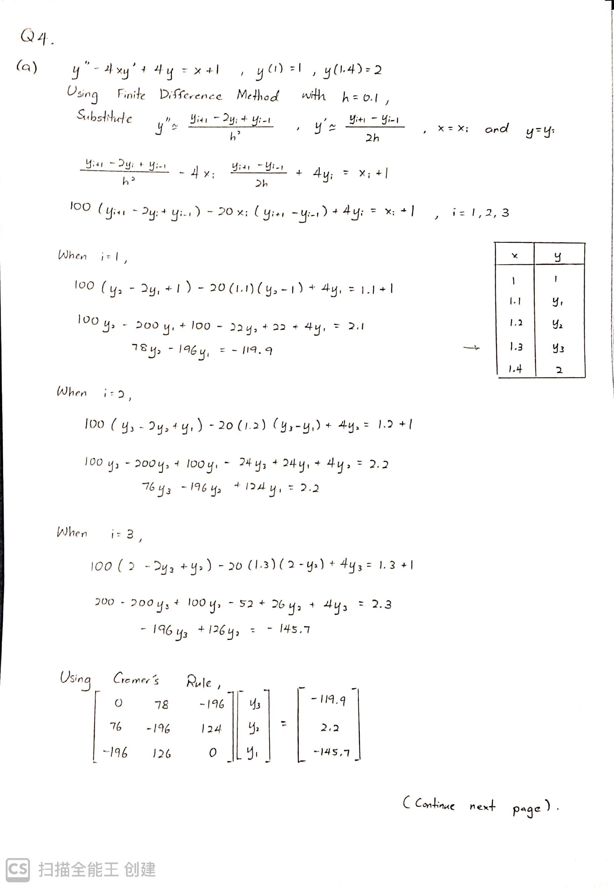

Index Number (in figure): A00082DBSCF Course Code: UDPS2013 Page: 12

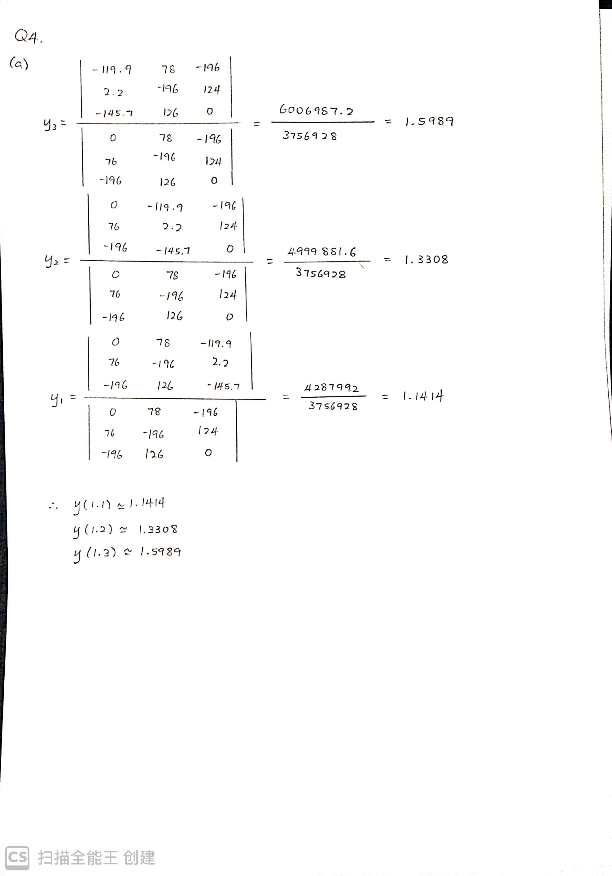

Index Number (in figure): A00082DBSCF Course Code: UDPS2013 Page: 13

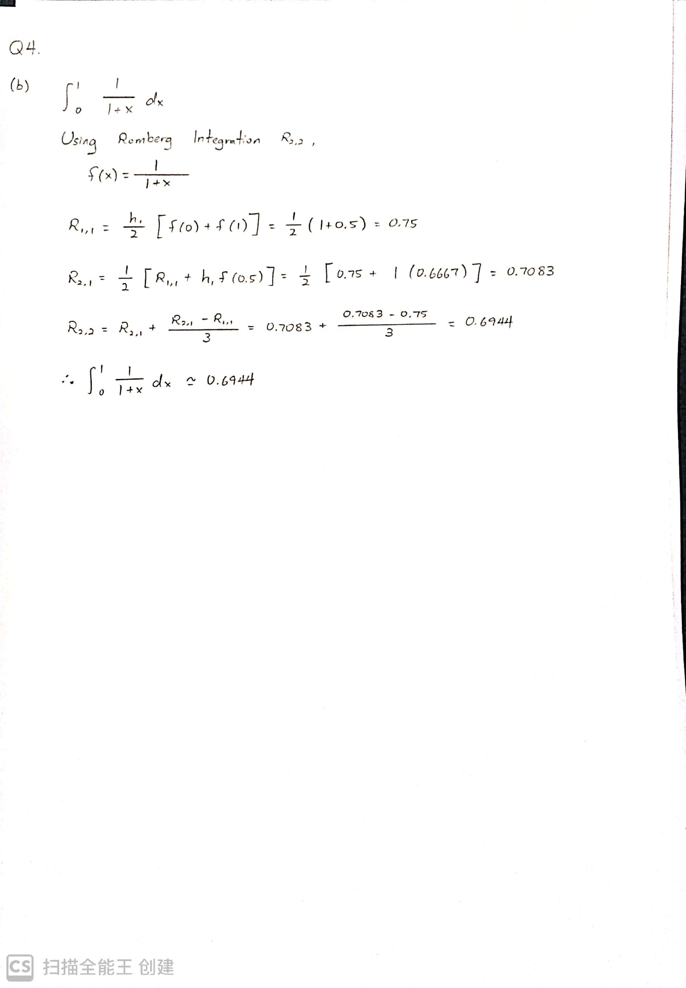

Index Number (in figure): A00082DBSCF Course Code: UDPS2013 Page: 14

