1. A couple plans to meet at the library. Each independently and randomly selects an arrival time within the same one-hour period. Each agrees to wait a maximum of ten minutes for the other to arrive. Find the probability that they will meet.

**Ans**:

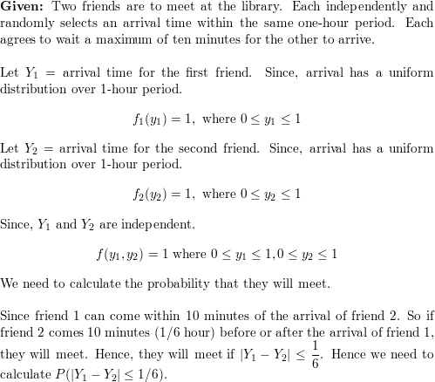

https://d2nchlq0f2u6vy.cloudfront.net/18/12/27/3386f9427a1fc5d190e11289986d48d3/80a6dad62f414f344f24f80099bc0492/lateximg.png?tcb=1585653409

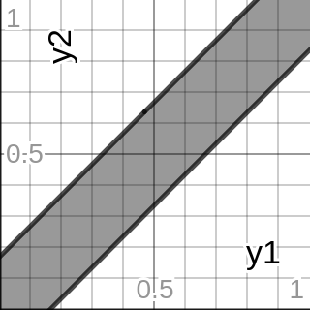

https://d2nchlq0f2u6vy.cloudfront.net/18/12/27/3386f9427a1fc5d190e11289986d48d3/841743b7b0c228bede5746364c277b71/lateximg.png?tcb=1585653409

https://d2nchlq0f2u6vy.cloudfront.net/18/12/27/3386f9427a1fc5d190e11289986d48d3/562da361d88ebec04d44934a0abd0f5c/lateximg.png?tcb=1585653409

1. The length of time that a machine operates without failure is denoted by Y1 and the length of time to repair a failure is denoted by Y2. After a repair is made, the machine is assumed to operate like a new machine. Y1 and Y2 are independent and each has the density function

**Ans**:

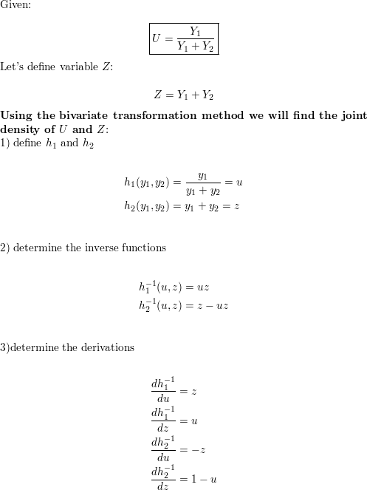

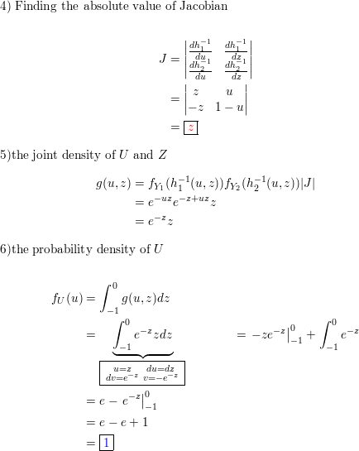

https://d2nchlq0f2u6vy.cloudfront.net/19/03/11/23f47af512cee37a1adeb256fa728b89/1469049380765b06cafd0df17143a835/lateximg.png?tcb=1585653774

1. Let Y1, Y2, . . . , Yn denote a random sample from the uniform distribution f(y) = 1, 0 ≤ y ≤ 1. Find and identify the probability density function for the range R = Y(n) − Y(1).

**Ans**:

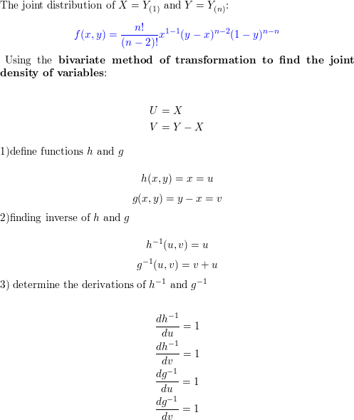

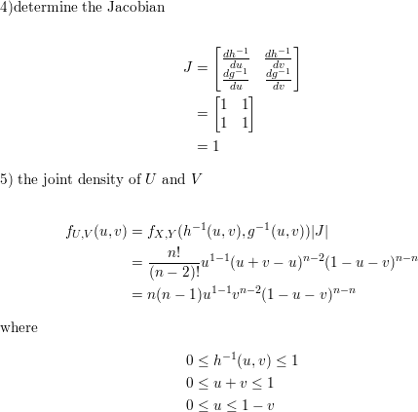

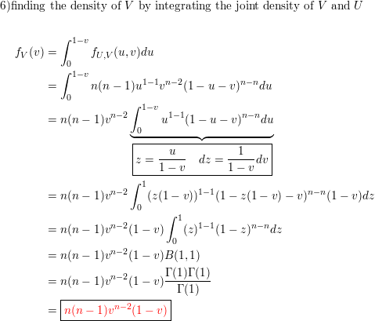

https://d2nchlq0f2u6vy.cloudfront.net/19/03/11/e294e5b2c5506e9a9668c79be418dda6/257bff723b3b0691c32a564e70686b6b/lateximg.png?tcb=1585655339

1. Suppose that n integers are drawn at random and with replacement from the integers, 1, 2, . . . , N. That is, each sampled integer has probability 1 N of taking on any of the values 1, 2, . . . , N, and the sampled values are independent.
2. Find the method of moment estimator Nˆ 1 of N

**Ans**:

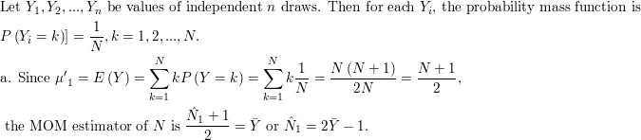

1. Find E(Nˆ 1) and V (Nˆ 1)

**Ans**:

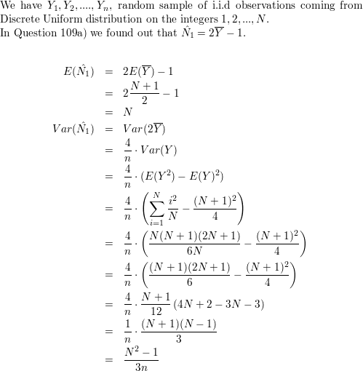

https://d2nchlq0f2u6vy.cloudfront.net/18/11/17/09a62fcca6c249f4b73fb2d8a2271d3b/a6cb55674981efb767ce4015d49fb551/lateximg.png?tcb=1585654156

1. Find the maximum likelihood estimator. Nˆ 2 of N

**Ans**:

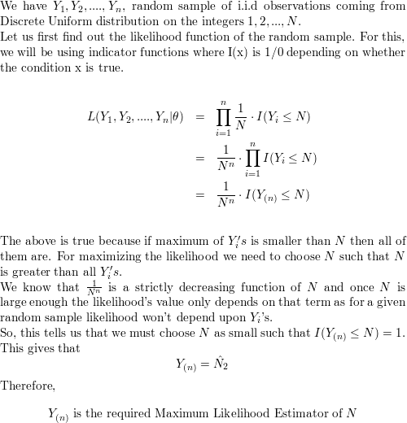

Or

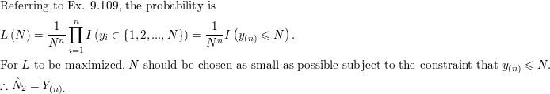

1. Show that E(Nˆ 2) is approximately n (n + 1)N. Adjust Nˆ 2 to form Nˆ 3 that is approximately unbiased for N.

**Ans**:

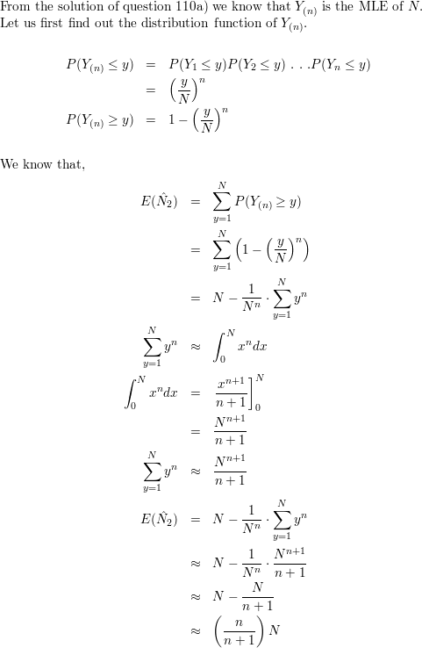

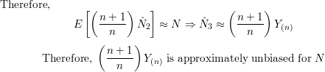

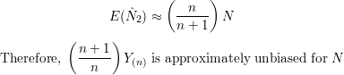

Or

