Semantic Information Retrevial System

Yi-I Chiu
New York University
New York, NY
yic211@nyu.edu
Po-Chih Lin
New York University
New York, NY
pcl322@nyu.edu

Yu-Chih Yu
New York University
New York, NY
ycy247@nyu.edu

Abstract—
In this paper, we build a system which performs semantic search on text data. Our system is constructed by building an expanded inverted-index using semantic content, combining the result of PageRank, and provides online queries. We use Hadoop, Hive, and Spark to constructed our system. We tested our system with a selected set of Wikipedia data which contends 10,228 articles.

Keywords—analytics, …

Introduction
The objective of this project is to build a system which can perform search on the semantic content of texts. Semantic retrieval differs from normal information retrieval in the following aspect: Normal information retrieval system only returns the documents contain the exact query words. Semantic retrieval systems, on the other hand, use the content of top ranked result to perform another round of search. For example, if the query word is ``White House’’, a semantic retrieval system could also results include only ``President Obama’’ but not `White House’’.

The project will be divided into five main parts: (1) parsing the html data to text (2) create the inverted-index of the content for retrieval (3) creating the PageRank (4) performing semantic expansion (5) online querying procedure.

(1) can be a simple Map function which take the (document id, html content) and produce (document id, text)
(2) is an offline MapReduce procedure which the Mapper takes (document id, text) and produce (word, document id), the Reducer takes (word, document id) and produce (word, vector(document id, term frequency))
(3) is an offline MapReduce procedure that generate the PageRank of the Wikipedia pages.
(4) is an offline MapReduce procedure that takes each document in the database, calculate the similarity of the document and expand the inverted index set.
(5) is an online procedure which perform DataBase like retrieval from the stored PageRank and inverted-index.

Motivation
(Write a couple of paragraphs describing why you think this analytic is important. Why should people care about this analytic?)

Related Work
Our paper is not the first attempt of building a search engine using Hadoop technologies. [5] describes, Ivory, a distributed retrieval system build using Hadoop and MapReduce Framework. There 3 main contributions of the paper: (1) build a retrieval architecture on HDFS (2) MapReduce for create inverted-index (3) classifying the webpage to enhance the effectiveness of retrieval. [1] compares three different inverted indexes (Indexer, IndexerCombiner, and IndexerMap) for Electronic Documents using the MapReduce paradigm in Hadoop environment. As for semantic content retrevial, [2] builds a content-based image retrieval (CBIR) system on Hadoop and Lucene. CBIR contains three important issues, image feature extraction, similarity measurement of images, and relevance feedback.
For online processing of data, [3] combines the power and simplicity of the MapReduce abstraction with a wide-scale distributed stream processor, Mortar.
We are also considering using machine learning algorithms to analyze the relations between pages. [4] demonstrates how to speed up different machine learning algorithms using Multicore in a MapReduce scheme. Various algorithms, including locally weighted linear regression, k-means, logistic regression, naïve Bayes, SVM, and neural network, are covered.

Design
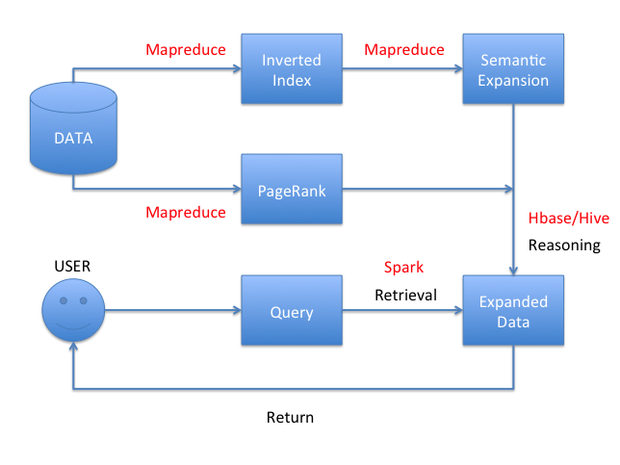

Results
(Future… In this section, you can describe: Your experimental setup/issues with data/performance/etc. Describe your experiments, describe what you learned. Did you prove or disprove your hypothesis? Were some results unexpected? Why? )

Future Work
(Future… Given time, how would you expand your analytic? Could it be applied to other areas? Etc…)

Conclusion
(Future… One or two paragraphs about the value/accuracy/goodness of your analytic.)

Acknowledgment
(This section is optional. It can be used to thank the people/companies/organizations who have made data available to you, for example. You can list any HPC people who were particularly helpful, if you used the NYU HPC.)

References
[1] Baban, Hediyeh, S. Kami Makki, and Stefan Andrei. "Comparison of Different Implementation of Inverted Indexes in Hadoop." The Second International Conference on E-Technologies and Business on the Web (EBW2014). The Society of Digital Information and Wireless Communication, 2014.
[2] Gu, Chunhao, and Yang Gao. "A content-based image retrieval system based on Hadoop and Lucene." Cloud and Green Computing (CGC), 2012 Second International Conference on. IEEE, 2012.
[3] Logothetis, Dionysios, and Kenneth Yocum. "Ad-hoc data processing in the cloud." Proceedings of the VLDB Endowment 1.2 (2008): 1472-1475.
[4] Chu, Cheng, et al. "Map-reduce for machine learning on multicore." Advances in neural information processing systems 19 (2007): 281.
[5] Lin, Jimmy, et al. Of Ivory and Smurfs: Loxodontan MapReduce experiments for web search. MARYLAND UNIV COLLEGE PARK DEPT OF COMPUTER SCIENCE, 2009.
[6] Busch, Michael, et al. "Earlybird: Real-time search at twitter." Data Engineering (ICDE), 2012 IEEE 28th International Conference on. IEEE, 2012.

