CSC2515：Assignment #2

Due: 10pm, 12th November

YIFAN ZHANG

Student Number: 1004245952

November 12, 2017

## Problem 1: Class-Conditional Gaussians

In this question, you will derive the maximum likelihood estimates for class-conditional Gaussians with independent features(diagonal covariance matrices), i.e. Gaussian Naïve Bayes, with shared variances. Start with the following generative model for a discrete class label  and a real valued vector of d features :

 (1)

 (2)

Where  is the prior on class are the shared variances for each feature (in all classes), and  is the mean of the feature  conditioned on class. We write to represent the vector with elements  and similarity is the vector of variances . The matrix of class mean is written  where the th row of  is the mean for class.

1. Use Bayes ‘rules to derive an expression for 



By using the law of total probability:



1. Write down an expression for the negative likelihood function(NLL)

 (3)

of a particular dataset  with parameters .(Assuming that the data are iid.)

Since we assume that the data are independent and identically distributed random variables, we could rewrite as following:









1. Take partial derivatives of the likelihood with respect to each of the parameters  and with respect to the shared variances .





Where 

1. Find the maximum likelihood estimates for  and  .

To maximize, we have 





In the same way, we have 





## Problem 2: Handwritten Digit Classification

## 2.0 Load Data

Load the data and plot the means for each of the digit classes in the training data (include these in your report). Given that each image is a vector of size 64, the mean will be a vector of size 64 which needs to be reshaped as an 8 *8 2D array to be rendered as an image. Plot all 10 means side by side using the same scale.

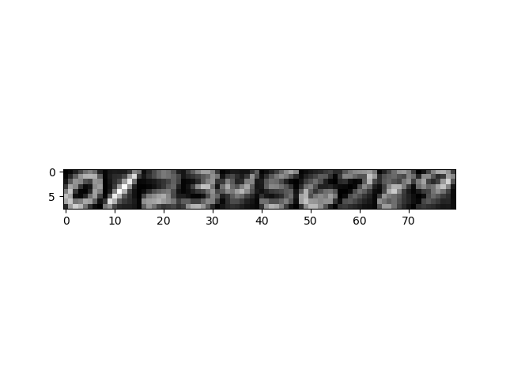

Image 1 the means for each of the digit classes in the training data

## 2.1 K-NN Classifier

1. Build a simple K nearest neighbor classifier using Euclidean distance on the raw pixel data.

(a) For K = 1 report the train and test classification accuracy.

When K = 1, the train accuracy is 1.0, the test accuracy is 0.96875.

(b) For K = 15 report the train and test classification accuracy.

When K = 15, the train accuracy is 0.9594285714285714, the test accuracy is 0.9585.

1. For K > 1 K-NN might encounter ties that need to be broken in order to make a decision. Choose any (reasonable) method you prefer and explain it briefly in your report.

When ties occurs, we could decrease the value of K until the tie is broken. If it doesn’t work, use the class given a 1NN classifier. When we choose K=1, there will be no ties when choose the class.

1. Use 10 fold cross validation to find the optimal K in the 1-15 range. You may use the KFold implementation in sklearn or your existing code from Assignment 1. Report this value of K along with the train classification accuracy, the average accuracy across folds and the test accuracy.

As shown in Table1, the optimal K is 1, and its test accuracy is 0.9689.

|  |  |  |
| --- | --- | --- |
| KNN | Train accuracy | validation accuracy |
| 1 | 1.0 | 0.964428571429 |
| 2 | 0.98173015873 | 0.957571428571 |
| 3 | 0.982507936508 | 0.963428571429 |
| 4 | 0.976952380952 | 0.961 |
| 5 | 0.976634920635 | 0.960857142857 |
| 6 | 0.972952380952 | 0.959 |
| 7 | 0.971936507937 | 0.957857142857 |
| 8 | 0.968825396825 | 0.957428571429 |
| 9 | 0.967206349206 | 0.955571428571 |
| 10 | 0.965333333333 | 0.952857142857 |
| 11 | 0.963666666667 | 0.952285714286 |
| 12 | 0.961666666667 | 0.951428571429 |
| 13 | 0.960365079365 | 0.950428571429 |
| 14 | 0.958111111111 | 0.95 |
| 15 | 0.957428571428 | 0.948764214768 |

Table 2 10 fold cross validation

## 2.2 Conditional Gaussian Classifier Training

1. Plot an 8 by 8 image of the log of the diagonal elements of each covariance matrix. Plot all ten classes side by side using the same grayscale.

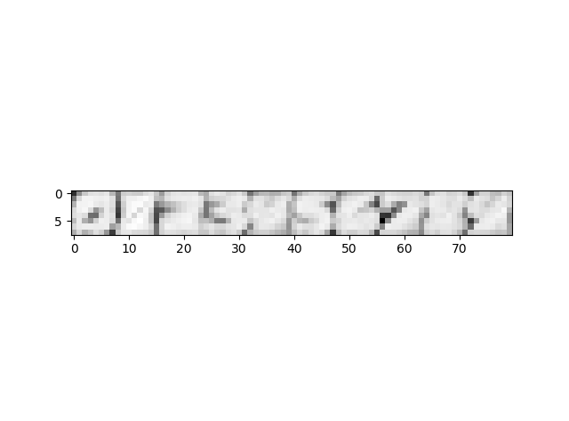

Image 2 the log of the diagonal elements of each covariance matrix

1. Using the parameters you fit on the training set and Bayes rule, compute the average conditional log-likelihood, i.e.  on both the train and test set and report it.

|  |  |  |
| --- | --- | --- |
|  | Train set | Test set |
| Class 0 | -0.55765323 | -1.01660556 |
| Class 1 | -0.17828708 | -2.18786422 |
| Class 2 | -0.16591792 | -0.13531796 |
| Class 3 | -0.23751501 | -0.92961064 |
| Class 4 | -0.2005425 | -0.34815886 |
| Class 5 | -0.76673969 | -1.55992474 |
| Class 6 | -0.16503264 | -1.5343051 |
| Class 7 | -1.56109209 | -5.61468263 |
| Class 8 | -0.17684204 | -0.54047012 |
| Class 9 | -0.50541123 | -1.87390801 |

Table 2 average conditional log-likelihood on train set and test set

1. Select the most likely posterior class for each training and test data point as your prediction, and report your accuracy on the train and test set.

The accuracy on train set is 0.98025.

The accuracy on test set is 0.95925.

## 2.3 Naïve Bayes Classifier Training

1. Convert the real-valued features  into binary features  b using 0.5 as a threshold:  if  otherwise.
2. Using the new binary features and the class labels, train a Bernoulli NAÏVE Bayes classifier using MAP estimation with prior  with . In particular, fit the model below on the training set.

 (6)

 (7)

 (8)

 (9)

You should compute parameters for ,

**Regularization:** Instead of the prior, you could add two training cases to your data set for each class, one which has every pixel off and one which has every pixel on. Make sure you understand why this is equivalent to using a prior. You may use either scheme in your own code.

1. Plot each of your vectors as an 8 by 8 grayscale image. These should be presented side by side and with the same scale.

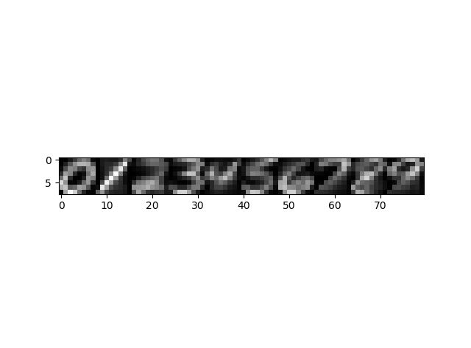

Image 3 vectors 

1. 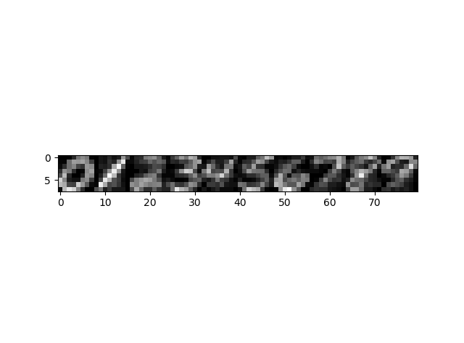Given your parameters, sample one new data point for each of the 10 digit classes. Plot these new data points as 8 by 8 grayscale images side by side.

Image 4 new data point for each of the 10 digit classes

1. Using the parameters you fit on the training set and Bayes rule, compute the average conditional log-likelihood, i.e.  on both the train and test set and report it.

|  |  |  |
| --- | --- | --- |
|  | Train set | Test set |
| Class 0 | -0.59446351 | -0.80802978 |
| Class 1 | -1.64538374 | -1.36832065 |
| Class 2 | -0.95763971 | -1.04132447 |
| Class 3 | -0.81003522 | -0.99495436 |
| Class 4 | -0.71168767 | -0.7376606 |
| Class 5 | -0.82672654 | -0.90549662 |
| Class 6 | -0.63869742 | -0.76775494 |
| Class 7 | -0.88781893 | -0.94937512 |
| Class 8 | -1.16369827 | -1.13435778 |
| Class 9 | -1.23605574 | -1.19641002 |

Table 3 average conditional log-likelihood on train set and test set

1. Select the most likely posterior class for each training and test data point, and report your accuracy on the train and test set.

The accuracy on train set is 0.78375.

The accuracy on test set is 0.76525

## 2.4 Model Comparison

Both K-NN Classifier and Conditional Gaussian Classifier performed well, the accuracy of training on train set and test set could reach 95% (even higher). However, the speed of K-NN is not quick as Conditional Gaussian and the accuracy will decrease when we choose a larger number of neighbors.

Naïve Bayes Classifier performed worst. The accuracy of it only reach about 77% on test set and 78% on train set. This match my expectation. Because we assume conditional independence of each dimension of x. But in fact, there is correlations between dimensions and it will have a highly negative influence on classification.