CSC2515：Assignment #3

Due: 10pm, 6th December

YIFAN ZHANG

Student Number: 1004245952

December 5, 2017

## Problem 1: 20 Newsgroups predictions

In this question, I choose to work with tf-idf feature representation.

There are 11314 train data points and 101631 feature dimensions in this dataset.

The most common word in training set is “the”.

### 1.1 Four models implemented on the dataset:

1. **Bernoulli Naïve Bayes (Baseline):** parameters as default.
2. **Multinomial Naïve Bayes:**

We tune the hyperparameters alpha of Multinomial Naïve Bayes with 5fold cross-validation in order to find the best accuracy. Alpha is a additive (Laplace/Lidstone) smoothing parameter.

When alpha = 0.2, the model has the best accuracy.

|  |  |
| --- | --- |
| Hyperparameter: alpha | Test accuracy( 5fold cross-validation) |
| 0 | 0.13 (+/- 0.01) |
| 0.2 | 0.72 (+/- 0.01) |
| 0.4 | 0.69 (+/- 0.02) |
| 0.6 | 0.67 (+/- 0.02) |
| 0.8 | 0.65 (+/- 0.02) |
| 1.0 | 0.64 (+/- 0.02) |

*(Other parameters: fit_prior=True, class_prior=None)*

1. **Logistic Regression:**

We tune the hyperparameters C with 5fold cross-validation. C is inverse of regularization strength, smaller values specify stronger regularization

When alpha = 1.0, the model has the best accuracy.

|  |  |
| --- | --- |
| Hyperparameter: alpha | Test accuracy( 5fold cross-validation) |
| 0.2 | 0.65 (+/- 0.02) |
| 0.4 | 0.69 (+/- 0.02) |
| 0.6 | 0.71 (+/- 0.02) |
| 0.8 | 0.72 (+/- 0.02) |
| 1.0 | 0.72 (+/- 0.01) |

*(Other parameters: penalty=’l2’, dual=False, tol=0.0001, fit_intercept=True, intercept_scaling=1, class_weight=None, random_state=None, solver=’liblinear’, max_iter=100, multi_class=’ovr’, verbose=0, warm_start=False, n_jobs=1)*

1. **SVM:**

We tune the hyperparameters of SVM in order to find the best accuracy. We use cross validation (split in 10 fold) to tune alpha of SVM. Alpha is a Constant that multiplies the regularization term.

When alpha = 1e-4, the performance of SVM is the best.

|  |  |  |
| --- | --- | --- |
| Hyperparameter: alpha | Train accuracy | Teat accuracy |
| 1e-03 | 0.915827 | 0.73590408 |
| 1e-04 | 0.95731934 | 0.76462948 |
| 1e-05 | 0.97316992 | 0.73590517 |
| 1e-06 | 0.97306188 | 0.71416021 |
| 1e-07 | 0.97315026 | 0.71142224 |

*(Other parameters: loss=’hinge’, penalty=’l2’, l1_ratio=0.15, fit_intercept=True, max_iter=None, tol=None, shuffle=True, verbose=0, epsilon=0.1, n_jobs=1, random_state=42, learning_rate=’optimal’, eta0=0.0, power_t=0.5, class_weight=None, warm_start=False, average=False, n_iter=5)*

1. In conclusion, the final train and test accuracy for each model is showed as following:

|  |  |  |  |
| --- | --- | --- | --- |
|  | Train accuracy | Test accuracy | 5-folds cross-validation |
| Bernoulli NB | 0.5987272405868835 | 0.4579129049389272 | 0.47(+/-0.03) |
| Multinomial NB | 0.9051617465087503 | 0.6712692511949018 | 0.72 (+/- 0.01) |
| LR | 0.8957044369807319 | 0.6775092936802974 | 0.72(+/-0.01) |
| SVM | 0.9537740852041718 | 0.6938396176314392 | 0.76(+/-0.02) |

### 1.2 Explain why you picked these 3 methods, did they work as you thought? Why/Why not?

Multinomial NB: we can take the idea of Bernoulli NB one step further and instead of "word occurs in the document" we have "count how often word occurs in the document", which could improve the accuracy of prediction. In fact, Multinomial NB did show a better performance than Bernoulli NB.

Logistic Regression: this model is the most familiar to me, which is robust to small noise and has a low variance. Since it can’t handle large number of categorical features/variables well, it has a worse performance than SVM on this dataset.

SVM: High accuracy, nice theoretical guarantees regarding overfitting, and especially popular in text classification problems where very high-dimensional spaces are the norm. SVM showed the best performance in this question which is as my prediction.

### 1.3 Confusion Matrix

It’s obvious that SVM has the best accuracy among those four models. The confusion matrix of SVM is showed as following, which is a k*k matrix where is the number of test examples belonging to class j that were classified as i.

[[ 158. 2. 1. 2. 0. 1. 4. 5. 13. 3. 1. 8.

6. 11. 11. 52. 7. 13. 4. 17.]

[ 6. 276. 18. 15. 6. 16. 5. 2. 8. 4. 0. 10.

7. 3. 10. 2. 0. 1. 0. 0.]

[ 6. 22. 234. 39. 13. 14. 4. 2. 17. 4. 1. 7.

1. 6. 11. 1. 3. 1. 6. 2.]

[ 0. 12. 30. 272. 21. 5. 11. 2. 9. 0. 1. 5.

20. 0. 1. 0. 0. 0. 2. 1.]

[ 2. 4. 9. 34. 267. 7. 10. 6. 20. 0. 1. 5.

9. 0. 6. 1. 3. 0. 1. 0.]

[ 0. 45. 32. 7. 6. 278. 4. 0. 6. 2. 0. 3.

4. 0. 6. 1. 0. 1. 0. 0.]

[ 0. 2. 1. 13. 12. 0. 317. 6. 13. 2. 3. 1.

9. 0. 3. 1. 5. 1. 1. 0.]

[ 7. 0. 2. 5. 1. 1. 12. 276. 40. 7. 2. 1.

15. 2. 7. 1. 7. 5. 3. 2.]

[ 3. 3. 0. 2. 1. 1. 7. 16. 318. 4. 4. 2.

7. 6. 6. 4. 6. 1. 5. 2.]

[ 4. 1. 0. 1. 1. 1. 9. 2. 21. 316. 24. 0.

1. 3. 1. 5. 1. 0. 6. 0.]

[ 2. 2. 1. 1. 1. 0. 0. 3. 9. 10. 356. 1.

1. 2. 4. 2. 2. 1. 0. 1.]

[ 3. 4. 6. 3. 4. 5. 5. 2. 20. 3. 3. 295.

5. 3. 5. 5. 13. 4. 7. 1.]

[ 2. 13. 6. 34. 10. 7. 17. 10. 21. 6. 3. 22.

211. 13. 11. 1. 2. 2. 2. 0.]

[ 8. 9. 2. 1. 1. 0. 2. 2. 16. 2. 6. 2.

6. 309. 6. 8. 4. 5. 6. 1.]

[ 6. 10. 4. 1. 2. 1. 3. 6. 21. 1. 3. 3.

9. 10. 297. 4. 6. 2. 5. 0.]

[ 23. 2. 2. 1. 0. 2. 1. 0. 15. 3. 2. 1.

1. 7. 4. 322. 0. 1. 2. 9.]

[ 3. 2. 5. 4. 1. 1. 3. 3. 16. 4. 0. 10.

2. 6. 6. 8. 253. 9. 21. 7.]

[ 26. 1. 2. 3. 1. 1. 1. 2. 12. 4. 1. 7.

3. 2. 2. 10. 8. 280. 10. 0.]

[ 16. 0. 0. 4. 2. 0. 0. 5. 13. 2. 5. 6.

1. 4. 12. 4. 93. 4. 135. 4.]

[ 38. 3. 3. 2. 0. 1. 2. 4. 9. 1. 3. 2.

1. 11. 6. 70. 24. 8. 7. 56.]]

### 1.4 What were the two classes your classifiers was most confused about?

Using *metrics.classification_report* on SVM prediction:

**precision recall f1-score support**

1 0.50 0.50 0.50 319

2 0.67 0.71 0.69 389

3 0.65 0.59 0.62 394

4 0.61 0.69 0.65 392

5 0.76 0.69 0.73 385

6 0.81 0.70 0.75 395

7 0.76 0.81 0.79 390

8 0.78 0.70 0.74 396

9 0.52 0.80 0.63 398

10 0.84 0.80 0.82 397

11 0.85 0.89 0.87 399

12 0.75 0.74 0.75 396

13 0.66 0.54 0.59 393

14 0.78 0.78 0.78 396

15 0.72 0.75 0.73 394

16 0.64 0.81 0.72 398

17 0.58 0.70 0.63 364

18 0.83 0.74 0.78 376

19 0.61 0.44 0.51 310

20 0.54 0.22 0.32 251

**Avg / total** 0.70 0.69 0.69 7532

In the report above, we could see that when test examples belonging to class 1(alt.atheism) and class 20(talk.religion.misc) have the lowest F1 scores. In this sense, class 1 and class 20 were the most confused class.

## Problem 2: Training SVM with SGD

### 2.1 SDG with momentum

Find the minimum of  using gradient descent. The blue line denotes  the using  and red line denotes the  using.

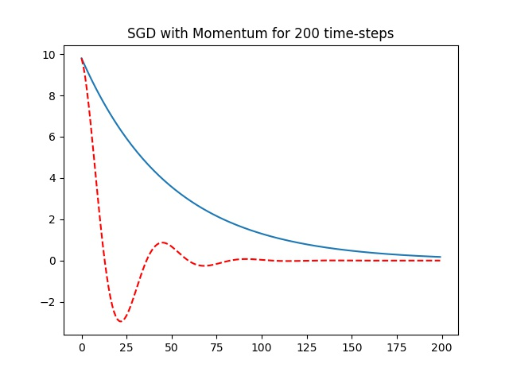

### 2.3 Apply on 4-vs-9 digits on MNIST

, a penalty of, minibatch sizes of, and total iterations.

1. :

Training loss = 0.593255121335

Test loss = 0.596883466246

Train accuracy = 0.9121995464852608

Test accuracy = 0.9125861443598113

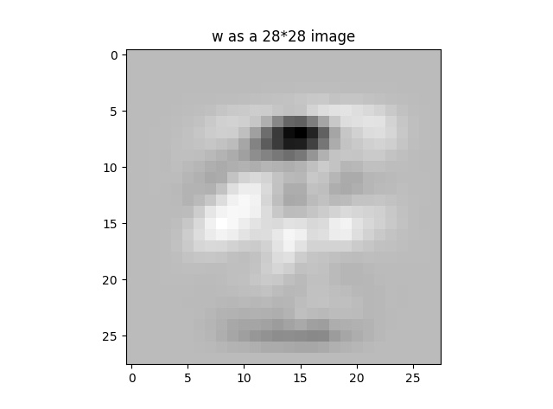

1. :

Training loss = 0.564242212128

Test loss = 0.564848859346

Train accuracy = 0.9254421768707483

Test accuracy = 0.9249183895538629

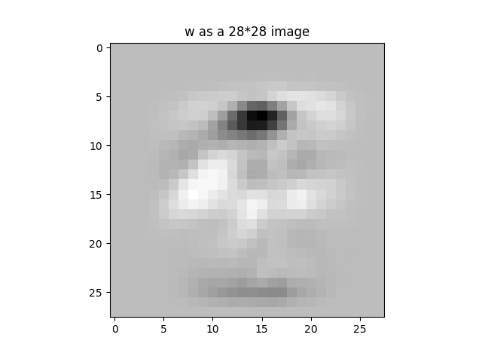

## Problem 3: Kernels

### 3.1 Positive semidefinite and quadratic form

1. Prove that a symmetric matrix  is positive semidefinite iff for all vectors  we have .

Suppose  be the linearly independent eigenvectors which correspond to the eigenvalues  of the real symmetric matrix.

Since  is positive semidefinite, we have are positive.

Also,  is a real symmetric matrix, it can be rewrite as following:



where the columns of  contain the right hand eigenvectors of matrix and  contain the left hand eigenvectors as its row. Thus, if's are the right hand eigenvectors, then's are the left hand eigenvectors of. Then, it holds:



Let  be a random  real vector.



### 3.2 Kernel properties

Prove the following properties:

1. The function  is a kernel for 

Suppose that: 

Then: 

1. is a kernel for all.

Suppose that: 

Since there is just one feature defined by : 

1. If  and are kernels then  for  is a kernel.

Suppose that:







Then:



1. If  is a kernel then is a kernel(hint: use the features  such that )

Suppose that:





Then:

