注意：最好先备份一份，该操作会直接修改active的Excel。

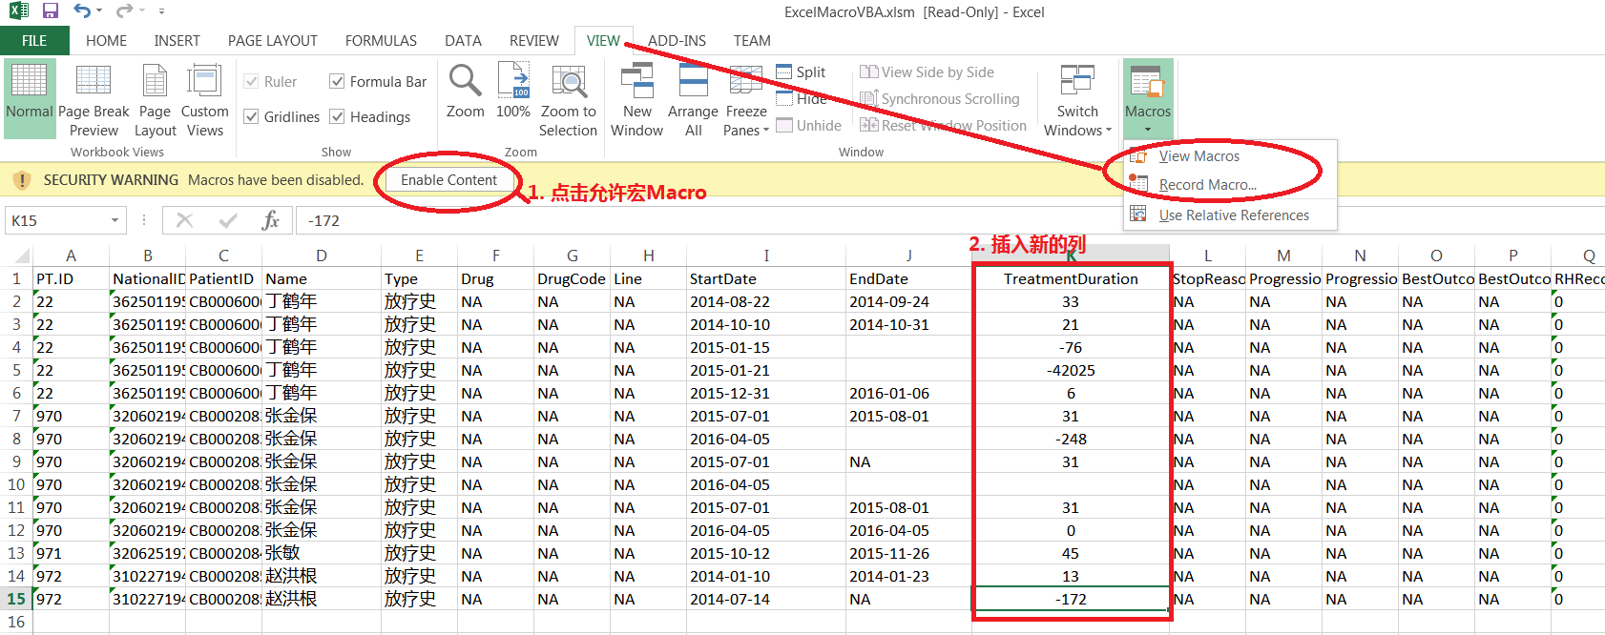

1. 打开Excel文件，如果出现1所示的WARNING，点击允许
2. 添加一个新列用来放结束时间减去起始时间的结果
3. 从View tab里面选Macros，选View Macros，然后点击Edit。如果还没有宏的话选Record Macro，然后给个名字点OK，然后从View Tab的Macros里面选Stop Recording

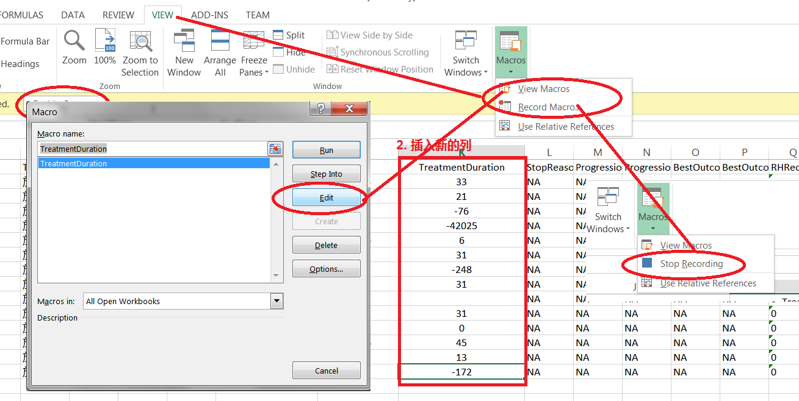

1. 点Edit后会出来Microsoft Visual basic 的编辑器

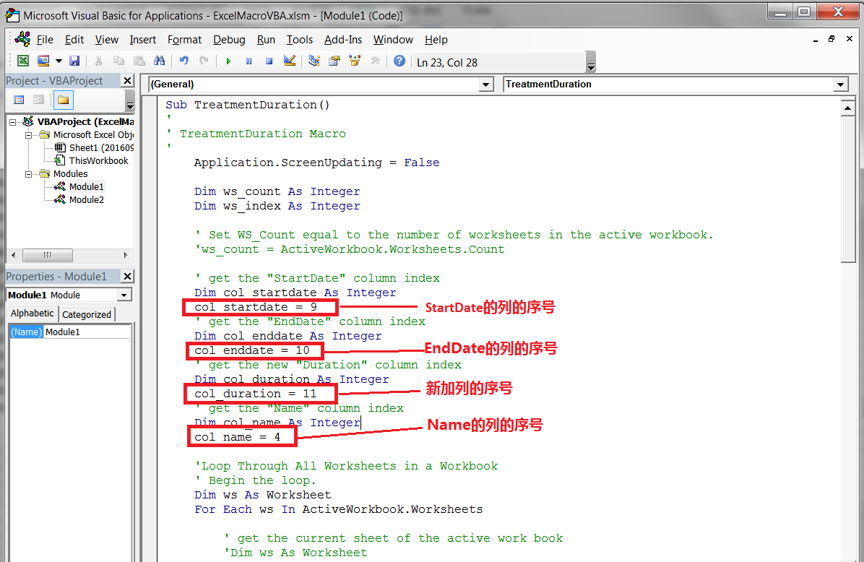

1. 确认里面的数值正确，对照Excel 表格的Header
   1. col_startdate = 9： 是startDate列的序号
   2. col_enddate = 10；是EndDate列的序号
   3. col_duration = 11：是新加列的序号
   4. col_name = 4： 是人名的列的序号，有重名的人，也可以用其它的如NationalID （col_name = 2）

如果不一致就自己修改上面的数字对应到Excel表里列的序号

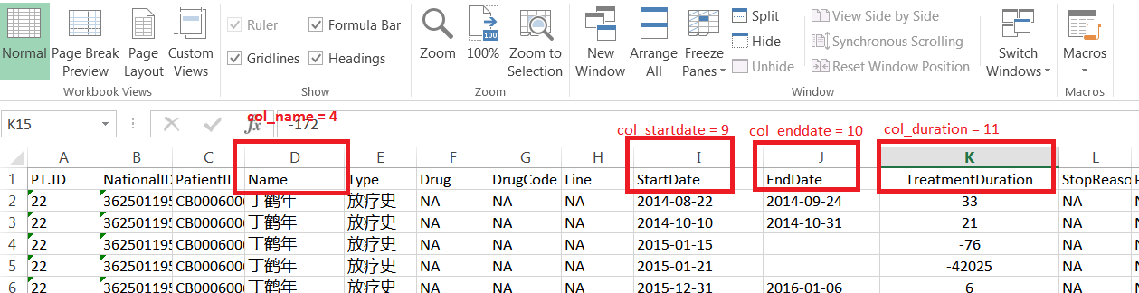

1. 保存后，点击运行这个宏

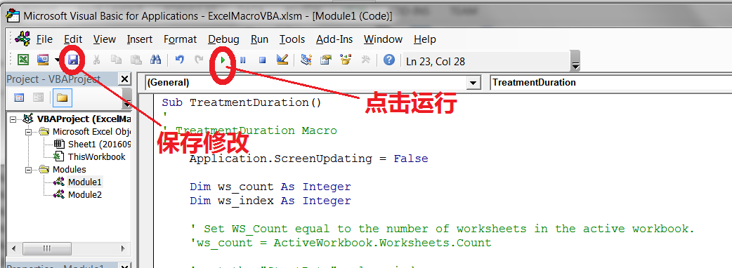

1. 也可以每次从View Tab的View macros，选中要运行的宏，点击Run

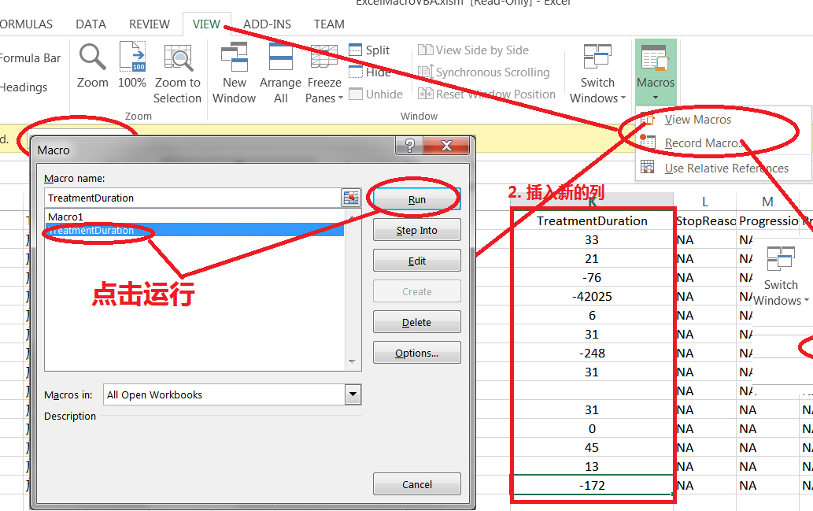

Code:

Sub TreatmentDuration()

'

' TreatmentDuration Macro

'

Application.ScreenUpdating = False

Dim ws_count As Integer

Dim ws_index As Integer

' Set WS_Count equal to the number of worksheets in the active workbook.

'ws_count = ActiveWorkbook.Worksheets.Count

' get the "StartDate" column index

Dim col_startdate As Integer

col_startdate = 9

' get the "EndDate" column index

Dim col_enddate As Integer

col_enddate = 10

' get the new "Duration" column index

Dim col_duration As Integer

col_duration = 11

' get the "Name" column index

Dim col_name As Integer

col_name = 4

'Loop Through All Worksheets in a Workbook

' Begin the loop.

Dim ws As Worksheet

For Each ws In ActiveWorkbook.Worksheets

' get the current sheet of the active work book

'Dim ws As Worksheet

' Insert your code here.

' The following line shows how to reference a sheet within

' the loop by displaying the worksheet name in a dialog box.

'MsgBox ActiveWorkbook.Worksheets(I).Name

'ws = ActiveWorkbook.Worksheets.Item(ws_index)

' get the row count

Dim row_count As Integer

row_count = ws.UsedRange.Rows.Count

Dim date_start As Date

Dim date_end As Date

' Loop through all rows except the header

Dim row_index As Integer

For row_index = 2 To row_count

' if we can find a end date for this row

Dim bHasEndDate As Boolean

bHasEndDate = True

' get the cell of "EndDate"

'Dim cell_enddate As Range

'set cell_enddate = OFFSET($A$1, row_index-1,col_enddate-1)

'date_end = ws.Cells(row_index, col_enddate)

Dim vEndDate As Variant

vEndDate = ws.Cells(row_index, col_enddate)

'If date_end = vbNullString Or date_end = "NA" Then

If IsEmpty(ws.Cells(row_index, col_enddate)) Or vEndDate = vbNullString Or vEndDate = "NA" Then

bHasEndDate = False

Dim name As Variant

name = ws.Cells(row_index, col_name)

'If name = vbNullString Then

'MsgBox "Row hasn't name!"

' the end date is empty then find a match date

Dim row_found As Integer

For row_found = row_index - 1 To 2 Step -1

' check if names match up

If ws.Cells(row_found, col_name) <> name Then

Exit For

End If

vEndDate = ws.Cells(row_found, col_enddate)

If Not IsEmpty(ws.Cells(row_index, col_enddate)) And vEndDate <> vbNullString And vEndDate <> "NA" Then

bHasEndDate = True

date_end = ws.Cells(row_found, col_enddate)

Exit For

End If

Next

Else

date_end = ws.Cells(row_index, col_enddate)

End If

' calculate duration

If bHasEndDate Then

'Dim cell_startdate As Range

date_start = ws.Cells(row_index, col_startdate)

ws.Cells(row_index, col_duration) = date_end - date_start

End If

Next

Next

Application.ScreenUpdating = True

'

End Sub