電通二乙微處理器實驗 實驗結報

實驗名稱 | Lab 01
組別 |  | 組員 | 何宜臻

- 實驗目的
- 使用Tinkercade模擬Arduino UNO 電路及程式
- 繪製電路圖
- 觀察Arduino UNO之輸出
- 學習將程式碼及實驗報告上傳至Github

- 實驗步驟
- 啟動Arduino IDE,載入Blink程式碼
- 至tinkercad註冊,啟動Arduino 模擬器
- 接上LED電路
- 修改程式,將LED輸出為Pin 9
- 觀察LED之閃爍間隔
- 修改程式,使用LED閃爍間隔分別增加為2倍及1/2倍,重新量測並截圖
- 畫出電路圖

- 程式碼
void setup()
{
pinMode(9, OUTPUT);
}

void loop()
{
digitalWrite(9, HIGH);
delay(100); // Wait for 1000 millisecond(s)
digitalWrite(9, LOW);
delay(100); // Wait for 1000 millisecond(s)
digitalWrite(9, HIGH);
delay(100); // Wait for 1000 millisecond(s)
digitalWrite(9, LOW);
delay(100); // Wait for 1000 millisecond(s)
digitalWrite(9, HIGH);
delay(100); // Wait for 1000 millisecond(s)
digitalWrite(9, LOW);
delay(100); // Wait for 1000 millisecond(s)

digitalWrite(9, HIGH);
delay(300); // Wait for 1000 millisecond(s)
digitalWrite(9, LOW);
delay(100); // Wait for 1000 millisecond(s)
digitalWrite(9, HIGH);
delay(300); // Wait for 1000 millisecond(s)
digitalWrite(9, LOW);
delay(100); // Wait for 1000 millisecond(s)
digitalWrite(9, HIGH);
delay(300); // Wait for 1000 millisecond(s)
digitalWrite(9, LOW);
delay(100); // Wait for 1000 millisecond(s)

digitalWrite(9, HIGH);
delay(100); // Wait for 1000 millisecond(s)
digitalWrite(9, LOW);
delay(100); // Wait for 1000 millisecond(s)
digitalWrite(9, HIGH);
delay(100); // Wait for 1000 millisecond(s)
digitalWrite(9, LOW);
delay(100); // Wait for 1000 millisecond(s)
digitalWrite(9, HIGH);
delay(100); // Wait for 1000 millisecond(s)
digitalWrite(9, LOW);
delay(100); // Wait for 1000 millisecond(s)

}

- 實驗結果及分析
LED有sos的閃爍狀態, HIGH時LED亮起,LOW時LED暗掉,透過秒數形成間隔。

- 心得討論
第一次學習Arduino UNO覺得有點複雜,不過慢慢了解之後程式也不是那麼困難,感覺跟之前學的數位系統或電路不同,很多不同的原件希望之後可以越來越上手。
- 修正電路圖
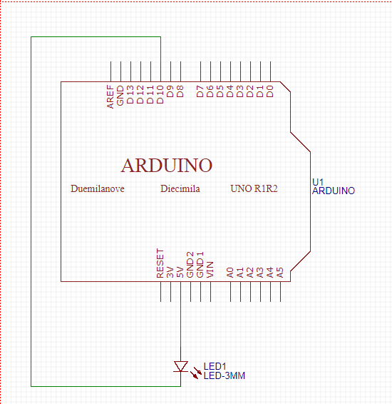
- 修正程式碼

void setup()
{
pinMode(9, OUTPUT);
}

void loop()
{
digitalWrite(9, HIGH);
delay(100); // Wait for 1000 millisecond(s)
digitalWrite(9, LOW);
delay(100); // Wait for 1000 millisecond(s)
digitalWrite(9, HIGH);
delay(100); // Wait for 1000 millisecond(s)
digitalWrite(9, LOW);
delay(100); // Wait for 1000 millisecond(s)
digitalWrite(9, HIGH);
delay(100); // Wait for 1000 millisecond(s)
digitalWrite(9, LOW);
delay(100); // Wait for 1000 millisecond(s)

digitalWrite(9, HIGH);
delay(300); // Wait for 1000 millisecond(s)
digitalWrite(9, LOW);
delay(100); // Wait for 1000 millisecond(s)
digitalWrite(9, HIGH);
delay(300); // Wait for 1000 millisecond(s)
digitalWrite(9, LOW);
delay(100); // Wait for 1000 millisecond(s)
digitalWrite(9, HIGH);
delay(300); // Wait for 1000 millisecond(s)
digitalWrite(9, LOW);
delay(100); // Wait for 1000 millisecond(s)

digitalWrite(9, HIGH);
delay(100); // Wait for 1000 millisecond(s)
digitalWrite(9, LOW);
delay(100); // Wait for 1000 millisecond(s)
digitalWrite(9, HIGH);
delay(100); // Wait for 1000 millisecond(s)
digitalWrite(9, LOW);
delay(100); // Wait for 1000 millisecond(s)
digitalWrite(9, HIGH);
delay(100); // Wait for 1000 millisecond(s)
digitalWrite(9, LOW);
delay(100); // Wait for 1000 millisecond(s)

digitalWrite(9, LOW);
delay(300); // Wait for 1000 millisecond(s)

}

