電通二甲微處理器實驗 實驗結報

實驗名稱 | Lab04
組別 |  | 組員 | 何宜臻

- 實驗目的
了解七段顯示器之顯示原理
- 實驗步驟
CHECK POINT 01
- Arduino接好四合一七段顯示器之電路
- 四合一七段顯示器每隔0.3秒會跳一個數字，從0000->0059->0100->跳至2359後規零

CHECK POINT 02
- 於PIN6按鍵，按下後歸零顯示
- 於PIN17接一個按鍵，按下後到數計時

CHECK POINT 03
- 於PIN6按鍵，按下後歸零顯示
- 於PIN17按下後到數計時，放開後恢復正數

- 程式碼
CHECk 01
#include "SevSeg.h"

SevSeg sevseg;
int Hour = 0, Min = 1;
void setup()
{
byte numDigits = 4;
byte digitPins[] = {5, 4, 3, 2};
byte segmentPins[] = {8, 9, 10, 11, 12, 13, 14, 15};
sevseg.begin(COMMON_CATHODE, numDigits, digitPins, segmentPins);
sevseg.setBrightness(90);
}
void loop()
{
sevseg.setNumber(Hour * 100 + Min, 4);
Min = Min + 1;
if (Min == 60)
{
Min = 0;
if (Hour == 23)
Hour = 0;
else
Hour++;
}
for(int i=0;i<1990909;i++)
sevseg.refreshDisplay();
}
CHECK 02
#include "SevSeg.h"

SevSeg sevseg;
int Hour = 0, Min = 1 , sw = 6;
void setup()
{
pinMode(sw, INPUT);
byte numDigits = 4;
byte digitPins[] = {5, 4, 3, 2};
byte segmentPins[] = {8, 9, 10, 11, 12, 13, 14, 15};
sevseg.begin(COMMON_CATHODE, numDigits, digitPins, segmentPins);
sevseg.setBrightness(90);
}
void loop()
{
if (digitalRead(6) == HIGH)
{
Hour = 0;
Min = 0;
}
else
{
sevseg.setNumber(Hour * 100 + Min, 4);
Min = Min + 1;
if (Min == 60)
{
Min = 0;
if (Hour == 23)
Hour = 0;
else
Hour++;
}
}
for (int i = 0; i < 1990909; i++)
sevseg.refreshDisplay();
}

CHECK 03
#include "SevSeg.h"

SevSeg sevseg;
int Hour = 0, Min = 1 , sw = 6 , x = 16;
void setup()
{
pinMode(sw, INPUT);
pinMode(x,INPUT);
byte numDigits = 4;
byte digitPins[] = {5, 4, 3, 2};
byte segmentPins[] = {8, 9, 10, 11, 12, 13, 14, 15};
sevseg.begin(COMMON_CATHODE, numDigits, digitPins, segmentPins);
sevseg.setBrightness(90);
}
void loop()
{
if (digitalRead(6) == HIGH)
{
Hour = 0;
Min = 0;
}
else if(digitalRead(16) == LOW)
{
sevseg.setNumber(Hour * 100 + Min, 4);
Min = Min - 1;
if (Min == -1)
{
Min = 59;
if (Hour == -1)
Hour = 23;
else
Hour--;
}
}
else
{
sevseg.setNumber(Hour * 100 + Min, 4);
Min = Min + 1;
if (Min == 60)
{
Min = 0;
if (Hour == 23)
Hour = 0;
else
Hour++;
}
}
for (int i = 0; i < 1990909; i++)
sevseg.refreshDisplay();

}
- 實驗結果及分析
四合一七段顯示器由數字0開始往往上增加,透過按鈕歸零,最後再結合兩種實驗加上倒數計時。
- 心得討論
這次的實驗三個都比較雷同,只是接線的部分比較複雜,需要小心是不是有接錯角位,也需要看是正陰極或是正陽極。不過這次的實驗真的蠻有趣的。

- 修正電路圖
CHECK 01
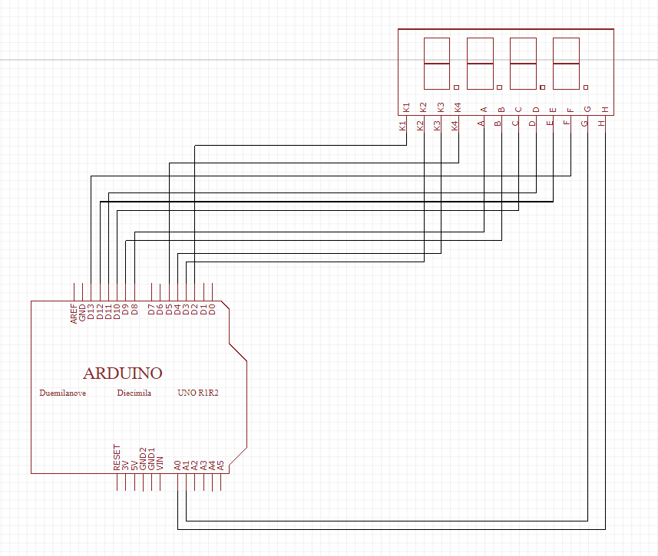
CHECK 02
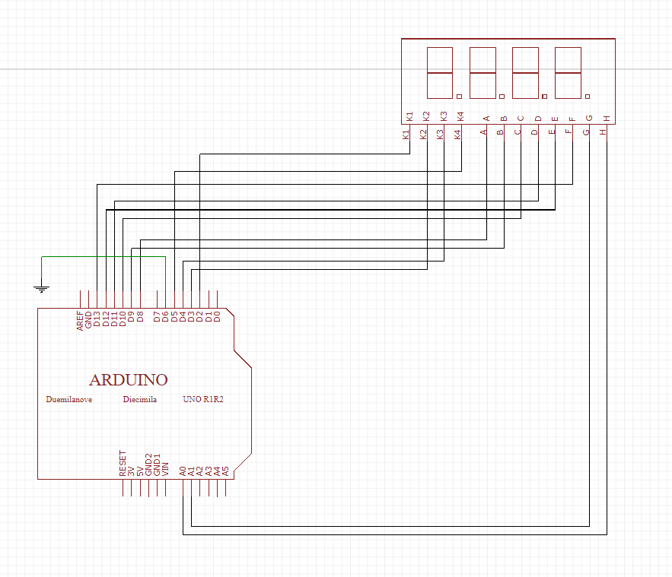
CHECK 03
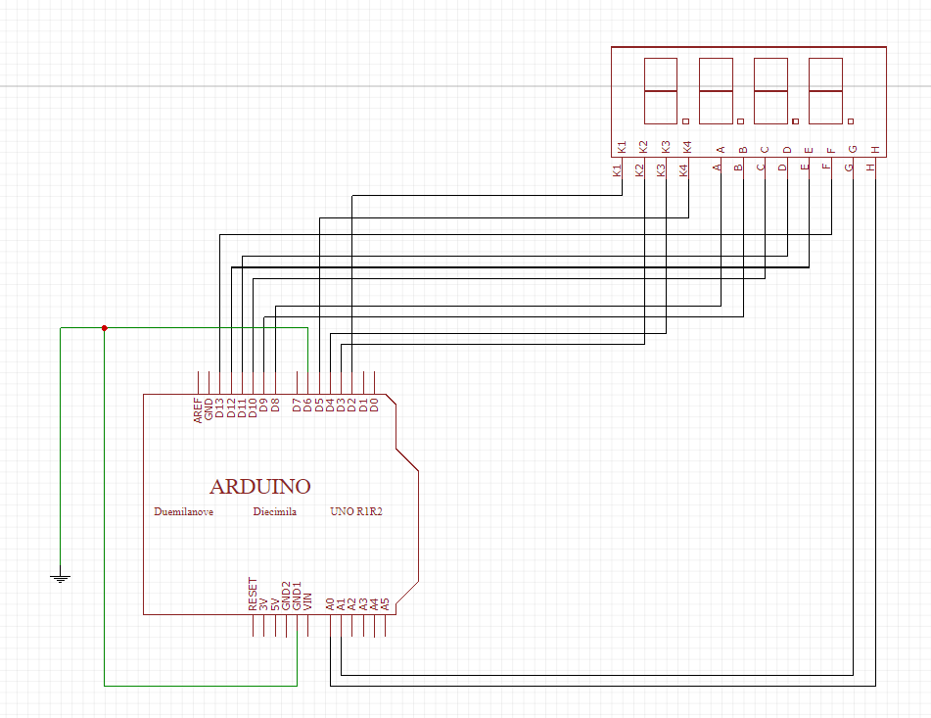
- 修正程式碼
CHECk 01
#include "SevSeg.h"

SevSeg sevseg;
int Hour = 0, Min = 1;
void setup()
{
byte numDigits = 4;
byte digitPins[] = {5, 4, 3, 2};
byte segmentPins[] = {8, 9, 10, 11, 12, 13, 14, 15};
sevseg.begin(COMMON_CATHODE, numDigits, digitPins, segmentPins);
sevseg.setBrightness(90);
}
void loop()
{
sevseg.setNumber(Hour * 100 + Min, 4);
Min = Min + 1;
if (Min == 60)
{
Min = 0;
if (Hour == 23)
Hour = 0;
else
Hour++;
}
for(int i=0;i<1990909;i++)
sevseg.refreshDisplay();
}
CHECK 02
#include "SevSeg.h"

SevSeg sevseg;
int Hour = 0, Min = 1 , sw = 6;
void setup()
{
pinMode(sw, INPUT);
byte numDigits = 4;
byte digitPins[] = {5, 4, 3, 2};
byte segmentPins[] = {8, 9, 10, 11, 12, 13, 14, 15};
sevseg.begin(COMMON_CATHODE, numDigits, digitPins, segmentPins);
sevseg.setBrightness(90);
}
void loop()
{
if (digitalRead(6) == HIGH)
{
Hour = 0;
Min = 0;
}
else
{
sevseg.setNumber(Hour * 100 + Min, 4);
Min = Min + 1;
if (Min == 60)
{
Min = 0;
if (Hour == 23)
Hour = 0;
else
Hour++;
}
}
for (int i = 0; i < 1990909; i++)
sevseg.refreshDisplay();
}

CHECK 03
#include "SevSeg.h"

SevSeg sevseg;
int Hour = 0, Min = 1 , sw = 6 , x = 16;
void setup()
{
pinMode(sw, INPUT);
pinMode(x,INPUT);
byte numDigits = 4;
byte digitPins[] = {5, 4, 3, 2};
byte segmentPins[] = {8, 9, 10, 11, 12, 13, 14, 15};
sevseg.begin(COMMON_CATHODE, numDigits, digitPins, segmentPins);
sevseg.setBrightness(90);
}
void loop()
{
if (digitalRead(6) == HIGH)
{
Hour = 0;
Min = 0;
}
else if(digitalRead(16) == LOW)
{
sevseg.setNumber(Hour * 100 + Min, 4);
Min = Min - 1;
if (Min == -1)
{
Min = 59;
if (Hour == -1)
Hour = 23;
else
Hour--;
}
}
else
{
sevseg.setNumber(Hour * 100 + Min, 4);
Min = Min + 1;
if (Min == 60)
{
Min = 0;
if (Hour == 23)
Hour = 0;
else
Hour++;
}
}
for (int i = 0; i < 1990909; i++)
sevseg.refreshDisplay();

}

