電通二乙微處理器實驗 實驗結報

實驗名稱 | Lab05
組別 |  | 組員 | 何宜臻

- 實驗目的
了解4*4鍵盤的工作原理
- 實驗步驟
CHECK 01
4*4鍵盤之案件值經由串列傳輸,顯示在PC上
CHECK 02
4*4鍵盤之按鍵值顯示在七段顯示器上
- 程式碼
CHECK 01
#include<Keypad.h>
const byte ROWS=4,COLS=4;

char keys[ROWS][COLS] = {{'7','8','9','C'},{'4','5','6','D'},{'1','2','3','E'},{'0','A','B','F'}};

byte rowPins[ROWS] = {8,9,10,11};
byte colPins[COLS] = {2,3,4,5};
Keypad keypad = Keypad(makeKeymap(keys),rowPins,colPins,ROWS,COLS);

void setup(){
Serial.begin(9600);
}
void loop(){
char key = keypad.getKey();

if(key!=NO_KEY){
Serial.println(key);
}
}
CHECK 02
#include<Keypad.h>
#include "SevSeg.h"
const byte ROWS=4,COLS=4;
SevSeg sevseg;

char keys[ROWS][COLS] = {{'7','8','9','C'},{'4','5','6','D'},{'1','2','3','E'},{'0','A','B','F'}};

byte rowPins[ROWS] = {8,9,10,11};
byte colPins[COLS] = {2,3,4,5};
Keypad keypad = Keypad(makeKeymap(keys),rowPins,colPins,ROWS,COLS);

void setup(){
byte numDigits = 1;
byte digitPins[] = {7};
byte segmentPins[] = {6,12,13,14,15,16,17};
sevseg.begin(COMMON_CATHODE,numDigits,digitPins,segmentPins);
Serial.begin(9600);
}
void loop(){
char key = keypad.getKey();

if(key!=NO_KEY){
Serial.println(key);
if(key>='0' && key <='9')
sevseg.setNumber(key-'0',1);
}
sevseg.refreshDisplay();
}
- 實驗結果及分析
加上鍵盤後可以讀出鍵盤按下的數值,再結合七段顯示器,就可以利用七段顯示器顯示出鍵盤按下的數值。
- 心得討論
這次的實驗是我覺得最好玩的一次,利用鍵盤可以顯示我按下的值,之後在結合上禮拜的實驗,加上七段顯示器,讓鍵盤的值顯示在七段顯示器上,蠻有趣的。
修正電路圖
CHECK 01
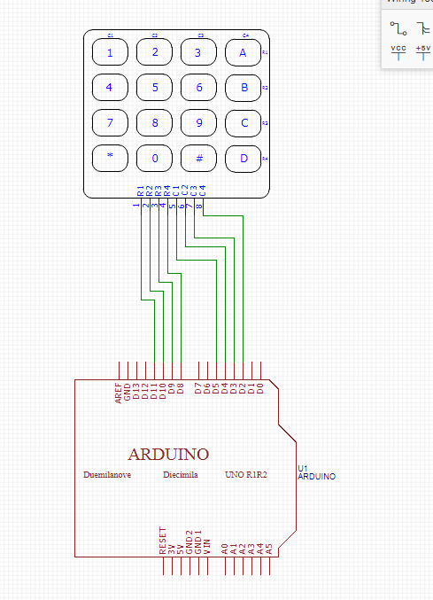
CHECK 02
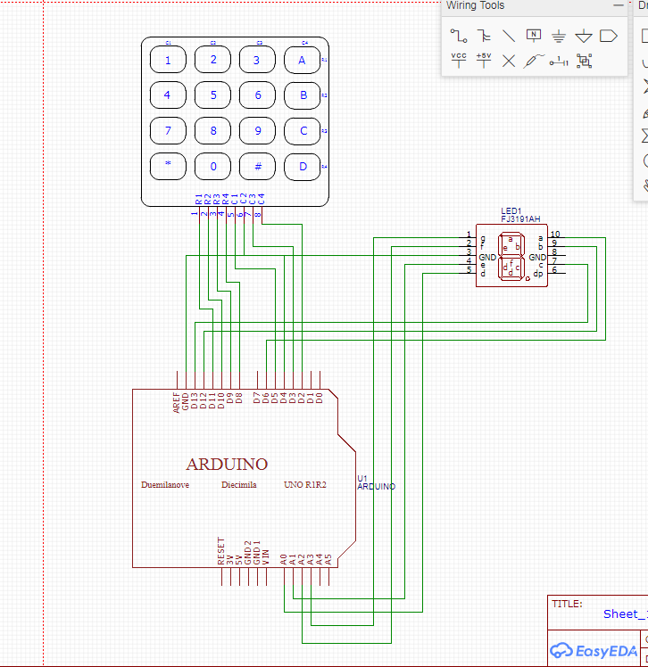
- 修正程式碼
CHECK 01
#include<Keypad.h>
const byte ROWS=4,COLS=4;

char keys[ROWS][COLS] = {{'7','8','9','C'},{'4','5','6','D'},{'1','2','3','E'},{'0','A','B','F'}};

byte rowPins[ROWS] = {8,9,10,11};
byte colPins[COLS] = {2,3,4,5};
Keypad keypad = Keypad(makeKeymap(keys),rowPins,colPins,ROWS,COLS);

void setup(){
Serial.begin(9600);
}
void loop(){
char key = keypad.getKey();

if(key!=NO_KEY){
Serial.println(key);
}
}
CHECK 02
#include<Keypad.h>
#include "SevSeg.h"
const byte ROWS=4,COLS=4;
SevSeg sevseg;

char keys[ROWS][COLS] = {{'7','8','9','C'},{'4','5','6','D'},{'1','2','3','E'},{'0','A','B','F'}};

byte rowPins[ROWS] = {8,9,10,11};
byte colPins[COLS] = {2,3,4,5};
Keypad keypad = Keypad(makeKeymap(keys),rowPins,colPins,ROWS,COLS);

void setup(){
byte numDigits = 1;
byte digitPins[] = {7};
byte segmentPins[] = {6,12,13,14,15,16,17};
sevseg.begin(COMMON_CATHODE,numDigits,digitPins,segmentPins);
Serial.begin(9600);
}
void loop(){
char key = keypad.getKey();

if(key!=NO_KEY){
Serial.println(key);
if(key>='0' && key <='9')
sevseg.setNumber(key-'0',1);
}
sevseg.refreshDisplay();
}

