電通二乙微處理器實驗 實驗結報

實驗名稱 | Lab06音樂教室
組別 |  | 組員 | 何宜臻

- 實驗目的
*如何使Arduino發出特定旋律的聲音
- Arduino接喇叭如何接線?
- 如何使用tone library?
- 如何演奏一段音樂?
- 如何發報摩斯電碼?
- 實驗步驟
- Arduino演奏一段特定音樂,旋律不得是小蜜蜂
- 使用4*4鍵盤演奏音樂
- 發報摩斯電碼
- 程式碼
Check 01
#define beat 500
#define pin 8
#define NOTE_C3 131
#define NOTE_CS3 139
#define NOTE_D3 147
#define NOTE_DS3 156
#define NOTE_E3 165
#define NOTE_F3 175
#define NOTE_FS3 185
#define NOTE_G3 196
#define NOTE_GS3 208
#define NOTE_A3 220
#define NOTE_AS3 233
#define NOTE_B3 247
#define NOTE_C4 262
#define NOTE_CS4 277
#define NOTE_D4 294
#define NOTE_DS4 311
#define NOTE_E4 330
#define NOTE_F4 349
#define NOTE_FS4 370
#define NOTE_G4 392
#define NOTE_GS4 415
#define NOTE_A4 440
#define NOTE_AS4 466
#define NOTE_B4 494
#define WHOLE 1 //全分符
#define HALF 0.5 //半分符
#define QUARTER 0.25
#define EIGHTH 0.125
#define SIXTEENTH 0.0625

void setup() {
pinMode(8, OUTPUT);
}

void aa(int a, int b, int c){
tone(a,b,c);
delay(c);
noTone(a);
}

void loop() {
aa(pin,NOTE_FS4,beat);
aa(pin,NOTE_E4,beat);
aa(pin,NOTE_D4,beat);
aa(pin,NOTE_E4,beat);

aa(pin,NOTE_FS4,beat);
aa(pin,NOTE_FS4,beat);
aa(pin,NOTE_FS4,beat/2);

aa(pin,NOTE_E4,beat);
aa(pin,NOTE_E4,beat);
aa(pin,NOTE_E4,beat/2);

aa(pin,NOTE_FS4,beat);
aa(pin,NOTE_G4,beat);
aa(pin,NOTE_G4,beat/2);

aa(pin,NOTE_FS4,beat);
aa(pin,NOTE_E4,beat);
aa(pin,NOTE_D4,beat);
aa(pin,NOTE_E4,beat);

aa(pin,NOTE_FS4,beat);
aa(pin,NOTE_FS4,beat);
aa(pin,NOTE_FS4,beat/2);

aa(pin,NOTE_E4,beat);
aa(pin,NOTE_E4,beat);
aa(pin,NOTE_FS4,beat);
aa(pin,NOTE_E4,beat);

aa(pin,NOTE_D4,beat/2);

}
Check 02
#include<Keypad.h>
#define beat 500
#define pin 12
#define NOTE_C3 131
#define NOTE_CS3 139
#define NOTE_D3 147
#define NOTE_DS3 156
#define NOTE_E3 165
#define NOTE_F3 175
#define NOTE_FS3 185
#define NOTE_G3 196
#define NOTE_GS3 208
#define NOTE_A3 220
#define NOTE_AS3 233
#define NOTE_B3 247
#define NOTE_C4 262
#define NOTE_CS4 277
#define NOTE_D4 294
#define NOTE_DS4 311
#define NOTE_E4 330
#define NOTE_F4 349
#define NOTE_FS4 370
#define NOTE_G4 392
#define NOTE_GS4 415
#define NOTE_A4 440
#define NOTE_AS4 466
#define NOTE_B4 494
#define WHOLE 1 //全分符
#define HALF 0.5 //半分符
#define QUARTER 0.25
#define EIGHTH 0.125
#define SIXTEENTH 0.0625

const byte ROWS=4,COLS=4;

char keys[ROWS][COLS] = {{'7','8','9','C'},{'4','5','6','D'},{'1','2','3','E'},{'0','A','B','F'}};

byte rowPins[ROWS] = {8,9,10,11};
byte colPins[COLS] = {2,3,4,5};
Keypad keypad = Keypad(makeKeymap(keys),rowPins,colPins,ROWS,COLS);

void setup() {
pinMode(12, OUTPUT);
Serial.begin(9600);
}

void aa(int a, int b, int c){
tone(a,b,c);
delay(c);
noTone(a);
}

void loop() {
char key = keypad.getKey();

if(key!=NO_KEY){
if(key=='0'){
aa(pin,NOTE_C3,500);
}

else if(key=='1'){
aa(pin,NOTE_CS3,500);
}

else if(key=='2'){
aa(pin,NOTE_D3,500);
}

else if(key=='3'){
aa(pin,NOTE_DS3,500);
}

else if(key=='4'){
aa(pin,NOTE_E3,500);
}

else if(key=='5'){
aa(pin,NOTE_F3,500);
}

else if(key=='6'){
aa(pin,NOTE_FS3,500);
}

else if(key=='7'){
aa(pin,NOTE_G3,500);
}

else if(key=='8'){
aa(pin,NOTE_GS3,500);
}

else if(key=='9'){
aa(pin,NOTE_A3,500);
}
}

}
Check 03
#define beat 500
#define pin 12
#define NOTE_C3 131
#define NOTE_CS3 139
#define NOTE_D3 147
#define NOTE_DS3 156
#define NOTE_E3 165
#define NOTE_F3 175
#define NOTE_FS3 185
#define NOTE_G3 196
#define NOTE_GS3 208
#define NOTE_A3 220
#define NOTE_AS3 233
#define NOTE_B3 247
#define NOTE_C4 262
#define NOTE_CS4 277
#define NOTE_D4 294
#define NOTE_DS4 311
#define NOTE_E4 330
#define NOTE_F4 349
#define NOTE_FS4 370
#define NOTE_G4 392
#define NOTE_GS4 415
#define NOTE_A4 440
#define NOTE_AS4 466
#define NOTE_B4 494
#define WHOLE 1 //全分符
#define HALF 0.5 //半分符
#define QUARTER 0.25
#define EIGHTH 0.125
#define SIXTEENTH 0.0625
void setup() {
pinMode(12, OUTPUT);
Serial.begin(9600);
}

void aa(int a, int b, int c){
tone(a,b,c);
delay(c);
noTone(a);
}

void loop() {
int R;
if(Serial.available())
{
R = Serial.read();
if(R== 'A'){
aa(pin,440,100);
delay(100);
aa(pin,440,300);
delay(100);
}

else if(R== 'B'){
aa(pin,440,300);
delay(100);
aa(pin,440,100);
delay(100);
aa(pin,440,100);
delay(100);
aa(pin,440,100);
delay(100);
}

else if(R== 'C'){
aa(pin,440,300);
delay(100);
aa(pin,440,100);
delay(100);
aa(pin,440,300);
delay(100);
aa(pin,440,100);
delay(100);
}

else if(R== 'D'){
aa(pin,440,300);
delay(100);
aa(pin,440,100);
delay(100);
aa(pin,440,100);
delay(100);
}

else if(R== 'E'){
aa(pin,440,100);
delay(100);
}

else if(R== 'F'){
aa(pin,440,100);
delay(100);
aa(pin,440,100);
delay(100);
aa(pin,440,300);
delay(100);
aa(pin,440,100);
delay(100);
}

else if(R== 'G'){
aa(pin,440,300);
delay(100);
aa(pin,440,300);
delay(100);
aa(pin,440,100);
delay(100);
}

else if(R== 'H'){
aa(pin,440,100);
delay(100);
aa(pin,440,100);
delay(100);
aa(pin,440,100);
delay(100);
aa(pin,440,100);
delay(100);
}

else if(R== 'I'){
aa(pin,440,100);
delay(100);
aa(pin,440,100);
delay(100);
}

else if(R== 'J'){
aa(pin,440,100);
delay(100);
aa(pin,440,300);
delay(100);
aa(pin,440,300);
delay(100);
aa(pin,440,300);
delay(100);
}

else if(R== 'K'){
aa(pin,440,300);
delay(100);
aa(pin,440,100);
delay(100);
aa(pin,440,300);
delay(100);
}

else if(R== 'L'){
aa(pin,440,100);
delay(100);
aa(pin,440,300);
delay(100);
aa(pin,440,100);
delay(100);
aa(pin,440,100);
delay(100);
}

else if(R== 'M'){
aa(pin,440,300);
delay(100);
aa(pin,440,300);
delay(100);
}

else if(R== 'N'){
aa(pin,440,300);
delay(100);
aa(pin,440,100);
delay(100);
}

else if(R== 'O'){
aa(pin,440,300);
delay(100);
aa(pin,440,300);
delay(100);
aa(pin,440,300);
delay(100);
}

else if(R== 'P'){
aa(pin,440,100);
delay(100);
aa(pin,440,300);
delay(100);
aa(pin,440,300);
delay(100);
aa(pin,440,100);
delay(100);
}

else if(R== 'Q'){
aa(pin,440,300);
delay(100);
aa(pin,440,300);
delay(100);
aa(pin,440,100);
delay(100);
aa(pin,440,300);
delay(100);
}

else if(R== 'R'){
aa(pin,440,100);
delay(100);
aa(pin,440,300);
delay(100);
aa(pin,440,100);
delay(100);
}

else if(R== 'S'){
aa(pin,440,100);
delay(100);
aa(pin,440,100);
delay(100);
aa(pin,440,100);
delay(100);
}

else if(R== 'T'){
aa(pin,440,300);
delay(100);
}

else if(R== 'U'){
aa(pin,440,100);
delay(100);
aa(pin,440,100);
delay(100);
aa(pin,440,300);
delay(100);
}

else if(R== 'V'){
aa(pin,440,100);
delay(100);
aa(pin,440,100);
delay(100);
aa(pin,440,100);
delay(100);
aa(pin,440,300);
delay(100);
}

else if(R== 'W'){
aa(pin,440,100);
delay(100);
aa(pin,440,300);
delay(100);
aa(pin,440,300);
delay(100);
}

else if(R== 'X'){
aa(pin,440,300);
delay(100);
aa(pin,440,100);
delay(100);
aa(pin,440,100);
delay(100);
aa(pin,440,300);
delay(100);
}

else if(R== 'Y'){
aa(pin,440,300);
delay(100);
aa(pin,440,100);
delay(100);
aa(pin,440,300);
delay(100);
aa(pin,440,300);
delay(100);
}

else if(R== 'Z'){
aa(pin,440,300);
delay(100);
aa(pin,440,300);
delay(100);
aa(pin,440,100);
delay(100);
aa(pin,440,100);
delay(100);
}
}
}
- 實驗結果及分析
透過程式碼使喇叭發出聲音,第二個實驗再利用上次的4*4鍵盤,使喇吧發出想要的聲音,最後利用鍵盤發報出摩斯電碼。
- 心得討論
這次的實驗是做的最快的一次,都是自己做的,而且很有趣,可以自己做自己想要的音樂。
- 修正電路圖
Check 01
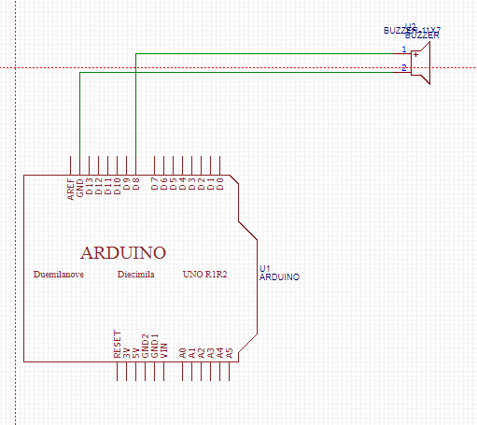
Check 02
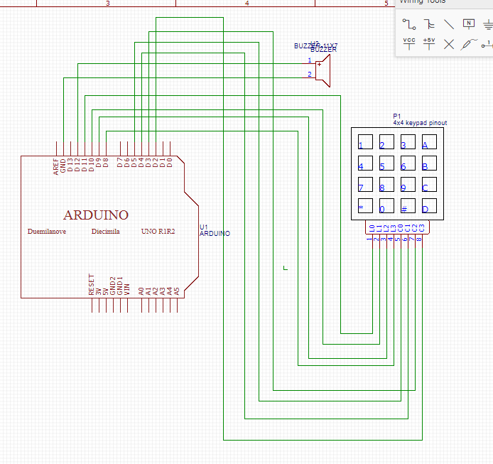
Check 03
- 修正程式碼

