電通二甲微處理器實驗 實驗結報

實驗名稱 | Lab12-溫濕度感應器
組別 |  | 組員 | 何宜臻

- 實驗目的
了解溫濕度感測器的做法
- 實驗步驟
- 讓FHT-11可以一直量測溫濕度
- 整合Timer與DHT-11測量溫濕度
- 使用Timer每隔10秒將溫濕度上傳至MCS could
- 程式碼
Check 01
#include "DHT.h"

#define DHTPIN 2 // Digital pin connected to the DHT sensor

#define DHTTYPE DHT11 // DHT 22 (AM2302), AM2321

DHT dht(DHTPIN, DHTTYPE);

void setup() {
Serial.begin(9600);
Serial.println(F("DHTxx test!"));

dht.begin();
}

void loop() {
// Wait a few seconds between measurements.
delay(2000);

// Reading temperature or humidity takes about 250 milliseconds!
// Sensor readings may also be up to 2 seconds 'old' (its a very slow sensor)
float h = dht.readHumidity();
// Read temperature as Celsius (the default)
float t = dht.readTemperature();
// Read temperature as Fahrenheit (isFahrenheit = true)
float f = dht.readTemperature(true);

// Check if any reads failed and exit early (to try again).
if (isnan(h) || isnan(t) || isnan(f)) {
Serial.println(F("Failed to read from DHT sensor!"));
return;
}

// Compute heat index in Fahrenheit (the default)
float hif = dht.computeHeatIndex(f, h);
// Compute heat index in Celsius (isFahreheit = false)
float hic = dht.computeHeatIndex(t, h, false);

Serial.print(F("Humidity: "));
Serial.print(h);
Serial.print(F("% Temperature: "));
Serial.println(t);
}
Check 02
#include "DHT.h"
#include "Arduino.h"
#include "LTimer.h"

#define DHTPIN 2
#define DHTTYPE DHT11

DHT dht(DHTPIN, DHTTYPE);
int val0 = 0;
LTimer timer0(LTIMER_0);
LTimer timer1(LTIMER_1);

void _callback0(void *usr_data)
{
float h = dht.readHumidity();
float t = dht.readTemperature();

Serial.print(F("Humidity: "));
Serial.print(h);
Serial.print(F("% Temperature: "));
Serial.println(t);
}

void setup() {
Serial.begin(9600);
Serial.println(F("DHTxx test!"));

dht.begin();

timer0.begin();
timer0.start(1000, LTIMER_REPEAT_MODE, _callback0, NULL);
}

void loop() {
float h = dht.readHumidity();
float t = dht.readTemperature();
}
Check 03
#include "MCS.h"
#include "Arduino.h"
#include "LTimer.h"
#include "DHT.h"
#define DHTPIN 2
#define DHTTYPE DHT11
#define _SSID "Jen"
#define _KEY "0934338038"
MCSDevice mcs("DkbiUhQo ", " p7g0Iu1t5iQa0E0F ");
MCSDisplayFloat Temp("Temperature");
MCSDisplayFloat Humidity("Humidity");
float h;
float t ;
float f ;
float hif ;

float hic ;
DHT dht(DHTPIN, DHTTYPE);
// instantiation

LTimer timer1(LTIMER_1);

void _callback1(void *usr_data)
{
h = dht.readHumidity();

t = dht.readTemperature();

f = dht.readTemperature(true);

if (isnan(h) || isnan(t) || isnan(f)) {
Serial.println(F("Failed to read from DHT sensor!"));
return;
}

hif = dht.computeHeatIndex(f, h);

hic = dht.computeHeatIndex(t, h, false);

Serial.print(F("Humidity: "));
Serial.print(h);
Serial.print(F("% Temperature: "));
Serial.print(t);
Serial.print(F("'C "));
Serial.print(f);
Serial.print(F("'F Heat index: "));
Serial.print(hic);
Serial.print(F("'C "));
Serial.print(hif);
Serial.println(F("'F"));
}

void setup() {
Serial.begin(9600);
while(WL_CONNECTED != WiFi.status())
{
Serial.print("WiFi.begin(");
Serial.print(_SSID);
Serial.print(",");
Serial.print(_KEY);
Serial.println(")...");
WiFi.begin(_SSID, _KEY);
}
Serial.println("WiFi connected !!");

// setup MCS connection
mcs.addChannel(Humidity);
mcs.addChannel(Temp);
while(!mcs.connected())
{
Serial.println("MCS.connect()...");
mcs.connect();
}
Serial.println("MCS connected !!");

Serial.println(F("DHTxx test!"));
dht.begin();
timer1.begin();
timer1.start(10000, LTIMER_REPEAT_MODE, _callback1, NULL);
}

void loop() {
mcs.process(100);
Temp.set(hic);
Humidity.set(h);
dht.readTemperature();

}

- 實驗結果及分析
利用溫濕度感測器測量溫濕度,之後加上Timer與DHT-11來測量溫濕度,最後利用mcs could 來看溫濕度的數值。
- 心得討論
這次的實驗蠻困難的,想了很久,一開始自己做出來第二題,但才發現用道延遲了,所以又重做一次,最後一個實驗,利用道上次的mcs could但還是一樣困難,希望下周抽到比較簡單的考題。

- 修正電路圖
Check 01 & Check 02 & Check 03
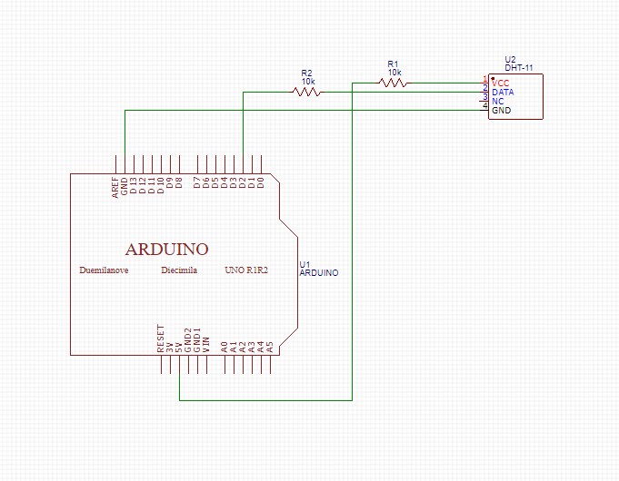
- 修正程式碼
Check 03

#include <LWiFi.h>
#include <WiFiClient.h>
#include "MCS.h"
#include "DHT.h"
#include "Arduino.h"
#include "LTimer.h"

#define DHTPIN 2
#define DHTTYPE DHT11

#define _SSID "Jen"
#define _KEY "0934338038"

MCSDevice mcs("DkbiUhQo", "p7g0Iu1t5iQa0E0F");
MCSDisplayFloat temperature("06051043");
MCSDisplayFloat humidity("0605104301");

DHT dht(DHTPIN, DHTTYPE);
int val0 = 0;
LTimer timer0(LTIMER_0);
LTimer timer1(LTIMER_1);

void _callback0(void *usr_data)
{
float h = dht.readHumidity();
float t = dht.readTemperature();

Serial.print(F("Humidity: "));
Serial.print(h);
Serial.print(F("% Temperature: "));
Serial.println(t);
}

void setup() {
Serial.begin(9600);
Serial.println(F("DHTxx test!"));
dht.begin();

timer0.begin();
timer0.start(10000, LTIMER_REPEAT_MODE, _callback0, NULL);

while(WL_CONNECTED != WiFi.status())
{
Serial.print("WiFi.begin(");
Serial.print(_SSID);
Serial.print(",");
Serial.print(_KEY);
Serial.println(")...");
WiFi.begin(_SSID, _KEY);
}
Serial.println("WiFi connected !!");
mcs.addChannel(temperature);
mcs.addChannel(humidity);
}

void loop() {

mcs.process(100);

float h = dht.readHumidity();
float t = dht.readTemperature();

temperature.set(t);
humidity.set(h);
}

